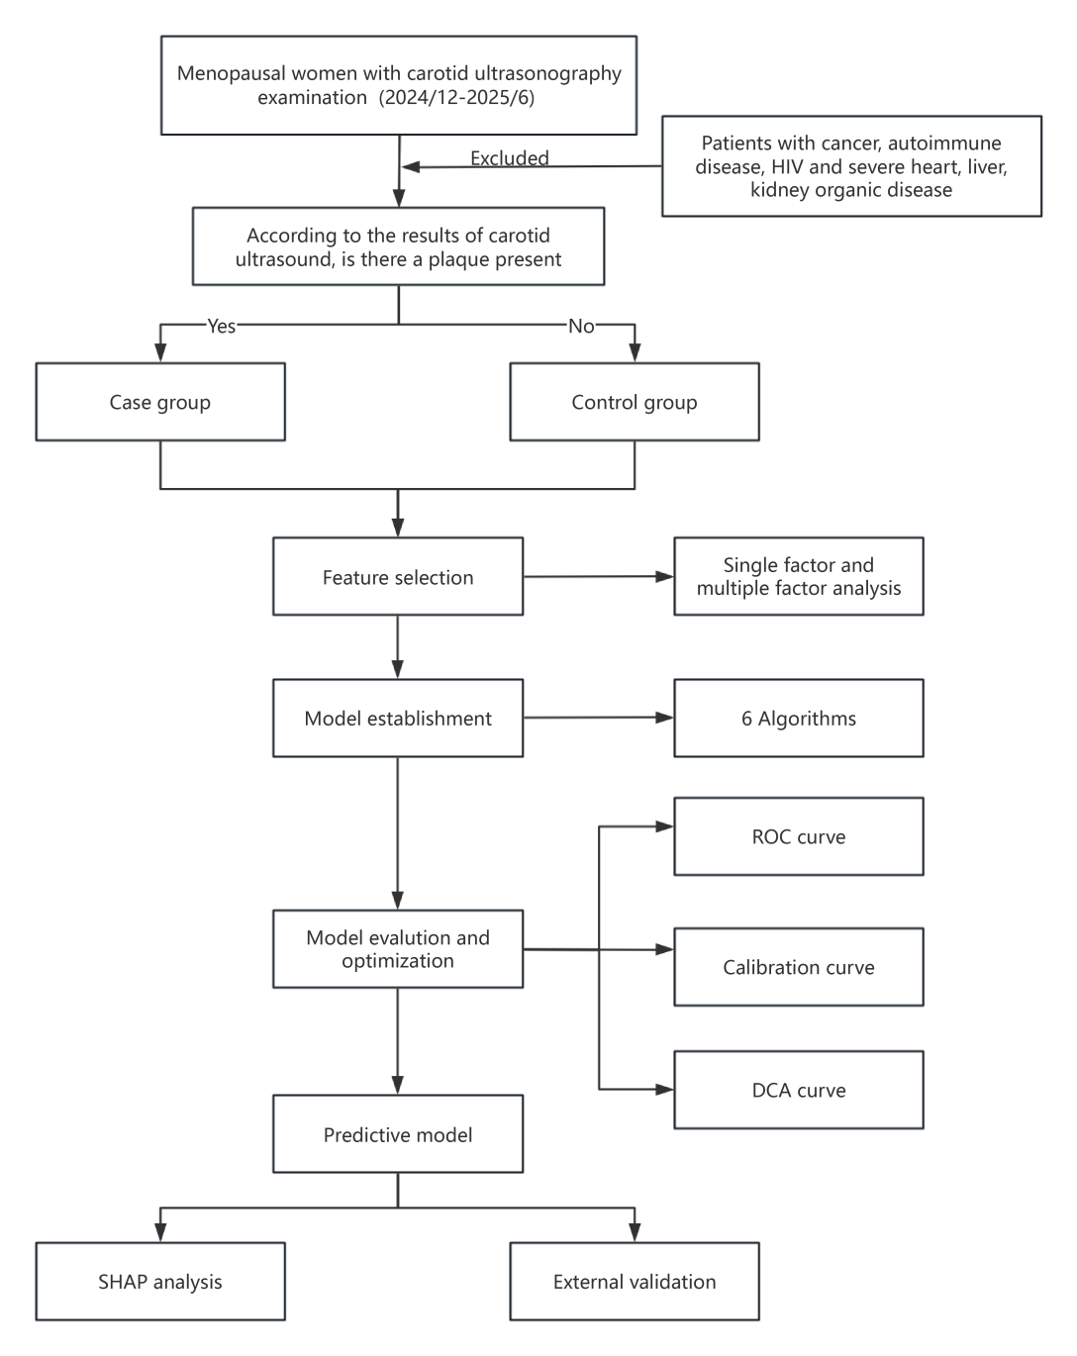
Supplementary Figure 1. Study flowchart.

Supplementary Figure 2. Calibration curves of six models.
(A) logistic regression. (B) decision tree. (C) random forest. (D) extreme gradient boosting. (E) support vector machine. (F) neural network.
Supplementary Figure 3. Decision curve analysis curves of six models.
Abbreviations: LR, logistic regression; DT, decision tree; RF, random forest; XGBoost, extreme gradient boosting; SVM, support vector machine; NN, neural network.

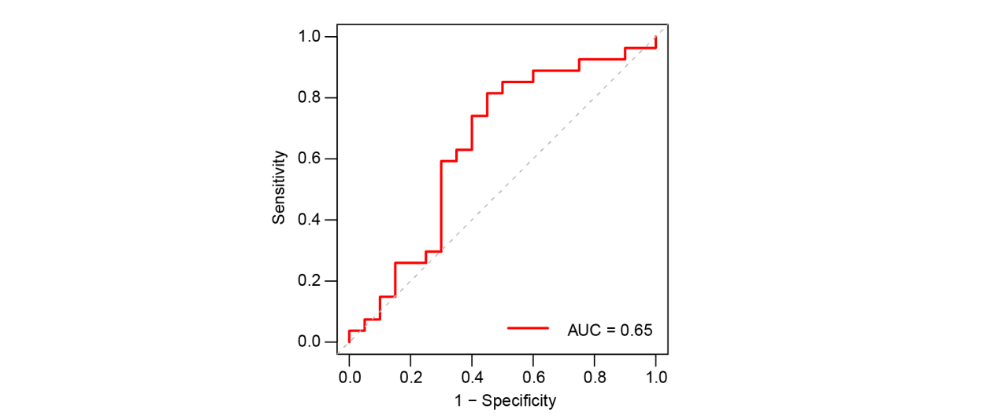
Supplementary Figure 4. The ROC results of external validation set. AUC, area under the curve.
Supplementary Table 1. Polymerase chain reaction primers and amplicons.
SNP |  | Direction | Sequence (5'–3') | Amplicon size (bp)
rs9340799 |  | Forward | TCTGTGTTGTCCATCAGTTCATCT | 125
 |  | Reverse | TCAGAACCATTAGAGACCAATGCT
Supplementary Table 2. The demographic characteristics of the study population.
Characteristics | Patients (n=162) | Controls (n=114) | P value
Age (years) | 61.00 (58.00, 67.00) | 57.00 (54.00, 62.00) | <0.001
Menopausal.age (years) | 51.00 (50.00, 52.00) | 50.00 (50.00, 52.00) | 0.078
Menopause duration# (years) | 10.00 (6.25, 17.00) | 7.00 (4.00, 12.00) | <0.001
Height (cm) | 160.00 (156.00, 163.00) | 161.00 (157.00, 165.00) | 0.243
Weight (kg) | 61.00 (55.00, 67.00) | 60.00 (54.50, 67.00) | 0.455
SBP (mmHg) | 133.00 (121.25, 149.00) | 127.00 (114.50, 138.25) | 0.002
DBP (mmHg) | 75.73±10.80 | 75.57±10.55 | 0.902
GLU (mmol/L) | 5.78 (5.35, 6.41) | 5.54 (5.22, 5.96) | 0.002
TC (mmol/L) | 5.70 (5.00, 6.37) | 5.43 (4.98, 6.24) | 0.317
TG (mmol/L) | 1.35 (1.00, 1.92) | 1.23 (0.94, 1.59) | 0.062
LDL (mmol/L) | 3.45 (2.78, 4.00) | 3.17 (2.71, 3.62) | 0.116
HDL (mmol/L) | 1.38 (1.20, 1.55) | 1.38 (1.26, 1.66) | 0.278
Rs9340799 |  |  | 0.075
AA | 114 (70.4%) | 78 (68.4%)
GA | 46 (28.4%) | 29 (25.4%)
GG | 2 (1.2%) | 7 (6.1%)
Notes: # The duration of menopause is calculated by subtracting the menopausal age from the age of enrollment. Bold text: P<0.05 indicates statistical significance. SBP, systolic blood pressure. DBP, diastolic blood Pressure. GLU, glucose. TC, total cholesterol. TG, triglycerides. LDL, low-density lipoprotein. HDL, high-density lipoprotein.

Supplementary Table 3. Diagnostic performance of model test set.
model | Sensitivity (95% CI) | Specificity (95% CI) | AUC (95% CI) | DeLong vs LR (P) | Adjusted P* | Brier Score | HL P-value | Calibration Slope
Logistic regression | 0.750 (0.597-0.868) | 0.526 (0.358-0.690) | 0.709 (0.596–0.821) | — |  | 0.227 | 0.263 | 6.177
Decision tree | 0.796 (0.647-0.902) | 0.447 (0.286-0.617) | 0.621 (0.521–0.722) | 0.079 | 0.395 | 0.240 | NA# | 3.294
Random forest | 0.705 (0.548-0.832) | 0.526 (0.358-0.690) | 0.642 (0.521–0.764) | 0.431 | 1.000 | 0.255 | 0.0006 | 2.641
eXtreme Gradient Boosting | 0.636 (0.572-0.850) | 0.526 (0.154-0.459) | 0.591 (0.467–0.716) | 0.044 | 0.220 | 0.275 | 0.0027 | 1.357
Support vector machine | 0.773 (0.622-0.885) | 0.368 (0.218-0.540) | 0.651 (0.531–0.771) | 0.128 | 0.640 | 0.242 | 0.267 | 7.800
Neural network | 0.455 (0.304-0.612) | 0.737 (0.569-0.866) | 0.657 (0.537–0.777) | 0.281 | 1.000 | 0.294 | <0.001 | 1.275
Notes: # Decision tree has only 2 terminal nodes, HL test is not applicable. *Bonferroni-adjusted P-values for five pairwise comparisons (adjusted α=0.01). Adjusted P = P × 5, capped at 1.000. AUC, area under the curve.

Supplementary Table 4: Comparison of demographic and clinical characteristics between the development and external validation cohorts.
Characteristics | Development cohort (n=276) | External validation (n=47) | P
Age (years) | 61 (55, 66) | 60 (56, 67) | 0.755
SBP (mmHg) | 131 (118, 143) | 133 (122, 143) | 0.427
GLU (mmol/L) | 5.66 (5.30, 6.21) | 5.67 (5.33, 6.74) | 0.316
CAS, n (%) | 162 (58.7%) | 27 (57.4%) | 0.872
rs9340799, n (%) |  |  | 0.087
AA | 192 (69.6%) | 40 (85.1%)
GA | 75 (27.2%) | 7 (14.9%)
GG | 9 (3.3%) | 0 (0.0%)
SBP, systolic blood pressure. GLU, glucose. CAS, carotid atherosclerosis.

Supplementary Table 5: Logistic regression model performance on the test set and external validation set.
Metric | Test set (n=82) | External validation (n=47)
AUC (95% CI) | 0.71 (0.60–0.82) | 0.65 (0.48–0.82)
Sensitivity (95% CI) | 0.68 (0.53–0.81) | 0.82 (0.62–0.94)
Specificity (95% CI) | 0.66 (0.48–0.81) | 0.55 (0.32–0.77)
PPV (95% CI) | 0.73 (0.57–0.85) | 0.71 (0.52–0.86)
NPV (95% CI) | 0.61 (0.43–0.76) | 0.69 (0.41–0.89)
Accuracy (95% CI) | 0.67 (0.56–0.77) | 0.70 (0.55–0.83)
AUC, area under the curve. PPV: positive predictive value. NPV: negative predictive value.

