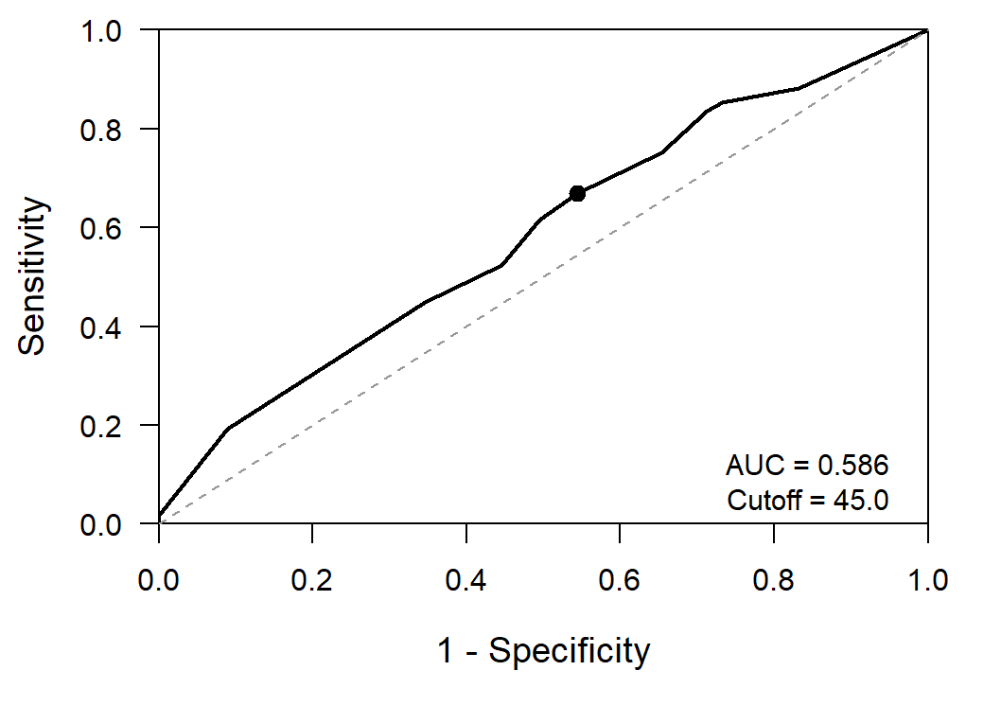
Supplementary Figure S1
Supplementary Figure S1. Receiver operating characteristic (ROC) curve of AR expression for predicting pathological complete response.
The optimal cutoff value for AR expression was 45%, with an area under the curve (AUC) of 0.586 (95% CI, 0.510–0.662). The marked point indicates the optimal cutoff used for outcome-oriented dichotomization in subgroup and survival analyses.
Abbreviations: AR, androgen receptor; ROC, receiver operating characteristic; AUC, area under the curve; CI, confidence interval; pCR, pathological complete response.
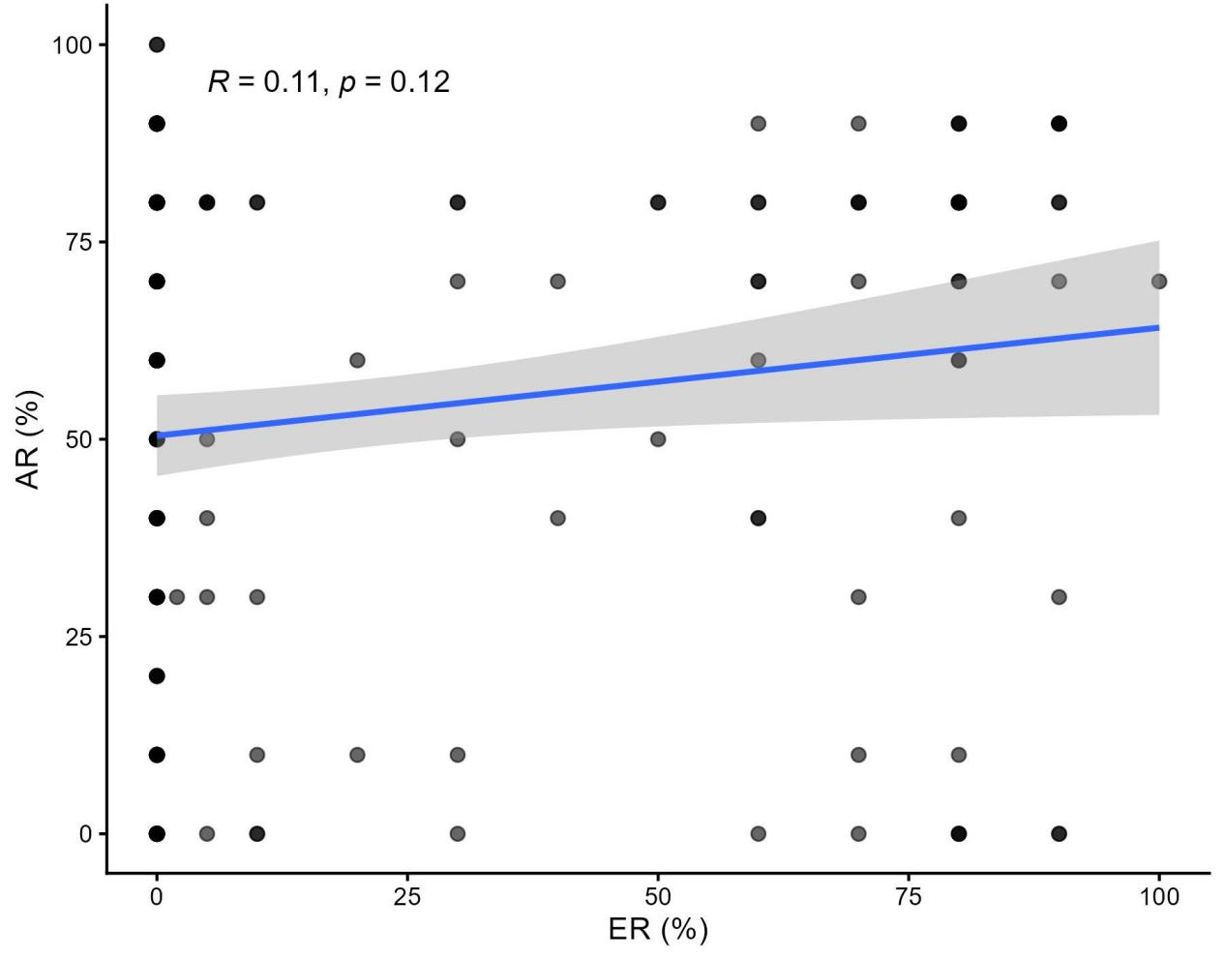
Supplementary Figure S2
Supplementary Figure S2. Correlation between AR and ER expression.
Scatter plot showing the association between AR and ER expression in the study cohort. The reported correlation coefficient and p value were derived from Spearman correlation analysis. The blue line represents the fitted trend, and the shaded area indicates the 95% confidence interval.
Abbreviations: AR, androgen receptor; ER, estrogen receptor.
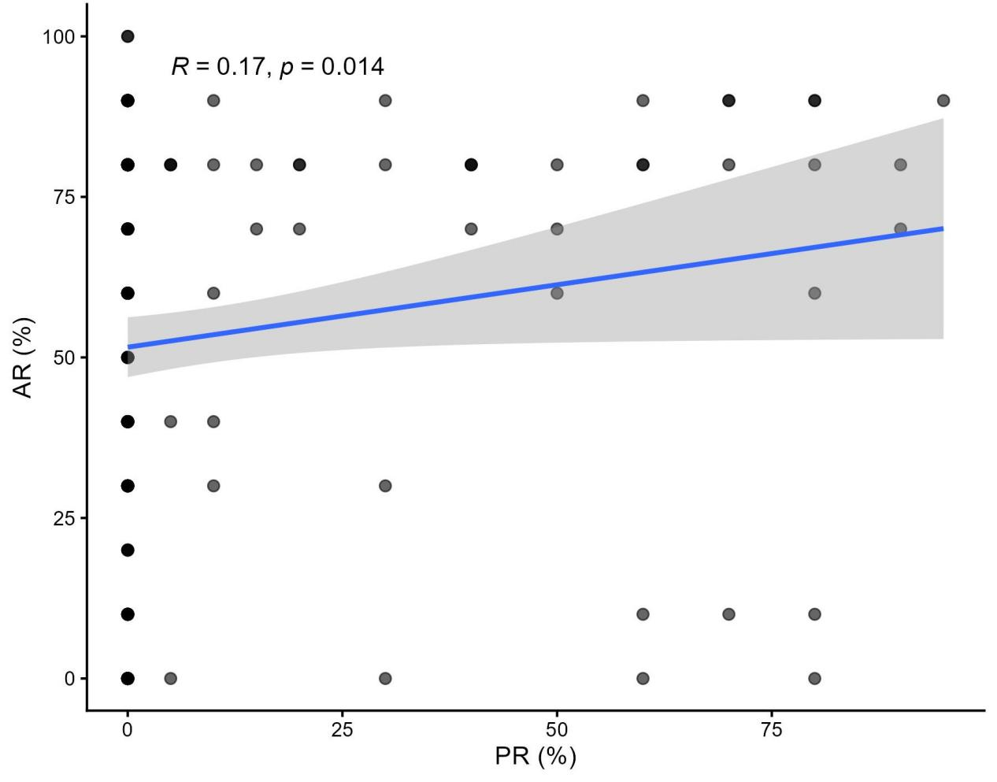
Supplementary Figure S3
Supplementary Figure S3. Correlation between AR and PR expression.
Scatter plot showing the association between AR and PR expression in the study cohort. The reported correlation coefficient and p value were derived from Spearman correlation analysis. The blue line represents the fitted trend, and the shaded area indicates the 95% confidence interval.
Abbreviations: AR, androgen receptor; PR, progesterone receptor.

