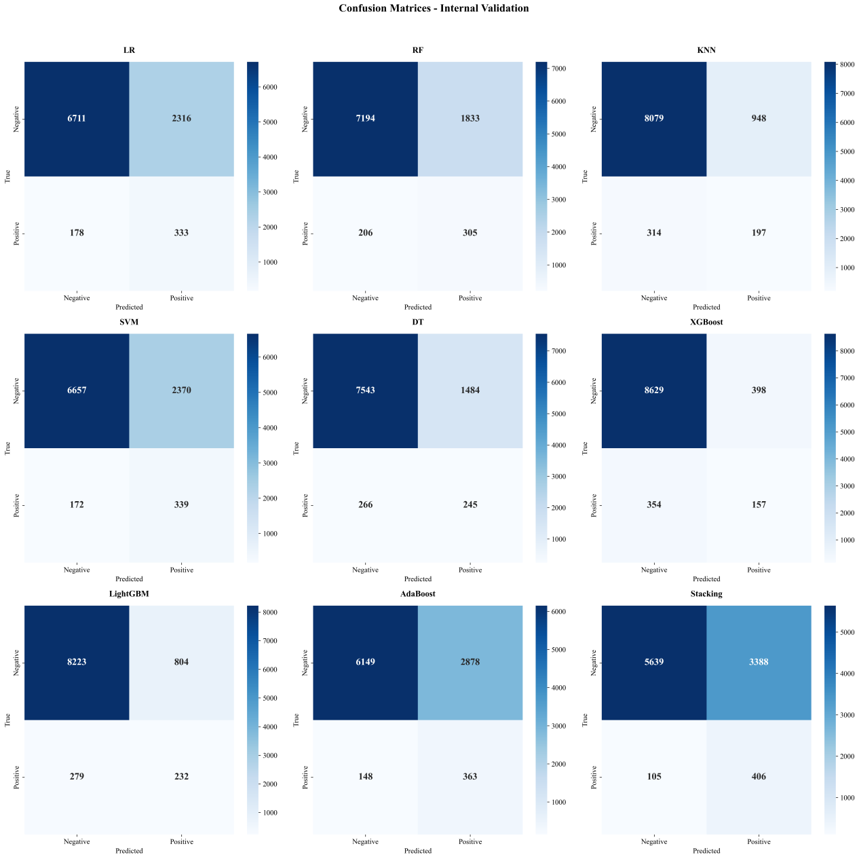
Supplemental Figure 1. The confusion Matrix for 3-month PDAP risk stratification models with different ML algorithms in the internal validation. PDAP, peritoneal dialysis-associated peritonitis; LR, Logistic Regression; RF, Random Forest; KNN: k-Nearest Neighbor; SVM: Support Vector machine; DT, Decision Tree; XGBoost: eXtreme Gradient Boosting; lightGBM: Light Gradient Boosting Machine, AdaBoost, Adaptive Boosting.

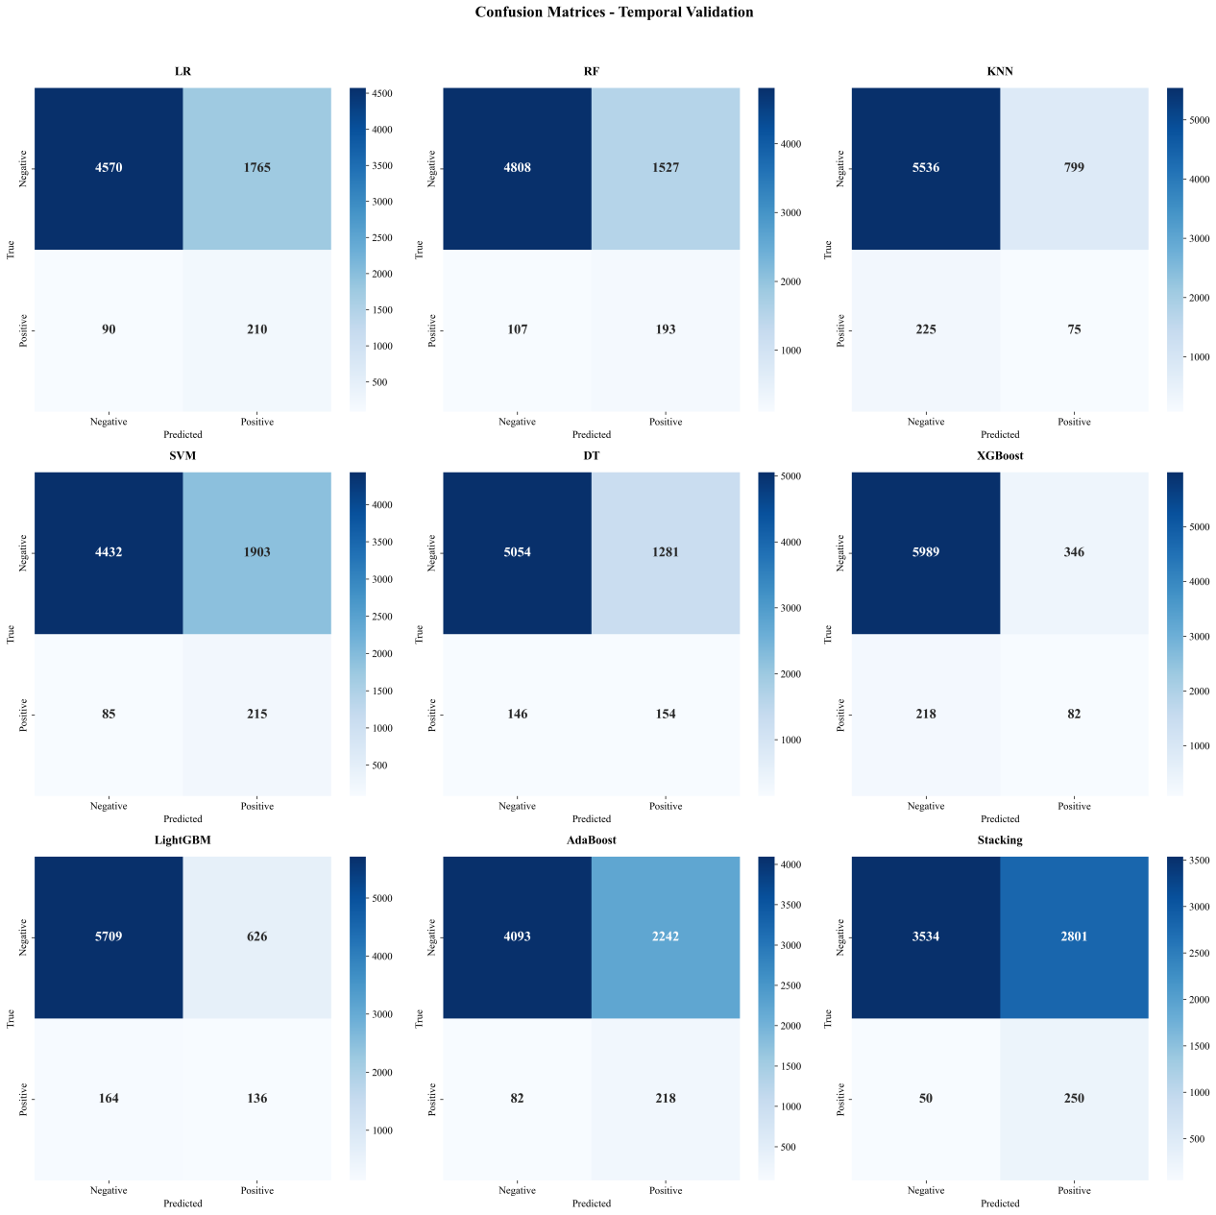
Supplemental Figure 2. The confusion Matrix for 3-month PDAP risk stratification models with different ML algorithms in the temporal validation. PDAP, peritoneal dialysis-associated peritonitis; LR, Logistic Regression; RF, Random Forest; KNN: k-Nearest Neighbor; SVM: Support Vector machine; DT, Decision Tree; XGBoost: eXtreme Gradient Boosting; lightGBM: Light Gradient Boosting Machine, AdaBoost, Adaptive Boosting.

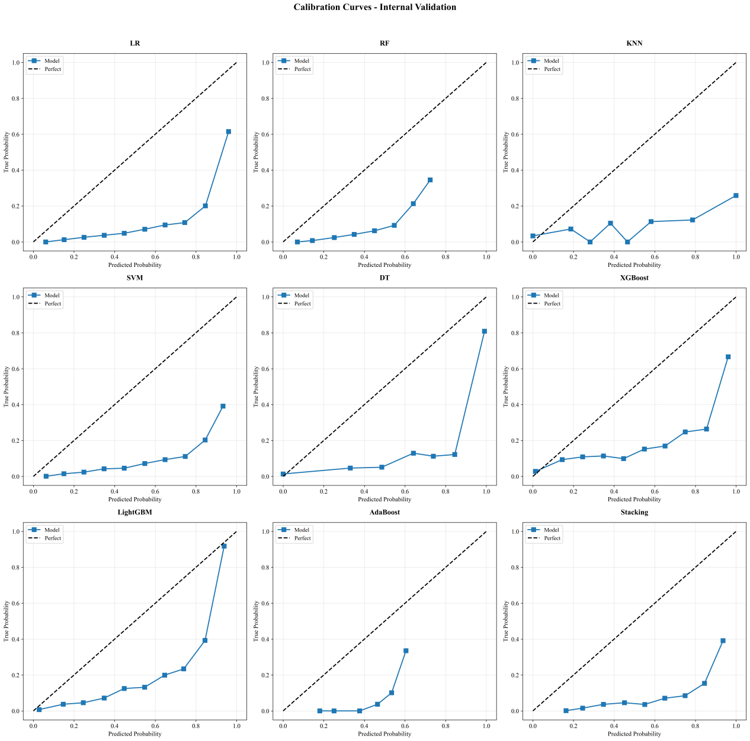
Supplemental Figure 3. The calibration plots for 3-month PDAP risk stratification models with different ML algorithms in the internal validation. PDAP, peritoneal dialysis-associated peritonitis; LR, Logistic Regression; RF, Random Forest; KNN: k-Nearest Neighbor; SVM: Support Vector machine; DT, Decision Tree; XGBoost: eXtreme Gradient Boosting; lightGBM: Light Gradient Boosting Machine, AdaBoost, Adaptive Boosting.

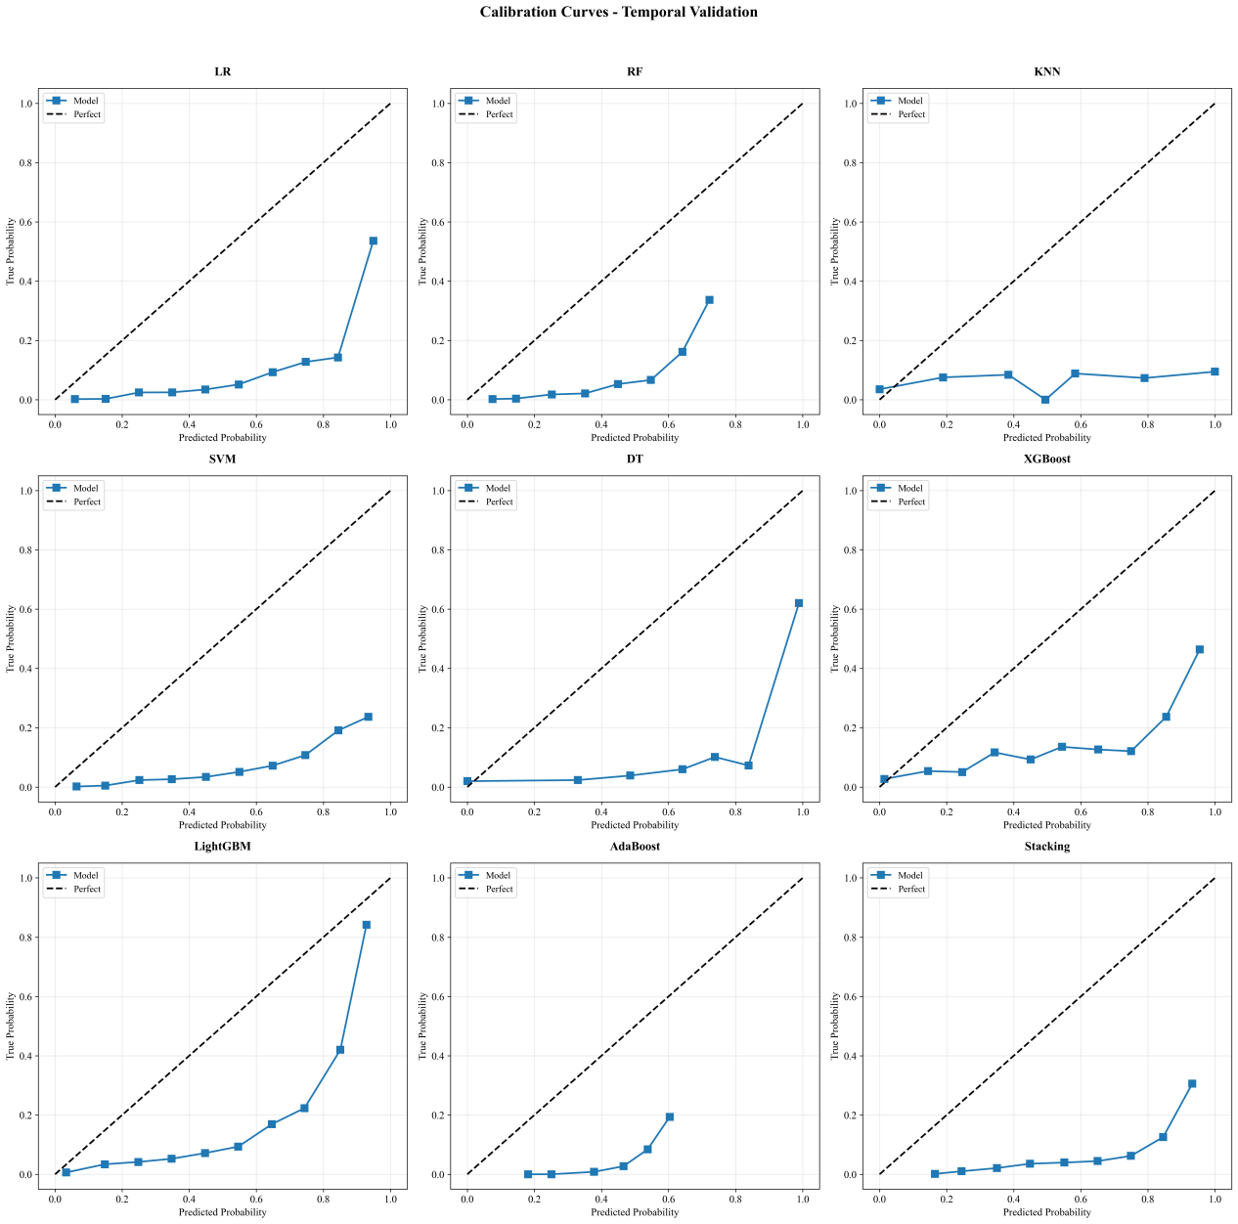
Supplemental Figure 4. The calibration plots for 3-month PDAP risk stratification models with different ML algorithms in the temporal validation. PDAP, peritoneal dialysis-associated peritonitis; LR, Logistic Regression; RF, Random Forest; KNN: k-Nearest Neighbor; SVM: Support Vector machine; DT, Decision Tree; XGBoost: eXtreme Gradient Boosting; lightGBM: Light Gradient Boosting Machine, AdaBoost, Adaptive Boosting.

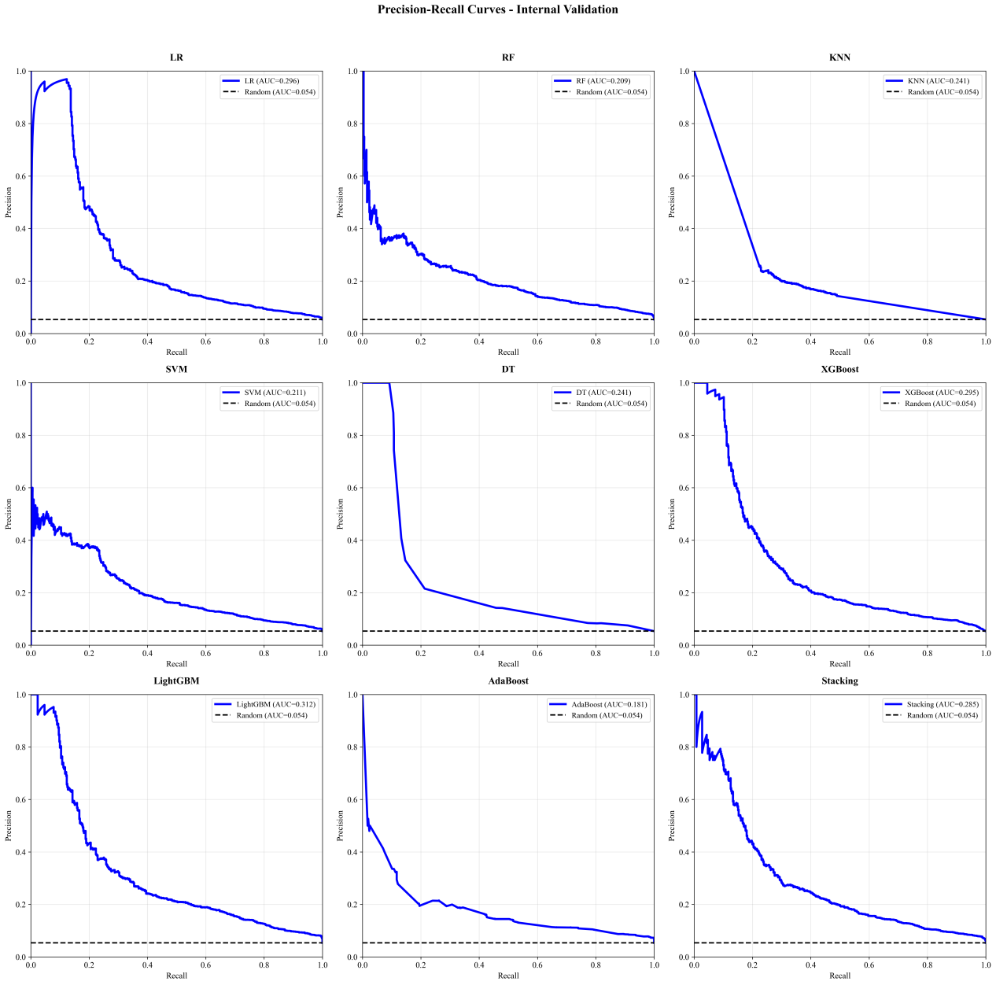
Supplemental Figure 5. The precision-recall plots for 3-month PDAP risk stratification models with different ML algorithms in the internal validation. PDAP, peritoneal dialysis-associated peritonitis; LR, Logistic Regression; RF, Random Forest; KNN: k-Nearest Neighbor; SVM: Support Vector machine; DT, Decision Tree; XGBoost: eXtreme Gradient Boosting; lightGBM: Light Gradient Boosting Machine, AdaBoost, Adaptive Boosting.

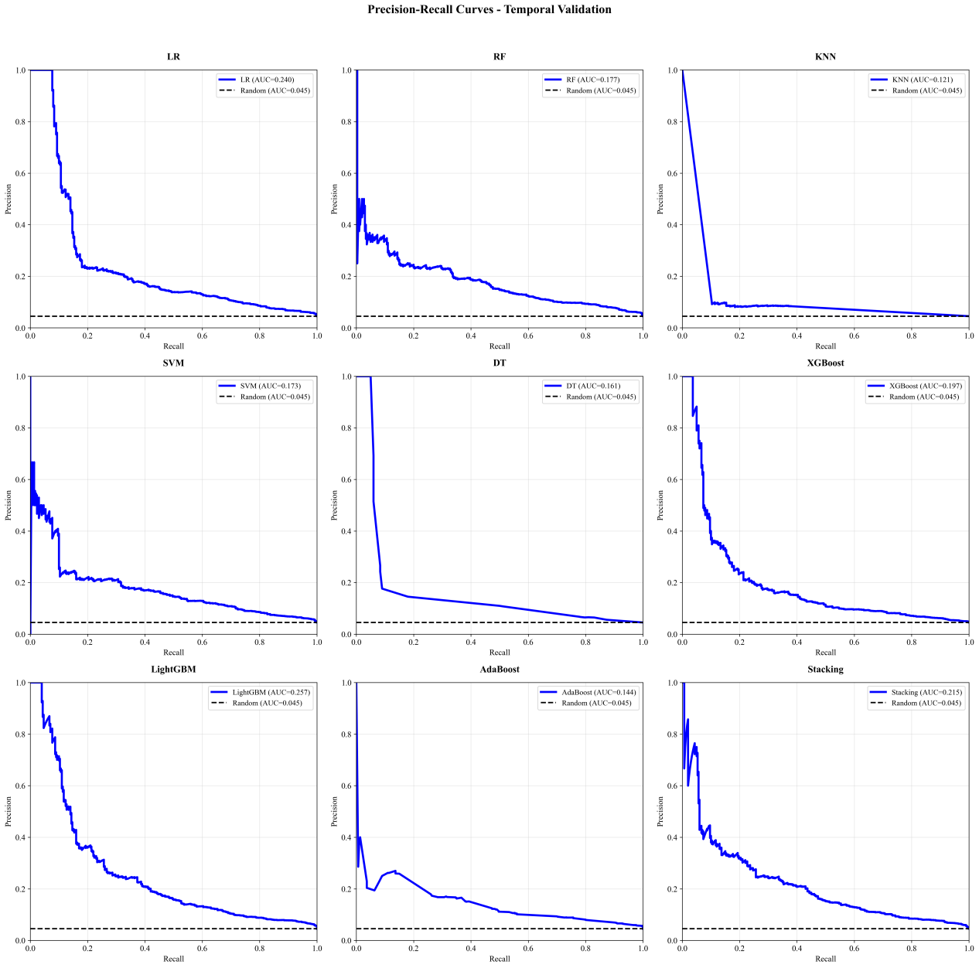
Supplemental Figure 6. The precision-recall plots for 3-month PDAP risk stratification models with different ML algorithms in the temporal validation. PDAP, peritoneal dialysis-associated peritonitis; LR, Logistic Regression; RF, Random Forest; KNN: k-Nearest Neighbor; SVM: Support Vector machine; DT, Decision Tree; XGBoost: eXtreme Gradient Boosting; lightGBM: Light Gradient Boosting Machine, AdaBoost, Adaptive Boosting.

Supplemental Table 1 Detailed information of the enrolled all features in the original feature set
Feature source | Feature name | Feature type
Sociodemographic information
 | Gender | Categorical feature
 | Age | Continuous feature
Personal history
 | Duration of CAPD | Continuous feature
Laboratory test indexes
 | WBC (Routine blood test) | Continuous feature
 | Neutrophils (Routine blood test) | Continuous feature
 | Lymphocytes (Routine blood test) | Continuous feature
 | PLT (Routine blood test) | Continuous feature
 | Hemoglobin (Routine blood test) | Continuous feature
 | RBC (Routine blood test) | Continuous feature
 | Hematocrit (Routine blood test) | Continuous feature
 | ALT (Biochemical test) | Continuous feature
 | AST (Biochemical test) | Continuous feature
 | TBIL (Biochemical test) | Continuous feature
 | Total protein (Biochemical test) | Continuous feature
 | Albumin (Biochemical test) | Continuous feature
 | Globulin (Biochemical test) | Continuous feature
 | TG (Biochemical test) | Continuous feature
 | Total cholesterol (Biochemical test) | Continuous feature
 | HDL-C (Biochemical test) | Continuous feature
 | LDL-C (Biochemical test) | Continuous feature
 | Blood glucose (Biochemical test) | Continuous feature
 | BUN (Biochemical test) | Categorical feature
 | Creatinine (Biochemical test) | Continuous feature
 | Uric acid (Biochemical test) | Continuous feature
 | Sodium (Biochemical test) | Continuous feature
 | Potassium (Biochemical test) | Continuous feature
 | Calcium (Biochemical test) | Continuous feature
 | Chlorine (Biochemical test) | Categorical feature
 | Phosphorus (Biochemical test) | Continuous feature
 | TCO2 (Biochemical test) | Continuous feature
 | iPTH (Biochemical test) | Categorical feature
CAPD, continuous ambulatory peritoneal dialysis, WBC, white blood cell, PLT, platelet, RBC, red blood cells, ALT, alanine aminotransferase, AST, aspartate aminotransferase, TBIL, total bilirubin, TG, triglyceride, HDL-C, high-density lipoprotein-cholesterol, LDL-C, low-density lipoprotein-cholesterol, BUN, blood urea nitrogen, TCO2, total carbon dioxide, iPTH, intact parathyroid hormone.

