Supplemental Methods

Targeted Literature Review
A search of the Ovid database (which includes medical literature databases such as EMBASE and MEDLINE) was conducted. In total, 20 studies published between 2008 and 2021 were identified, including nine DCE studies, three conjoint analyses, three Likert Scale surveys/questionnaires, two qualitative interview/focus group studies, two best-worst scaling case 1 studies, and one health-related quality of life questionnaire study (Supplemental Table 1). These studies focused on age-related macular degeneration (AMD; n=11), glaucoma (n=7), geographic atrophy (GA; n=2), diabetic retinopathy (n=2), diabetic macular edema (n=1), and other retinal vascular disease (n=1).
The following concepts were identified as attributes that may affect patient or physician preferences for treatments:
- Benefits: Stabilization or improvement in visual functioning, quality of life measures (e.g., vision-dependent activities of daily living such as the ability to read, recognize facial expressions, or navigate around a room, social and emotional quality of life), delaying disease progression, and maintaining quality of vision for longer.
- Risks: Treatment-related side effects, including side effects described in terms of severity (mild, moderate, or severe) and specific side effects such as the risk of headache, tiredness, eye discomfort, sudden loss of vision, or post-operative complications.
- Treatment characteristics: Administration mode, drug label approval status, and monitoring requirements.
- Other measures: Financial concerns regarding annual out-of-pocket costs and cost of treatment to insurance company.
Because most identified studies were not GA-specific, side effects associated with GA therapies were added to the qualitative interview guide. As no preference study explored gene therapy in ophthalmic conditions, this concept was also included.

Qualitative Interviews
Qualitative interviews with 15 retina specialists (RS) were conducted with a semi-structured interview guide that focused on the symptoms and diagnosis of GA, RS’ treatment experiences and perspectives regarding gene therapy, desired treatment benefits, treatment side effects, non-clinical treatment features (e.g., intravitreal injection frequency), and the trade-offs RS would be willing to make between frequency of intravitreal injections and side effects.
RS reported that the most bothersome symptoms of GA varied substantially between patients, with problems with reading (n=9; 60%) and seeing dark or blind spots (n=10; 67%) commonly reported. All RS (n=15; 100%) noted that patients often experienced impacts on their daily activities, such as driving, engaging in hobbies (e.g., card games), paying bills, cooking, or using the computer. Overall, RS considered the impact on the patients’ emotional or mental wellbeing as the most frequent and bothersome impacts of GA.
In terms of treatment attributes, RS ranked maintaining quality of vision and slowing progression of GA as the most important treatment benefits. They considered the risks of mild-to-moderate and transient uveitis (15%) or endophthalmitis (0.05% per injection) as acceptable. However, an increase in risk of progression to wet AMD was a concern. Although it was not specifically probed, five RS spontaneously raised a concern with any potential risk of retinal vasculitis. RS also considered the frequency of intravitreal injections as a relevant treatment attribute.
Finally, RS generally viewed gene therapy positively and most were not concerned about the need for a concomitant 20-day course of oral steroids. However, a minority noted they would be cautious in prescribing gene therapy to patients who may be prone to risks from steroids.

Cognitive Pilot Interviews
Cognitive pilot interviews with RS (n=5) confirmed that RS were willing and able to make trade-offs between treatment attributes and that no key treatment attributes were missing. Key changes to the BB-DCE survey included: adding information on the patient’s visual acuity (VA) in both eyes (the eye with the GA lesion and the other eye) as part of the patient profile as this was noted to impact treatment decision-making, specifying “gene therapy” as the one-time treatment, revising “Reduction in the growth rate of linearized lesion size after 18 months” to the “Reduction in the growth rate of lesion size after 18 months” for clarity, changing the “Risk of mild to moderate uveitis” to the “Risk of mild to moderate intraocular inflammation” to ensure RS did not consider retinal vasculitis within this risk as this was a separate attribute, and refining the wording and presentation format to optimize clinical accuracy and comprehension.

Data Validity Assessments
Internal validity of the BB-DCE data was assessed using a repeated-choice task (stability test), two dominance tasks, trade-off behavior, serial nonparticipation, and response time.
In the repeated-choice task, the third choice task was repeated and the number of respondents making the same choice in the repeated task was used to assess choice stability.
Two dominance tasks presented choice tasks where one treatment option was superior to the alternative option on efficacy and risk attributes, while injection frequency was the same for both. RS passed the tests if they selected either the dominant treatment option as their first-best recommendation, or the “No treatment” option as their first-best recommendation and the dominant option as their second-best recommendation. Dominant decision-making was analyzed by counting the number of times an RS selected the option offering the better level for each attribute (for benefits and risks); an RS was deemed to have dominant decision-making when all choices were driven by only one attribute in all the experimental tasks. This analysis was based on first-best choices and did not consider patient characteristics or injection frequency.
Serial nonparticipation was assessed by counting the number of times an RS selected the same first-best recommendation (“Treatment A” or “Treatment B”) in all experimental choice tasks. RS who selected the “No treatment” option for every choice task were not classified as serial nonparticipants, as opting out of every choice task could be a legitimate preference.
The time required by each RS to complete the practice task and the 12 experimental choice tasks in the BB-DCE survey was recorded; a response time of <2 minutes (unless they systematically selected “No treatment”) was considered an indication of a potential lack of engagement.
Of the 198 RS who completed the BB-DCE, 32 RS were excluded from the main analyses because of lower data quality (Supplemental Figure 2): failing both dominance tests (n=7), always choosing treatment A (n=1) or B (n=2), or completing all BB-DCE tasks in <2 minutes unless they had systematically selected “No treatment” (n=28) (Supplemental Table 4).

Full survey
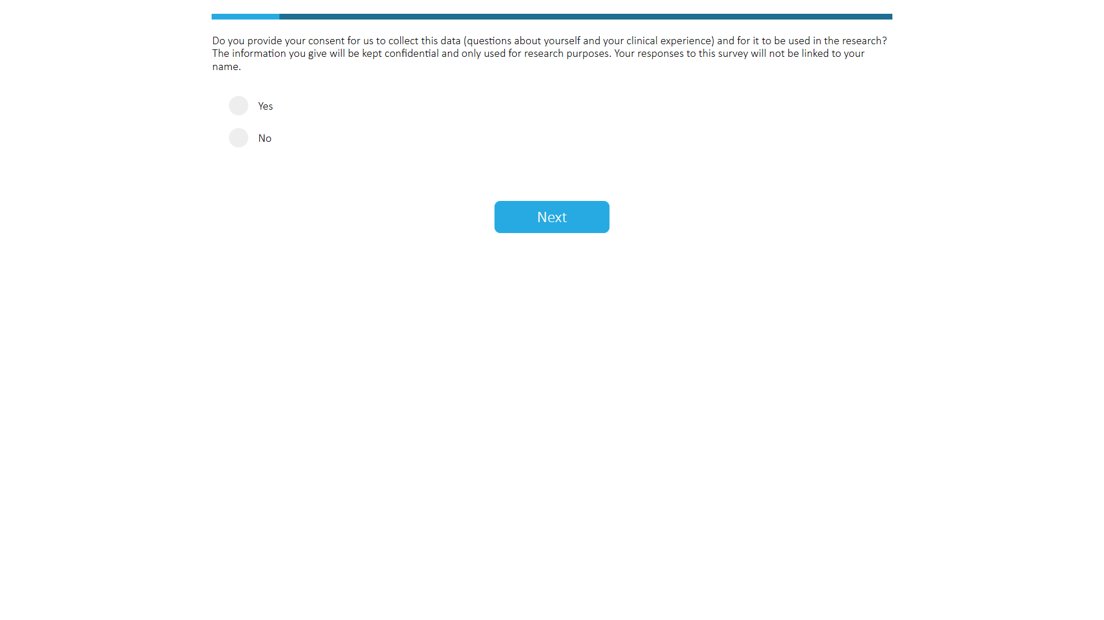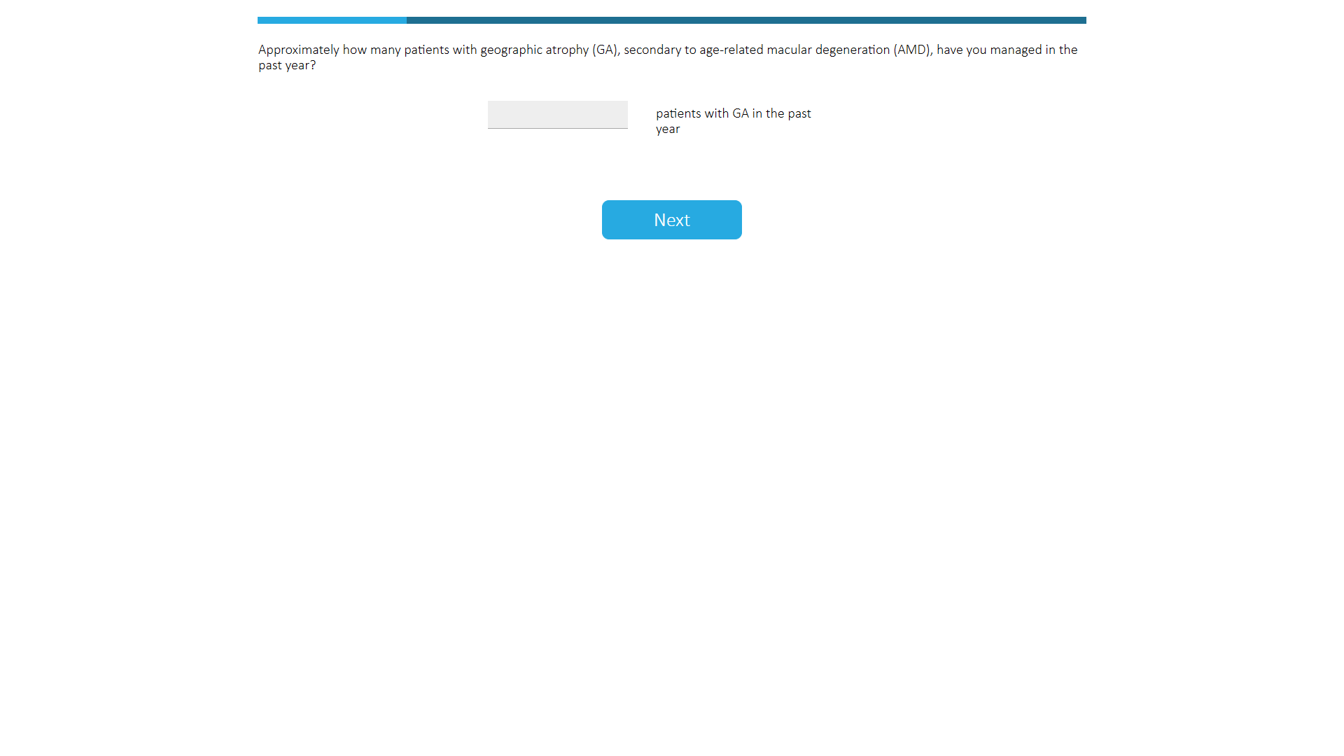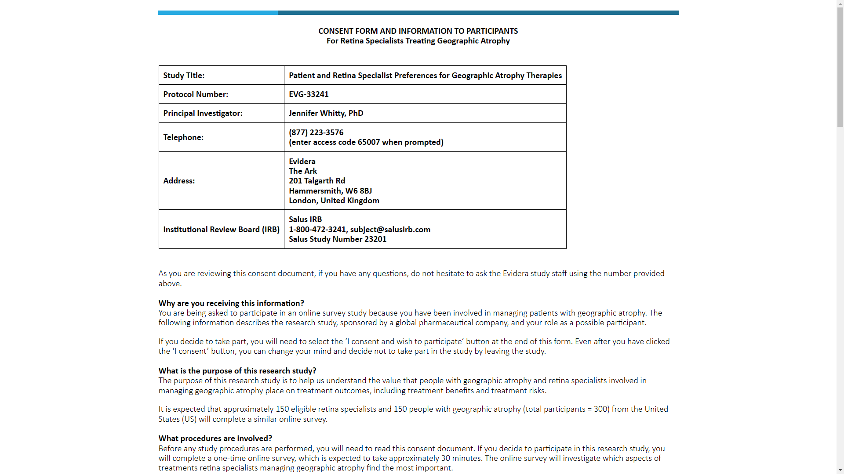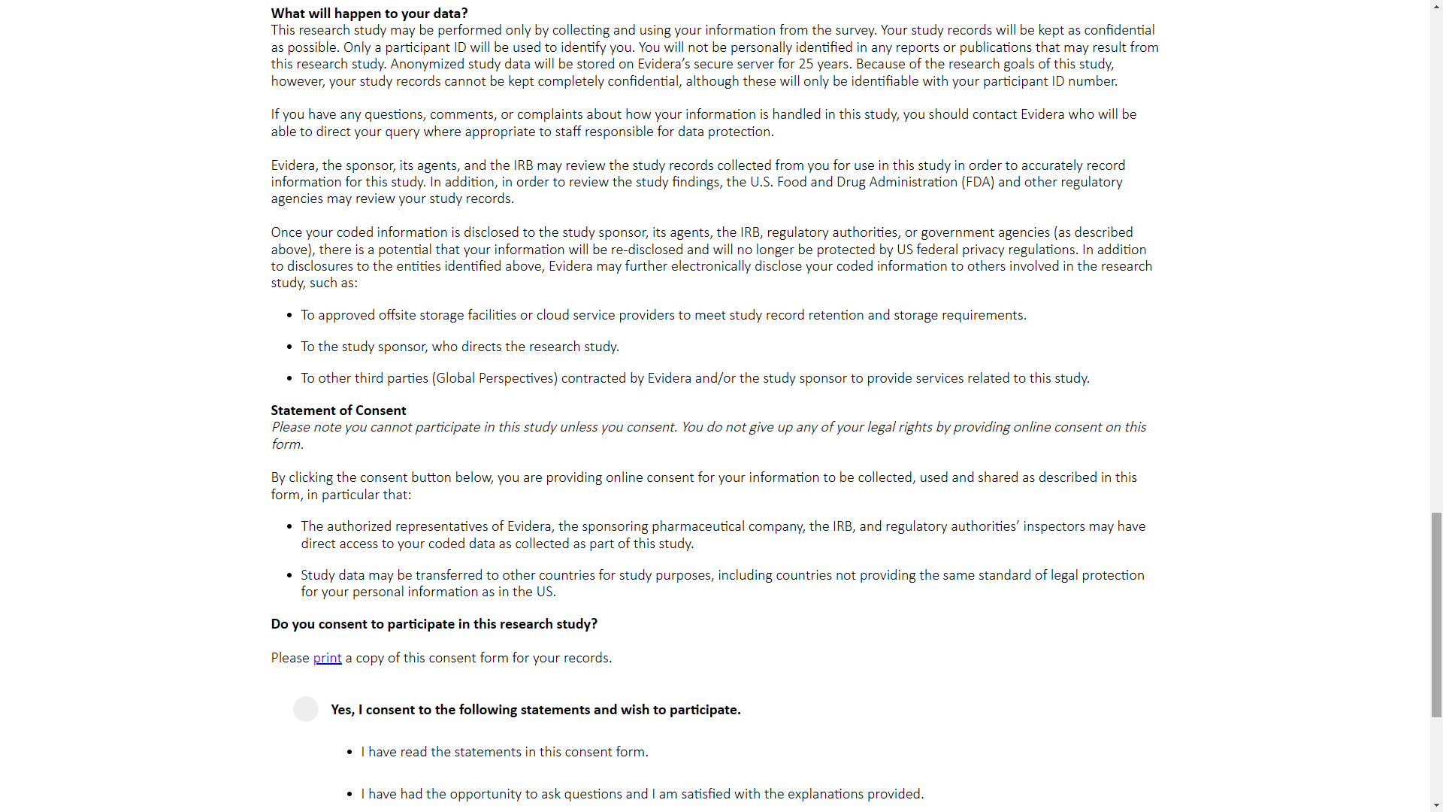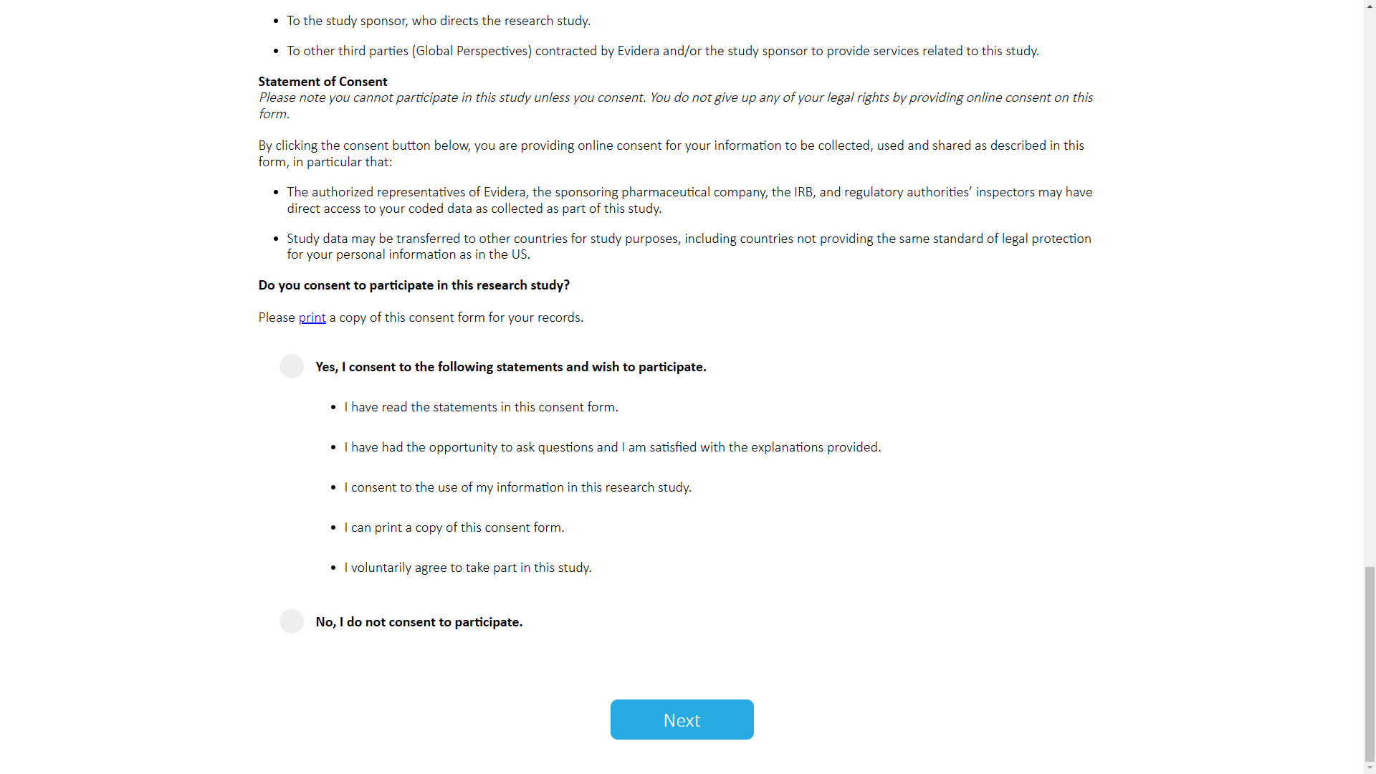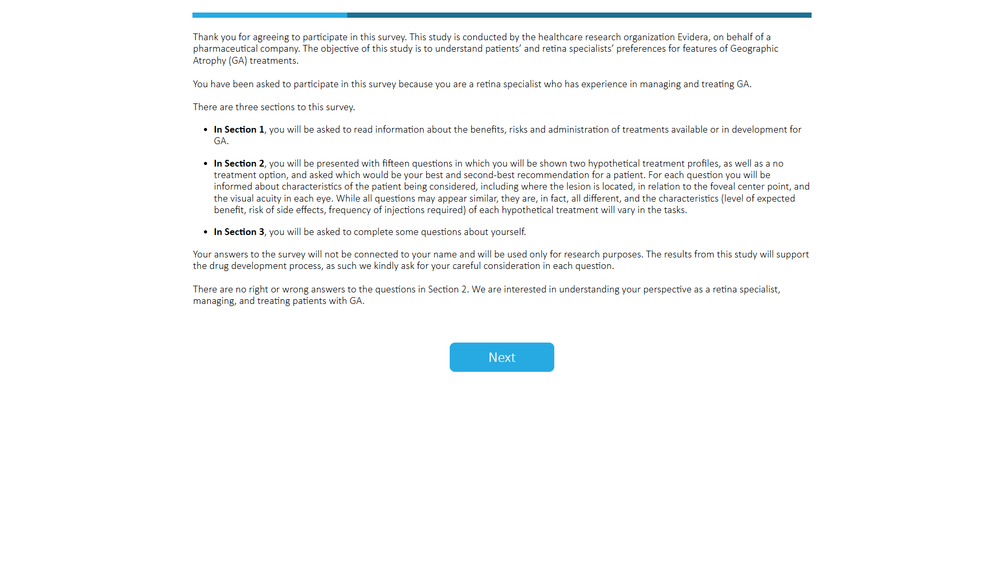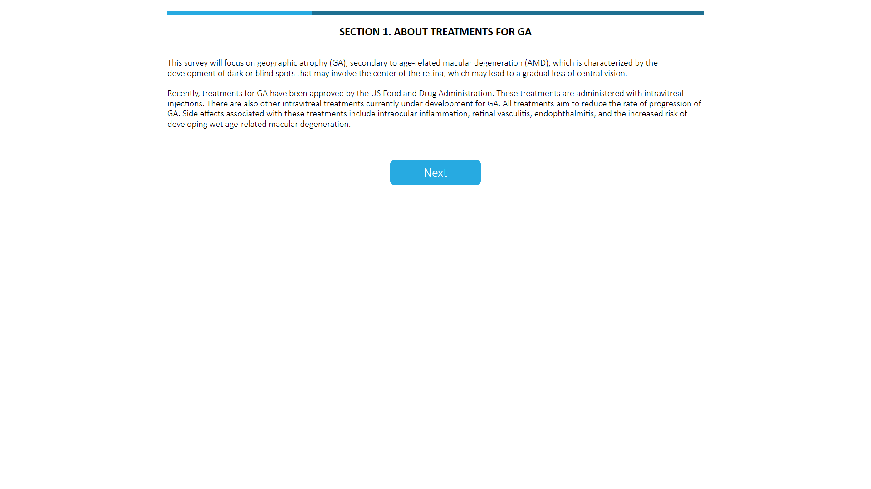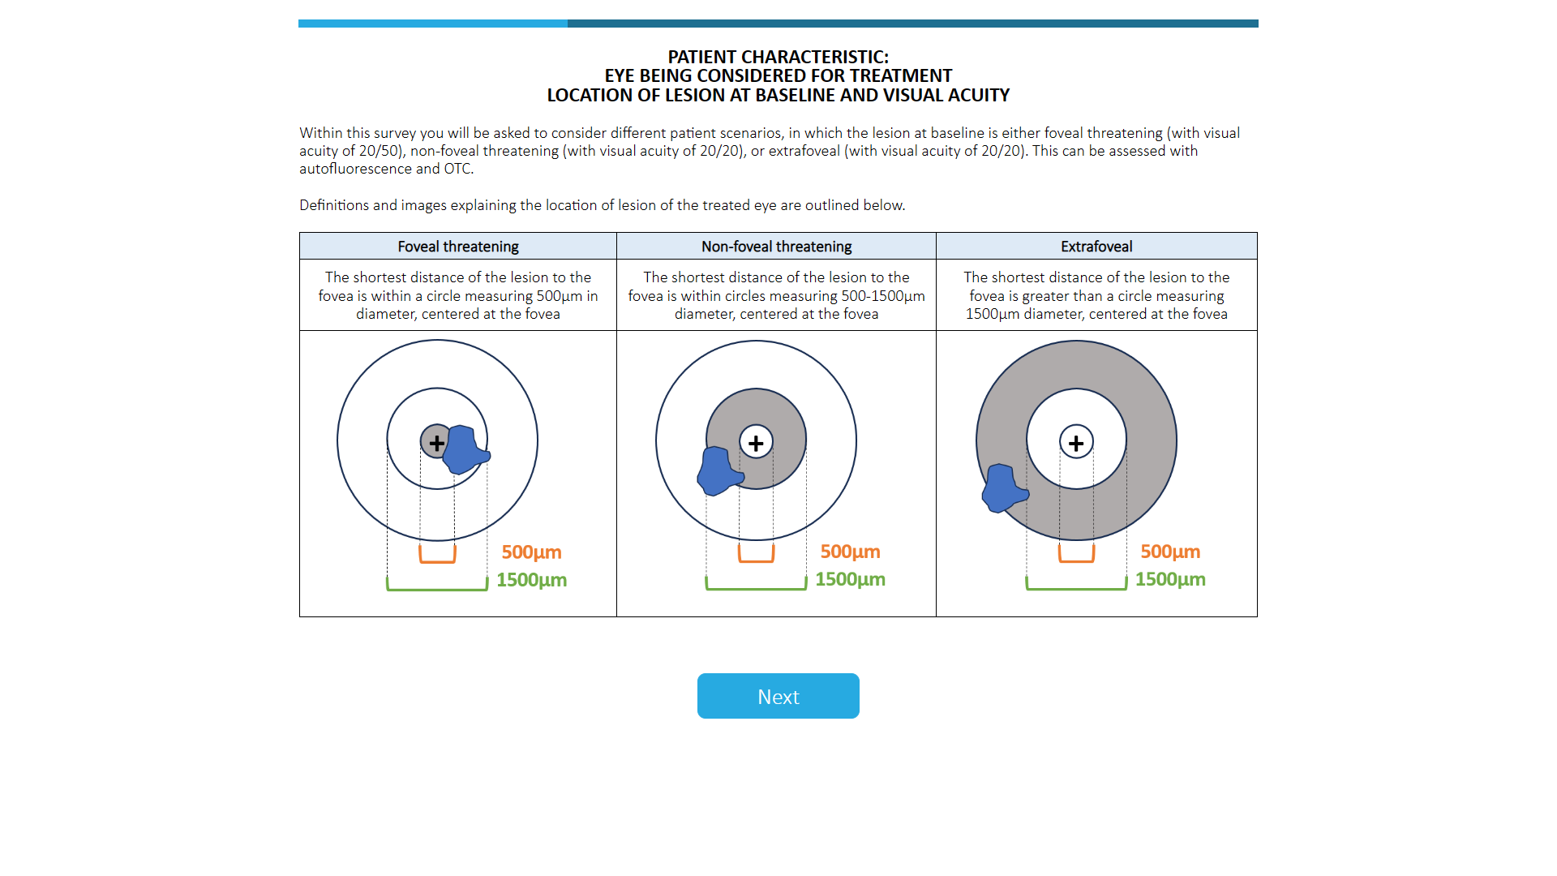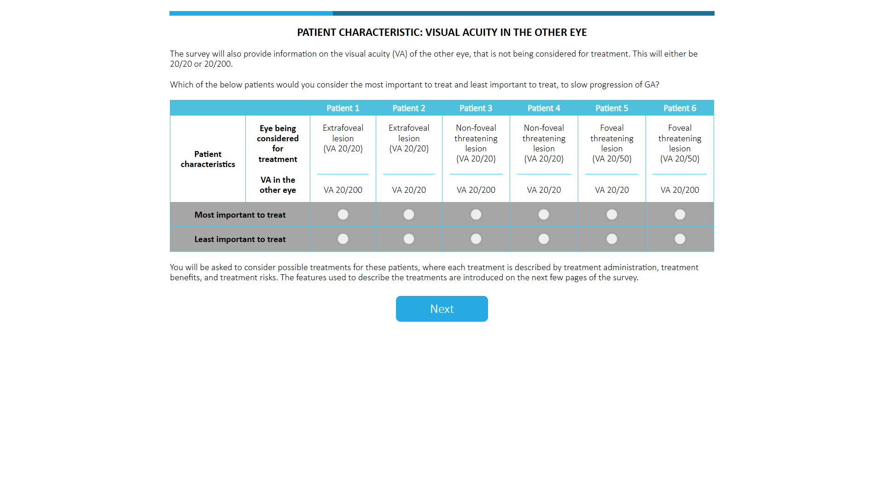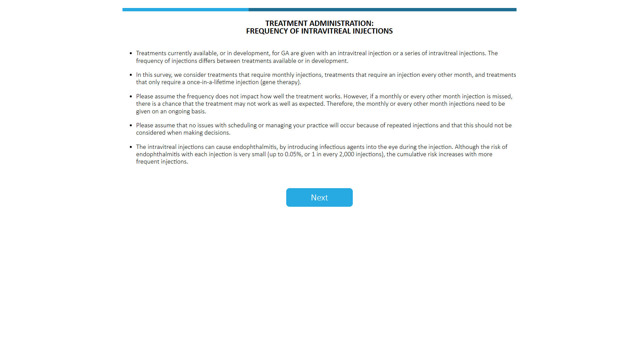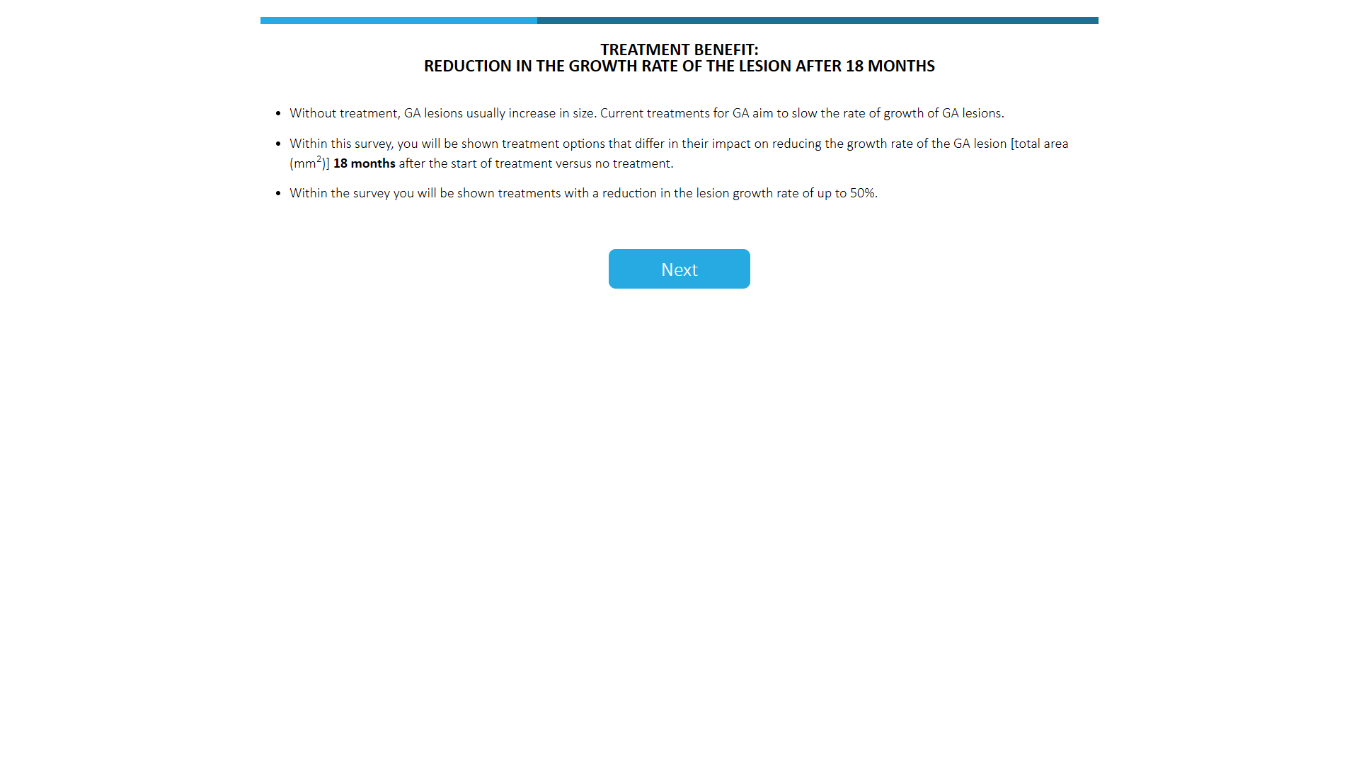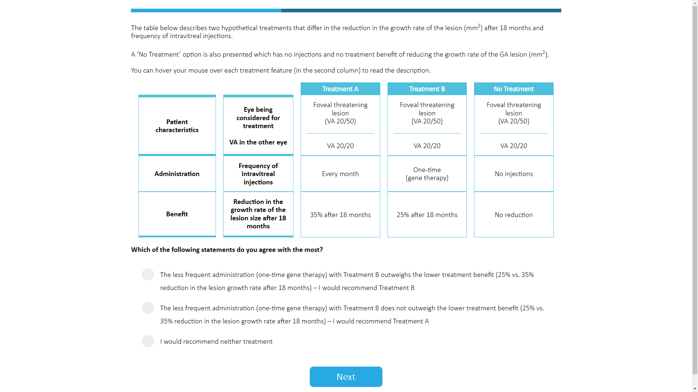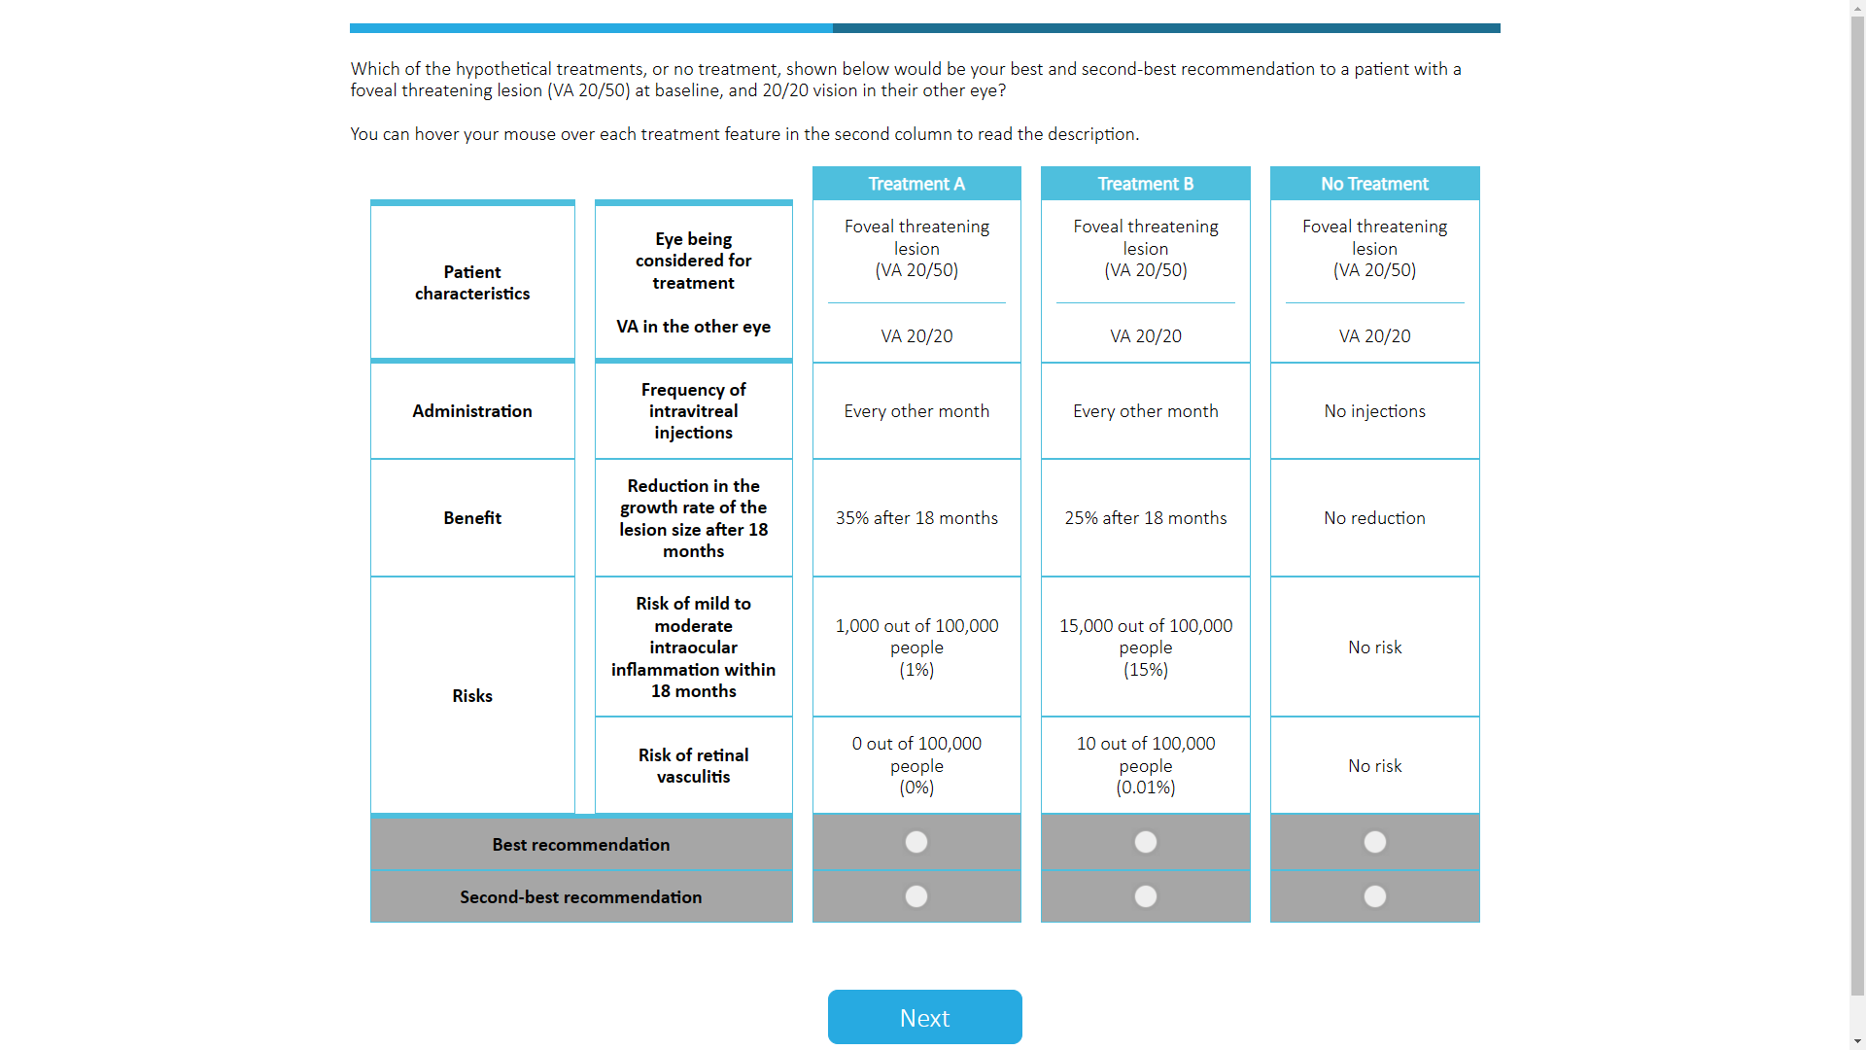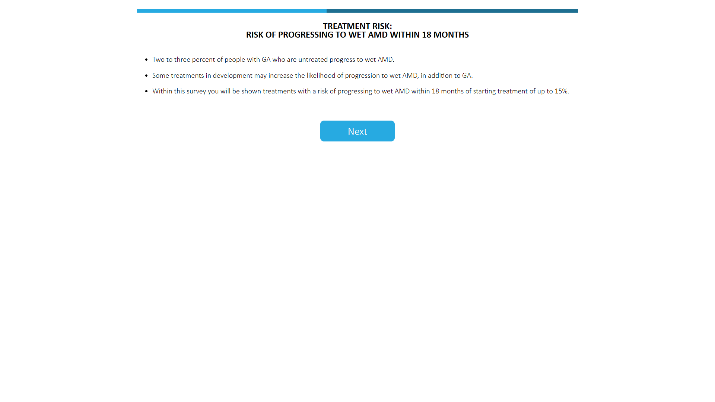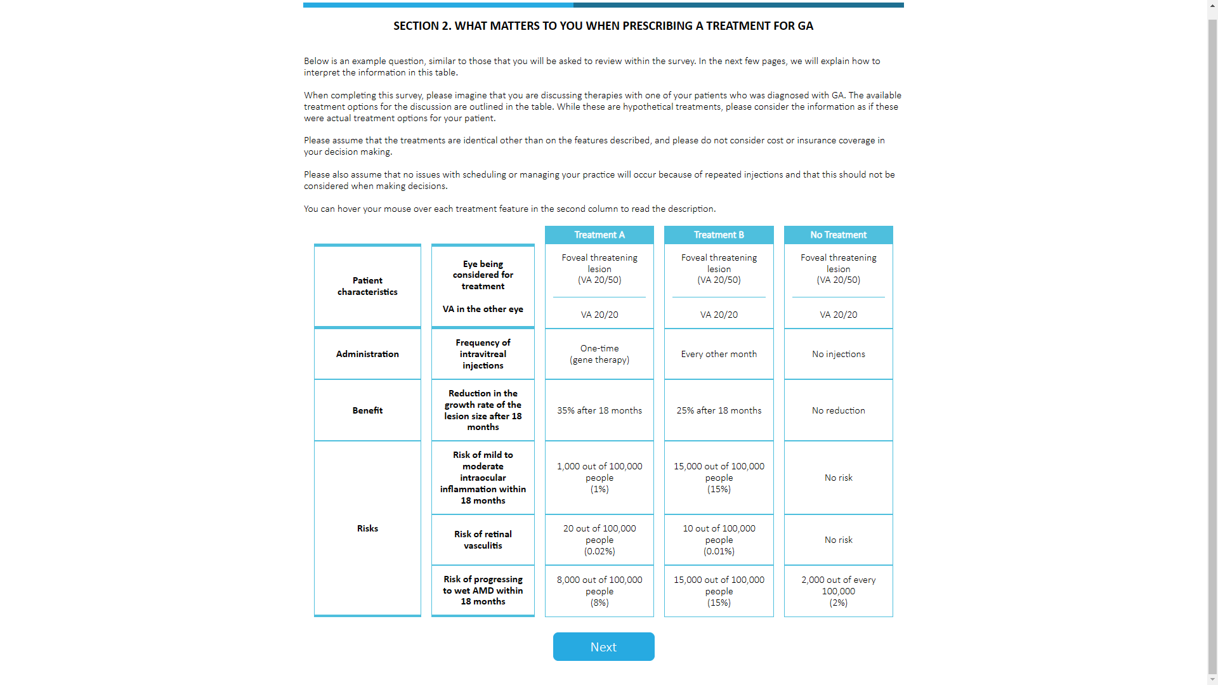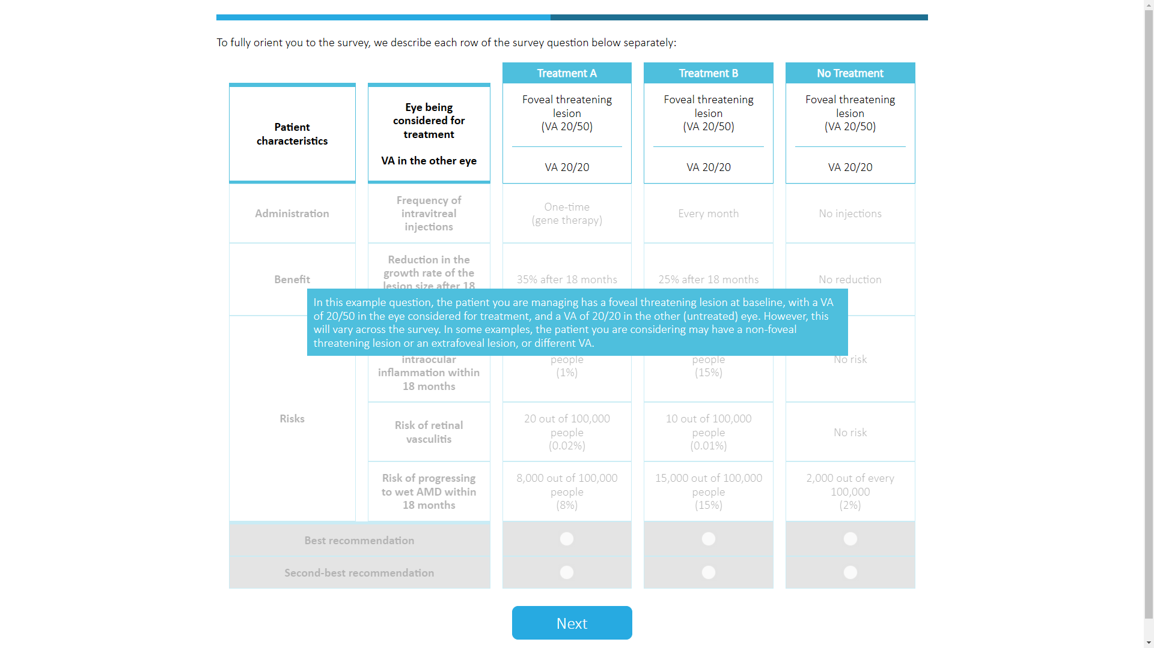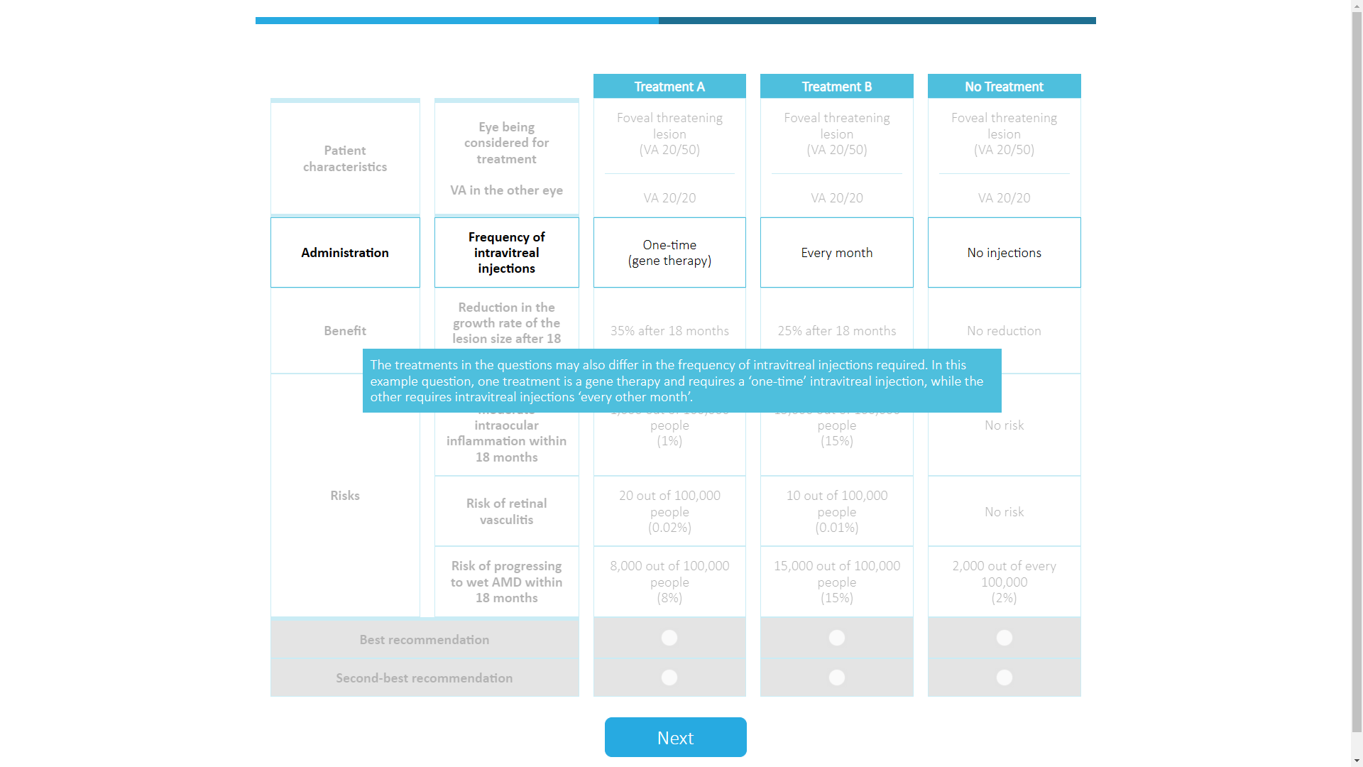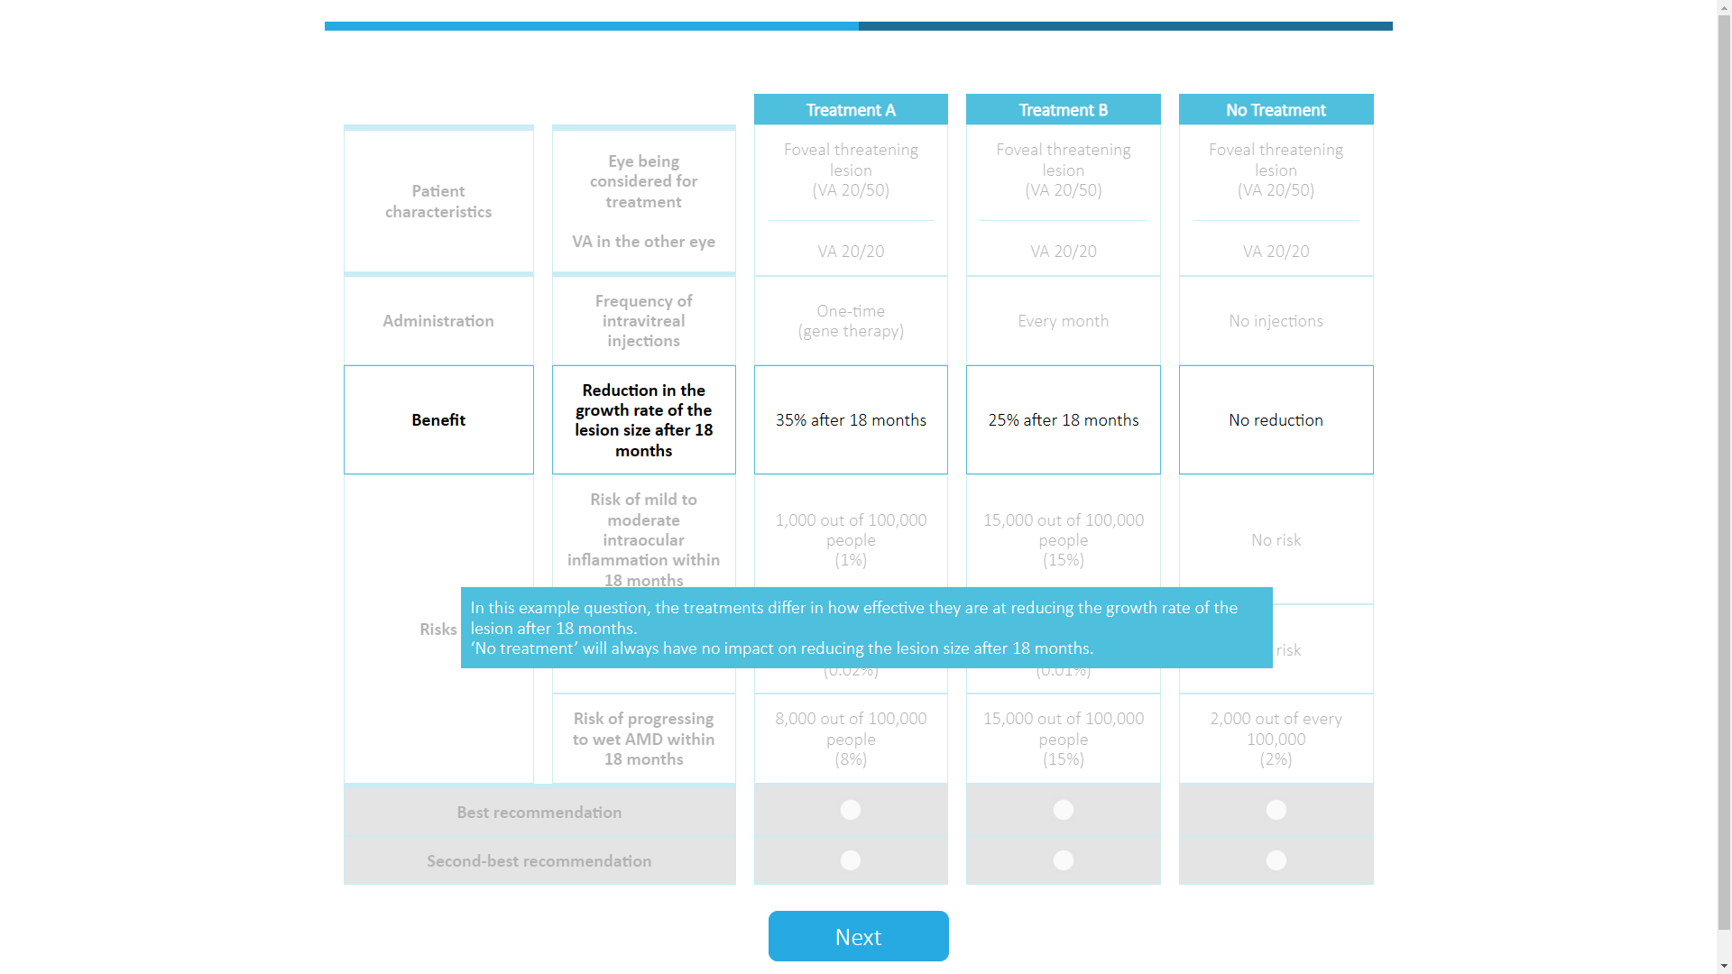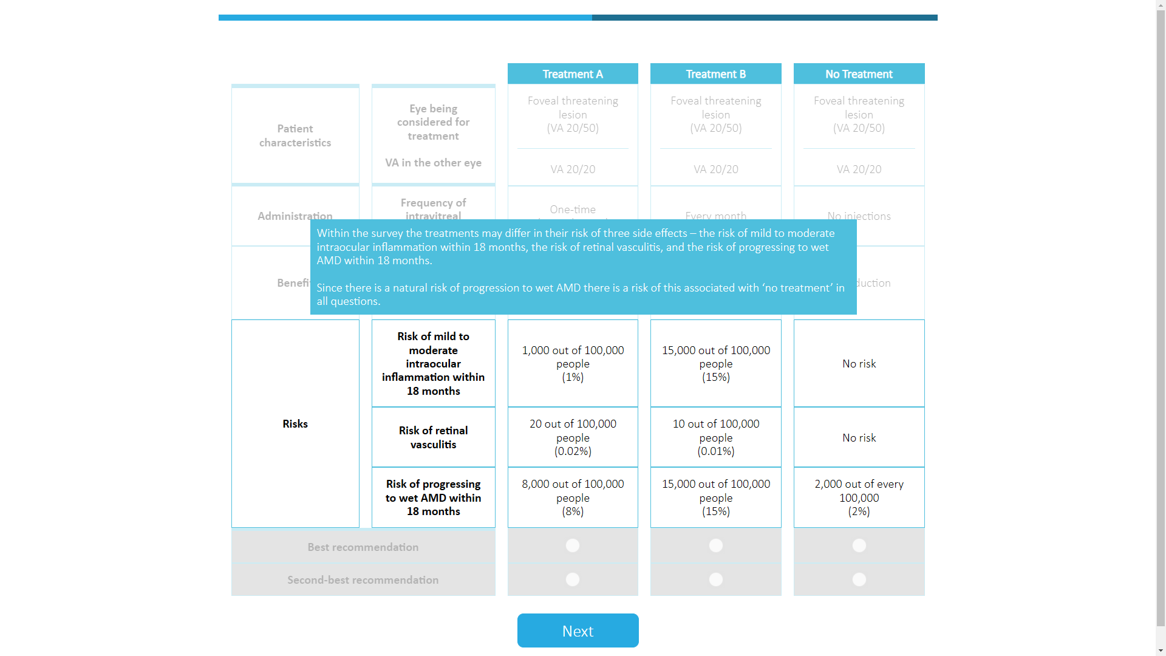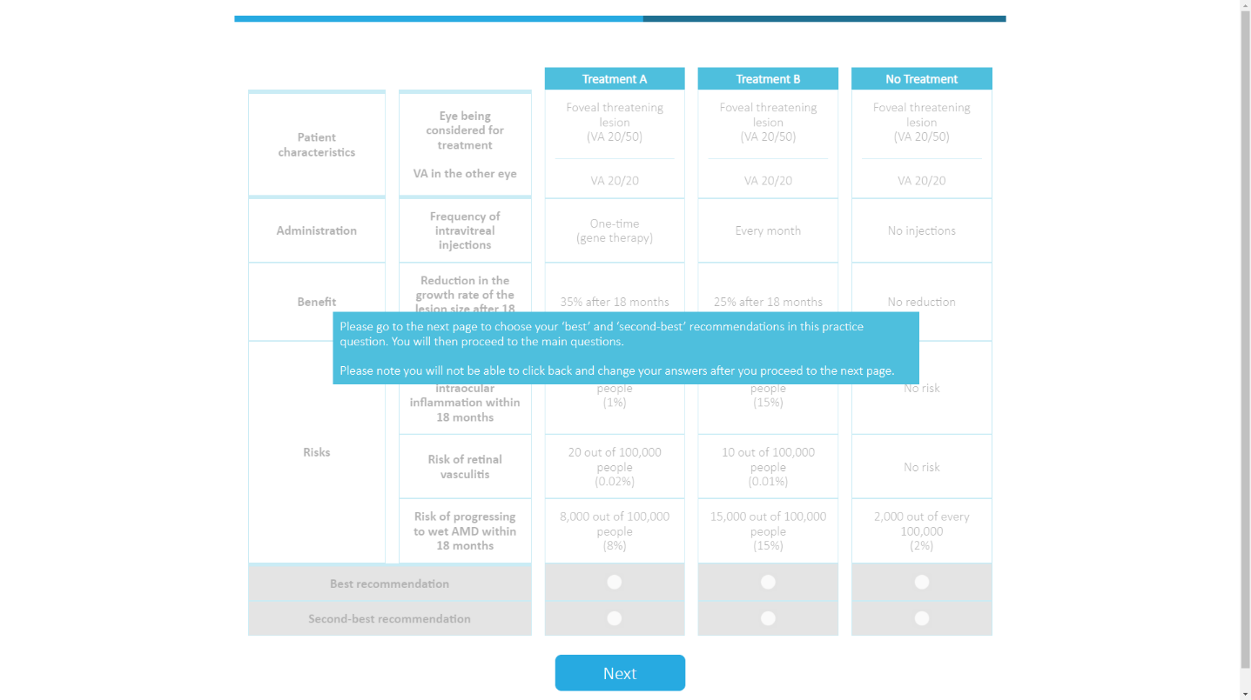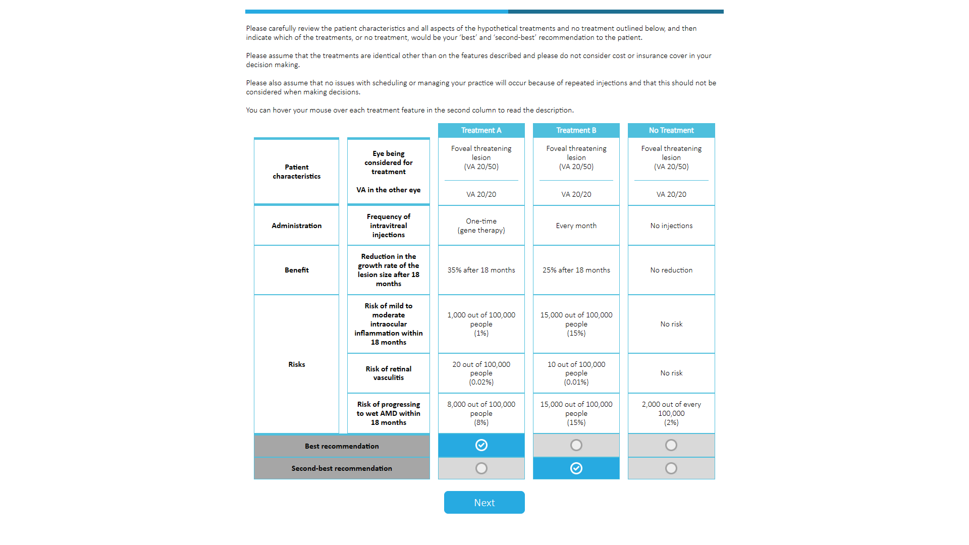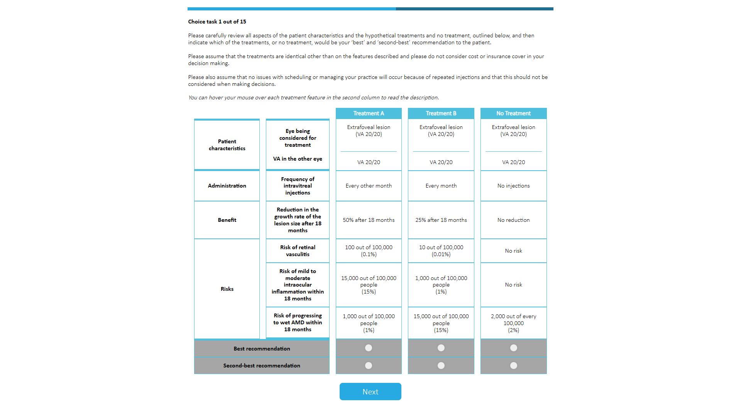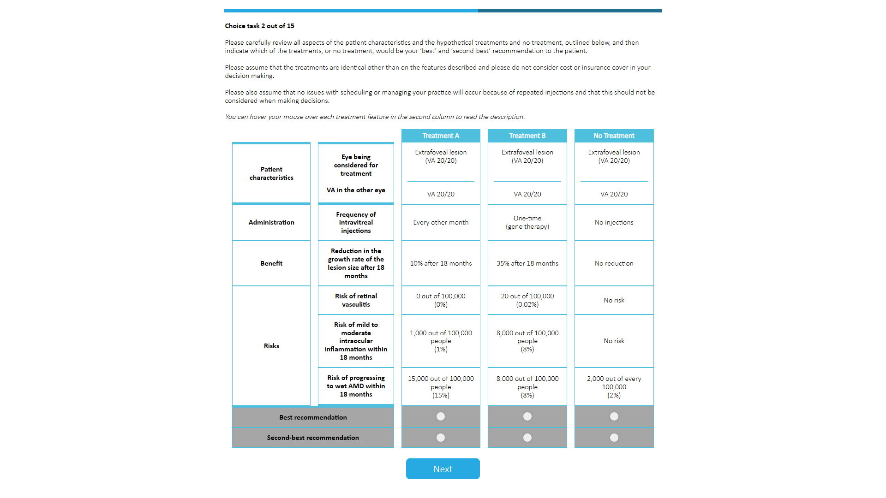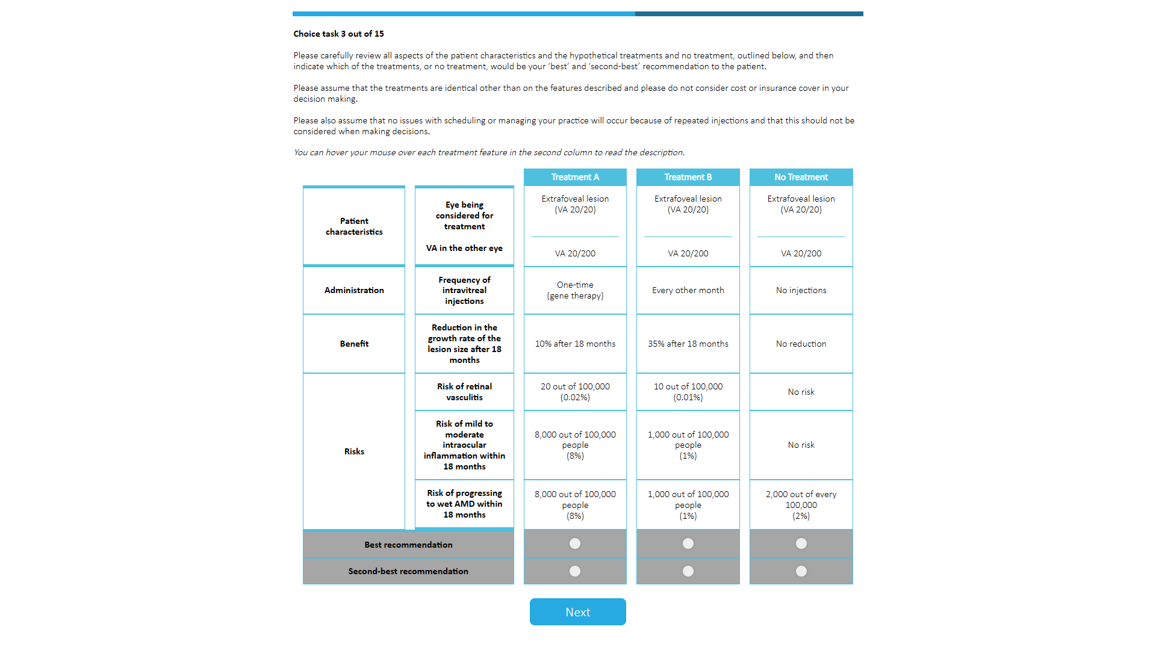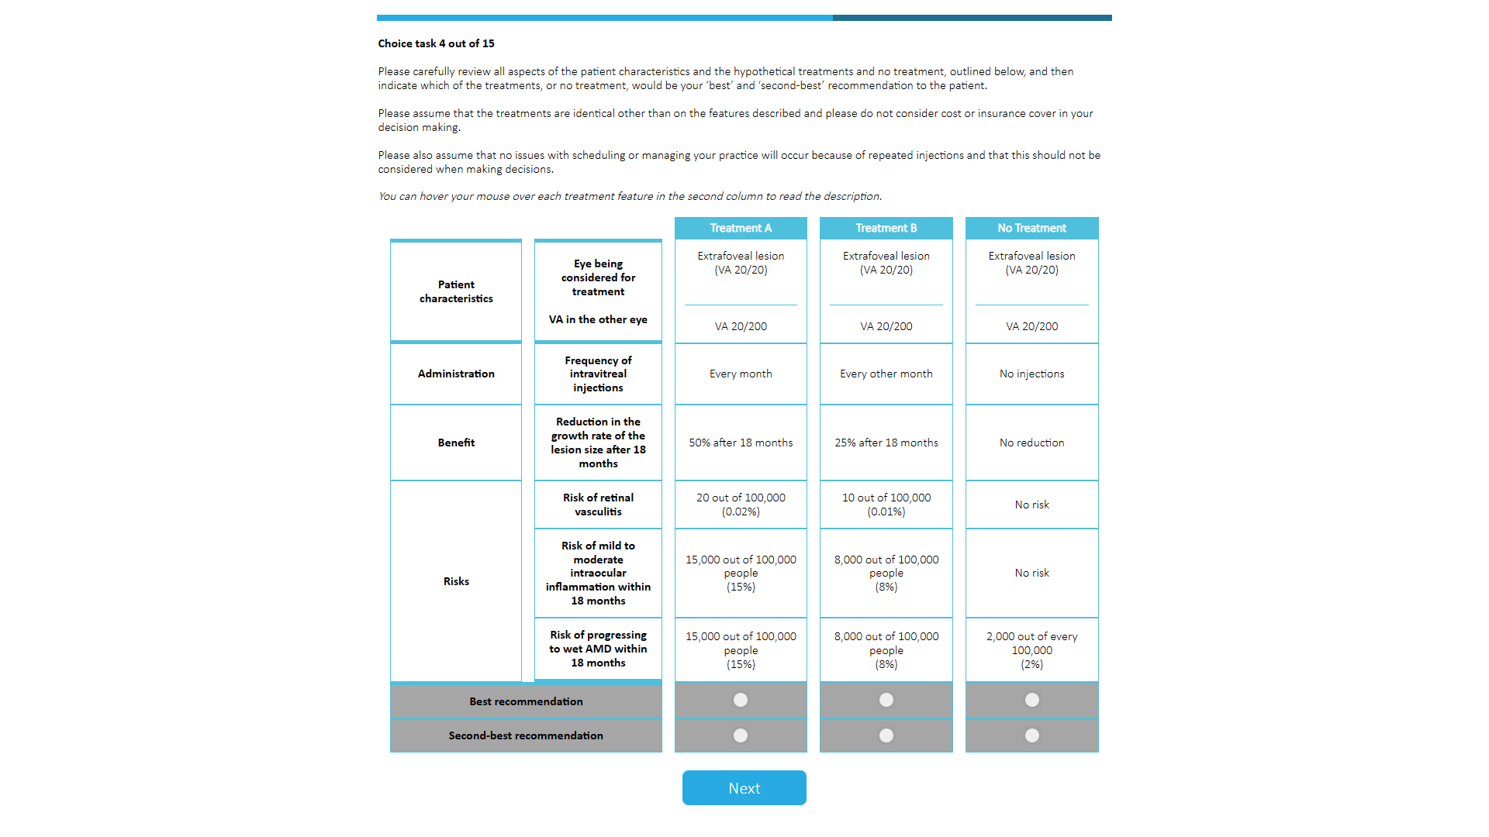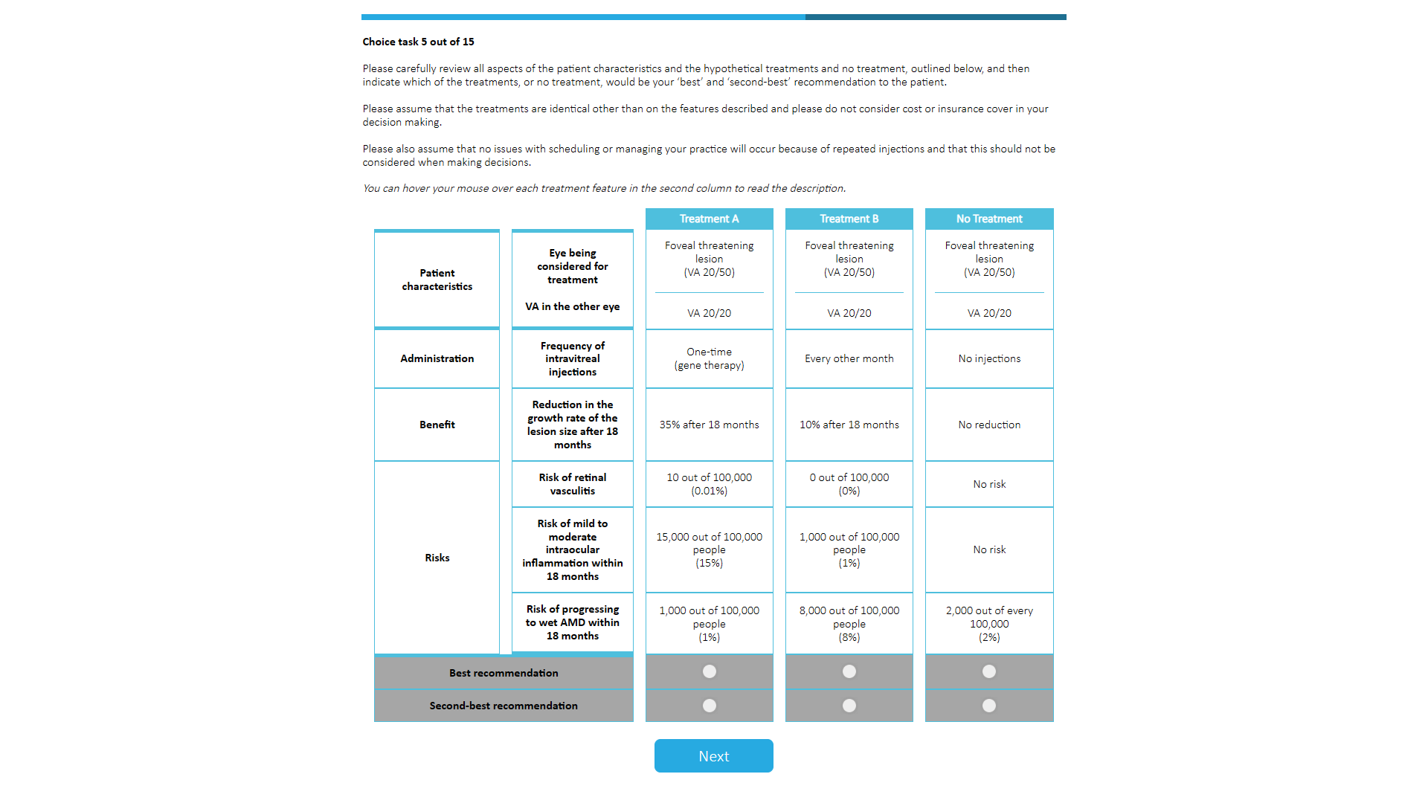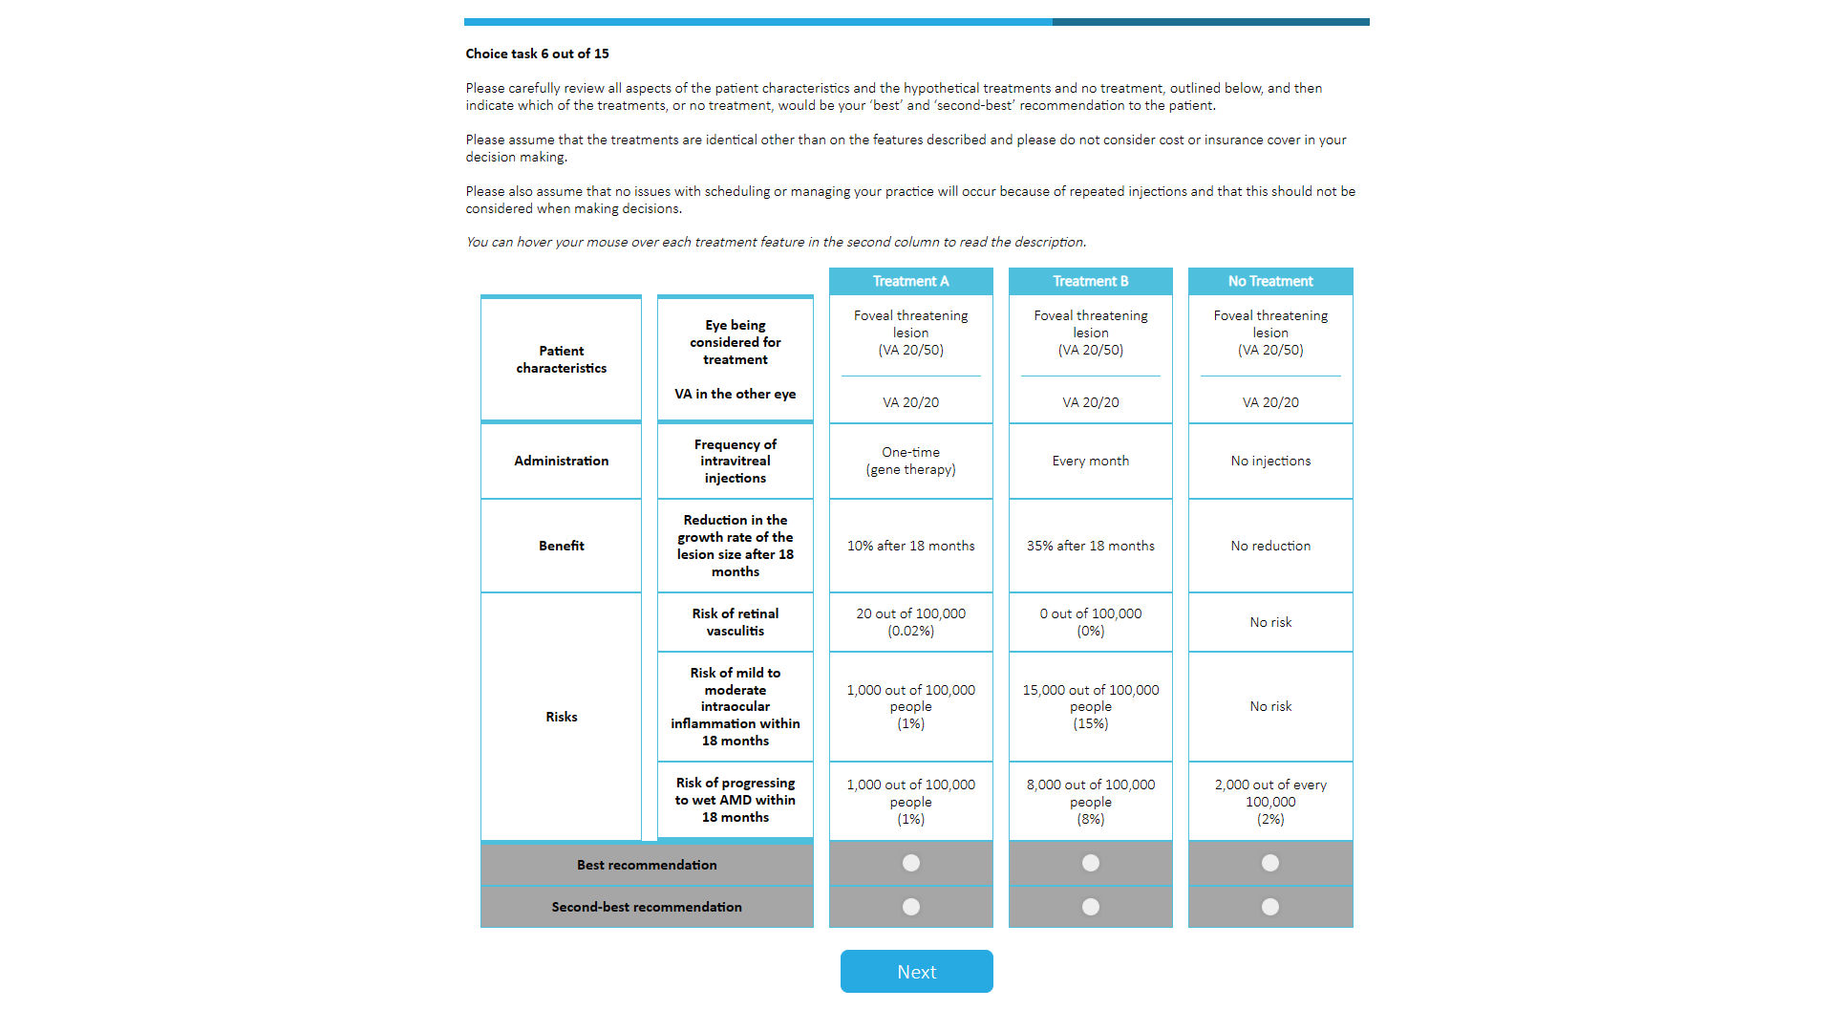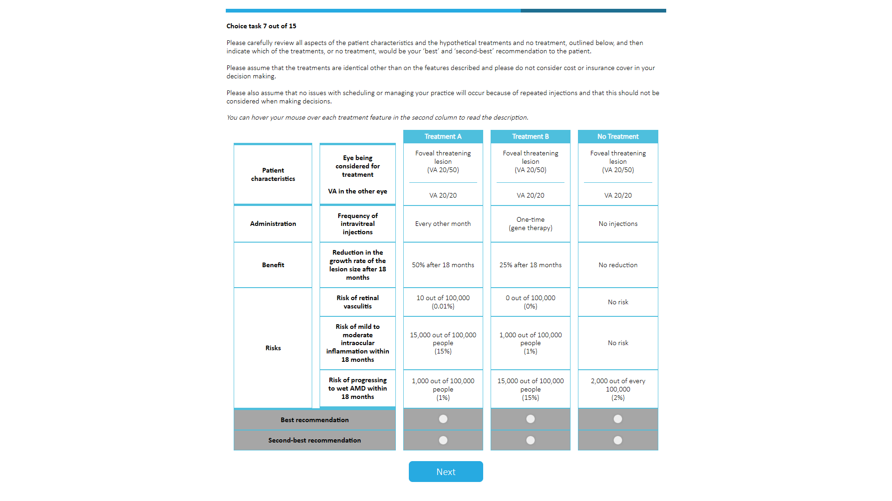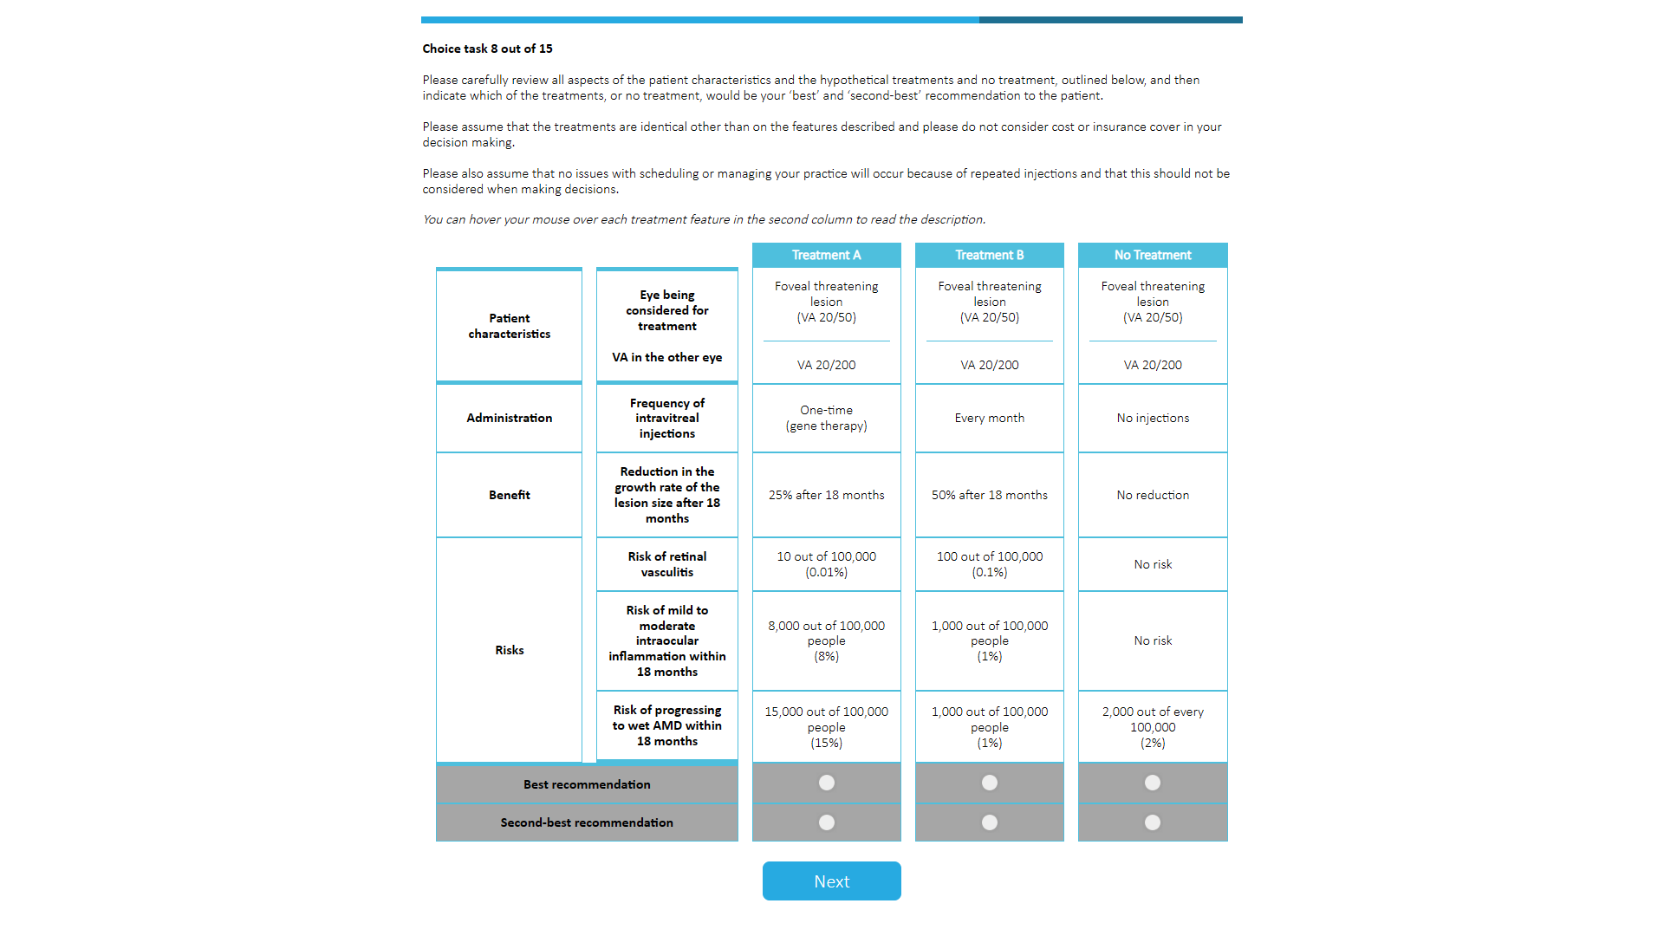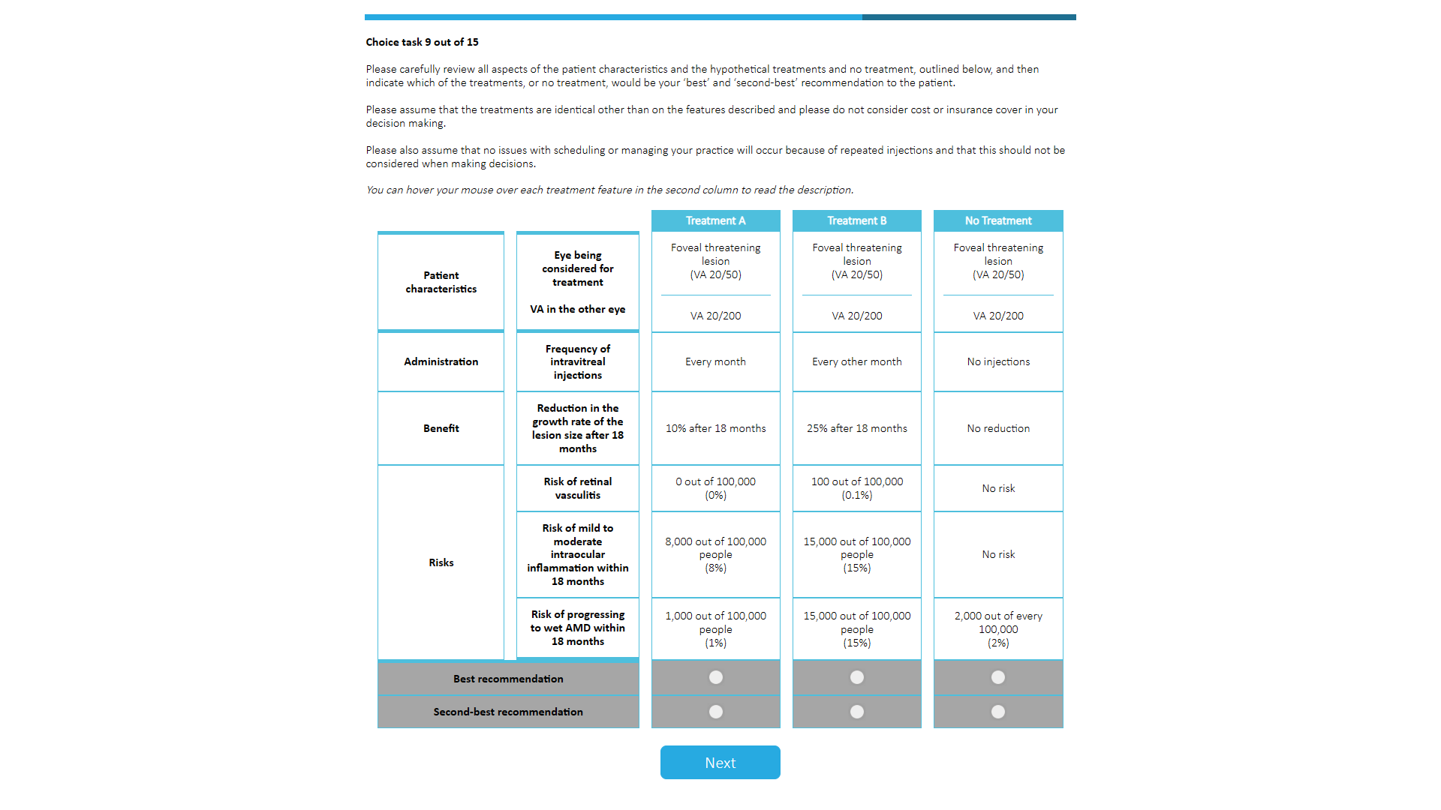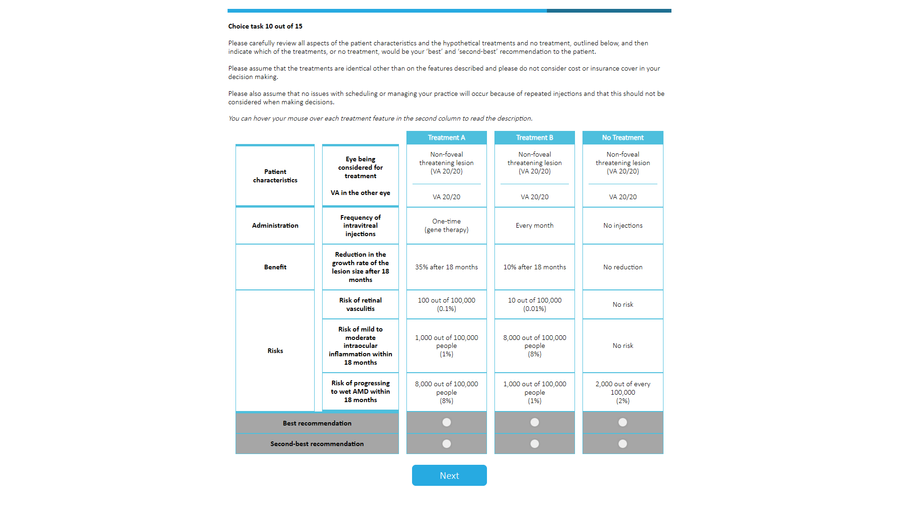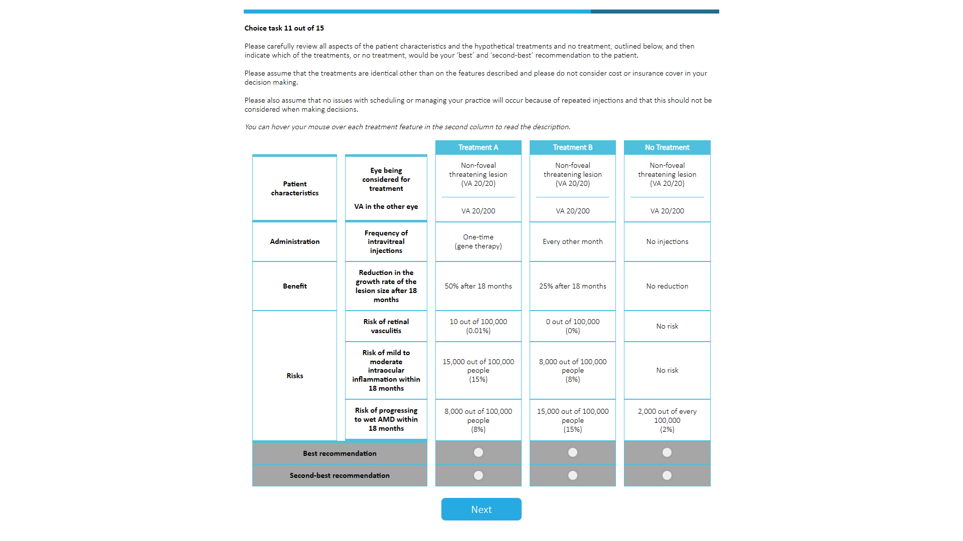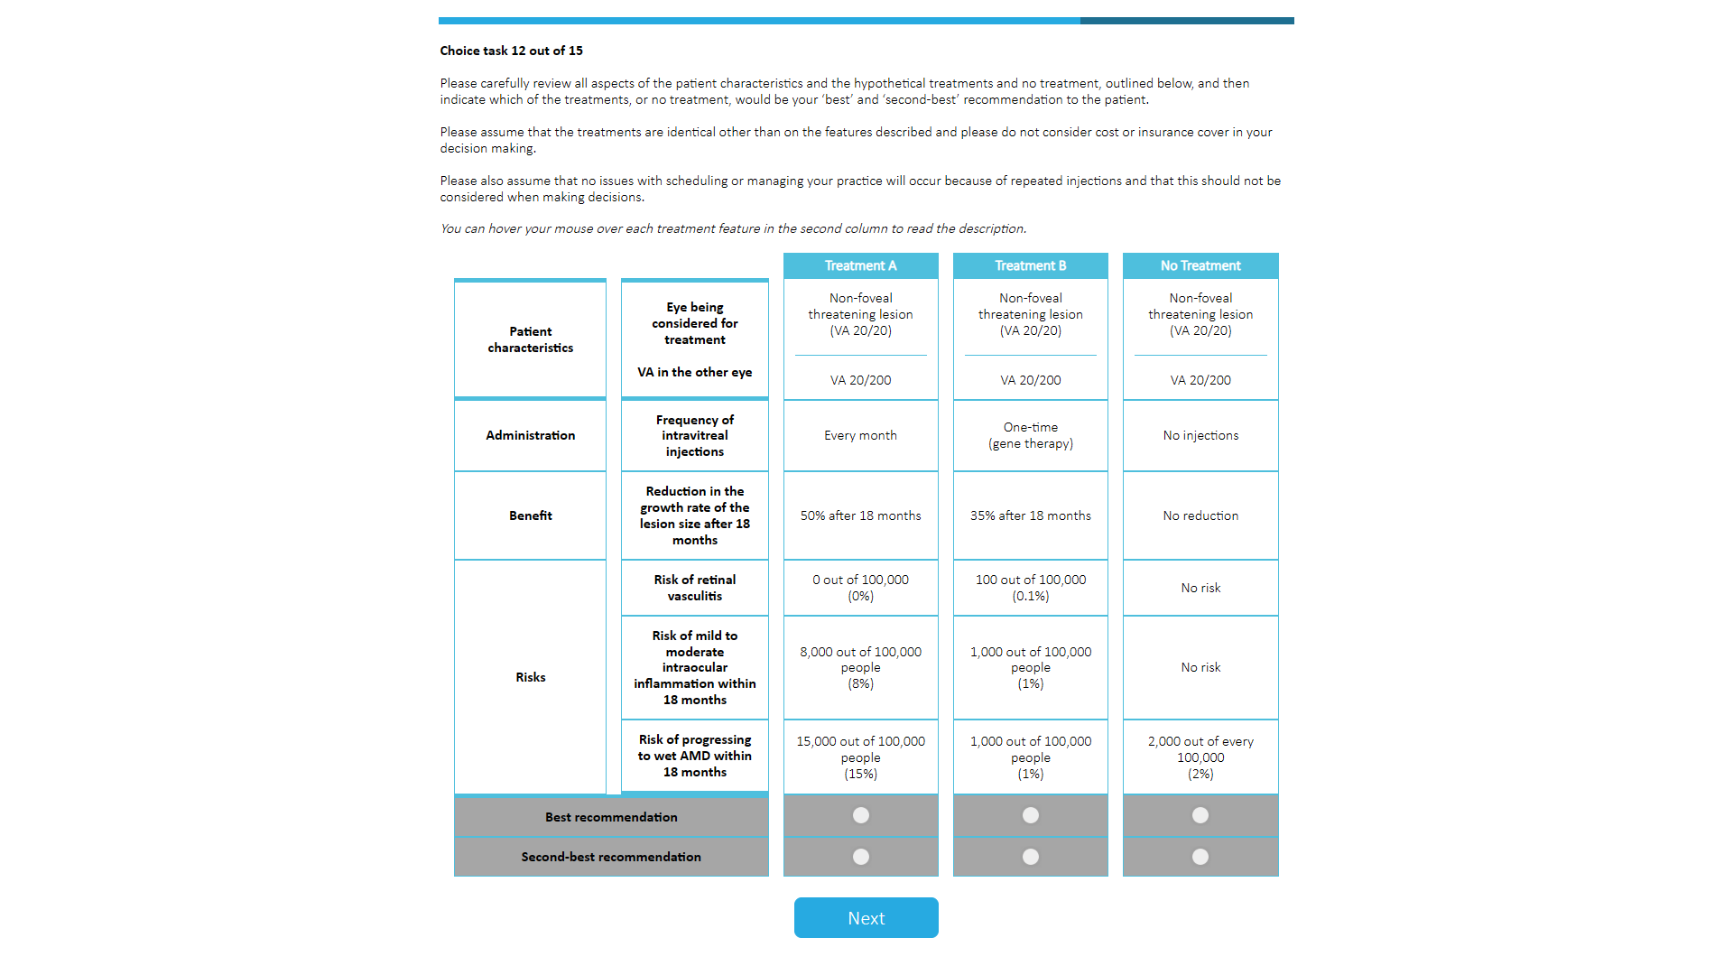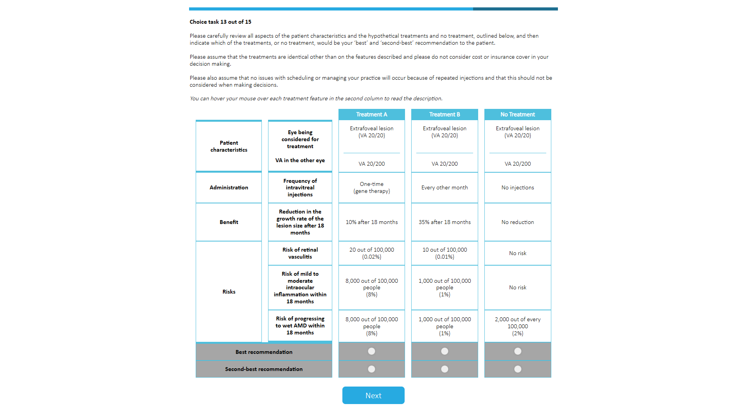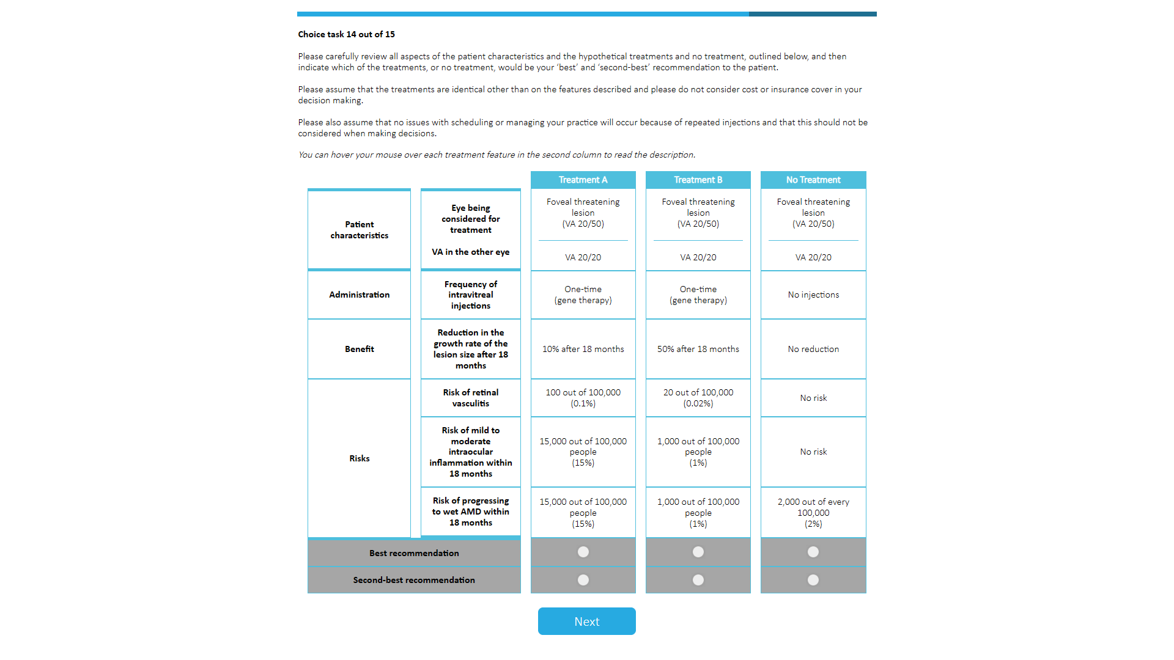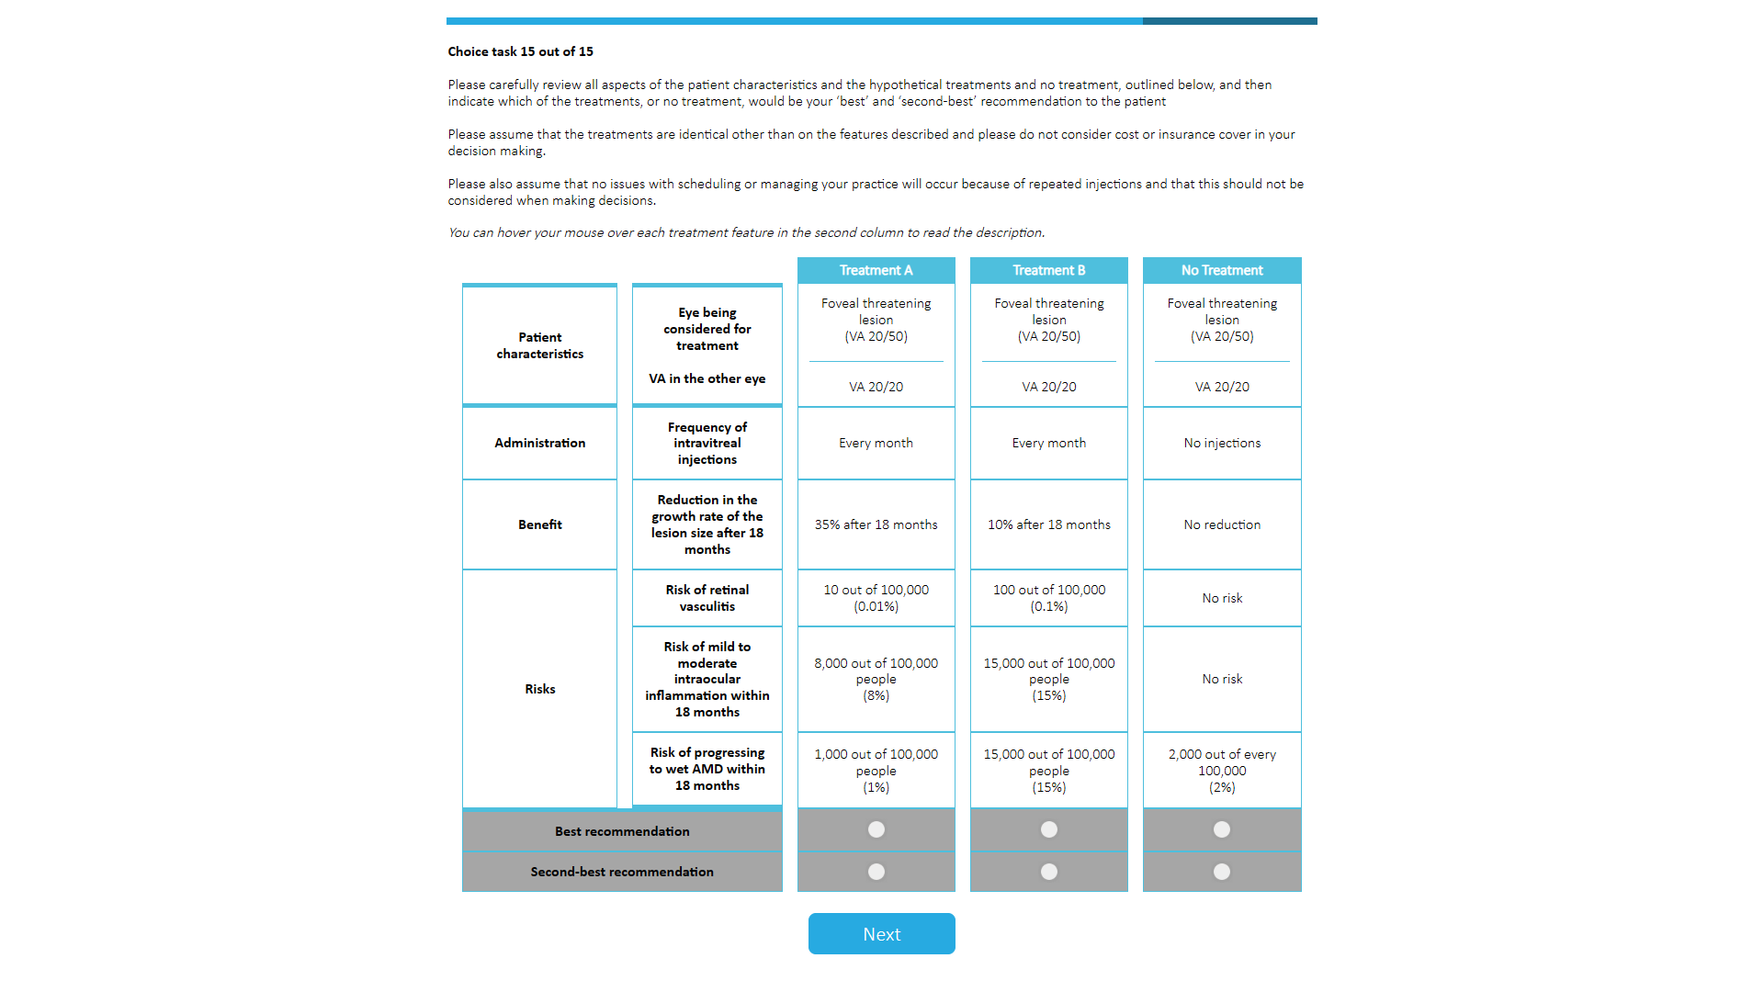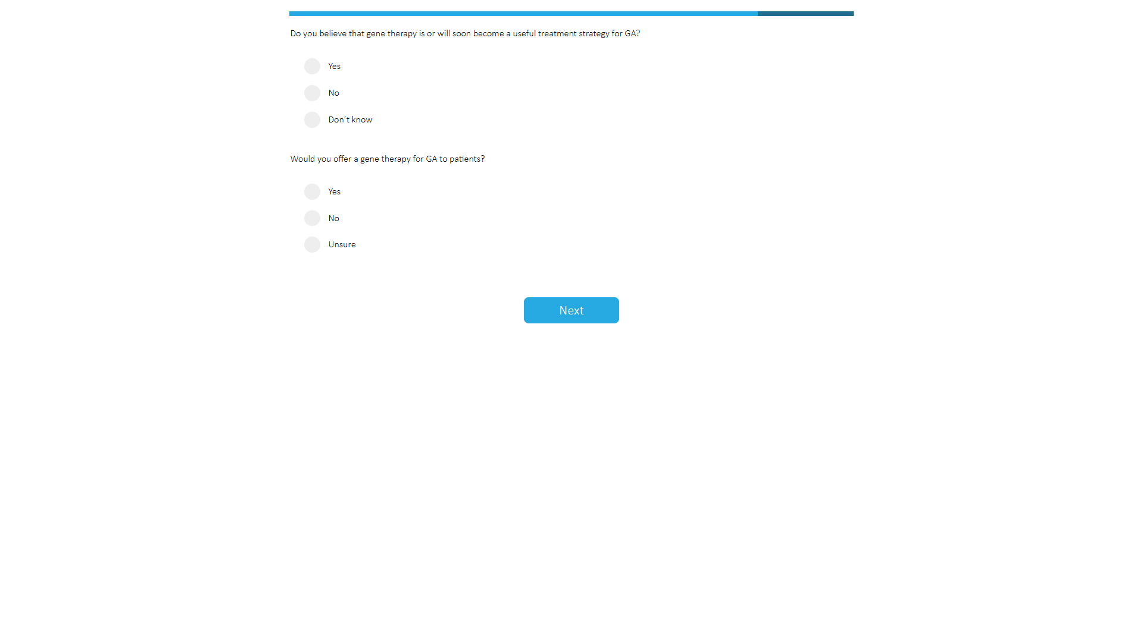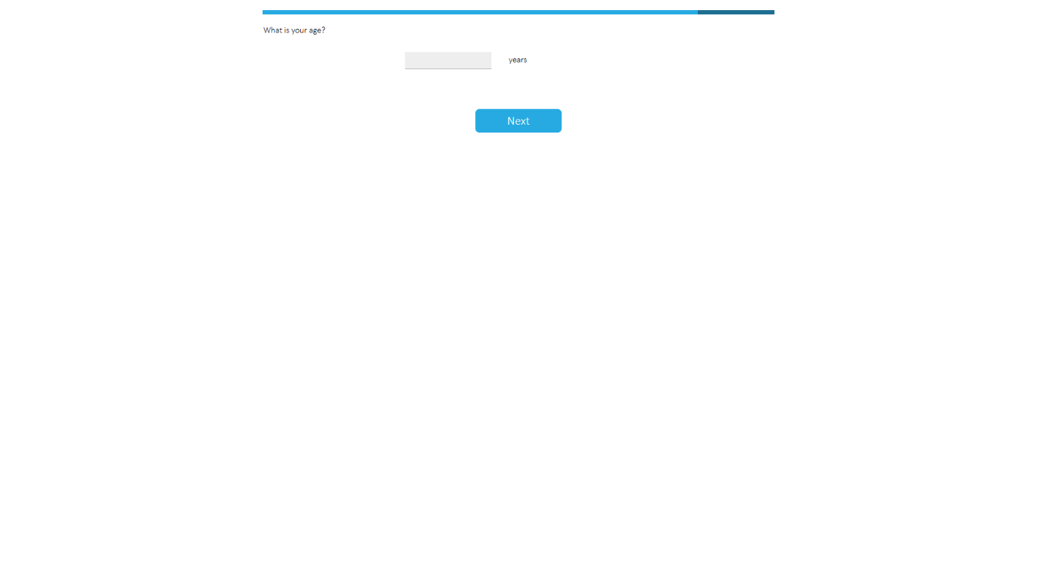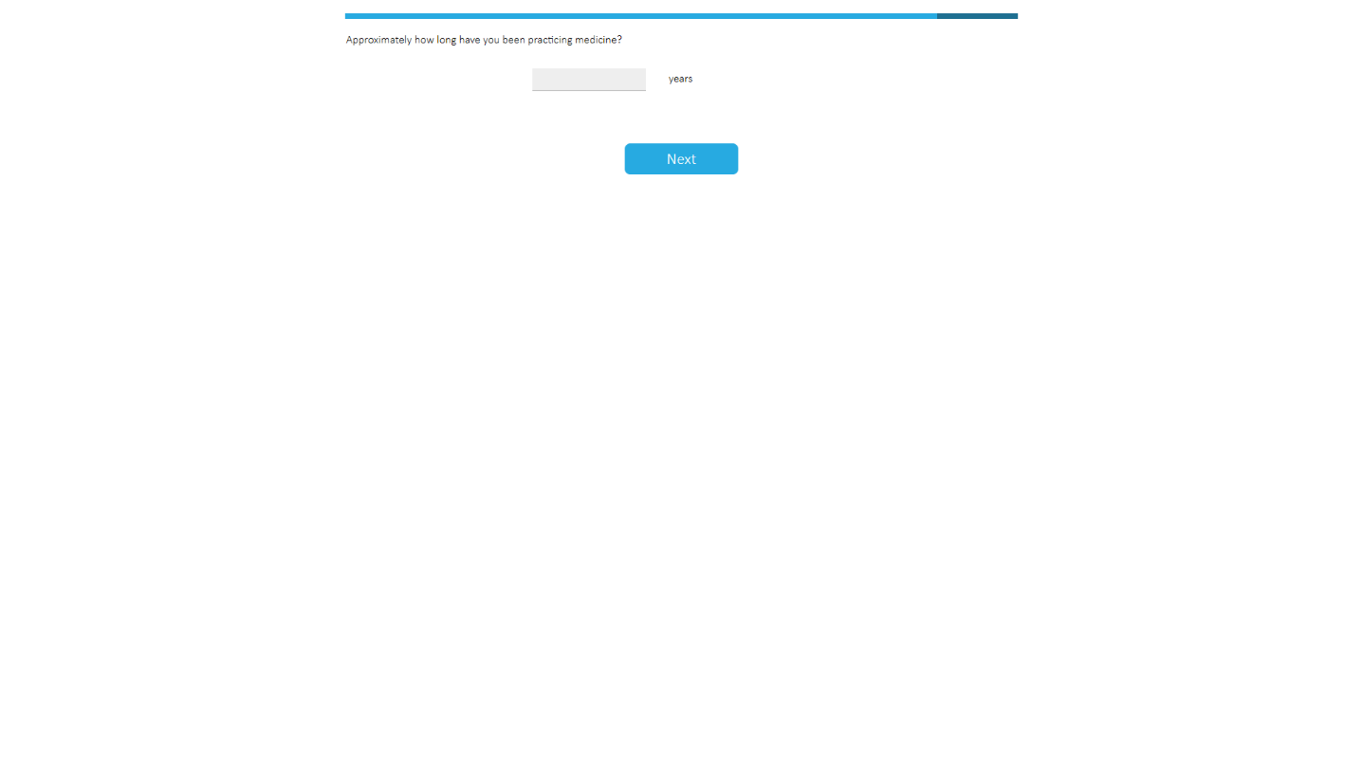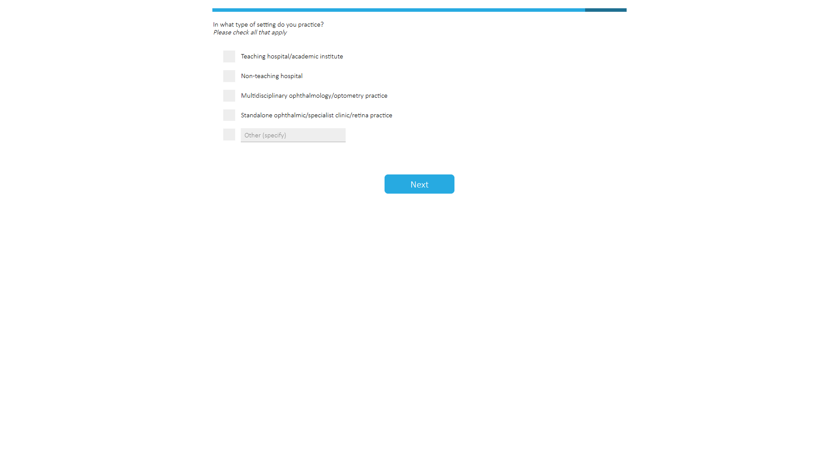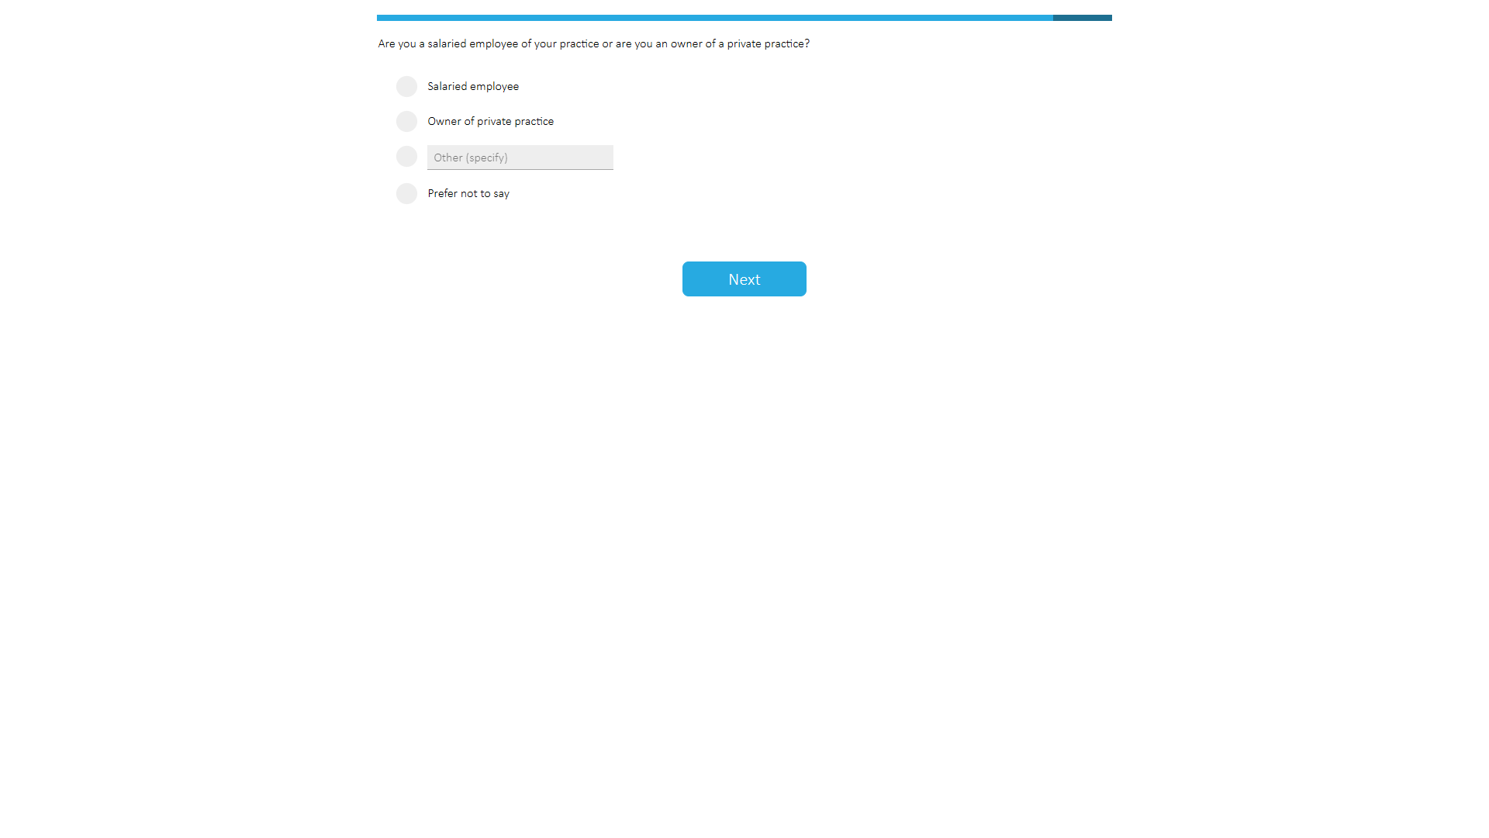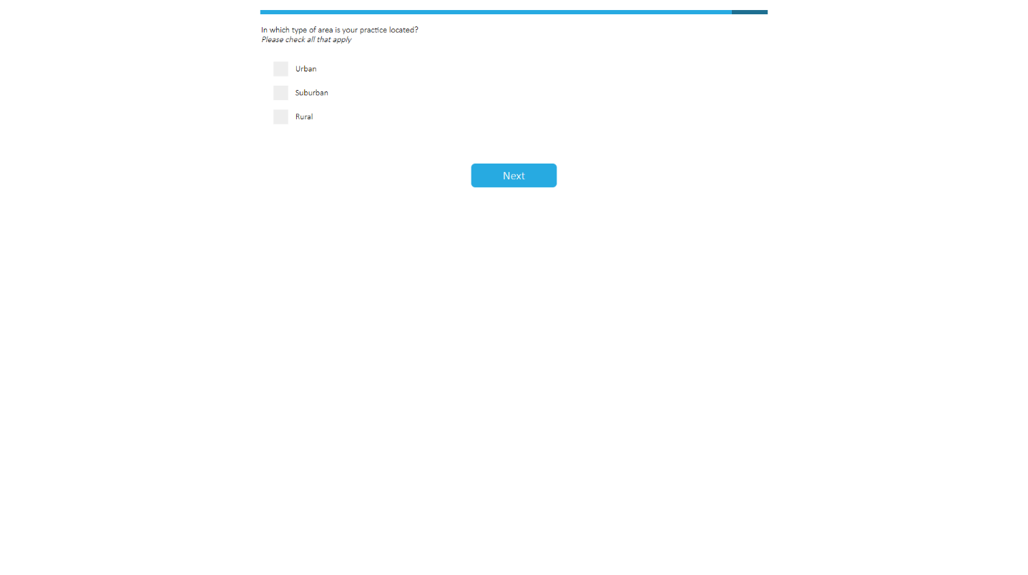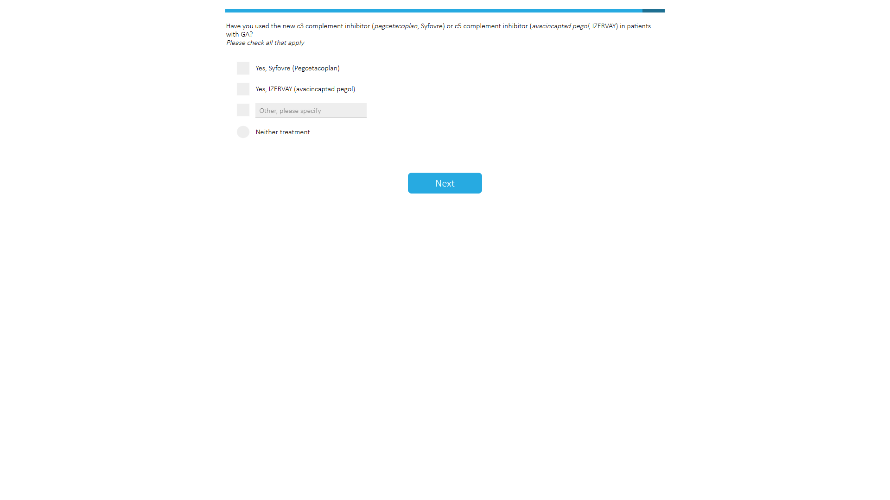

Statistical Analyses

BB-DCE
BB-DCE data were analyzed within the random utility maximization framework,^{38,39} which assumed that participant n chooses the most preferred alternative j $∈C$ in task t such that utility is maximized.
$$u_{nt(j∈C)}^{first}=v\left(x_{ntj}\right)+ε_{ntj}$$
where $ε_{ntj}$ is a random error following an extreme value type I distribution, and $v\left(x_{jnt}\right)$ is the systematic/observable utility component. The probability of choosing the alternative becomes:
$$P_{j}^{first}=\frac{\exp\left(v\left(x_{jnt}\right)\right)}{\sum_{j∈C}{\exp\left(v\left(x_{jnt}\right)\right)}}$$
Similarly, it was assumed that the participant then chooses the second most preferred alternative among the remaining ones. Therefore the probability of choosing this alternative is
$$P_{i}^{second}=\frac{\exp\left(v\left(x_{int}\right)\right)}{\sum_{i∈C-j}{\exp\left(v\left(x_{int}\right)\right)}}$$
The joint probability of a given choice sequence is given by
$$P_{j}^{ranking}= P_{j}^{first}P_{i}^{second}$$

Relative attribute importance (RAI)
RAI was calculated for the overall patient sample as well as for each of the six patient profiles (based on the location of the lesion and VA in the eye being considered for treatment and VA in the other eye [Supplemental Table 2]).
$${RAI}_{k}=100×\frac{{\hat{β}}_{k}^{max}-{\hat{β}}_{k}^{min}}{\sum_{k∈\left[1;K\right]}{\left({\hat{β}}_{k}^{max}-{\hat{β}}_{k}^{min}\right)}}$$
where (${\hat{β}}_{k}^{max}-{\hat{β}}_{k}^{min}$) corresponds to the largest change in utility obtained when moving from the worst (least desirable) to best (most desirable) level of the $k$^{th} attribute. If the worst level was also the reference category for the dummy coding of the effects, then ${\hat{β}}_{k}^{min}=0$. The standard error (SE) and 95% confidence interval (CI) were obtained with the Krinsky–Robb procedure, a parametric bootstrapping procedure, using 10,000 draws.

Simultaneous maximum acceptable risk threshold (SMART) curves
SMART curves were calculated for varying levels of the “Risk of mild to moderate uveitis within 18 months” and the “Risk of progressing to wet AMD within 18 months”. SMART curves were generated for three injection frequencies (one-time, every other month, every month) with two efficacy levels (10% or 35% reduction in the growth of lesion after 18 months) and a fixed risk for retinal vasculitis (0.01%).
The range of values from 1 to 100 for the risk of mild-to-moderate uveitis was defined by increments of 0.2, resulting in a total of 496 unique values.
- The SMART analysis determined the values for the risk of wet AMD such that the difference in utility between treatment risks (mild-to-moderate uveitis, wet AMD, and retinal vasculitis) and other attributes (reduction in the growth rate of lesion and frequency of intravitreal injection) was null.
- A mixed-logit model (MXL) was selected as the source model, and the Krinsky–Robb method was used to simulate the uncertainty around the utility estimates, computing 1,000 sets of utility estimates.
- A SMART analysis was run for both scenarios (10% and 35% lesion growth rate reduction), set of utility estimates (n=1,000), and uveitis value (n=496).
- For each uveitis value in every scenario, a distribution of values for the marginal rate of substitution was obtained (i.e., one per set of utility estimates). This distribution was used to compute the SE, lower bound of 95% CI (obtained as 2.5th percentile of distribution), and upper bound of 95% CI (obtained as 97.5th percentile of distribution).

Model specification and estimation
The model estimated the linear effect of a 1% increase in lesion growth rate reduction, 1% decrease in the risk of mild-to-moderate uveitis, and 1% in the risk of progressing to wet AMD, as the underlying assumption of linearity was supported by the data. However, this hypothesis was not verified for the risk of retinal vasculitis, and the model estimated a non-linear (quadratic) effect of a 0.01% risk decrease. The model also estimated the effect of categorical changes in injection frequency from every month (reference) to every other month and one-time, and included a constant term capturing preference for the “No treatment” option relative to “Treatment A”/“Treatment B”. Inter-individual variability in sensitivity to attribute changes was captured by allowing the effects to be normally distributed with diagonal covariance. The choice data were used to estimate the mean and SD of these distributions. The model was estimated with the Apollo package (version 0.3.3) from R software (version 4.4) using 1,000 modified Latin hypercube sampling draws.⁴⁰ The effect of each patient profile on utilities was captured by adding interaction effects to the model. The patient profile was first effect-coded (a mean-centering procedure for categorical variables). This effect-coded variable was then interacted with the main utility parameters of the model to capture the average deviation of each profile from the overall sample.

Subgroup analyses
Subgroup analyses were conducted to evaluate the effect of differences in the following demographics and clinical experience characteristics on RS treatment preferences: gender, age, clinical practice setting, practice location, number of years practicing medicine, number of patients with GA managed in the previous year, experience in prescribing C3 or C5 inhibitors (pegcetacoplan and avacincaptad pegol) for patients with GA, and risk tolerance. Only characteristics with ≥30 RS per category were included in the analysis, so some groups were combined.
The model was re-estimated for each characteristic after adding the interaction effects between the levels of that characteristic. The additional interaction effects were used to capture subgroup departures from average sensitivities to changes in the attributes. The overall effect of each characteristic on treatment preferences was evaluated with likelihood ratio test comparing the statistical performance of the models with and without the additional interaction effects.

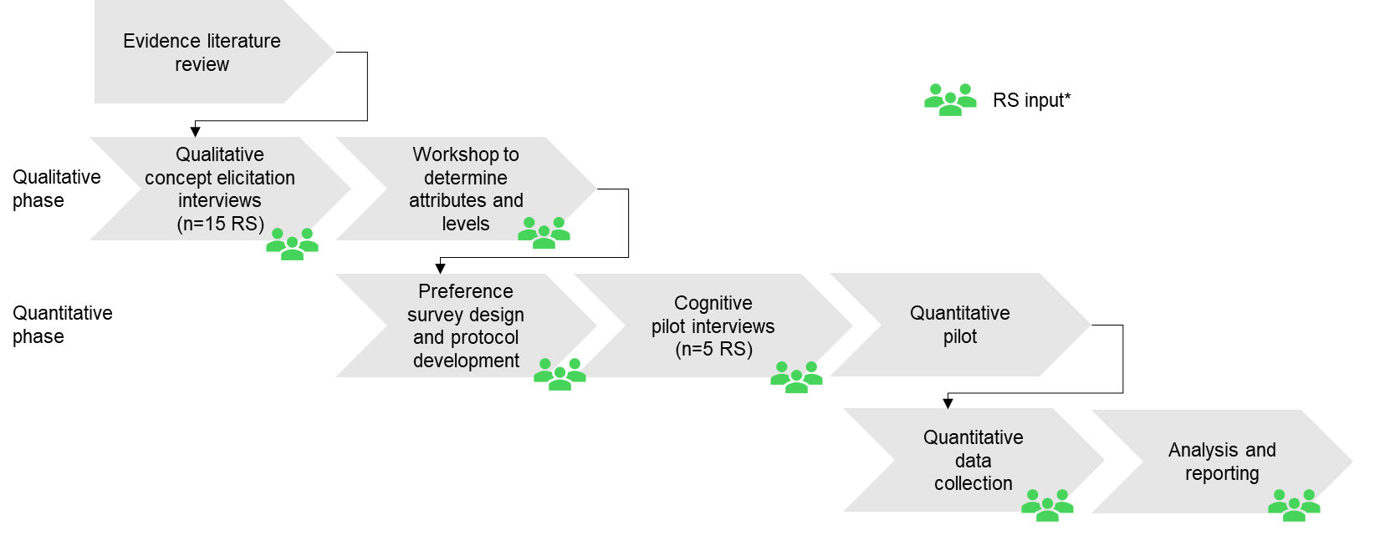

Supplemental Figure 1. Overall Study Design
*Input from an external RS (Karl Csaky) and internal clinical experts.
Abbreviations: RS, retina specialists.

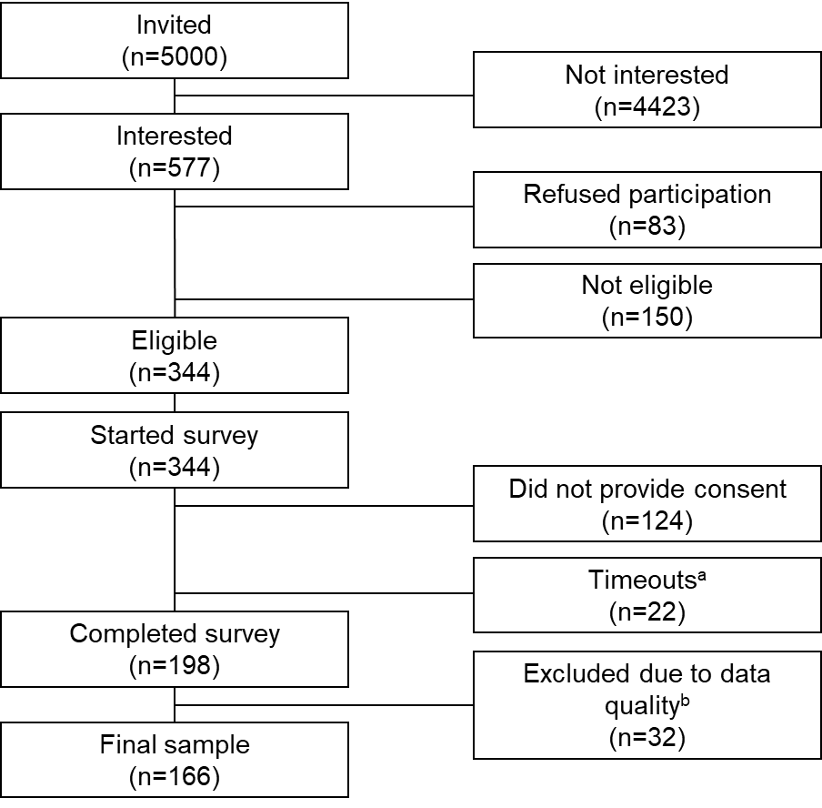

Supplemental Figure 2. RS Disposition
Abbreviations: BB-DCE, best-best discrete choice experiment; RS, retina specialists.
ªTimeouts represent RS who closed the survey without completing it and did not open it again before recruitment was complete.
^{b}Thirty-two RS were excluded because of failing both dominance tests (n=7), always choosing treatment A (n=1) or B (n=2), or completing all BB-DCE tasks in <2 minutes unless they had systematically opted out (n=28). Some participants fell into more than one of these categories.
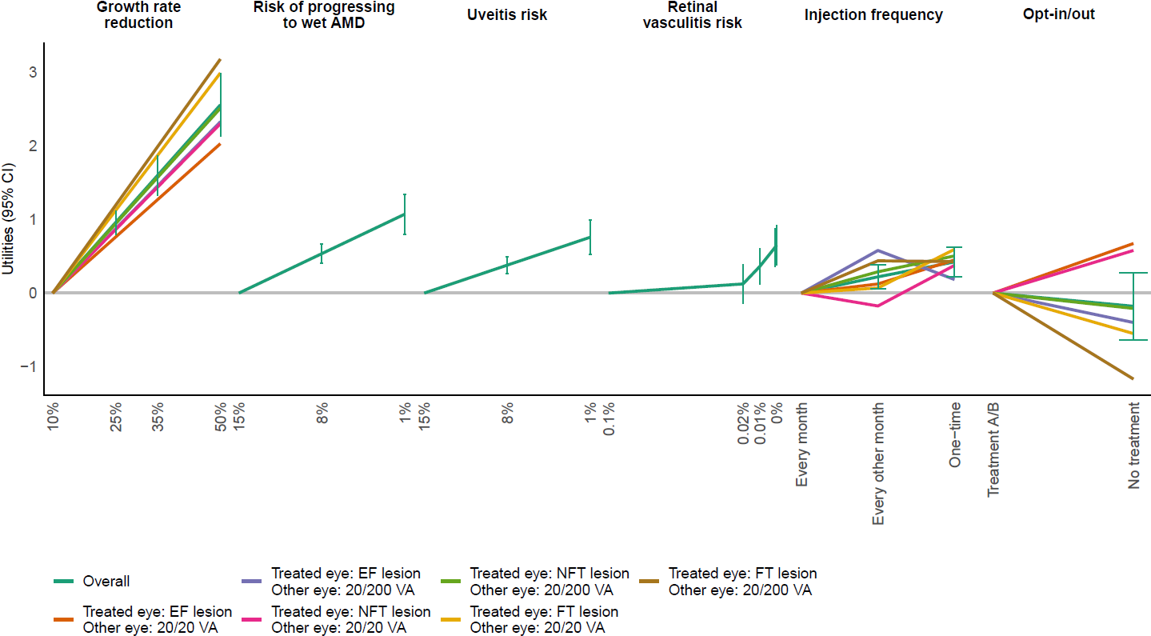

Supplemental Figure 3. RS Preferences, Overall and by Patient Profile (MXL Model)
Preference estimates for each treatment attribute. The larger the impact on utility (vertical distance), the more influential the attribute is on decision-making; 95% CI ranges are shown only for the overall sample. For patients with an EF lesion and 20/200 VA in the other eye, despite an apparent preference for injection every other month vs. one-time, the utility difference between both was not significantly different from zero (p=0.166; two-sided z-test).
Abbreviations: AMD = age-related macular degeneration; CI = confidence interval; EF = extrafoveal; FT = foveal threatening; MXL = mixed-logit; NFT = non-foveal threatening; RS = retina specialist; VA = visual acuity.
ªPositive utilities denote preference for the Treatment A or Treatment B options, and negative utilities denote preference for the No treatment option.

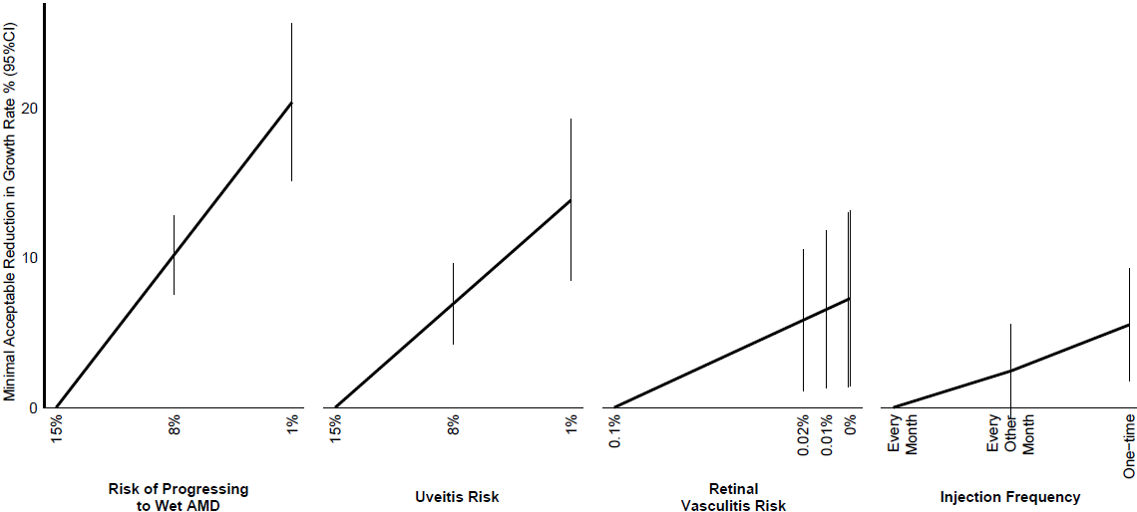 Supplemental Figure 4. Minimum Acceptable Benefit of Growth Rate Reduction in Exchange for Changes in Other Attributes
Numerical values are provided in Supplemental Table 11.
Abbreviations: AMD = age-related macular degeneration; CI = confidence interval.

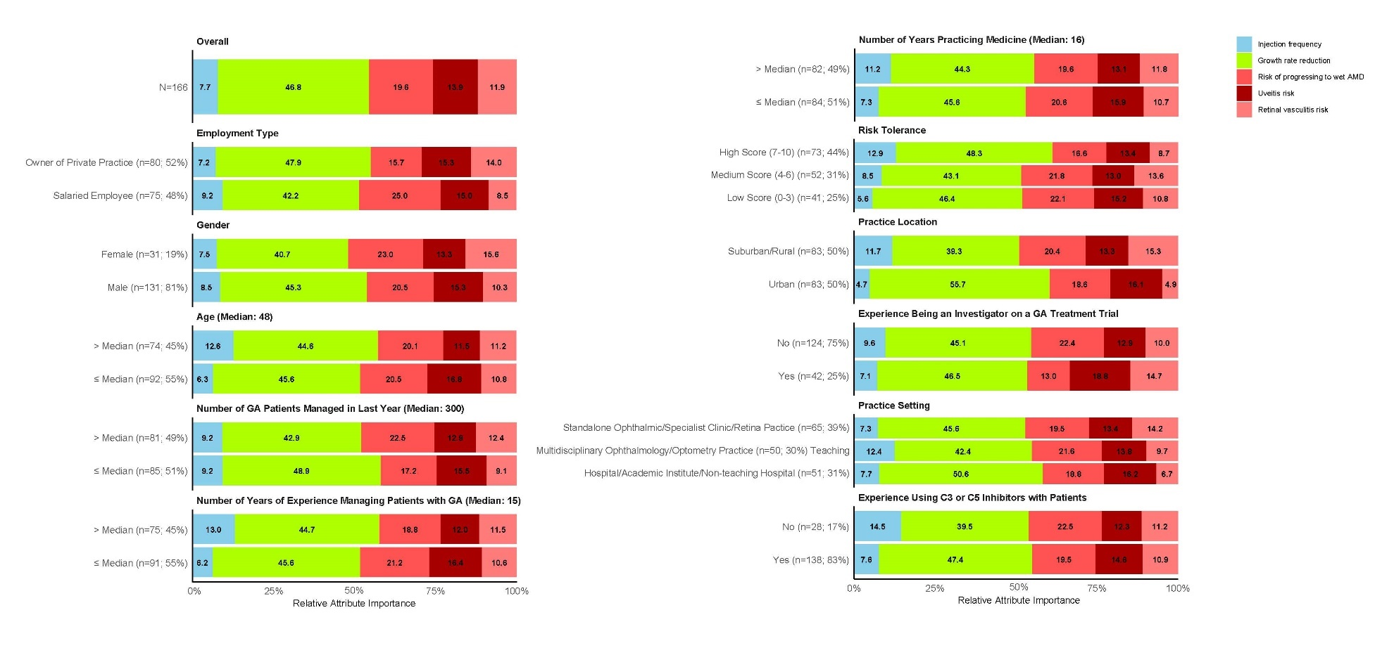 Supplemental Figure 5. Preference Heterogeneity (RAI by RS Subgroups)
Four RS responded “prefer not to say” to the gender question; their data were treated as not available (missing) and excluded from analysis in the IMXL model. Answers to some variables were not mutually exclusive so they were recoded as follows for statistical modelling. For practice location, suburban and rural were merged to obtain a bigger group; RS responding both urban and rural/suburban were reallocated to rural/suburban only. For practice setting, RS responding both multidisciplinary ophthalmology and either teaching hospital or standalone ophthalmic were recoded as multidisciplinary ophthalmology; RS responding both teaching hospital and standalone ophthalmic were recoded as teaching hospital.
Abbreviations: AMD = age-related macular degeneration; GA = geographic atrophy; IMXL = interacted mixed-logit; RAI = relative attribute importance; RS = retina specialist.

Supplemental Table 1. TLR Findings
First Author, yearª | Country | Sample size | Sample characteristics | Study type
Carlton, 2019⁷ | UK | N=9 | GA | Two focus groups sorted by visual acuity
McCloud, 2014²⁵ | Australia | N=34 | AMD  GA: n=6 (17.6%)  Wet AMD: n=28 (82.4%) | Focus groups of three to five participants; and single, in-depth, semistructured interviews
Danner, 2016²⁶ | Germany | N=86 | Wet AMD | AHP in interview setting with additional qualitative insights
Gallego-Pinazo, 2021²⁷ | Spain | Patients: N=110  RS:  N=66 | Wet AMD | DCE
Droege, 2014²⁸ | Germany | N=200 | Wet AMD | 14-item preference questionnaire
Bhagat, 2020²⁹ | US | N=300 | Wet AMD, DME | DCE
Jacobs, 2021³⁰ | US | N=54 | AMD, Diabetic retinopathy  Retinal vein occlusion, Retinal detachment, Macular edema  Glaucoma, Other retinal vascular disease | Questionnaire using  5-level Likert-style questions
Fenwick, 2021³¹ | Singapore | N=304 | Primary Open Angle Glaucoma, Normal Tension Glaucoma, Angle Closure Glaucoma | DCE
Aspinall, 2008³² | UK | N=72 | Glaucoma diagnosis categories: Primary Open Angle Glaucoma, Normal Tension Glaucoma, Angle Closure Glaucoma, Pseudoexfoliative syndrome | Questionnaire: EQ-5D, time trade-off, and choice-based conjoint analysis
Yu, 2015³³ | US | N=182 | Noninfectious uveitis | BWS case 1
Li, 2020³⁴ | US | N=25 | Glaucoma patients | Identified important benefit and risk outcomes qualitatively, using semistructured, one-on-one interviews
Le, 2019³⁵ | US | N=274 | Ocular hypertension and open-angle glaucoma, Newly diagnosed or suspected of having mild to moderate primary open-angle glaucoma | BWS
Fenwick, 2020³⁶ | Australia | N=220 | Diabetic Retinopathy–VTDR (severe non-proliferative DR, proliferative DR, and clinically significant macular edema) and associated vision impairment | DCE
Bhargava, 2006³⁷ | UK | N=82 | Glaucoma | Conjoint analysis (ranking of scenarios)
Danner, 2017³⁸ | Germany | N=84 | Wet AMD | AHP and DCE
Baxter, 2016³⁹ | UK | N=87 | Wet AMD | Conjoint analysis (ranking of scenarios)
Joko, 2020⁴⁰ | Japan | N=120 | Wet AMD | DCE
Vennedey, 2016⁴¹ | Germany | N=86 | Wet AMD | DCE
Bhargava, 2008⁴² | UK | N=96 | Glaucoma | Conjoint analysis (ranking of scenarios)
Mueller, 2016⁴³ | Germany | N=284 | Wet AMD | DCE
Abbreviations: AHP = analytic hierarchy process; AMD = age-related macular degeneration; BWS = best-worst scaling; DCE = discrete choice experiment; DR = diabetic retinopathy; GA = geographic atrophy; RS = retina specialist; TLR = targeted literature review; VTDR = vision-threatening diabetic retinopathy.
ªSee article reference list for full citations.

Supplemental Table 2. Patient Profiles in the BB-DCE Survey
Patient characteristic | Patient profile 1 | Patient profile 2 | Patient profile 3 | Patient profile 4 | Patient profile 5 | Patient profile 6
Eye being considered for treatment | EF lesion  VA 20/20 | EF lesion  VA 20/20 | NFT lesion  VA 20/20 | NFT lesion  VA 20/20 | FT lesion  VA 20/50 | FT lesion  VA 20/50
VA in the other eye | VA 20/20 | VA 20/200 | VA 20/20 | VA 20/200 | VA 20/20 | VA 20/200
Abbreviations: BB-DCE = best-best discrete choice experiment; EF = extrafoveal; FT = foveal threatening; NFT = non-foveal threatening; VA = visual acuity.

Supplemental Table 3. Description of Attributes Included in the BB-DCE
Attribute |  | Description
Patient characteristicsª | Eye being considered for treatment (location of lesion at baseline and visual acuity) | You will be asked to consider different patient scenarios, in which the lesion at baseline is either FT (with VA of 20/50), NFT (with VA of 20/20), or EF (with VA of 20/20). This can be assessed with autofluorescence and optical coherence tomography. Definitions explaining these scenarios are outlined below.  - FT: The shortest distance of the lesion to the fovea is within a circle measuring 500 µm in diameter, centered at the fovea.  - NFT: The shortest distance of the lesion to the fovea is within circles measuring 500–1500 µm diameter, centered at the fovea.  - EF: The shortest distance of the lesion to the fovea is greater than a circle measuring 1500 µm diameter, centered at the fovea.
Patient characteristicsª | VA in the other eye | The survey will also provide information on the VA of the other eye that is not being considered for treatment. The VA will either be 20/20 or 20/200.
Benefit | Reduction in the growth rate of lesion size after 18 months | Without treatment, GA lesions usually increase in size. Current treatments for GA aim to slow the rate of growth of GA lesions.  You will be shown treatment options that differ in their impact on reducing the growth rate of the GA lesion [total area (mm²)] 18 months after the start of treatment vs. no treatment.  You will be shown treatments with a reduction in the lesion growth rate of up to 50%.

Administration regimen | Frequency of intravitreal injections | Treatments available or in development for GA are given with an intravitreal injection or multiple intravitreal injections. The frequency of injections differs between treatments. This survey presents treatements that require monthly injections or an injection every other month, and treatments that only require a once-in-a-lifetime injection (gene therapy).  Please assume that the injection frequency does not impact how well the treatment works. However, if a monthly or every other month injection is missed there is a chance that the treatment may not work as well as expected. Therefore, the monthly or every other month injections need to be given on an ongoing basis.  Please assume that no issues with scheduling or managing your practice will occur because of repeated injections and that this should not be considered when making decisions.  The intravitreal injections can cause endophthalmitis, by introducing infectious agents into the eye during the injection. Although the risk of endophthalmitis with each injection is very small (up to 0.05%, or 1 in every 2000 injections), the cumulative risk increases with more frequent injections.
Risks | Risk of mild to moderate uveitis^{b} within 18 months | Some treatments in development can cause differing types of mild to moderate intraocular inflammation such as uveitis, vitritis, vitreal cells, iridocyclitis, anterior chamber cells, iritis, corneal keratic precipitates, and anterior chamber flare.  Steroid treatment is usually administered for up to 4 months to treat intraocular inflammation, though in some cases steroids may be given for longer.  Different types of steroid medicines are recommended, depending on the type of intraocular inflammation, including intravitreal injections, subtenon injections, tablets, or eyedrops.  You will be shown treatments with a risk of mild to moderate intraocular inflammation within 18 months of starting treatment, of up to 15%.

 | Risk of progressing to wet AMD within 18 months | 2%–3% of people with GA who are untreated progress to wet AMD.  Some treatments in development may increase the likelihood of progression to wet AMD, in addition to GA.  You will be shown treatments with a risk of progressing to wet AMD within 18 months of starting treatment of up to 15%.
 | Risk of retinal vasculitis | Retinal vasculitis may be associated as a rare adverse event with some treatments.  This is a type of inflammation that may occur 1–2 weeks after the initial injection, hindering blood flow to and/or from the retina.  Retinal vasculitis, which can be either occlusive or non-occlusive, can lead to significant irreversible vision loss, including blindness.  You will be shown treatments with a risk of retinal vasculitis of up to 0.1%.
Abbreviations: AMD = age-related macular degeneration; BB-DCE = best-best discrete choice experiment; EF = extrafoveal; FT = foveal threatening; GA = geographical atrophy; NFT = non-foveal threatening; RS = retina specialist; VA = visual acuity.
ªPatient characteristics were presented in the BB-DCE survey as a single attribute with six levels/profiles. Patient characteristics were constrained to be the same across all alternatives in each choice task to make RS choose a preferred recommendation for a given patient profile.
^{b}Uveitis was referred to as “intraocular inflammation” in the final survey.

Supplemental Table 4. RS Demographics and Clinical Experience
Characteristics | Overall (N=166)
Mean age (SD), years | 48.9 (9.2)
Sex, n (%)
Male | 131 (78.9)
Female | 31 (18.7)
Prefer not to say | 4 (2.4)
Employment, n (%)
Salaried employee | 75 (45.2)
Owner of private practice | 80 (48.2)
Prefer not to say | 11 (6.6)
Practice setting,ª n (%)
Standalone ophthalmic or specialist clinic | 82 (49.4)
Non-teaching hospital | 82 (49.4)
Teaching hospital or academic institute | 50 (30.1)
Multidisciplinary ophthalmology or optometry | 50 (30.1)
Practice location,ª n (%)
Urban | 96 (57.8)
Suburban | 82 (49.4)
Rural | 6 (3.6)
Clinical experience in practicing medicine, years
Mean (SD) | 18.5 (8.4)
Median (Q1–Q3) | 16 (12–24)
Range | (7–40)
Clinical experience in managing patients with GA, years
Mean (SD) | 17.1 (8.5)
Median (Q1–Q3) | 15 (10–23)
Range | (7–39)
Number of patients treated for GA in the previous year
Mean (SD) | 395.7 (283.4)
Median (Q1–Q3) | 300 (150–500)
Range | (55–1000)
Experience in prescribing GA treatments, n (%)
Pegcetacoplan | 127 (76.5)
Avacincaptad pegol | 97 (58.4)
Neither | 28 (16.9)
Other | 1 (0.6)
Experience being an investigator on GA clinical trials, n (%)
No | 124 (74.7)
Believes that gene therapy is/will soon be useful for GA, n (%)
Yes | 125 (75.3)
No | 14 (8.4)
Do not know | 27 (16.3)
Willing to offer gene therapy to patients with GA, n (%)
Yes | 133 (80.1)
No | 9 (5.4)
Not sure | 24 (14.5)
Abbreviations: GA = geographic atrophy; Q = quartile; RS = retina specialist; SD = standard deviation.
ªResponses were not mutually exclusive.

Supplemental Table 5. Data Validity Assessments
Characteristics, n (%) | Included (N=166) | Excluded (N=32) | Overall (N=198)
Dominance tests
Failed both tests | 0 (0.0) | 7 (21.9) | 7 (3.5)
Passed one test | 10 (6.0) | 10 (31.3) | 20 (10.1)
Passed both tests | 156 (94.0) | 15 (46.9) | 171 (86.4)
Choice stability
Consistent answers | 131 (78.9) | 18 (56.3) | 149 (75.3)
Inconsistent answers | 35 (21.1) | 14 (43.8) | 49 (24.8)
Dominated decision-making
Growth rate reduction | 15 (9.0) | 5 (15.6) | 20 (10.1)
Risk of uveitis | 1 (0.6) | 0 (0.0) | 1 (0.5)
Risk of progressing to wet AMD | 0 (0.0) | 0 (0.0) | 0 (0.0)
Risk of retinal vasculitis | 1 (0.6) | 0 (0.0) | 1 (0.5)
None | 149 (89.8) | 27 (84.4) | 176 (88.9)
Serial non-participation
Always choosing A | 0 (0.0) | 1 (3.1) | 1 (0.5)
Always choosing B | 0 (0.0) | 2 (6.3) | 2 (1.0)
Always choosing No treatment | 8 (4.8) | 1 (3.1) | 9 (4.6)
None | 158 (95.2) | 28 (87.5) | 186 (93.9)
Number of experimental tasks opted out of (selected “No treatment”)
0/12 | 55 (33.1) | 16 (50.0) | 71 (35.9)
1/12 | 11 (6.6) | 2 (6.3) | 13 (6.6)
2/12 | 13 (7.8) | 1 (3.1) | 14 (7.1)
3/12 | 11 (6.6) | 2 (6.3) | 13 (6.6)
4/12 | 15 (9.0) | 4 (12.5) | 19 (9.6)
5/12 | 8 (4.8) | 2 (6.3) | 10 (5.1)
6/12 | 11 (6.6) | 0 (0.0) | 11 (5.6)
7/12 | 12 (7.2) | 2 (6.3) | 14 (7.1)
8/12 | 6 (3.6) | 1 (3.1) | 7 (3.5)
9/12 | 11 (6.6) | 0 (0.0) | 11 (5.6)
10/12 | 2 (1.2) | 0 (0.0) | 2 (1.0)
11/12 | 3 (1.8) | 1 (3.1) | 4 (2.0)
12/12 | 8 (4.8) | 1 (3.1) | 9 (4.6)
Response time
Median (Q1–Q3), min | 21.8 (14.4–44.9) | 9.3 (7.3–20.4) | 21.2 (12.9–39.9)
<2 minª | 2 (1.2) | 28 (87.5) | 30 (15.2)
2–<5 min | 63 (38.0) | 2 (6.3) | 65 (32.8)
5–<10 min | 60 (36.1) | 1 (3.1) | 61 (30.8)
10–<15 min | 25 (15.1) | 1 (3.1) | 26 (13.1)
≥15 min | 16 (9.6) | 0 (0.0) | 16 (8.1)
Abbreviations: AMD = age-related macular degeneration; BB-DCE = best-best discrete choice experiment; Q = quartile; RS = retina specialist.
ªTwo RS who completed the BB-DCE in <2 minutes were retained, as they selected “No treatment” in every choice task (which could be a legitimate preference).

Supplemental Table 6. RS Perspectives on the Most Important Patients to Treat
Patient profile | Most important to treat, n (%)ª  (N=166)
EF lesion and 20/20 VA in other eye | 1 (0.6)
EF lesion and 20/200 VA in other eye | 4 (2.4)
NFT lesion and 20/20 VA in other eye | 3 (1.8)
NFT lesion and 20/200 VA in other eye | 14 (8.4)
FT lesion and 20/20 VA in other eye | 11 (6.6)
FT lesion and 20/200 VA in other eye | 133 (80.1)
Abbreviations: EF = extrafoveal; FT = foveal threatening; NFT = NFT non-foveal threatening; RS = retina specialist;
VA = visual acuity.
ªRS could only select one patient profile.

Supplemental Table 7. Proportion of Opt-in/-out Across Patient Profiles
 | Frequency, n (%)^{b}
Patient profileª | Opt-in^{c} | Opt-out^{d}
Overall | 1679 (70.7) | 697 (29.3)
EF lesion and 20/20 VA in the other eye | 223 (56.3) | 173 (43.7)
EF lesion and 20/200 VA in the other eye | 282 (71.2) | 114 (28.8)
NFT lesion and 20/20 VA in the other eye | 235 (59.3) | 161 (40.7)
NFT lesion and 20/200 VA in the other eye | 279 (70.5) | 117 (29.5)
FT lesion and 20/20 VA in the other eye | 315 (79.5) | 81 (20.5)
FT lesion and 20/200 VA in the other eye | 345 (87.1) | 51 (12.9)
Abbreviations: EF = extrafoveal; FT = foveal threatening; NFT = NFT non-foveal threatening; VA = visual acuity.
ªVA in the affected eye was fixed per lesion location, while VA in the non-treated eye could vary independently.
^{b}Frequency (%) of opt-in differed significantly across patient profiles (Chi-2 test: P<0.001).
^{c}Selected “Treatment A” or “Treatment B.”
^{d}Selected “No treatment”.

Supplemental Table 8. RS Risk Tolerance and Willingness to Prescribe Gene Therapy
 | Willingness to prescribe gene therapy
 | Overall  (N=166) | Yes  (N=133; 80.1%) |  | No/Unsureª  (N=33: 19.9%) | P-value (Wilcoxon test)
Risk tolerance
(scale: 0–10)
Mean (SD) | 5.6 (2.3) | 5.8 (2.3) |  | 4.9 (2.3)
Min–Max | 1.0–10.0 | 1.0–10.0 |  | 1.0–9.0
Median (Q1–Q3) | 6.0 (4.0–7.0) | 6.0 (4.0–7.00) |  | 5.0 (3.0–7.0) | 0.059
Abbreviations: Q = quartile; RS = retina specialist; SD = standard deviation.
ªRS who responded “No” or “Unsure” were combined to have a sufficient sample for statistical testing.

Supplemental Table 9. RS Preferences Across Patient Profiles (MXL Model)
Attribute | Level | Mean (SE) | SD  (SE) | Total effect (SE)
 |  |  |  | EF lesion (other eye: 20/20 VA) | EF lesion (other eye: 20/200 VA) | NFT lesion (other eye: 20/20 VA) | NFT (other eye: 20/200 VA) | FT lesion (other eye: 20/20 VA) | FT lesion (other eye: 20/200 VA)
Opt-in/  Opt-out | Treatment A/B (reference) | – | – | – | – | – | – | – | –
 | No treatment | –0.179 (0.231) | 2.221 (0.175)*** | 0.674 (0.323)* | –0.400 (0.318) | 0.579 (0.310) | –0.208 (0.317) | –0.550 (0.321) | –1.168 (0.338)***
Lesion growth rate reduction | 10% (reference) | – | – | – | – | – | – | – | –
 | 25% | 0.958 (0.081)*** | 0.785 (0.068)*** | 0.761 (0.116)*** | 0.872 (0.110)*** | 0.863 (0.113)*** | 0.941 (0.119)*** | 1.121 (0.118)*** | 1.192 (0.127)***
 | 35% | 1.597 (0.135)*** | 1.309 (0.114)*** | 1.268 (0.193)*** | 1.454 (0.183)*** | 1.438 (0.188)*** | 1.569 (0.199)*** | 1.868 (0.196)*** | 1.986 (0.212)***
 | 50% | 2.555 (0.216)*** | 2.094 (0.182)*** | 2.029 (0.308)*** | 2.326 (0.292)*** | 2.300 (0.300)*** | 2.511 (0.318)*** | 2.989 (0.314)*** | 3.178 (0.339)***
Risk of mild to moderate uveitis | 1% | 0.759 (0.118)*** | 0.892 (0.139)*** | – | – | – | – | – | –
 | 8% | 0.379 (0.059)*** | 0.446 (0.069)*** | – | – | – | – | – | –
 | 15% (reference) | – | – | – | – | – | – | – | –
Risk of progressing to wet AMD | 1% | 1.073 (0.138)*** | 1.258 (0.134)*** | – | – | – | – | – | –
 | 8% | 0.536 (0.069)*** | 0.629 (0.067)*** | – | – | – | – | – | –
 | 15% (reference) | – | – | – | – | – | – | – | –
Risk of retinal vasculitis | 0% | 0.651 (0.133)*** | 1.067 (0.160)*** | – | – | – | – | – | –
 | 0.001% | 0.620 (0.131)*** | 1.057 (0.158)*** | – | – | – | – | – | –
 | 0.01% | 0.363 (0.122)** | 0.967 (0.143)*** | – | – | – | – | – | –
 | 0.02% | 0.124 (0.133) | 0.866 (0.127)*** | – | – | – | – | – | –
 | 0.1% (reference) | – | – | – | – | – | – | – | –
Injection  frequency | One-time | 0.423 (0.100)*** | 0.683 (0.143)*** | 0.451 (0.222)* | 0.184 (0.198) | 0.377 (0.204) | 0.505 (0.203)* | 0.595 (0.212)** | 0.428 (0.236)
 | Every other month | 0.221 (0.085)** | 0.331 (0.146)* | 0.124 (0.203) | 0.579 (0.205)** | –0.175 (0.191) | 0.289 (0.212) | 0.070 (0.203) | 0.439 (0.231)
 | Every month (reference) | – | – | – | – | – | – | – | –
*P <0.05, **P <0.01, ***P <0.001.
Abbreviations: AMD = age-related macular degeneration; CI = confidence interval; SD = standard deviation; SE = standard error; MXL = mixed-logit; RS = retina specialist; VA = visual acuity.

Supplemental Table 10. Maximum Acceptable Risks for Each Risk Independently Based on Other Treatment Characteristics
 | 10% lesion growth rate reduction |  |  |  | 35% lesion growth rate reduction
Intravitreal injection frequency |  | One–time | Every other month | Every month |  | One–time | Every other month | Every month
Maximum acceptable risk of progression to wet AMD with 0% risk of mild to moderate uveitis (%, 95% CI) |  | 10.10  (5.68–14.53) | 7.46  (3.93–10.99) | 4.58  (2.25–6.91) |  | 30.94  (21.36–40.53) | 28.30  (19.62–36.99) | 25.42  (17.66–33.19)
Maximum acceptable risk of mild to moderate uveitis with 0% risk of progression to wet AMD (%, 95% CI) |  | 14.28  (7.50–21.06) | 10.55  (5.20–15.90) | 6.47  (2.91–10.04) |  | 43.74  (27.94–59.24) | 40.01  (25.71–54.31) | 35.94  (22.96–48.91)
Abbreviations: AMD = age-related macular degeneration; CI = confidence interval.

Supplemental Table 11. Minimum Acceptable Benefit of Lesion Growth Rate Reduction
Attribute | Level | MLE (SE) | 95% CI
Risk of progressing to wet AMD | 1% | 20.415 (2.681)*** | 15.160, 25.669
 | 8% | 10.207 (1.340)*** | 7.580, 12.834
 | 15% (reference) | – | –
Risk of mild to moderate uveitis | 1% | 13.868 (2.755)*** | 8.468, 19.268
Risk of mild to moderate uveitis | 8% | 6.934 (1.378)*** | 4.234, 9.634
Risk of mild to moderate uveitis | 15% (reference) | – | –
Risk of retinal vasculitis | 0% | 7.294 (2.997)* | 1.420, 13.169
Risk of retinal vasculitis | 0.001% | 7.222 (2.967)* | 1.406, 13.037
Risk of retinal vasculitis | 0.01% | 6.565 (2.697)* | 1.278, 11.852
Risk of retinal vasculitis | 0.02% | 5.836 (2.398)* | 1.136, 10.535
Risk of retinal vasculitis | 0.1% (reference) | – | –
Injection  frequency | One-time | 5.528 (1.929)** | 1.748, 9.309
Injection  frequency | Every other month | 2.451 (1.593) | –0.671, 5.573
Injection  frequency | Every month (reference) | – | –
*P <0.05, **P <0.01, ***P <0.001.
Abbreviations: AMD = age-related macular degeneration; CI = confidence interval; MLE = maximum likelihood estimate; SE = standard error.

