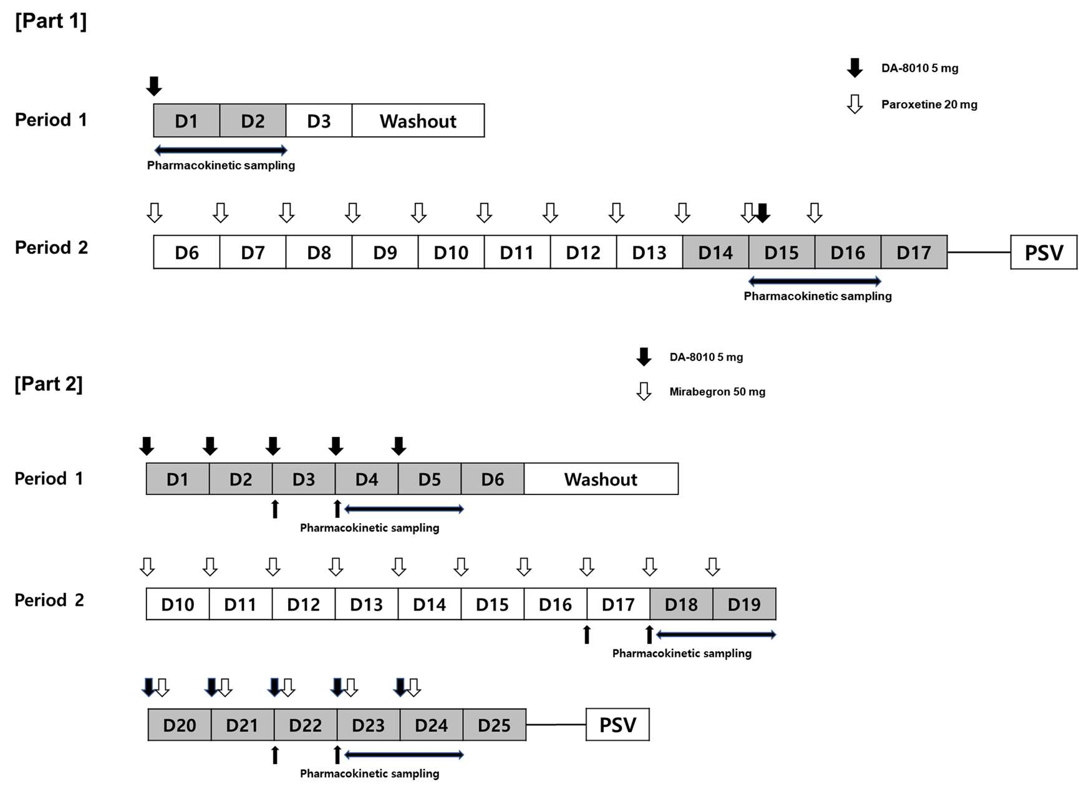
Figure S1. Study design

Table S1. Incidence of Treatment-Emergent Adverse Events (TEAEs) of Part 1 by System Organ Class and Preferred Terms
System Organ Class  Preferred Term | DA-8010 5 mg  (N=18) | Paroxetine 20 mg  QD for 11 days  +  DA-8010 5 mg  (N=18)
Subjects with at least one TEAEs | 3 (16.7) [6] | 10 (55.6) [35]
Eye disorders | . | 1 (5.6) [1]
Visual Disturbance | . | 1 (5.6) [1]
Gastrointestinal disorders | 2 (11.1) [4] | 4 (22.2) [10]
Abdominal Pain | 1 (5.6) [1] | .
Diarrhea | 1 (5.6) [1] | .
Dry Mouth | 1 (5.6) [1] | 1 (5.6) [2]
Dyspepsia | . | 3 (16.7) [3]
Loose Stool | . | 2 (11.1) [2]
Lower Abdominal Tenderness | . | 1 (5.6) [1]
Nausea | 1 (5.6) [1] | 2 (11.1) [2]
General disorders and administration site conditions | . | 4 (22.2) [4]
Fatigue | . | 4 (22.2) [4]
Investigations | 2 (11.1) [2] | 3 (16.7) [3]
Absolute Neutrophil Count Decreased | . | 1 (5.6) [1]
Absolute Neutrophil Count Increased | 1 (5.6) [1] | .
Blood Phosphorus Increased | . | 2 (11.1) [2]
Blood Triglycerides Increased | 1 (5.6) [1] | .
Metabolism and nutrition disorders | . | 2 (11.1) [2]
Appetite Lost | . | 2 (11.1) [2]
Musculoskeletal and connective tissue disorders | . | 2 (11.1) [2]
Myalgia | . | 2 (11.1) [2]
Nervous system disorders | . | 6 (33.3) [7]
Dizziness | . | 1 (5.6) [1]
Drowsiness | . | 2 (11.1) [2]
Headache | . | 3 (16.7) [3]
Taste Sour | . | 1 (5.6) [1]
Psychiatric disorders | . | 1 (5.6) [1]
Visual Illusion | . | 1 (5.6) [1]
Renal and urinary disorders | . | 1 (5.6) [2]
Urinary Frequency | . | 1 (5.6) [1]
Urinary Retention | . | 1 (5.6) [1]
Respiratory, thoracic and mediastinal disorders | . | 1 (5.6) [2]
Nasal Itching | . | 1 (5.6) [1]
Rhinorrhea | . | 1 (5.6) [1]
Skin and subcutaneous tissue disorders | . | 1 (5.6) [1]
Cold Sweat | . | 1 (5.6) [1]
Medical Coding Dictionary: MedDRA® (version 26.1)
Data are displayed as number of subjects (percentage of subjects) [number of events]
Percentages are based on the subjects within each part

Table S2. Incidence of Treatment-Emergent Adverse Events (TEAEs) by System Organ Class and Preferred Terms
System Organ Class  Preferred Term | DA-8010 5 mg  QD for 5 days  (N=18) | Mirabegron 50 mg  QD for 10 days  (N=17) | Mirabegron 50 mg  QD for 5 days  +  DA-8010 5 mg  QD for 5 days  (N=17)
Subjects with at least one TEAEs | 7 (38.9) [11] | 5 (27.8) [6] | 2 (11.1) [6]
Cardiac disorders | 1 (5.6) [1] | 1 (5.6) [1] | .
Palpitation | 1 (5.6) [1] | 1 (5.6) [1] | .
Eye disorders | 2 (11.1) [2] | . | .
Bloodshot Eye | 1 (5.6) [1] | . | .
Dry Eyes | 1 (5.6) [1] | . | .
Gastrointestinal disorders | 2 (11.1) [2] | 1 (5.6) [1] | .
Diarrhea | 1 (5.6) [1] | . | .
Dyspepsia | 1 (5.6) [1] | 1 (5.6) [1] | .
General disorders and administration site conditions | 1 (5.6) [1] | 1 (5.6) [1] | .
Chest Pain | 1 (5.6) [1] | . | .
Feeling Hot | . | 1 (5.6) [1] | .
Investigations | 3 (16.7) [5] | 2 (11.1) [2] | .
Absolute Neutrophil Count Decreased | . | 1 (5.6) [1] | .
Blood Pressure Diastolic Increased | . | 1 (5.6) [1] | .
Blood Pressure Systolic Increased | 1 (5.6) [1] | . | .
CPK Increased | 1 (5.6) [1] | . | .
Electrocardiogram QT Shortened | 1 (5.6) [1] | . | .
Heart Rate Increased | 1 (5.6) [1] | . | .
Pulse Rate Increased | 1 (5.6) [1] | . | .
Musculoskeletal and connective tissue disorders | . | . | 1 (5.6) [1]
Wrist Pain | . | . | 1 (5.6) [1]
Nervous system disorders | . | 1 (5.6) [1] | .
Drowsiness | . | 1 (5.6) [1] | .
Respiratory, thoracic and mediastinal disorders | . | . | 2 (11.1) [4]
Cough | . | . | 1 (5.6) [1]
Rhinorrhea | . | . | 2 (11.1) [2]
Sore Throat | . | . | 1 (5.6) [1]
Skin and subcutaneous tissue disorders | . | . | 1 (5.6) [1]
Dry Skin | . | . | 1 (5.6) [1]
Medical Coding Dictionary: MedDRA® (version 26.1)
Data are displayed as number of subjects (percentage of subjects) [number of events]
Percentages are based on the subjects within each part

