Supporting Information

A Photothermally Triggered Nanoplatform for Multidimensional Antibacterial Therapy and Accelerated Healing of Infected Wounds
Yueying Fan^{1,} *, Jinfu Li^{1,} *, Peng Wang^{1,} *, Yuhuan Peng¹, Chao Yan¹, Xiangyang Li¹, Zhaoxiang Wang¹, Xiao Li¹, Zhanchen He¹, Wenqiang Li², Bin Yin^{1, #}, Chiyu Jia^{1, #}
¹ Center of Burn & Plastic and Wound Healing Surgery, The First Affiliated Hospital of University of South China, Hengyang Medical School, University of South China, Hengyang, Hunan, 421001, People’s Republic of China
² Guangdong Traditional Medical and Sports Injury Rehabilitation Research Institute, The Affiliated Guangdong Second Provincial General Hospital of Jinan University, Guangzhou, 510317, People’s Republic of China.
*These authors contributed equally to this work.
#Corresponding authors.
E-mail addresses: ybyinbin@126.com (Bin Yin), jiachiyu309@163.com (Chiyu Jia).

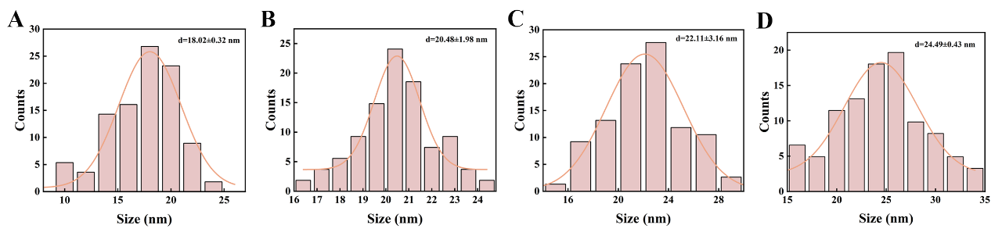
Figure S1. (A-D) Particle size distributions of Cu₇S₄ (A), CSC (B), CCP (C) and CCP-DFO(Fe) measured from the TEM images.
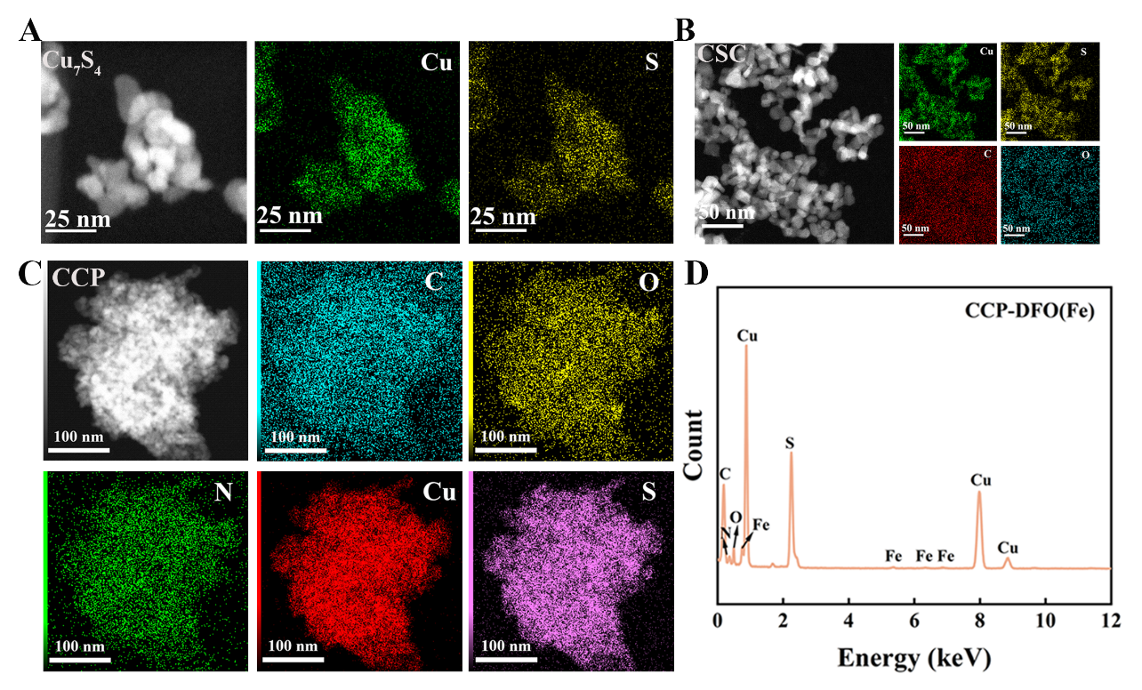
Figure S2. TEM elemental mapping images of the nanoparticles: (A) Cu₇S₄, (B) CSC, (C) CCP and (D) EDS spectrum of CCP-DFO(Fe).
Figure S3. (A) UV spectra of different nanoparticles and CGA; (B) Standard fitting curve of UV absorbance for CGA.
Figure S4. (A) UV spectra of DFO, DFO(Fe), CCP nanoparticles, and CCP-DFO(Fe) nanoparticles; (B) Standard fitting curve of UV absorbance for DFO(Fe).

Table S1. Mass percentages of components in CCP-DFO(Fe) nanoparticles.
Component | Cu₇S₄ | CGA | PVCL | DFO(Fe)
Mass percentage (%) | 70.3 | 14.93 | 8.26 | 6.5

Figure S5. Storage stability of CCP-DFO(Fe) nanoparticles in different media (pH 6.5, pH 7.4, pH 8.5, and serum).
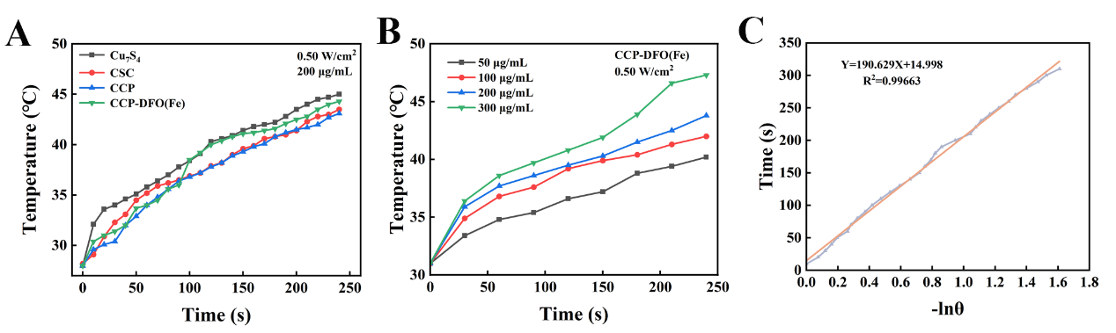
Figure S6. (A) Temperature elevation curves of different materials (200 μg/mL) under NIR laser irradiation (0.5 W/cm²) for 4 minutes. (B) Heating curves of CCP‑DFO(Fe) at different concentrations over 4 minutes. (C) Linear fit of the cooling stage for CCP‑DFO(Fe).
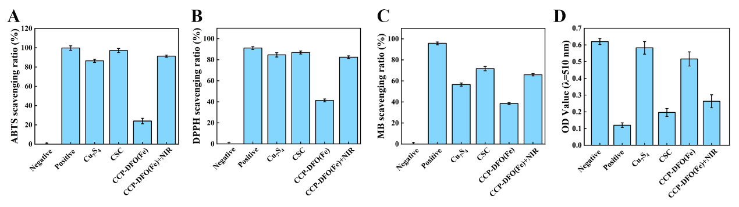
Figure S7. Free radical scavenging activity of different materials. (A) ABTS, (B) DPPH, and (C) MB scavenging efficiency. (D) OD values (λ = 510 nm) from the salicylic acid chromogenic assay.
Figure S8. Comparison of bacterial survival ratios among different materials via plating assay.
Figure S9. Cell survival rate of CCK-8 experiment after co-culturing HUVECs with CCP-DFO(Fe) nanoparticle solution for 24 hours under different NIR power irradiation for 10 minutes.
Figure S10. Photothermal heating effect of CCP-DFO(Fe) nanoparticle solution on SD rat wounds. (A) Infrared thermal imaging of rat wounds under NIR irradiation at 0.5W/cm² for 2 minutes; (B) Wound temperature rise/drop cycle under NIR irradiation at 0.5W/cm²; (C) Wound temperature changes under NIR on/off at 0.5W/cm² for 10 minutes.
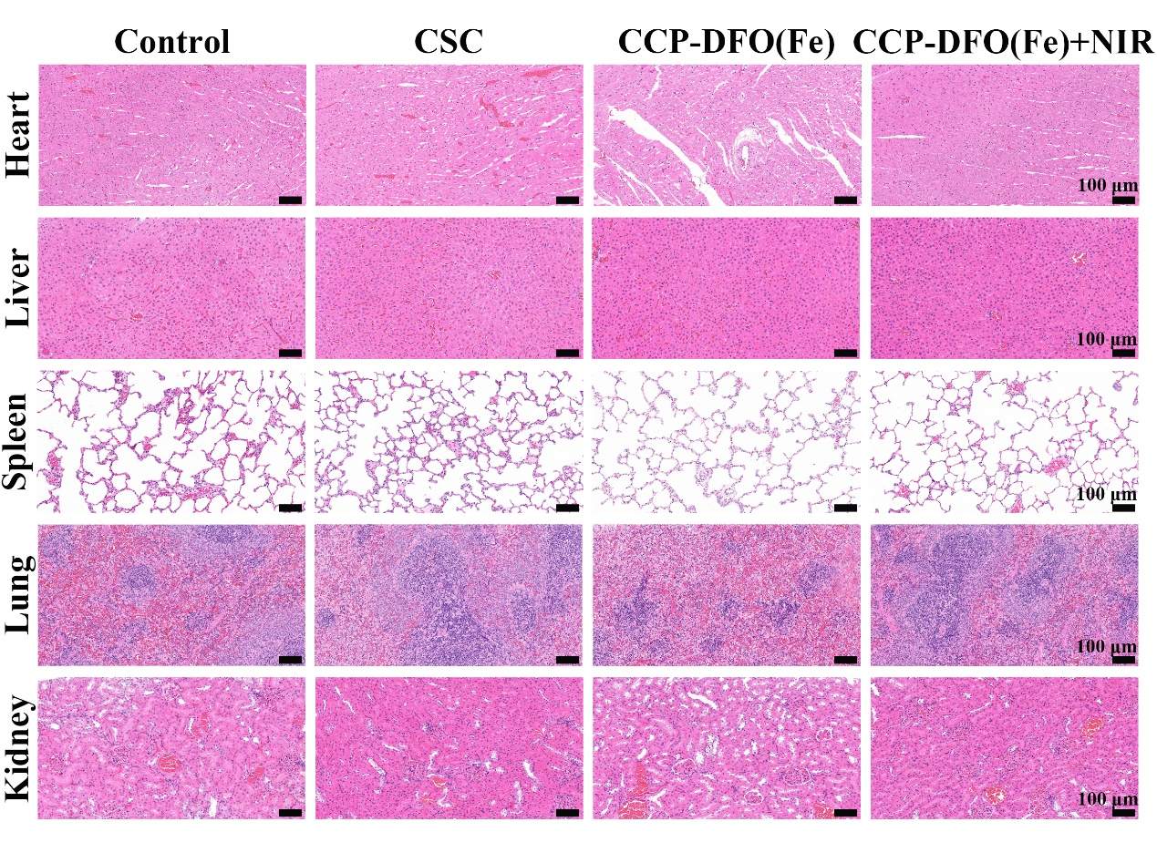
Figure S11. Representative histological sections of rat heart, liver, spleen, lung, and kidney from different treatment groups at day 14 post-treatment.
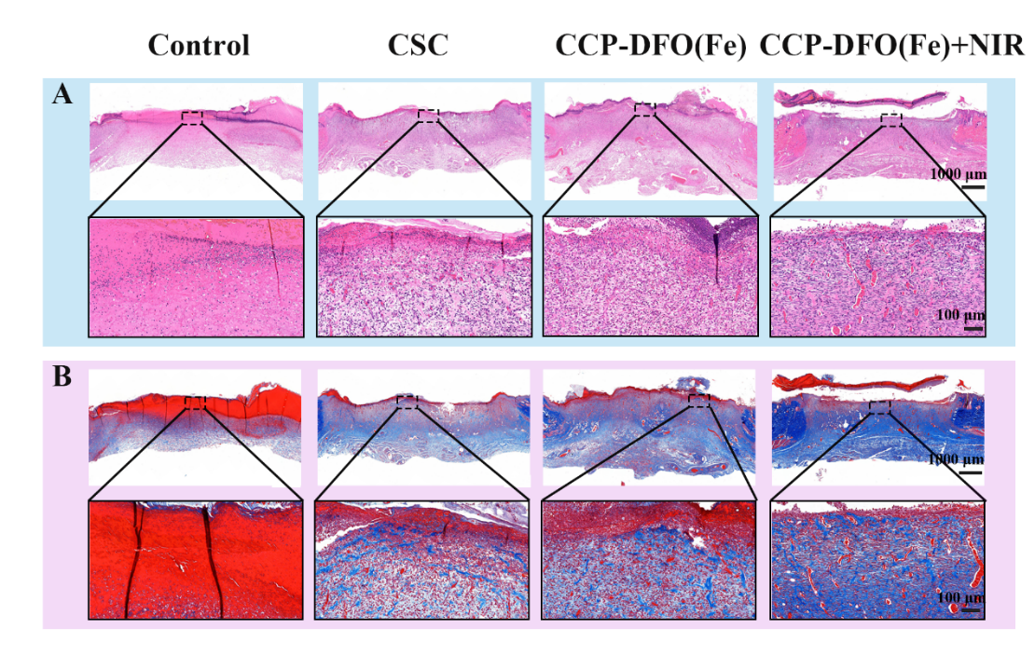
Figure S12. Representative histological images of rat wound sections from different treatment groups at day 7 post-treatment. (A) H&E staining. (B) Masson’s trichrome staining.

