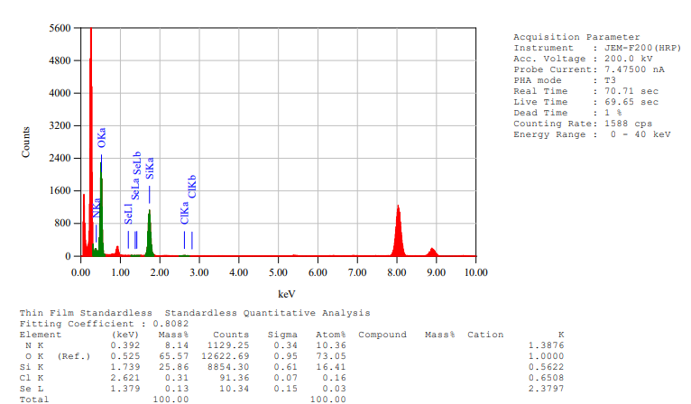
Figure S1. Energy-dispersive X-ray spectroscopy (EDS) analysis was performed at an accelerating voltage of 200 kV. The results show that the material is mainly composed of N, O, Si, Cl, and Se. The characteristic peaks correspond to N K (0.392 keV), O K (0.525 keV), Si K (1.739 keV), Cl K (2.617 keV), and Se L (1.379 keV). Among them, O, Si, and Se are the predominant elements in the composite system, confirming the presence of the MSN (SiO₂) carrier and the doped Se element.

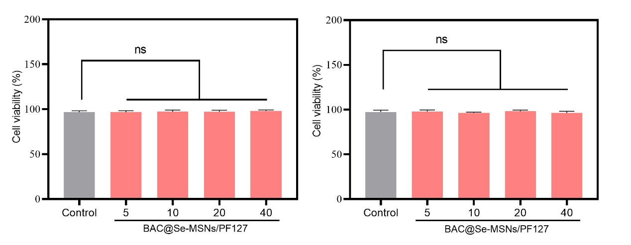
Figure S2. Cell viability after treatment with different concentrations of BAC@Se-MSNs/PF127.
Cell viability was assessed by the CCK-8 assay after 24 h exposure to BAC@Se-MSNs/PF127 at concentrations of 5, 10, 20, and 40 μg/mL. The results showed no significant difference in cell viability between the treated groups and the control group (ns, P > 0.05), indicating good cytocompatibility of the composite material.

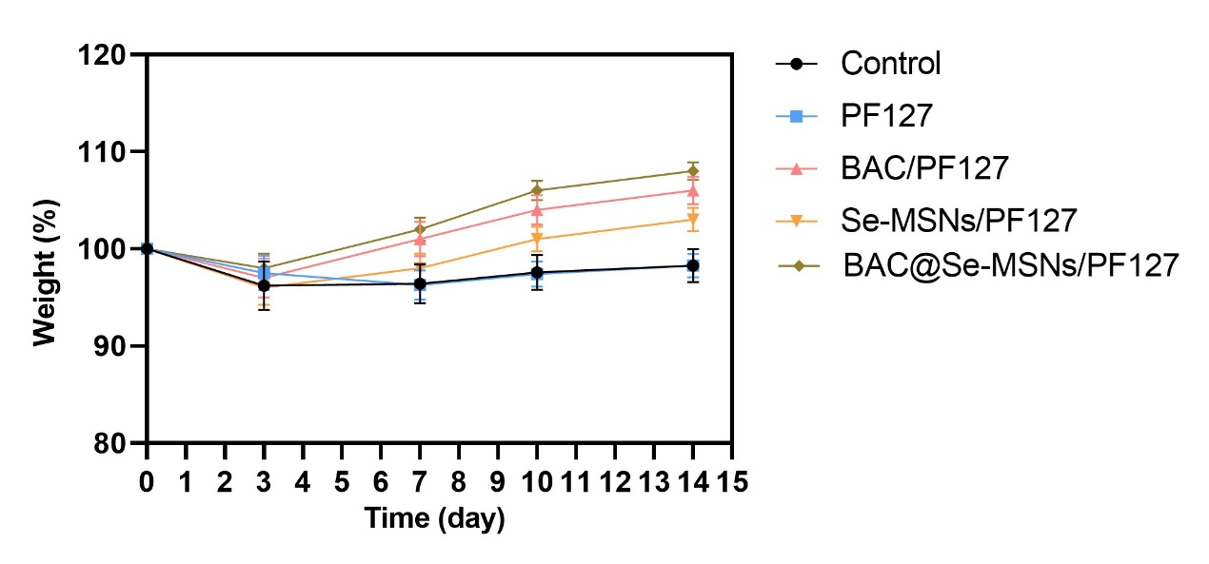
Figure S3. Body weight change curves of mice in each group.
Postoperative body weight changes were recorded from day 0 to day 14 for different treatment groups. Compared with the control group, mice treated with BAC/PF127, Se-MSNs/PF127, and BAC@Se-MSNs/PF127 exhibited faster body weight recovery, with the BAC@Se-MSNs/PF127 group showing the highest recovery ratio on day 14 (n = 5, mean ± SD).

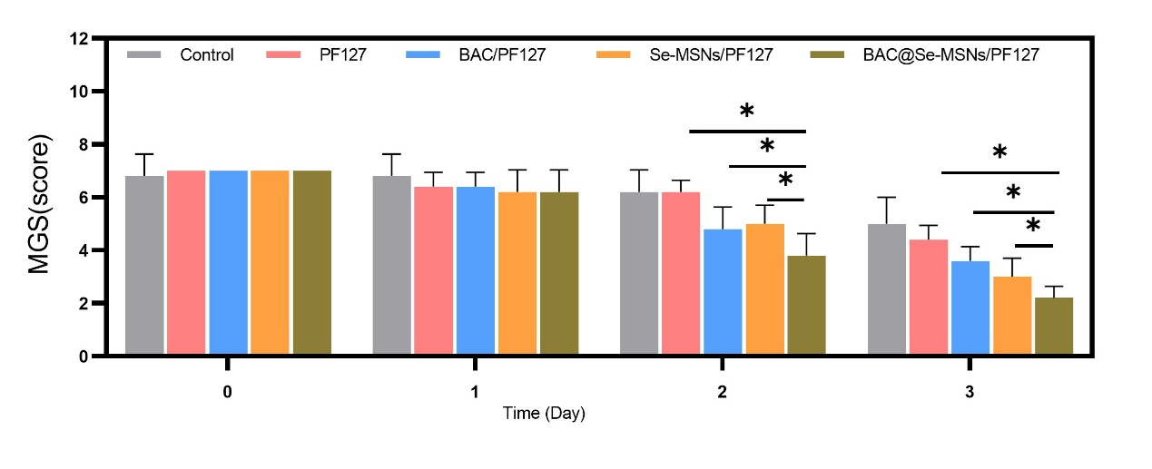
Figure S4. Mouse Grimace Scale (MGS) scores of different treatment groups over time.
Bar graphs show the MGS scores (mean ± SD, n = 5) for the Control, PF127, BAC/PF127, Se-MSNs/PF127, and BAC@Se-MSNs/PF127 groups on days 0, 1, 2, and 3. The BAC@Se-MSNs/PF127 treatment led to a significant reduction in MGS scores over time (*P < 0.05).

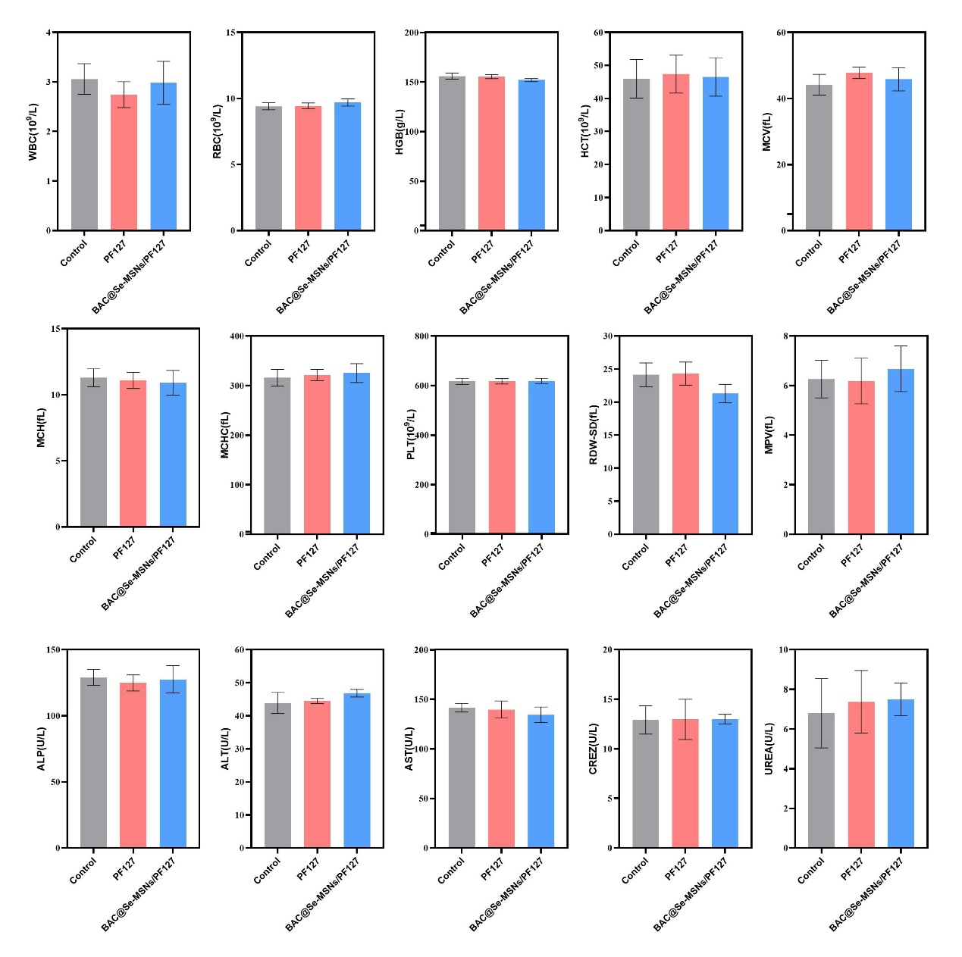
Figure S5. Hematological and serum biochemical analysis of mice from different treatment groups.
Parameters including white blood cells (WBC), red blood cells (RBC), hemoglobin (HGB), hematocrit (HCT), mean corpuscular volume (MCV), mean corpuscular hemoglobin (MCH), mean corpuscular hemoglobin concentration (MCHC), platelet count (PLT), red blood cell distribution width (RDW-SD), mean platelet volume (MPV), alkaline phosphatase (ALP), alanine aminotransferase (ALT), aspartate aminotransferase (AST), creatinine (CREZ), and urea (UREA) were measured. No significant differences were observed between the BAC@Se-MSNs/PF127 group and the control group, indicating good in vivo safety of the hydrogel (n = 5, mean ± SD).
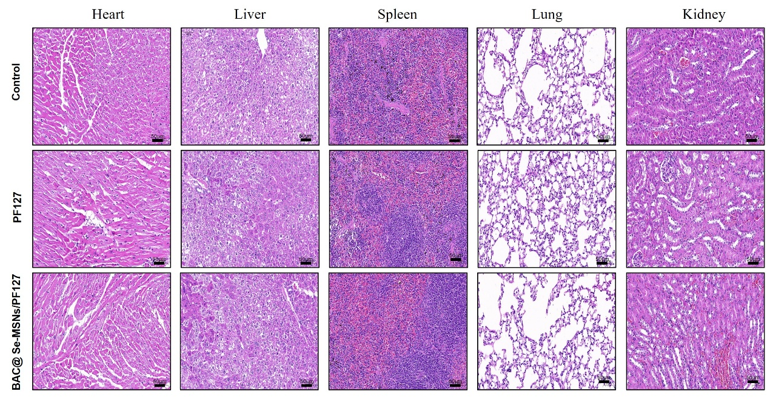
Figure S6. In vivo biosafety evaluation of BAC@Se-MSNs/PF127 hydrogel.
H&E-stained images of major organs (heart, liver, spleen, lung, and kidney) are shown (scale bar = 50 μm). All groups exhibited intact tissue architecture without signs of inflammation or necrosis, indicating good in vivo biocompatibility.

