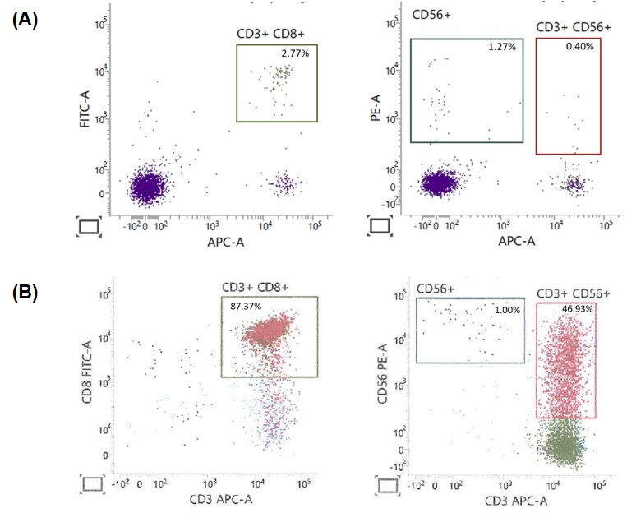
Supplementary Figure 1. Immunophenotypic analysis of CIK cells from healthy donor 1 PBMCs. The percentages of T (CD3⁺CD8⁺), NK (CD3⁻CD56⁺) and NKT (CD3⁺CD56⁺) cells were determined by flow cytometry, with results expressed as mean ± SD (n = 3). (A) Representative phenotype analysis of PBMCs on Day 0. (B) Representative phenotype analysis of the CIK cell population after culture.
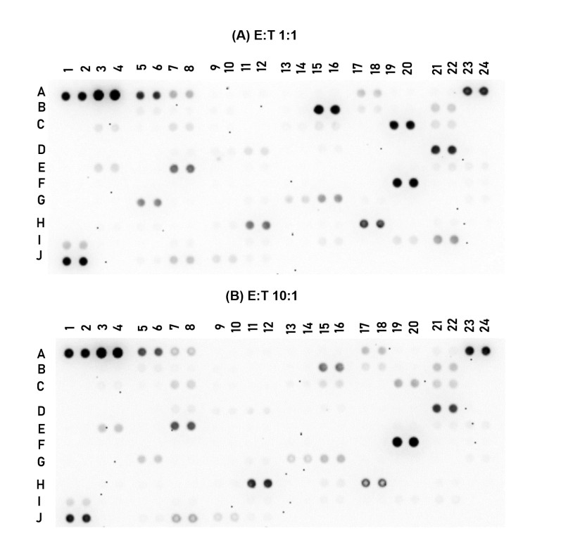
Supplementary Figure 2. Membranes labelled with highly expressed markers in the coculture of CIK cells and HCT-15 cells at E:T ratios of (A) 1:1 and (B) 10:1. The analytes coordinates and mean spot pixel density were tabulated in Supplementary Table 1.
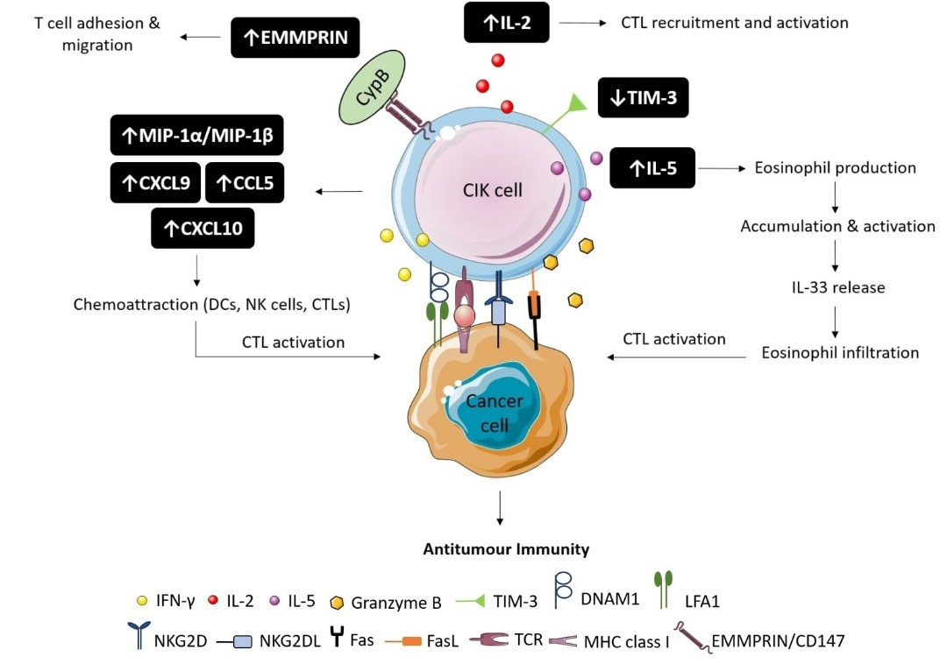
Supplementary Figure 3. Antitumour activity of CIK cells against HCT-15 cells. CIK cells, particularly CD3⁺CD56⁺ NKT cells, recognise tumour cells via MHC restricted (TCR-MHC) and unrestricted pathways (NKG2D-NKG2DL and DNAM1-LFA1). Upon tumour stimulation, they release pro-inflammatory cytokines such as IFN-γ to create an antitumour microenvironment, granzyme B to induce cytotoxicity, and express FasL to trigger tumour cell death. CIK cells also secrete IL-2 to enhance CTL activation and proliferation, while chemokines such as MIP1α, MIP-1β, CCL5, CXCL9, and CXCL10 recruit additional immune effector cells to the tumour, boosting T and NK cell cytotoxicity. Activation of CIK cells also upregulates EMMPRIN, which binds to its ligand CypB, promoting T cell proliferation and adhesion through endothelial adhesion molecules such as intercellular adhesion molecule 1 (ICAM-1), which are essential for immune synapse formation. Increased IL-5 production stimulates eosinophil production, enhancing T cell activation, while downregulation of TIM-3 enhances Th1 immune responses by inhibiting Treg suppressive activity and reducing T cell exhaustion. Notes: ↑, increased expression, secretion, or activation; ↓, decreased expression or inhibition; →, activation or interaction.
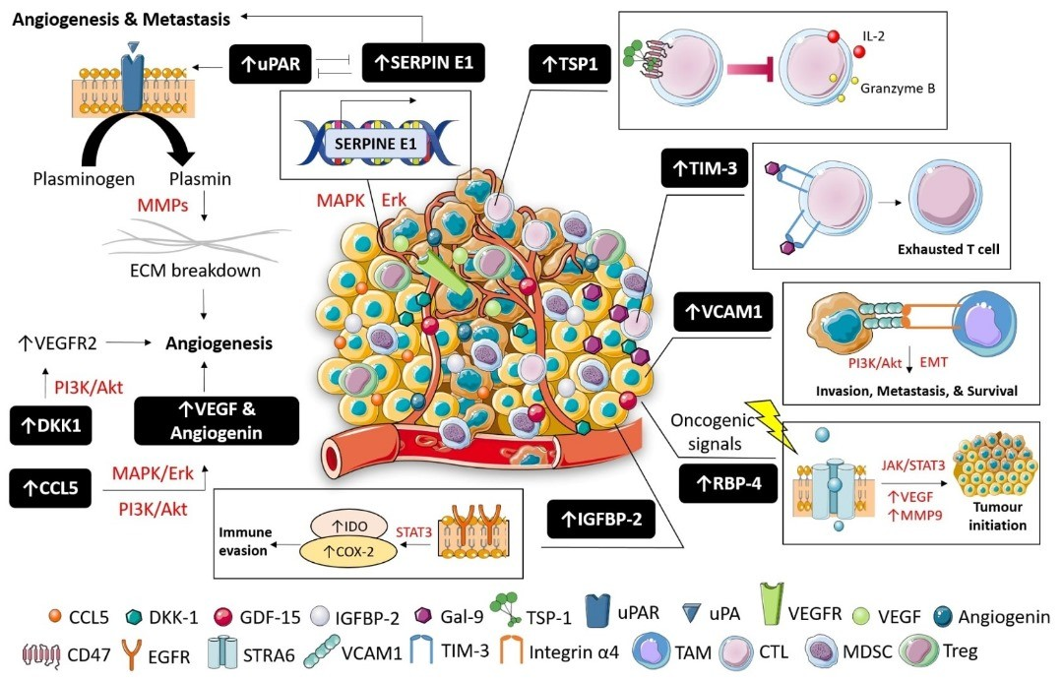

Supplementary Figure 4. Mechanisms of action of cytokines contributing to cancer progression in HCT-15 cells. HCT-15 cells upregulated several key cytokines and inhibitory co-stimulatory molecules, promoting tumour progression and immune evasion. For instance, tumour-derived CCL5 upregulates VEGF and angiogenin to stimulate angiogenesis, while DKK1 activates the PI3K/Akt pathway to upregulate VEGFR2, enhancing angiogenesis, cell survival, and proliferation. The uPA/uPAR complex increases plasmin production, leading to extracellular matrix (ECM) degradation and facilitating tumour invasion. SERPINE E1 exhibits a protective role against tumour dissemination by inhibiting uPA/uPAR activity, but its overexpression can enhance tumour cell migration and invasion. Additionally, TSP-1 signalling through CD47 reduces CTL activation and cytotoxicity by inhibiting IL-2 and immune effector molecules release. High TIM-3 expression in the tumour microenvironment (TME) is associated with reduced cytotoxicity and T cell dysfunction, aiding immune evasion. Aberrant VCAM-1 expression recruits tumour-associated macrophages (TAMs), promoting invasion and metastasis through EMT and enhancing cell survival via PI3K/Akt signalling. Oncogenic signals such as hypoxia can induce RBP-4 expression, which upregulates angiogenic factors through the JAK/STAT3 pathway, driving tumour initiation and progression. Elevated IGFBP-2 promotes STAT3 activity in HCT-15 cells, upregulating indoleamine 2,3 dioxygenase (IDO) and cyclooxygenase-2 (COX-2), key drivers of immunosuppression that allow the tumour cells to evade immune surveillance. Notes: ↑, increased expression or activation; ↓, decreased expression or inhibition; →, activation or induction; ⊣, inhibition.

Supplementary Table 1. Average pixel density of the cytokines, chemokines, growth factors and other soluble proteins in the supernatant of CIK cells only, HCT-15 cells only, and their co-cultures at E:T ratios of 1:1 and 10:1.
No. | Type | Average pixel density
No. | Type | CIK cells | HCT-15 cells | E:T 1:1 | E:T 10:1
A1, A2 | Reference Spots | 1,346,604.50 | 1,468,895.00 | 1,248,816.50 | 1,335,350.00
A3, A4 | ªAdiponectin (Acrp30) | 2,624,334.50 | 2,684,312.50 | 2,548,873.00*#### | 2,422,601.00****####
A5, A6 | ªApolipoprotein A-I (ApoA1) | 1,053,975.00 | 954,393.00 | 839,337.50****### | 698,020.50****####
A7, A8 | ªAngiogenin | 499,753.50 | 444,262.00 | 352,457.00****## | 288,341.50****####
A9, A10 | Angiopoietin-1 (Ang-1) | 20,310.00 | 13,665.00 | 12,163.50 | 13,299.50
A11, A12 | Angiopoietin-2 (Ang-2) | 34,629.50 | 49,088.00 | 21,642.50 | 20,359.00
A13, A14 | B-cell activating factor (BAFF) | 20,441.00 | 26,202.00 | 28,198.50 | 22,717.50
A15,A16 | Brain-derived neurotrophic factor (BDNF) | 26,041.50 | 80,858.50 | 104,741.50 | 48,433.50
A17, A18 | ªComplement Component C5/C5a (C5/C5a) | 372,919.50 | 318,481.00 | 266,436.50*** | 277,005.00**
A19, A20 | CD14 | 38,273.00 | 57,359.00 | 39,006.50 | 30,954.00
A21, A22 | CD30 | 146,660.50 | 75,580.00 | 78,393.00 | 106,667.00
A23,A24 | Reference Spots | 1,031,822.50 | 812,844.50 | 959,443.50 | 1,060,001.50
B3, B4 | CD40 Ligand (CD40L) | 174,104.50 | 195,160.00 | 130,794.50 | 127,646.50
B5, B6 | ªChitinase 3-like 1 (CHI3L1) | 256,327.50 | 165,297.00 | 117,974.00**** | 102,609.50****
B7, B8 | Complement Factor D (CFD) | 135,326.50 | 84,607.50 | 66,638.50 | 55,092.50
B9, B10 | C-Reactive Protein (CRP) | 66,989.50 | 38,247.50 | 32,037.50 | 24,442.50
B11, B12 | Cripto-1 | 14,847.00 | 9,755.50 | 38,571.50 | 6,367.00
B13, B14 | Cystatin C | 36,210.00 | 68,776.00 | 59,247.50 | 30,509.50
B15,B16 | ªDickkopf WNT signaling pathway inhibitor 1 (Dkk-1) | 44,094.50 | 1,147,429.50 | 1,291,783.50****#### | 589,743.00****####
B17, B18 | Dipeptidyl peptidase-4 (DPPIV) | 203,082.50 | 152,650.00 | 124,975.50 | 135,622.50
B19, B20 | Epidermal growth factor (EGF) | 36,669.50 | 93,575.50 | 81,871.50 | 47,697.00
B21, B22 | ªExtracellular Matrix Metalloproteinase Inducer (EMMPRIN) (CD147) | 248,673.50 | 214,548.50 | 285,512.50# | 307,169.50##
C3, C4 | Epithelial neutrophil-activating peptide 78 (ENA-78) (CXCL5) | 45,309.50 | 207,621.50 | 146,771.00 | 95,783.50
C5, C6 | Endoglin (CD105) | 90,015.50 | 54,280.50 | 36,924.50 | 44,529.00
C7, C8 | ªFas Ligand (CD95L) | 302,104.50 | 165,126.50 | 148,850.50**** | 219,148.00**
C9, C10 | Fibroblast growth factors (FGF)-basic (FGF-2) | 66,634.00 | 63,678.00 | 18,338.50 | 24,650.50
C11, C12 | FGF-7 | 22,422.50 | 13,461.00 | 7,491.50 | 12,268.00
C13, C14 | FGF-19 | 97,179.50 | 97,514.00 | 55,738.50 | 41,744.00
C15,C16 | ªFms-related tyrosine kinase 3 (Flt-3) ligand (FLT3LG) | 218,192.50 | 171,982.50 | 158,807.00* | 151,632.00*
C17, C18 | Granulocyte colony-stimulating factor (G-CSF)(CSF3) | 21,176.50 | 51,400.00 | 52,792.00 | 30,663.00
C19, C20 | ªGrowth differentiation factor 15 (GDF-15)(MIC-1) | 46,460.50 | 1,120,349.00 | 1,066,868.50**** | 340,576.00****####
C21, C22 | ªGranulocyte macrophage colony-stimulating factor (GM-CSF)(CSF2) | 469,625.50 | 214,112.50 | 204,182.00**** | 249,383.50****
D1, D2 | Growth Regulated Oncogene Alpha (GROα) (CXCL1) | 27,068.50 | 29,926.00 | 22,044.50 | 26,337.00
D3, D4 | Growth Hormone (GH) | 15,667.50 | 16,717.50 | 10,569.50 | 13,391.00
D5, D6 | Hepatocyte growth factor (HGF) | 28,225.00 | 26,562.50 | 21,145.50 | 27,860.50
D7, D8 | Intercellular Adhesion Molecule 1 (ICAM-1) | 80,473.00 | 69,571.00 | 66,779.50 | 102,838.50
D9, D10 | Interferon-ү (IFN-ү) | 104,957.00 | 59,101.50 | 62,338.00 | 44,287.50
D11, D12 | ªInsulin-like growth factor binding protein-2 (IGFBP-2) | 135,740.00 | 179,519.50 | 145,702.00 | 63,458.00**####
D13, D14 | Insulin-like growth factor binding protein-3 (IGFBP-3) | 47,072.00 | 23,556.00 | 14,373.50 | 15,706.50
D15, D16 | Interleukin (IL)-1α | 67,432.50 | 61,159.50 | 56,534.50 | 43,519.00
D17, D18 | Interleukin (IL)-1β | 14,425.00 | 29,674.50 | 46,850.50 | 26,868.00
D19, D20 | Interleukin (IL)-1ra | 41,544.50 | 55,197.00 | 67,172.00 | 55,926.50
D21, D22 | ªInterleukin (IL)-2 | 1,166,484.50 | 816,791.00 | 970,888.00****#### | 807,959.50****
D23, D24 | Interleukin (IL)-3 | 62,316.50 | 36,232.00 | 45,224.50 | 29,267.50
E1, E2 | Interleukin (IL)-4 | 21,585.00 | 14,534.50 | 10,739.50 | 12,601.50
E3, E4 | ªInterleukin (IL)-5 | 430,153.50 | 230,607.00 | 192,906.00**** | 289,099.50****##
E5, E6 | Interleukin (IL)-6 | 39,988.50 | 40,300.50 | 29,425.00 | 32,193.00
E7, E8 | ªInterleukin (IL)-8 (CXCL8) | 938,971.50 | 708,966.00 | 636,509.50****#### | 701,435.00****
E9, E10 | Interleukin (IL)-10 | 24,247.00 | 18,520.00 | 18,811.00 | 14,540.00
E11, E12 | Interleukin (IL)-11 | 29,088.00 | 28,651.50 | 32,050.50 | 15,886.50
E13, E14 | Interleukin (IL)-12 p70 | 14,349.50 | 12,453.00 | 11,682.50 | 11,067.50
E15, E16 | Interleukin (IL)-13 | 12,687.50 | 13,487.50 | 17,409.00 | 13,373.50
E17, E18 | Interleukin (IL)-15 | 13,817.00 | 35,748.00 | 42,424.50 | 51,206.00
E19, E20 | Interleukin (IL)-16 | 89,612.00 | 106,324.00 | 101,716.00 | 134,479.00
E21, E22 | Interleukin (IL)-17A | 132,745.50 | 86,344.00 | 132,555.50 | 94,324.00
E23, E24 | Interleukin (IL)-18 Bpa | 112,801.50 | 51,886.00 | 79,741.00 | 88,217.00
F1, F2 | Interleukin (IL)-19 | 7,501.00 | 11,153.50 | 7,414.50 | 7,122.00
F3, F4 | Interleukin (IL)-22 | 32,148.50 | 54,823.00 | 15,642.50 | 21,517.00
F5, F6 | Interleukin (IL)-23 | 18,153.50 | 42,922.00 | 31,596.50 | 23,969.50
F7, F8 | Interleukin (IL)-24 | 42,234.00 | 36,737.00 | 33,175.00 | 33,075.00
F9, F10 | Interleukin (IL)-27 | 23,261.00 | 19,851.50 | 15,128.50 | 14,785.50
F11, F12 | Interleukin (IL)-31 | 25,804.00 | 17,129.00 | 15,169.50 | 14,945.00
F13, F14 | Interleukin (IL)-32 | 35,563.00 | 24,271.50 | 42,636.00 | 25,741.00
F15, F16 | Interleukin (IL)-33 | 19,146.00 | 27,426.50 | 31,371.00 | 21,925.00
F17, F18 | Interleukin (IL)-34 | 26,797.50 | 51,753.00 | 54,935.00 | 66,643.00
F19, F20 | ªHuman interferon-inducible protein 10 (IP-10) (CXCL10) | 51,967.00 | 902,458.00 | 1,251,936.00****#### | 1,657,827.00****####
F21, F22 | Interferon-inducible T cell alpha chemoattractant (I-TAC) (CXCL11) | 29,243.00 | 27,406.50 | 41,263.50 | 34,532.00
F23, F24 | Kallikrein 3 (KLK3) | 55,682.00 | 39,334.50 | 34,652.50 | 40,249.50
G1, G2 | Leptin | 4,116.50 | 7,295.00 | 5,120.50 | 6,155.50
G3, G4 | Leukemia inhibitory factor (LIF) | 12,831.50 | 18,957.50 | 13,133.50 | 43,559.00
G5, G6 | ªLipocalin-2 (LCN2) | 86,380.00 | 543,899.00 | 479,235.50****#### | 225,648.00****####
G7, G8 | Monocyte chemoattractant protein (MCP)-1 | 23,453.50 | 29,164.00 | 23,834.50 | 20,548.00
G9, G10 | Monocyte chemoattractant protein (MCP)-3 | 23,186.50 | 13,696.00 | 11,608.50 | 13,638.50
G11, G12 | ªMacrophage colony-stimulating factor (M-CSF) | 105,885.00 | 57,392.50 | 46,945.50*** | 57,483.50**
G13, G14 | ªMacrophage migration inhibitory factor (MIF) | 245,395.50 | 158,981.00 | 154,712.00**** | 185,293.50***
G15, G16 | ªMonokine induced by gamma interferon (MIG) (CXCL9) | 130,831.50 | 306,356.50 | 435,735.50****#### | 300,766.50****
G17, G18 | ªMacrophage inflammatory protein-1 alpha/Macrophage inflammatory protein-1 beta (MIP-1α/MIP-1β) (CCL3/CCL4) | 338,681.00 | 145,177.00 | 64,626.50****#### | 48,697.00****####
G19, G20 | ªMacrophage inflammatory protein 3α (MIP-3α) (CCL20) | 16,261.00 | 58,452.00 | 66,222.50** | 71,619.00***
G21, G22 | Macrophage inflammatory protein 3β (MIP-3β) (CCL19) | 17,784.00 | 18,551.00 | 21,770.00 | 18,970.50
G23, G24 | ªMatrix metalloproteinase-9 (MMP-9) | 115,419.50 | 43,135.00 | 46,534.00**** | 41,010.00****
H1, H2 | Myeloperoxidase | 10,845.50 | 21,235.00 | 24,086.00 | 18,578.50
H3, H4 | Osteopontin (OPN) | 59,671.50 | 34,269.50 | 47,125.50 | 43,593.50
H5, H6 | Platelet-derived growth factor (PDGF)-AA | 43,677.00 | 48,752.50 | 43,442.50 | 24,673.00
H7, H8 | Platelet-derived growth factor (PDGF)-AB/BB | 24,161.00 | 26,427.50 | 12,966.00 | 9,643.50
H9, H10 | Pentraxin 3 | 82,866.50 | 59,411.50 | 50,620.00 | 41,974.00
H11, H12 | ªPlatelet factor 4 (PF4) (CXCL4) | 1,583,442.00 | 671,156.00 | 586,360.50****#### | 872,224.00****####
H13, H14 | Receptor for advanced glycation endproducts (RAGE) | 49,749.00 | 40,714.50 | 17,178.00 | 19,386.00
H15, H16 | ªRegulated upon Activation, Normal T Cell Expressed and Presumably Secreted (RANTES) (CCL5) | 550,009.50 | 135,671.50 | 39,832.50****#### | 75,849.50****###
H17, H18 | ªRetinol binding protein 4 (RBP-4) | 757,990.00 | 927,422.50 | 750,062.50#### | 607,517.50****####
H19, H20 | Relaxin-2 | 25,172.00 | 45,651.00 | 36,715.00 | 28,910.50
H21, H22 | Resistin | 46,232.50 | 79,759.00 | 56,656.50 | 30,438.00
H23, H24 | Stromal cell-derived factor 1 (SDF-1α) (CXCL12) | 18,418.50 | 10,984.00 | 11,636.50 | 9,902.50
I1, I2 | ªEndothelial plasminogen activator inhibitor (Serpin E1) | 144,226.00 | 350,185.50 | 349,262.50**** | 209,345.50****####
I3, I4 | Sex hormone-binding globulin (SHBG) | 54,540.50 | 24,095.00 | 24,302.50 | 23,604.50
I5, I6 | Interleukin 1 receptor-like 1 (ST2)(IL1RL1) | 25,457.50 | 16,298.00 | 10,790.50 | 13,262.50
I7, I8 | ªThymus and activation-regulated chemokine (TARC) (CCL17) | 158,466.50 | 58,748.50 | 47,100.50**** | 46,340.00****
I9, I10 | Trefoil factor 3 (TFF3) | 46,612.00 | 23,778.50 | 18,999.00 | 20,435.50
I11, I12 | ªTransferrin receptor 1 (TfR) | 129,817.50 | 75,264.50 | 60,901.50**** | 61,054.00****
I13, I14 | Transforming growth factor alpha (TGF-α) | 29,515.00 | 14,112.00 | 13,336.50 | 31,181.00
I15, I16 | ªThrombospondin-1 (TSP-1) | 72,844.50 | 103,939.00 | 88,545.50 | 42,631.00###
I17, I18 | Tumor necrosis factor (TNF)-α | 60,165.00 | 47,870.00 | 41,824.50 | 41,181.00
I19, I20 | ªUrokinase type plasminogen activator receptor (uPAR) | 31,517.00 | 150,575.50 | 149,915.00**** | 48,747.00####
I21, I22 | ªVascular endothelial growth factor (VEGF) | 102,485.00 | 637,801.50 | 463,404.00****#### | 59,339.00*####
J1,J2 | Reference Spots | 1,090,736.50 | 895,051.00 | 1,097,915.50 | 914,952.00
J5, J6 | ªVitamin D-binding protein (BP) | 99,761.00 | 81,978.00 | 41,550.50***# | 53,735.50**
J7, J8 | ªCluster of differentiation 31 (CD31) | 652,744.00 | 288,051.00 | 276,345.50**** | 401,091.00****####
J9, J10 | ªT-cell immunoglobulin and mucin domain 3 (TIM-3) | 312,833.50 | 330,947.50 | 148,851.00****#### | 160,764.50****####
J11, J12 | ªVascular cell adhesion protein 1 (VCAM-1) | 121,030.50 | 168,925.50 | 46,038.50****#### | 47,983.50****####
J23, J24 | Negative Controls | 0 | 0 | 0 | 0
Two-way ANOVA followed by Tukey’s post hoc test was performed. ª Represents growth factors and cytokines that were significantly regulated in the co-culture of CIK cells and HCT-15 cells. *p < 0.05, **p < 0.01, ***p < 0.001, ****p < 0.0001 compared to CIK cells, and #p < 0.05, ##p < 0.01, ###p < 0.001, ####p < 0.0001 compared to HCT-15 cells.

Supplementary Table 2. The expression of growth factors and cytokines that present in the CIK cells and HCT-15 culture supernatant.
No. | Cytokines/ Growth Factors | Average Pixel Density
No. | Cytokines/ Growth Factors | CIK cells | HCT-15 cells
1 | Adiponectin | 2,624,334.50 | 2,684,312.50
2 | Apolipoprotein A-I | 1,053,975.00 | 954,393.00
3 | Angiogenin | 499,753.50 | 444,262.00
4 | Complement component C5/C5a | 372,919.50 | 318,481.00
5 | Fas ligand | 302,104.50 | -
6 | Granulocyte macrophage colony-stimulating factor (GM-CSF) | 469,625.50 | -
7 | Interleukin-2 (IL-2) | 1,166,484.50 | 816,791.00
8 | Interleukin-5 (IL-5) | 430,153.50 | -
9 | Interleukin-8 (IL-8)(CXCL8) | 938,971.50 | 708,966.00
10 | Macrophage inflammatory protein-1 alpha/Macrophage inflammatory protein-1 beta (MIP-1α/MIP-1β) (CCL3/CCL4) | 338,681.00 | -
11 | Platelet factor 4 (PF4) (CXCL4) | 1,583,442.00 | 671,156.00
12 | Regulated upon Activation, Normal T Cell Expressed and Presumably Secreted (RANTES) (CCL5) | 550,009.50 | -
13 | Retinol binding protein 4 (RBP-4) | 757,990.00 | 927,422.50
14 | CD31 | 652,744.00 | -
15 | T-cell immunoglobulin and mucin domain 3 (TIM-3) | 312,833.50 | 330,947.50
16 | Dickkopf WNT signaling pathway inhibitor 1 (Dkk-1) | - | 1,147,429.50
17 | Growth differentiation factor 15 (GDF-15) | - | 1,120,349.00
18 | Human interferon-inducible protein 10 (IP-10)(CXCL10) | - | 902,458.00
19 | Lipocalin-2 | - | 543,899.00
20 | Monokine induced by gamma interferon (MIG)(CXCL9) | - | 306,356.50
21 | Serpin E1 | - | 350,185.50
22 | Vascular endothelial growth factor (VEGF) | - | 637,801.50
A pixel density >300,000 was the threshold for being classified as highly expressed. The values were presented after subtracted from negative value. The numbering corresponds to the data points plotted in Figure 6. The numerical labels (1–22) correspond to the boxed cytokines indicated on the membrane in Figure 5.

