Supplementary Materials
Supplementary Table 1. Comparison of baseline characteristics between study subjects and excluded group(n=697).
Variable | Study Subjects  (n = 324) | Excluded from initial enrollment(n = 373) | P value
Demographic
Age, years | 51.9 ± 15.9 | 52.8 ± 17.8 | 0.485
Age group, n (%)
< 65 years | 247 (76.2) | 269(72.1) | 0.216
≥ 65 years | 77 (23.8) | 104(27.9)
Sex, n (%)
Male | 226 (69.8) | 251(67.3) | 0.486
Female | 98 (30.2) | 122(32.7)
Body mass index, kg m⁻² | 22.0 ± 3.5 | 21.5 ± 4.6 | 0.111
Residence, n (%)
Urban | 99 (30.6) | 112(30.0) | 0.880
Rural | 225 (69.4) | 261(70.0)
Educational level, n (%)
Primary school or below | 106 (32.7) | 135(36.2) | 0.347
Junior high/technical school | 106 (32.7) | 101(27.1)
Senior high/vocational school | 69 (21.3) | 91(24.4)
College or above | 43 (13.3) | 46(12.3)
Marital status, n (%)
Married | 224 (69.2) | 265(72.0) | 0.077
Divorced or widowed | 61 (18.8) | 77(20.9)
Unmarried | 39 (12.0) | 26(7.1)
Medical history
Active smoking, n (%)
No | 151 (46.6) | 185(49.6) | 0.430
Yes | 173 (53.4) | 188(50.4)
Passive smoking, n (%)
No | 136 (42.0) | 174(46.6) | 0.216
Yes | 188 (58.0) | 199(53.4)
Alcohol consumption, n (%)
No | 181 (55.9) | 200(53.6) | 0.553
Yes | 143 (44.1) | 173(46.4)
Dust exposure, n (%)
No | 292 (90.1) | 340(91.2) | 0.641
Yes | 32 (9.9) | 33(8.8)
Hypertension, n (%)
No | 220 (67.9) | 256(68.6) | 0.836
Yes | 104 (32.1) | 117(31.4)
Diabetes mellitus, n (%)
No | 229 (70.7) | 240(64.3) | 0.075
Yes | 95 (29.3) | 133(35.7)
BCG vaccination, n (%)
No | 41 (12.7) | 55(14.7) | 0.424
Yes | 283 (87.3) | 318(85.3)

Supplementary Table 2. Multicollinearity diagnosis of independent variables included in the logistic regression model.
Factors | Tolerance | VIF
Age group | 0.851 | 1.176
Active smoking | 0.957 | 1.045
Dust exposure | 0.978 | 1.022
BCG vaccination | 0.865 | 1.156
Cavitary pulmonary tuberculosis | 0.850 | 1.176
Invasive fungal disease | 0.963 | 1.039
Systemic corticosteroid use | 0.839 | 1.191
Cough | 0.960 | 1.042
Dyspnea | 0.908 | 1.101
Systemic immune-inflammation index (SII) | 0.955 | 1.047
CD4⁺/CD8⁺ T-cell ratio | 0.935 | 1.069

Supplementary Table 3. Final multivariable prediction model for COPD after PTB cure.
Variable | β coefficient | s.e. | Wald χ² | Odds ratio (95% CI) | P value
Age group
< 65 years | Reference | - | - | 1.00 (reference) | -
≥ 65 years | 1.118 | 0.322 | 12.028 | 3.06 (1.63 ,5.75) | 0.001
Active smoking
No | Reference | - | - | 1.00 (reference) | -
Yes | 1.020 | 0.311 | 10.741 | 2.77 (1.51 ,5.10) | 0.001
Cavitary PTB
No | Reference | - | - | 1.00 (reference) | -
Yes | 1.063 | 0.338 | 9.878 | 2.89 (1.49 ,5.61) | 0.002
Invasive fungal disease
No | Reference | - | - | 1.00 (reference) | -
Yes | 0.692 | 0.306 | 5.116 | 2.00 (1.10 ,3.64) | 0.024
Dyspnea
No | Reference | - | - | 1.00 (reference) | -
Yes | 1.004 | 0.418 | 5.765 | 2.73 (1.20 ,6.20) | 0.016
SII | 0.001 | <0.001 | 11.569 | 1.001 (1.0004 ,1.002) | 0.001
CD4⁺/CD8⁺ T-cell ratio | -0.373 | 0.176 | 4.488 | 0.69 (0.49 ,0.97) | 0.034
Abbreviations:
CI, confidence interval; OR, odds ratio; PTB, pulmonary tuberculosis; SE, standard error; SII, systemic immune–inflammation index.

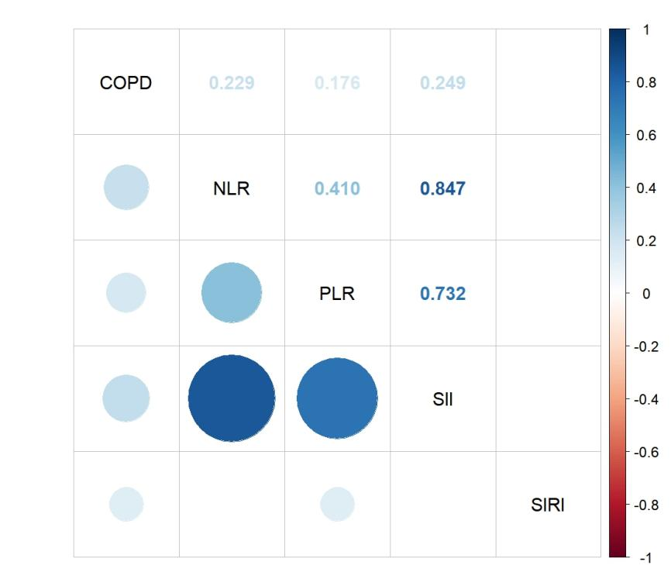

Supplementary Figure 1. Correlations between blood cell–derived inflammatory indices and COPD occurrence after pulmonary tuberculosis cure. Spearman correlation heatmap illustrating associations between inflammatory indices and post-PTB COPD. Circle size represents the strength of correlation, and color indicates direction and magnitude of the correlation coefficient.
NLR, neutrophil-to-lymphocyte ratio; PLR, platelet-to-lymphocyte ratio; SII, systemic immune-inflammation index; SIRI, systemic inflammation response index.

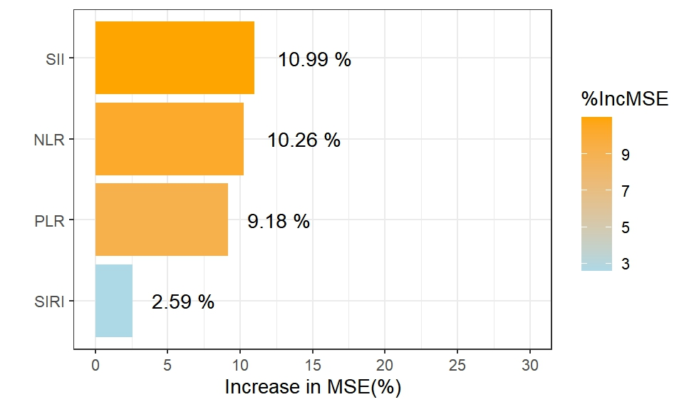
Supplementary Figure 2. Relative importance of blood cell–derived inflammatory indices for post-tuberculosis COPD identified by random forest analysis. Variable importance ranked by percentage increase in mean squared error (%IncMSE) upon permutation.
NLR, neutrophil-to-lymphocyte ratio; PLR, platelet-to-lymphocyte ratio; SII, systemic immune-inflammation index; SIRI, systemic inflammation response index.

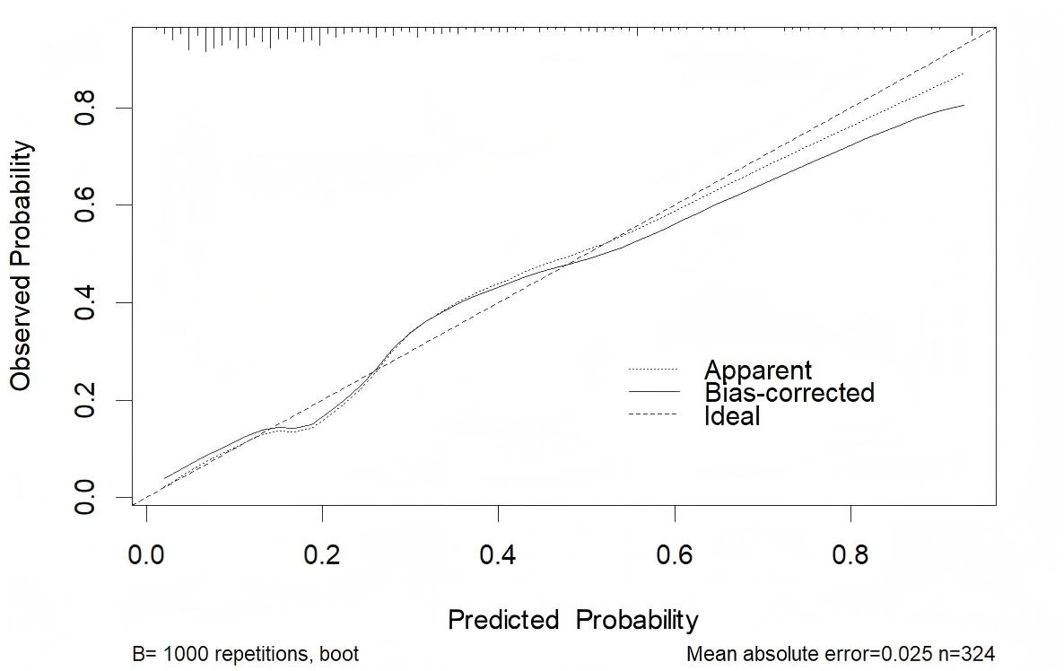
Supplementary Figure 3. Calibration plot of the prediction model for COPD after PTB cure.
Calibration plot comparing predicted and observed probabilities of COPD. The dashed diagonal line represents perfect calibration. The dotted line indicates the apparent calibration, whereas the solid line represents the bootstrap-corrected calibration based on 1,000 bootstrap resamples. The model demonstrated good agreement between predicted and observed probabilities, with a mean absolute calibration error of 0.025 in the study cohort.

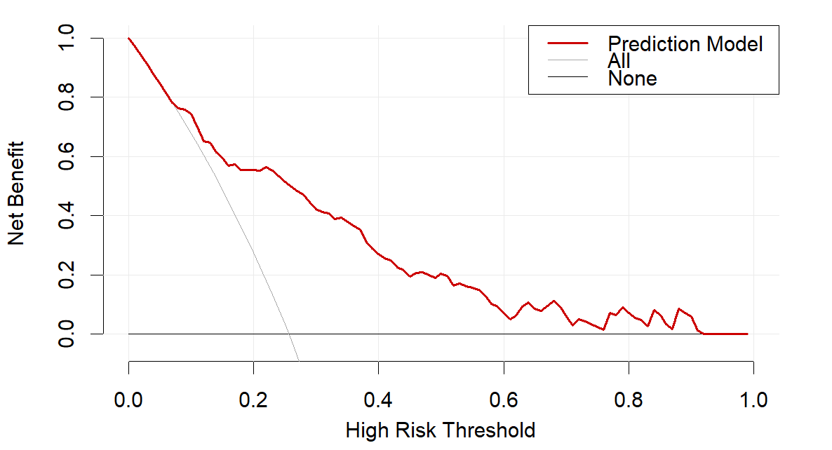
Supplementary Figure 4. Decision curve analysis of the prediction model for chronic obstructive pulmonary disease after pulmonary tuberculosis cure. Decision curve analysis illustrating the net clinical benefit of the prediction model across a range of threshold probabilities. The red line represents the prediction model, while the grey lines indicate the treat-all and treat-none strategies. Across a broad range of clinically relevant thresholds, the prediction model yields a higher net benefit than either reference strategy, supporting its potential clinical utility for risk-guided follow-up after pulmonary tuberculosis cure.

