Supplementary information
Table S1. Local dependence test in graded response model with Q3 value
Symptom |  | I1 | I2 | I3 | I4 | I5 | I6 | I7 | I8
Symptom | I1 | 1 | 0.116 | -0.214 | -0.317 | -0.215 | -0.297 | -0.275 | -0.231
Symptom | I2 | 0.116 | 1 | -0.321 | -0.359 | -0.139 | -0.217 | -0.193 | -0.143
Symptom | I3 | -0.214 | -0.321 | 1 | 0.258 | -0.157 | -0.19 | -0.189 | -0.265
Symptom | I4 | -0.317 | -0.359 | 0.258 | 1 | -0.036 | -0.051 | -0.069 | -0.114
Symptom | I5 | -0.215 | -0.139 | -0.157 | -0.036 | 1 | 0.178 | 0.162 | 0.118
Symptom | I6 | -0.297 | -0.217 | -0.19 | -0.051 | 0.178 | 1 | 0.663 | 0.144
Symptom | I7 | -0.275 | -0.193 | -0.189 | -0.069 | 0.162 | 0.663 | 1 | 0.134
Symptom | I8 | -0.231 | -0.143 | -0.265 | -0.114 | 0.118 | 0.144 | 0.134 | 1
Concern |  | I9 | I15 | I22 | I28 | I32
Concern | I9 | 1 | -0.043 | -0.234 | 0.074 | -0.119
Concern | I15 | -0.043 | 1 | -0.381 | -0.293 | -0.367
Concern | I22 | -0.234 | -0.381 | 1 | -0.258 | -0.307
Concern | I28 | 0.074 | -0.293 | -0.258 | 1 | -0.032
Concern | I32 | -0.119 | -0.367 | -0.307 | -0.032 | 1
Activities |  | I10 | I11 | I13 | I19 | I20 | I27 | I29
Activities | I10 | 1 | 0.014 | -0.249 | -0.233 | -0.214 | -0.123 | -0.048
Activities | I11 | 0.014 | 1 | 0.01 | -0.335 | -0.356 | -0.258 | -0.221
Activities | I13 | -0.249 | 0.01 | 1 | -0.173 | -0.224 | -0.15 | -0.249
Activities | I19 | -0.233 | -0.335 | -0.173 | 1 | 0.109 | -0.013 | -0.082
Activities | I20 | -0.214 | -0.356 | -0.224 | 0.109 | 1 | -0.139 | -0.071
Activities | I27 | -0.123 | -0.258 | -0.15 | -0.013 | -0.139 | 1 | 0.108
Activities | I29 | -0.048 | -0.221 | -0.249 | -0.082 | -0.071 | 0.108 | 1
Energy/mood |  | I12 | I17 | I23 | I24 | I25 | I31 | I35
Energy/mood | I12 | 1 | 0.162 | -0.317 | -0.395 | -0.046 | -0.076 | 0.052
Energy/mood | I17 | 0.162 | 1 | -0.292 | -0.299 | -0.053 | -0.016 | -0.041
Energy/mood | I23 | -0.317 | -0.292 | 1 | 0.168 | -0.303 | -0.196 | -0.256
Energy/mood | I24 | -0.395 | -0.299 | 0.168 | 1 | -0.303 | -0.112 | -0.332
Energy/mood | I25 | -0.046 | -0.053 | -0.303 | -0.303 | 1 | -0.191 | -0.068
Energy/mood | I31 | -0.076 | -0.016 | -0.196 | -0.112 | -0.191 | 1 | -0.076
Energy/mood | I35 | 0.052 | -0.041 | -0.256 | -0.332 | -0.068 | -0.076 | 1
Control |  | I14 | I16 | I26 | I30 | I34
Control | I14 | 1 | -0.024 | -0.174 | -0.262 | -0.35
Control | I16 | -0.024 | 1 | -0.025 | -0.305 | -0.311
Control | I26 | -0.174 | -0.025 | 1 | -0.041 | -0.109
Control | I30 | -0.262 | -0.305 | -0.041 | 1 | -0.265
Control | I34 | -0.35 | -0.311 | -0.109 | -0.265 | 1
Sexual function |  | I36 | I37
Sexual function | I36 | 1 | -0.629
Sexual function | I37 | -0.629 | 1

Table S2 Extracted items with CTT and IRT from UFS-QoL.
 | CTT | IRT | Final SF-UFS-QoL
Symptom severity | 1. Heavy bleeding during your menstrual period? | 1. Heavy bleeding during your menstrual period? | 1. Heavy bleeding during your menstrual period?
Symptom severity | 2. Passing blood clots during your menstrual period? | 3. Variations in the length of your menstrual periods? | 2. Passing blood clots during your menstrual period?
Concern | 15. Made you concerned about soiling your underwear? | 15. Made you concerned about soiling your underwear? | 15. Made you concerned about soiling your underwear?
Concern | 22. Made you concerned about soiling bed linen? | 22. Made you concerned about soiling bed linen? | 22. Made you concerned about soiling bed linen?
Activities | 11. Interfered with your physical activities? | 13.Made you spend less time on exercise or other physical activities? | 13.Made you spend less time on exercise or other physical activities?
Activities | 13.Made you spend less time on exercise or other physical activities? | 20. Interfered with your social activities (e.g., going out to the cinema, restaurants, parties, etc)? | 20. Interfered with your social activities (e.g., going out to the cinema, restaurants, parties, etc)?
Energy/Mood | 24. Made you feel down-hearted and blue? | 24. Made you feel down-hearted and blue? | 24. Made you feel down-hearted and blue?
Energy/Mood | 25. Made you feel exhausted? | 25. Made you feel exhausted? | 25. Made you feel exhausted?
Control | 30. Made you feel uncertain about your future? | 30. Made you feel uncertain about your future? | 30. Made you feel uncertain about your future?
Control | 34. Made you feel that you are not in control of your health? | 34. Made you feel that you are not in control of your health? | 34. Made you feel that you are not in control of your health?
Sexual function | 36. Decreased your sex drive? | 36. Decreased your sex drive? | 36. Decreased your sex drive?

Table S3. Missing data of each selected item in validated data set (n=970)
Item | Preoperative |  |  |  | 6-month  after discharge |  |  |  | 12-month  after discharge
Item | n | Means±SD | missing |  | n | Means±SD | missing |  | n | Means±SD | missing
U_1 | 970 | 2.2±1.17 | 0.00% |  | 939 | 1.45±0.7 | 3.20% |  | 900 | 1.32±0.57 | 7.22%
U_2 | 970 | 2.09±0.99 | 0.00% |  | 939 | 1.54±0.64 | 3.20% |  | 900 | 1.42±0.59 | 7.22%
U_15 | 970 | 2.45±1.17 | 0.00% |  | 939 | 1.9±0.91 | 3.20% |  | 900 | 1.71±0.86 | 7.22%
U_22 | 970 | 2.5±1.17 | 0.00% |  | 939 | 1.91±0.92 | 3.20% |  | 898 | 1.69±0.87 | 7.42%
U_11 | 970 | 2.11±1.1 | 0.00% |  | 936 | 1.74±0.83 | 3.51% |  | 899 | 1.54±0.74 | 7.32%
U_19 | 970 | 1.77±0.89 | 0.00% |  | 938 | 1.49±0.71 | 3.30% |  | 900 | 1.44±0.66 | 7.22%
U_24 | 970 | 2.04±0.95 | 0.00% |  | 939 | 1.73±0.78 | 3.20% |  | 899 | 1.59±0.7 | 7.32%
U_12 | 970 | 2.06±0.98 | 0.00% |  | 938 | 1.81±0.85 | 3.30% |  | 900 | 1.61±0.74 | 7.22%
U_16 | 970 | 1.93±0.95 | 0.00% |  | 939 | 1.62±0.76 | 3.20% |  | 899 | 1.51±0.74 | 7.32%
U_34 | 969 | 1.86±0.91 | 0.10% |  | 938 | 1.52±0.72 | 3.30% |  | 900 | 1.44±0.67 | 7.22%
U_36 | 968 | 2.27±1.06 | 0.21% |  | 937 | 1.83±0.88 | 3.40% |  | 900 | 1.66±0.83 | 7.22%

Table S4. Relationship of UFS-QoL-11 Subscale Scores and SF-36*
 | PF | PR | BP | GH | VT | SF | ER | MH
Baseline
Symptom severity | -0.26 | -0.28 | -0.23 | -0.22 | -0.25 | -0.19 | -0.25 | -0.17
Concern | 0.18 | 0.19 | 0.15 | 0.24 | 0.22 | 0.22 | 0.18 | 0.19
Daily life interference | 0.38 | 0.38 | 0.35 | 0.50 | 0.54 | 0.47 | 0.41 | 0.49
Treatment Month 6
Symptom severity | -0.16 | -0.1 | -0.19 | -0.13 | -0.13 | -0.14 | -0.14 | -0.16
Concern | 0.22 | 0.16 | 0.21 | 0.20 | 0.21 | 0.16 | 0.15 | 0.23
Daily life interference | 0.41 | 0.36 | 0.38 | 0.45 | 0.44 | 0.33 | 0.35 | 0.42
Treatment Month 12
Symptom severity | -0.33 | -0.26 | -0.27 | -0.21 | -0.18 | -0.21 | -0.23 | -0.16
Concern | 0.34 | 0.2 | 0.21 | 0.26 | 0.21 | 0.13 | 0.24 | 0.20
Daily life interference | 0.46 | 0.35 | 0.38 | 0.44 | 0.39 | 0.36 | 0.37 | 0.4
* Spearman correlations: all P<0.0001;
Abbreviation: UFS-QoL-11, the 11 items short form uterine fibroid symptom and quality of life; PF, Physical Functioning; RP, Role-physical; BP, Bodily Pain; GH, General Health; VT, Vitality; SF, Social Functioning; RE, Role-emotional; MH, Mental Health

Table S5. Known-group validity: comparison of UFS-QOL-11 symptom and quality of life scores and known health status
 | Baseline |  |  |  | 6-month |  |  |  | 12-month
 | Goodª | Poor^{b} | Mean difference^{c} | Effect size^{d} | Good | Poor | Mean difference | Effect size | Good | Poor | Mean difference | Effect size
N | 636 | 334 |  |  | 780 | 156 |  |  | 793 | 107
Symptom severity | 26.55±23.92 | 32.63±25.95 | 6.1 (2.8 to 9.3) | 0.26* | 11.54±13.37 | 17.07±17.97 | 5.5 (3.1 to 8) | 0.41* | 8.2±11.38 | 16.59±17.15 | 8.4(5.9 to 10.9) | 0.74*
Concern | 65.39±26.87 | 58.68±26.84 | -6.7 (-10.3 to -3.1) | -0.25* | 79.47±19.18 | 67.47±25.9 | -12 (-15.5 to -8.5) | -0.63* | 84.06±18.44 | 71.5±26.59 | -12.6(-16.5 to -8.6) | -0.68*
Daily life  interference | 78.4±15.92 | 67.95±18.3 | -10.4(-12.7 to 8.2) | -0.65* | 85.21±12.33 | 72.79±17.76 | -12.4 (-14.7 to -10.1) | -1.01* | 88.2±10.74 | 73.15±17.76 | -15.1(-17.5 to -12.7) | -1.41*
Abbreviations: UFS-QoL-11, the 11 items short form uterine fibroid symptom and quality of life;
ª Good health status: patients reported SF-36-1 “In general, would you say your health is excellent, very good, and good”
^{b} Poor health status: patients reported fair, or poor.
^{c} mean difference: Good health status vs. Poor health status
^{d} A value of 0.2 was considered as a ‘small’ effect, 0.5 a ‘moderate’ effect, and ≥0.8 a ‘large’ effect.
* P<0.001

Figure S1. Final UFS-QoL-11 questionnaire
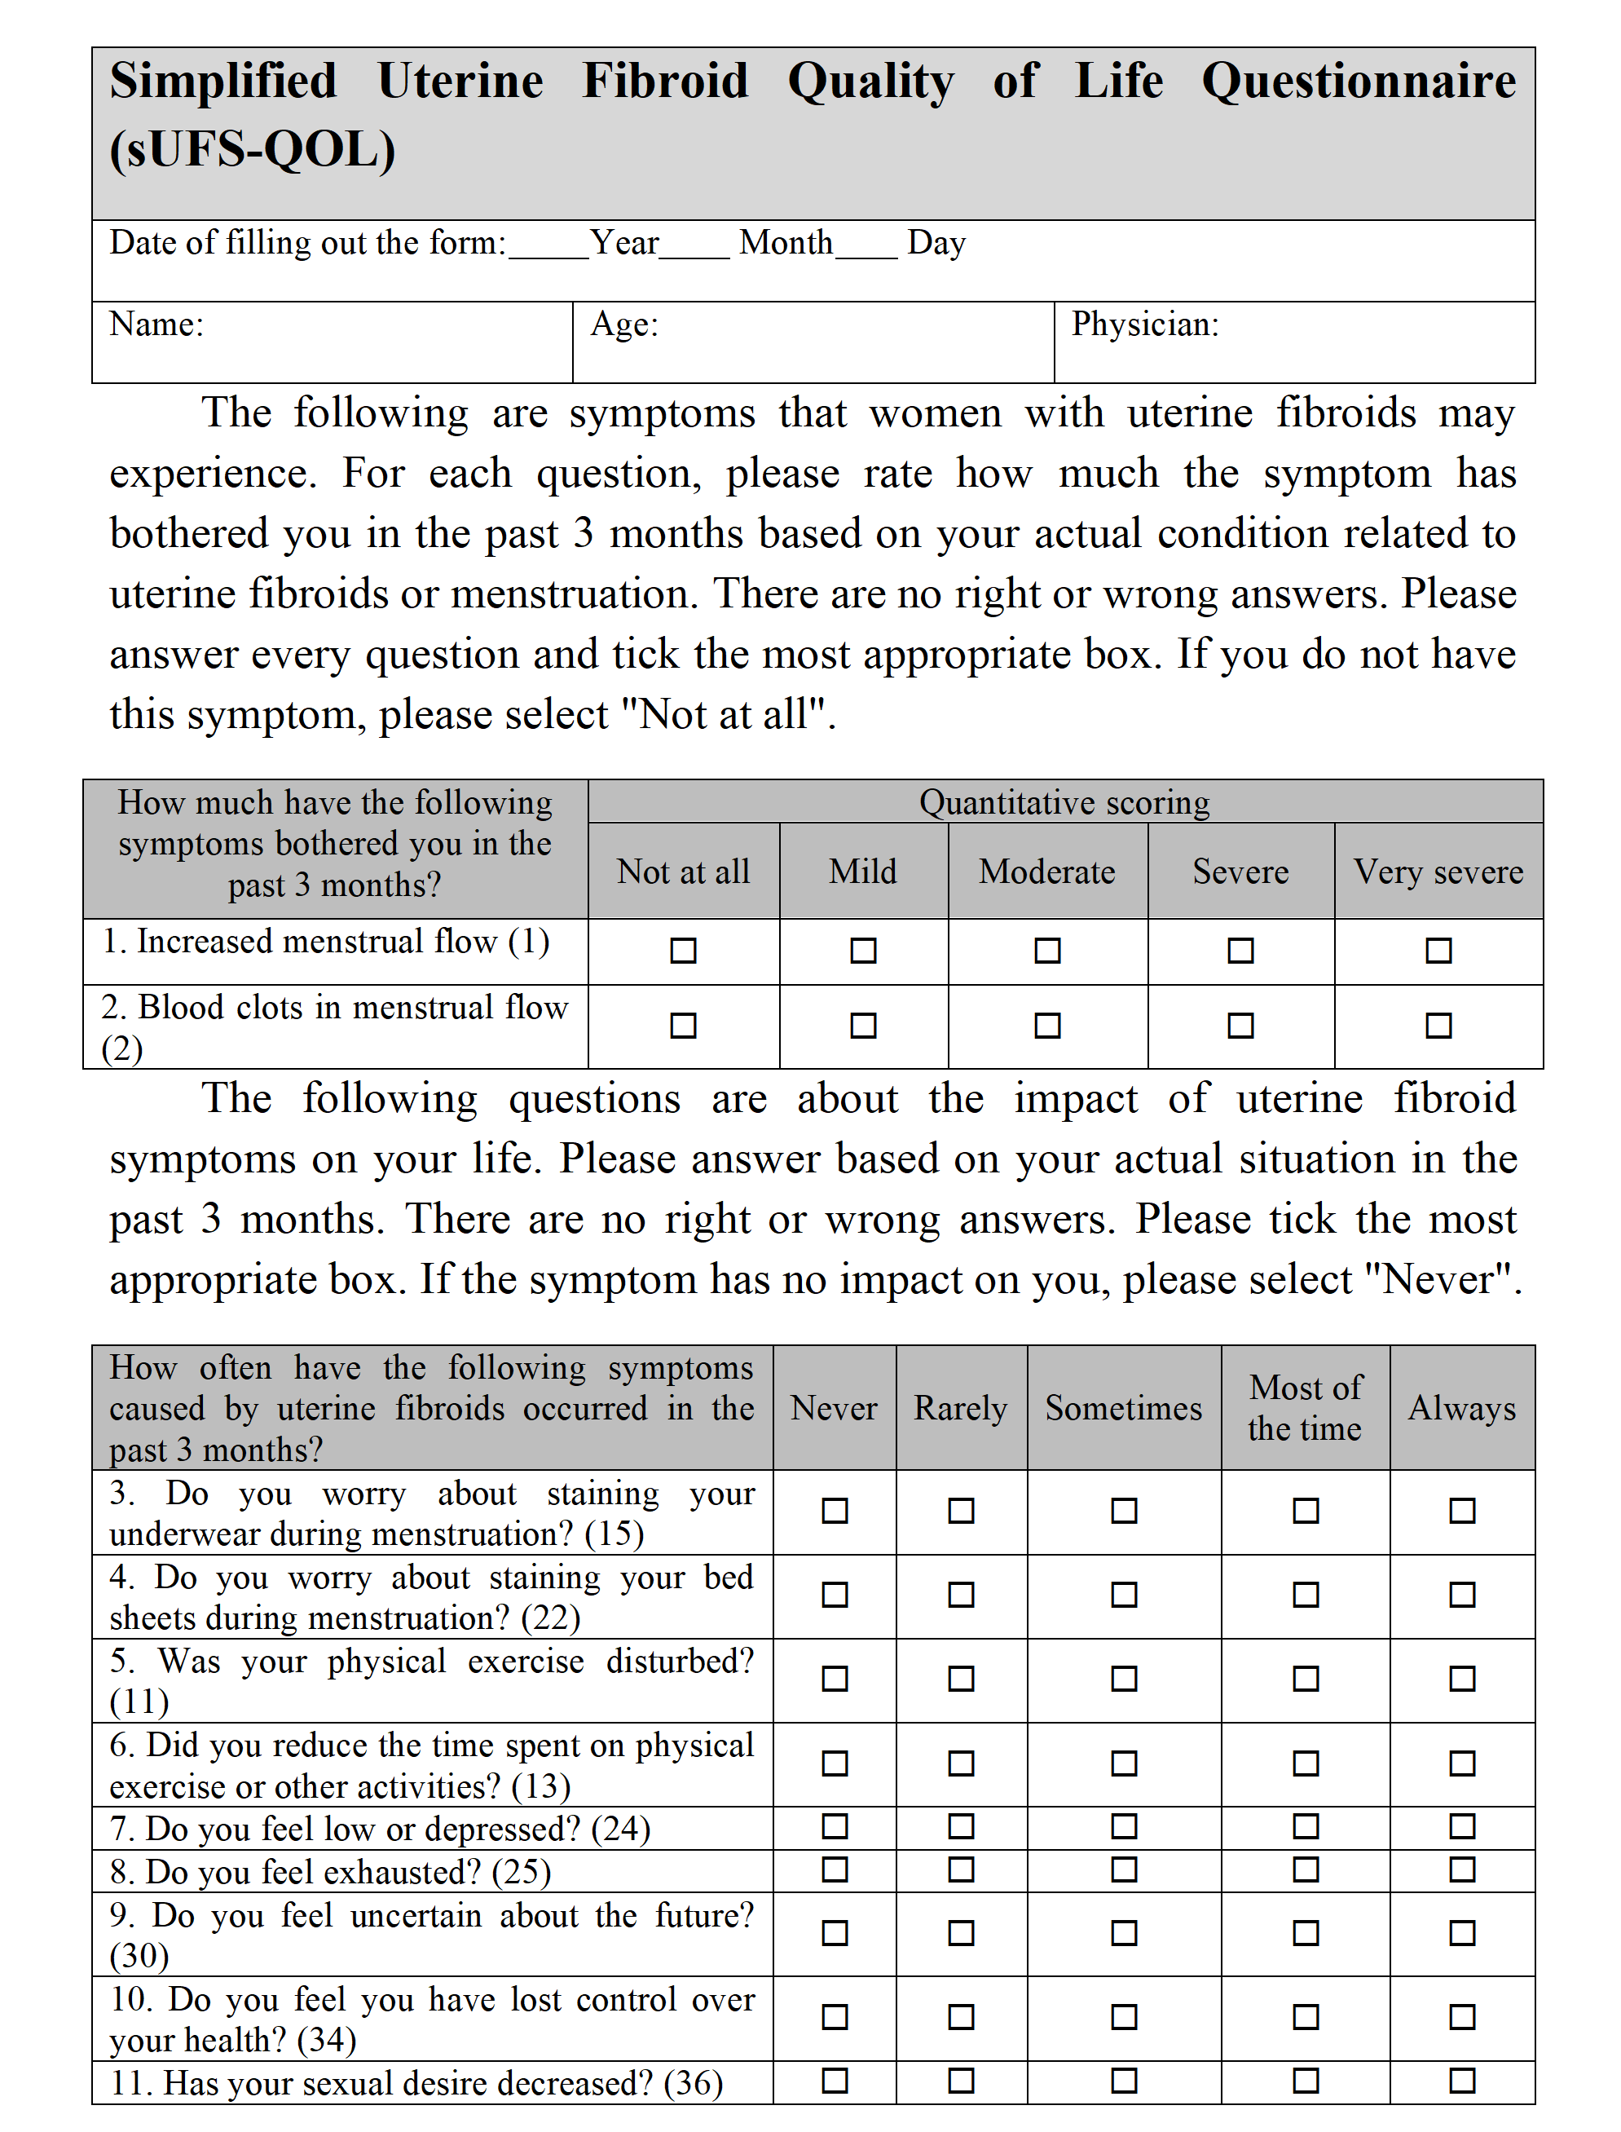

Supplementary Method: Scoring Method for the UFS-QoL-11
To calculate a symptom score for symptom severity, create a summed score from the items listed below and then use the formula below the table to transform the value. This will provide symptom scores where higher score values are indicative of greater symptom severity or bother and lower scores will indicate minimal symptom severity (high scores = bad)
Scale | Sum Item Values | Lowest and Highest Possible Raw Scores | Possible Raw Score Range
Symptom Severity | Sum 1 – 2 | 2, 10 | 8

$$Transformedscore=(\frac{Actual raw score-lowest possible raw score}{Possible raw score range})$$
For the HRQL subscales (concern, activities, energy/mood, control, and sexual function), create summed scores of the items listed below for each individual subscale. To calculate the HRQL total score, sum the value of each individual subscale (do not sum individual items). Use the formula below the table to transform all values. Higher scores will be indicative of better HRQL (high = good).
Scale | Sum Item Values | Lowest and Highest Possible Raw Scores | Possible Raw Score Range
Daily life interference | 5+6+7+8+9+10+11 | 7, 35 | 28
Concern | 3 + 4 | 2, 10 | 8
HRQL TOTAL | Sum of 2 Subscale Scores | 9, 45 | 36

Formula for transformation of HRQL raw scores ONLY:
$$Transformedscore=(\frac{Highest possible score-Actual raw score}{Possible raw score range})$$
Missing Items
For the subscale analyses, if < 50% of the scale items are missing, the scale should be retained with the mean scale score of the items present used to impute a score for the missing items. If ≥ 50% of the items are missing, no scale score should be calculated, the subscale score should be considered missing. If a subscale score is missing, the HRQL total cannot be calculated.

