Supplementary Materials

Supplementary Methods 1: PCR condition for Cryptococcus variant identification
Primers:
Forward primer ITS1: 5'-TCCGTAGGTGAACCTGCGG-3'
Reverse primer ITS4: 5'-TCCTCCGCTTATTGATATGC-3'

PCR reaction system for Cryptococcus variant identification
Component | Volume (μL)
2X EasyTaq PCR SuperMix (+dye) | 25
DNA (20 ng) | 2
ITS1 (5 μmol/L) | 2
ITS4 (5 μmol/L) | 2
ddH2O | 19
Total | 50

PCR Reaction Conditions:

Initial denaturation: 94°C for 5 minutes.
Denaturation: 94°C for 60 seconds.
Annealing: 50°C for 60 seconds.
Extension: 72°C for 60 seconds.
Repeat steps 2-4 for 30 cycles.
Final extension: 72°C for 10 minutes.

Supplementary Methods 2: PCR condition for Cryptococcus genotype identification
Primers:
For the Cryptococcus neoformans:
Forward primer CNF: 5'-AAGCCTCTCATCCATATCTT-3'
Reverse primer CNR: 5'-TTCAACCACGAATATGTA-3'

PCR condition for Cryptococcus genotype identification
Component | Volume (μL)
2X EasyTaq PCR SuperMix (+dye) | 25
DNA (20 ng) | 2
CNF/CGF (5 μmol/L) | 2
CNF/CGR (5 μmol/L) | 2
ddH2O | 19
Total | 50

PCR Reaction Conditions:
Initial denaturation: 94°C for 3 minutes.
Denaturation: 94°C for 30 seconds.
Annealing: 52°C for 30 seconds.
Extension: 72°C for 1.5 minutes.
Repeat steps 2-4 for 35 cycles.
Final extension: 72°C for 10 minutes.

Supplementary Methods 3: PCR condition for Cryptococcus Mating identification Identification
Primers:
For α-mating type specific:
Forward primer α -mating-type-specific F: 5'-CTTCACTGCCATCTTCACCA-3'
Reverse primer α -mating-type-specific R: 5'-GACACAAAGGGTCATGCCA-3'
Fragment size：101-bp
For a-mating type specific:
Forward primer A- mating-type-specific F: 5'-CGCCTTCACTGCTACCTTCT-3'
Reverse primer A- mating-type-specific R: 5'-AACGCAAGAGTAAGTCGGGC-3'
Fragment size：117-bp

PCR reaction system for Cryptococcus mating identification
Component | Volume (μL)
DNA (20 ng) | 2
2X EasyTaq PCR SuperMix (+dye) | 10
α -mating primer F (5 μmol/L) | 1
α -mating primer R (5 μmol/L) | 1
ddH2O | 6
Total | 20

PCR Reaction Conditions:
Initial denaturation: 95°C for 3 minutes.
Denaturation: 94°C for 1 minute.
Annealing: 57.5°C for 1 minute.
Extension: 72°C for 1 minute.
Repeat steps 2-4 for 30 cycles.
Final extension: 72°C for 10 minutes.

Supplementary Methods 4:PCR condition for Cryptococcus MLST identification
Gene | Primer (5'-3') | PCR Amplification Conditions: | Fragment size(bp)
CAP59 | F :CTCTACGTCGAGCAAGTCAAG R:TCCGCTGCACAAGTGATACCC | 94°C3min;35cycles: 94°C30s, 56°C30s, 72°C1min; 72°C 10min | 559
GPD1 | F:CCACCGAACCCTTCTAGGATA R:CTTCTTGGCACCTCCCTTGAG | 94°Cmin;35cycles: 94°C45s, 63°C1min, 72°C2min; 72°C 10min | 543
IGS1 | F:ATCCTTTGCAGACGACTTGA R:GTGATCAGTGCATTGCATGA | 94°C3min;35cycles: 94°C30s, 60°C30s, 72°C1min; 72°C 10min | 723
LAC1 | F:AACATGTTCCCTGGGCCTGTG R:ATGAGAATTGAATCGCCTTGT | 94°C3min;30cycles: 94°C30s, 58°C30s, 72°C 1min; 72°C 10min | 469
PLB1 | F:CTTCAGGCGGAGAGAGGTTT R:GATTTGGCGTTGGTTTCAGT | 94°C3min;30cycles: 94°C45s, 61°C45s, 72°C1min; 72°C 10min | 532
SOD1 | CNF:AAGCCTCCTCATCCATATTCTT CNR:TTCAACCACGAATATGTA CGF:GATCCTCACGCCATTACG CGR:GAATGATGCGCTTAGTTGGA | 94°C3min;35cycles: 94°C30s, 52°C30s, 72°C1.5min; 72°C 10min | 535
URA5 | F:ATGTCCTCCCAAGCCCTCGAC R:TTAAGACCTCTGAACACCGTACTC | 94°C3min;35cycles: 94°C45s, 63°C1min， 72°C2min; 72°C 10min | 601

Supplementary Figures

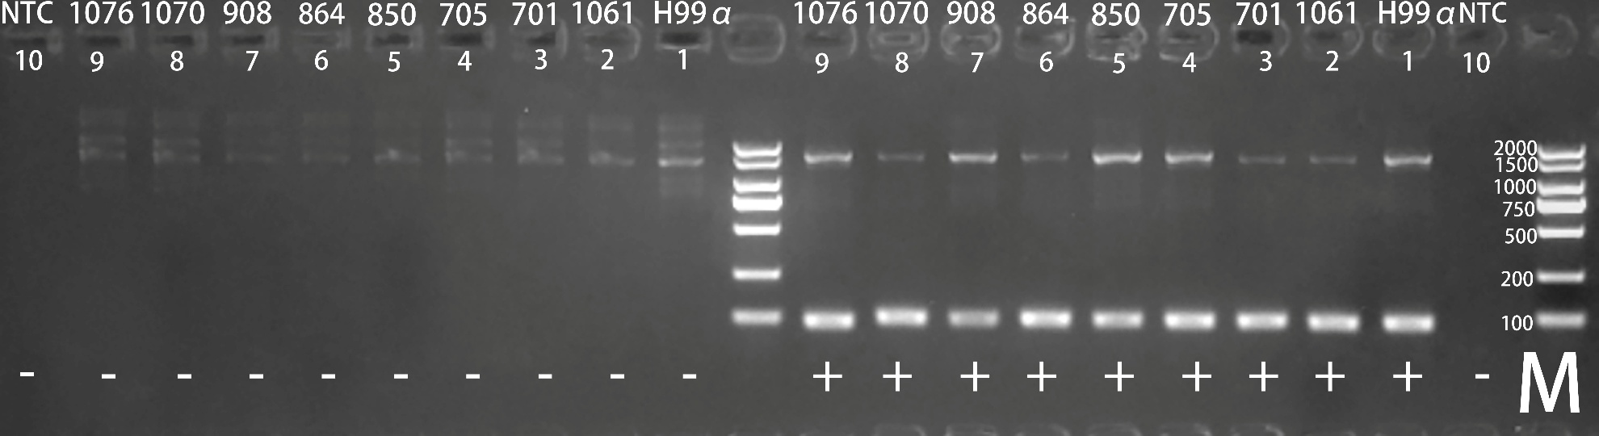
Figure S1. PCR amplification for mating type determination of C. neoformans clinical isolates.
M: DL2000 DNA Marker (fragment sizes: 100 bp, 250 bp, 500 bp, 750 bp, 1000 bp, 2000 bp); Lane 1: C. neoformans H99 (MATα) positive control. Lanes 2–9: Clinical isolates tested in this study (ID: 1061, 701, 705, 850, 864, 908, 1070, 1076). Lane 10: NTC (No-template control: nuclease-free water); "+" indicates amplification with MATα-specific primers; "-" indicates amplification with MATa-specific primers. The presence of a specific band only in the “+” lanes confirms the α mating type for all isolates.
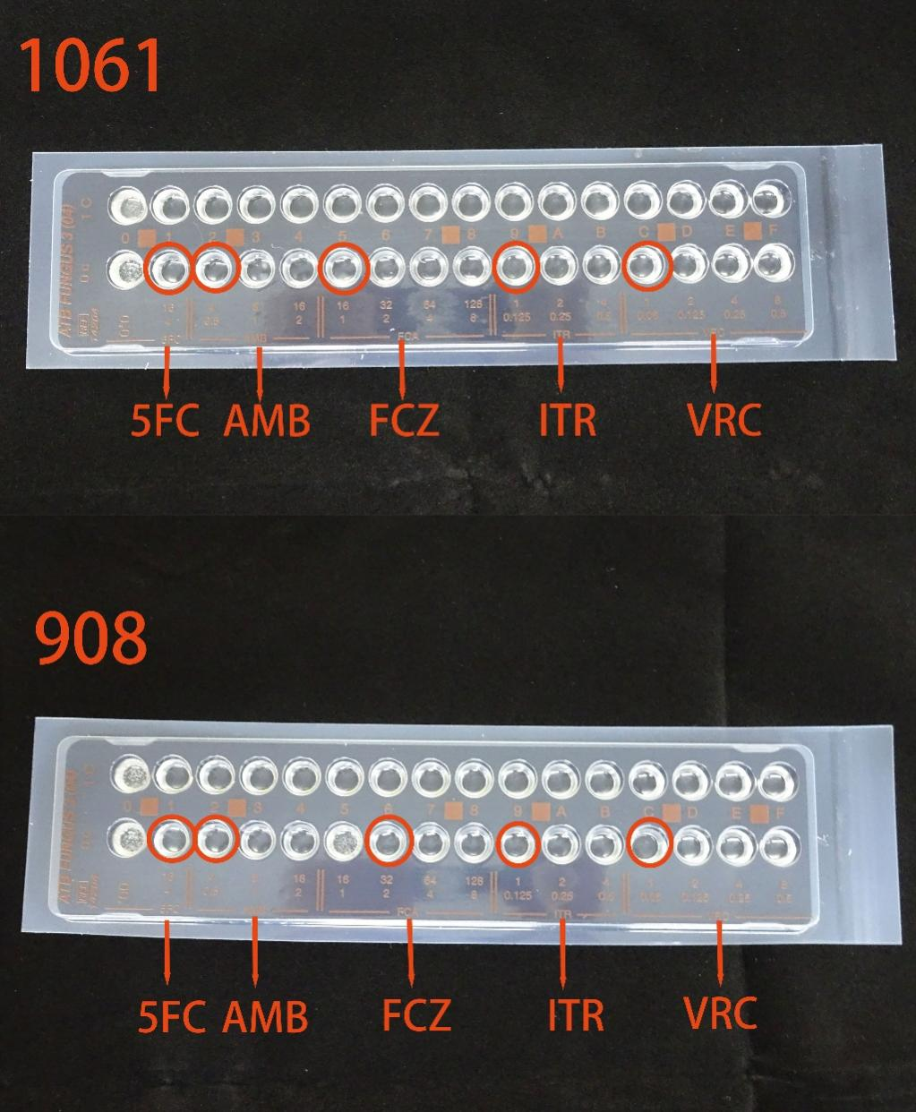
Figure S2. Antifungal susceptibility testing of C. neoformans strains 1061 and 908 using the ATB FUNGUS 3 kit.
Red solid circles indicate the specific wells of the microtiter plate corresponding to the minimum inhibitory concentration (MIC) of each antifungal agent. Both strains had identical MICs for 5-fluorocytosine (5-FC; ≤4 μg/mL), amphotericin B (AMB; ≤0.5 μg/mL), itraconazole (ITR; ≤0.125 μg/mL), and voriconazole (VCZ; ≤0.06 μg/mL). A difference was observed in fluconazole (FCZ) susceptibility, with MICs ≤1 μg/mL for strain 1061 and 2 μg/mL for strain 908.

