S1
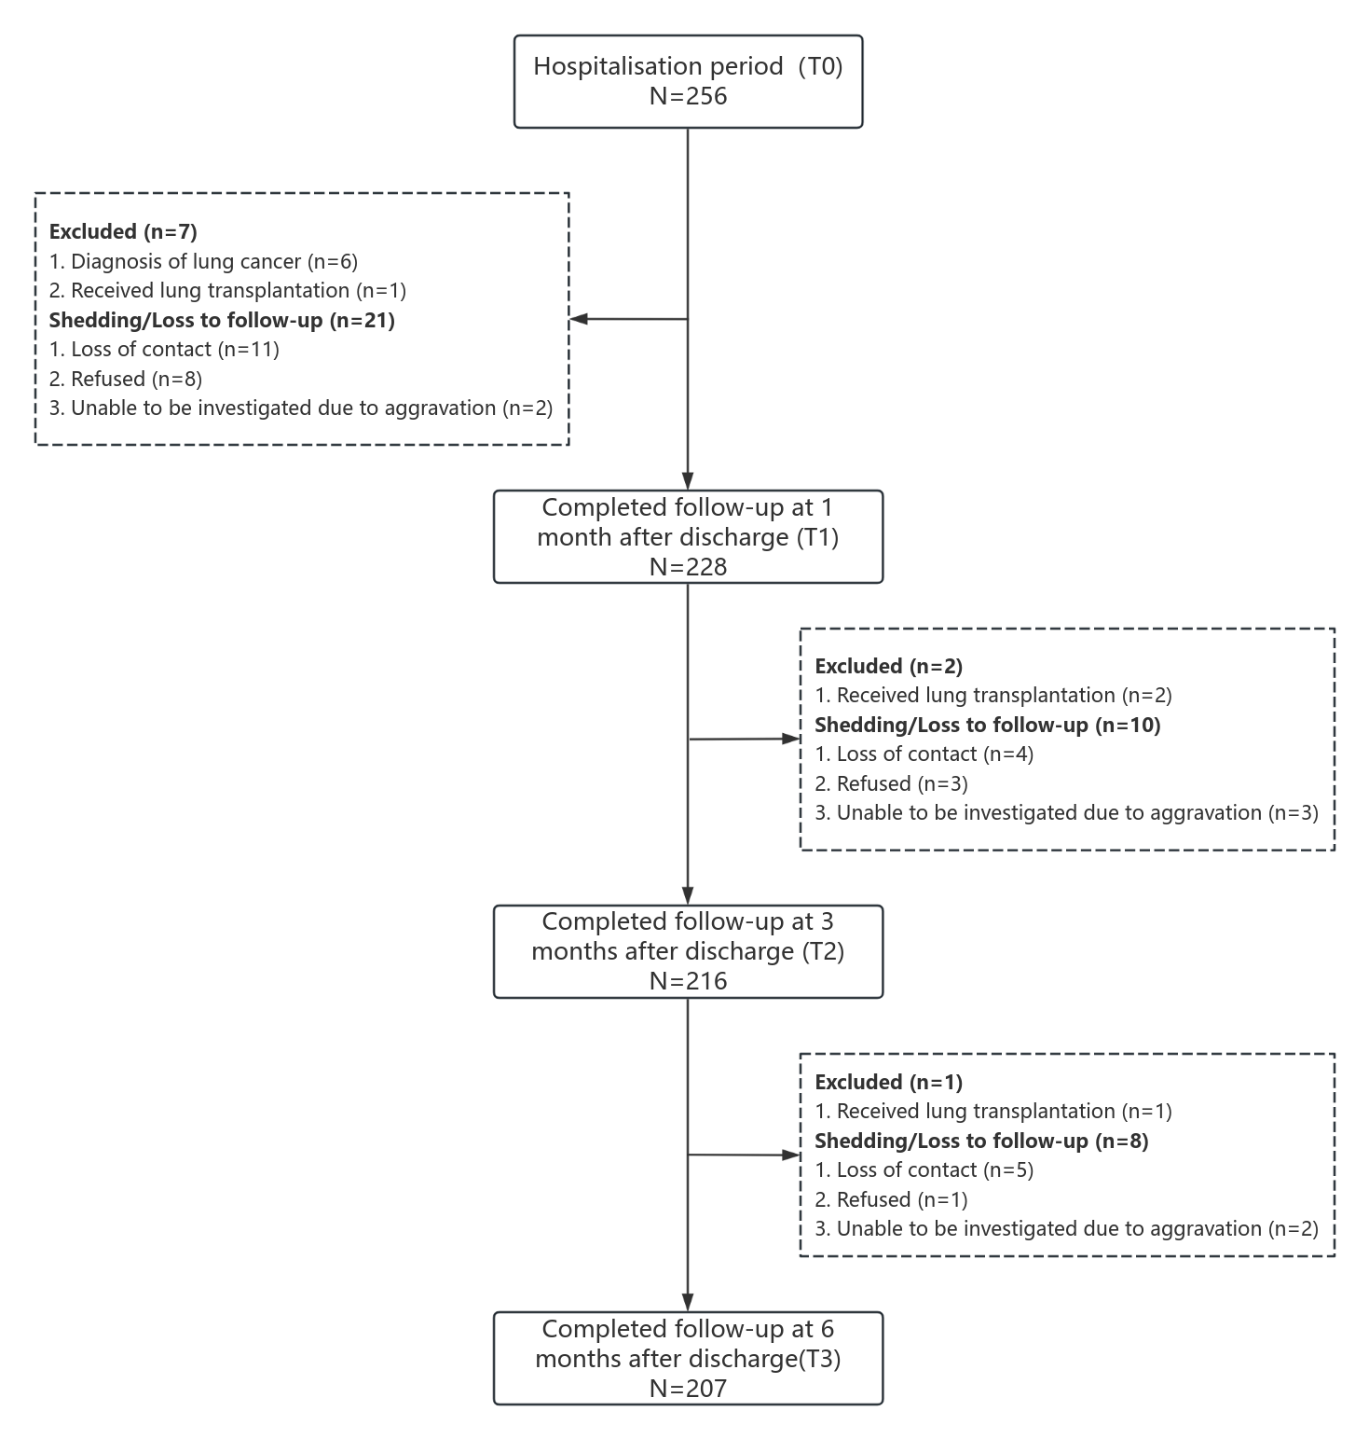
Supplementary Figure 1 Flowchart of the study population

S2
Supplementary Table 1 Comparison of general information between completed follow-up patients and lost patients [n (%)]
Variables | Categorisation | Completed follow- up (n=207) | Lost follow- up (n=49） | χ² | P
Age (year-old) | ＜60 | 42(20.3) | 8(16.3) | 1.028 | 0.794
 | 60～64 | 51(24.6) | 15(30.6)
 | 65～69 | 83(40.1) | 18(36.7)
 | ≥70 | 31(15.0) | 8(16.3)
Sex | Male | 189(91.3) | 47(95.9) | - | 0.383^{①}
 | Female | 18(8.7) | 2(4.1)
Marital status | Married | 204(98.6) | 48(98.0) | - | 0.575^{①}
 | Unmarried/Divorced/Widowed | 3(1.4) | 1(2.0)
Residence | Town | 110(53.1) | 27(55.1) | 0.061 | 0.804
 | Village | 97(46.9) | 22(44.9)
live alone | Yes | 13(6.3) | 2(4.1) | - | 0.743^{①}
 | No | 194(93.7) | 47(95.9)
Educational background | Primary school and below | 61(29.5) | 20(40.8) | 2.368 | 0.320
 | Junior high school | 74(35.7) | 15(30.6)
 | High school and above | 72(34.8) | 14(28.6)
Occupational status | Employed | 29(14.0) | 6(12.2) | 0.105 | 0.822
 | Unemployed | 178(86.0) | 43(87.8)
Family per capita monthly income | ＜3000 CNY | 80(38.6) | 19(38.8) | 0.582 | 0.748
 | 3000～6000 CNY | 105(50.7) | 23(46.9)
 | ＞6000 CNY | 22(10.6) | 7(14.3)
Payment method for medical expenses | Public expense | 2(1.0) | 0(0) | - | 0.716^{①}
 | Medical insurance | 201(97.1) | 48(98.0)
 | Self-pay | 4(1.9) | 1(2.0)
Note: χ2: Chi-square test; ^{①}Using Fisher’s exact test; CNY: Chinese Yuan

S3
Supplementary Table 2 Participant characteristics (n=256)
Variables | Categorisation | n (%)/M (Q25, Q75)
Age (year-old) | ＜60 | 50(19.5)
 | 60～64 | 66(25.8)
 | 65～69 | 101(39.5)
 | ≥70 | 39(15.2)
Sex | Male | 236(92.2)
 | Female | 20(7.8)
Marital status | Married | 252(98.4)
 | Unmarried/Divorced/Widowed | 4(1.6)
Residence | Town | 137(53.4)
 | Village | 119(46.5)
Live alone | Yes | 15(5.9)
 | No | 241(93.7)
Educational background | Primary school and below | 81(31.6)
 | Junior high school | 89(34.8)
 | High school and above | 86(33.6)
Occupational status | Employed | 35(13.7)
 | Unemployed | 221(86.3)
Family per capita monthly income | ＜3000 CNY | 99(38.7)
 | 3000～6000 CNY | 128(50.0)
 | ＞6000 CNY | 29(11.3)
Payment method for medical expenses | Public expense | 2(0.8)
 | Medical insurance | 249(97.3)
 | Self-pay | 5(2.0)
Daily use of biofuels or occupational exposure to dust | Yes | 39(15.2)
 | No | 217(84.8)
Smoking status | Never smoker | 45(17.6)
 | Current smoker | 57(22.3)
 | Ex-smoker | 154(60.2)
Smoking index | ＜400 | 66(25.8)
 | 400～800 | 124(48.4)
 | ＞800 | 66(25.8)
Disease duration (years) | ＜5 | 78(30.5)
 | 5～10 | 137(53.5)
 | ＞10 | 41(16.0)
Number of exacerbation admissions within the last year | 0 | 59(23.0)
 | 1 | 120(46.9)
 | ≥2 | 77(30.1)
GOLD grades | GOLD 1 | 6(2.3)
 | GOLD 2 | 53(20.7)
 | GOLD 3 | 105(41.0)
 | GOLD 4 | 92(35.9)
CAT |  | 25(21,29)
aCCI |  | 3(3,4)
Type of Inhaler device | pMDI | 155(60.5)
 | DPI | 96(37.5)
 | SMI | 5(2.0)
Type of inhaled medication | LAMA | 5(2.0)
 | LAMA-LABA | 36(14.1)
 | LABA-ICS | 44(17.2)
 | LAMA-LABA-ICS | 171(66.8)
Frequency of inhaler device use | Once a day | 61(23.8)
 | Twice a day | 195(76.2)
Duration of inhaler device use（years） | ＜1 | 53(20.7)
 | 1～2 | 91(35.5)
 | ≥3 | 112(43.8)
Long-term home oxygen therapy | Yes | 173(67.6)
 | No | 83(32.4)
Note: CNY: Chinese Yuan; smoking index: smoking years × number of cigarettes/day; GOLD: Global Initiative for Chronic Obstructive Lung Disease; pMDI: pressurized metered dose inhaler; DPI: dry powder inhaler; SMI: soft mist inhaler; LAMA: long-acting antagonist; LABA: long-acting β2 receptor agonists; ICS: inhaled corticosteroid; CAT: COPD assessment test; aCCI: age-adjusted Charlson comorbidity index.

S4a
Supplementary Table 3 GBTM grouping criteria for inhaled medication adherence in COPD patients (n=207)
Groups | Polynomial Order | AIC | BIC(n=207) | Percentage of the least member group(%)
1 | 3 | -1446.02 | -1454.35 | 100
2 | 33 | -1254.50 | -1271.16 | 35.23
3 | 333 | -1215.77 | -1240.77 | 16.16
4 | 3333 | -1199.73 | -1231.39 | 5.20
5 | 33333 | -1196.04 | -1237.70 | 0.97
Note: Optimal trajectory groups are shown in bold font; AIC: akaike information criterion; BIC: bayesian information criteria

S4b
Supplementary Table 4 Optimal polynomial results of GBTM for inhaled medication adherence in COPD patients
Groups | Subgroup order | Parameter | Estimated value | SE | t | p
1 | 0 | Intercept | 70.666 | 5.771 | 12.245 | ＜0.001
2 | 0 | Intercept | 46.482 | 0.901 | 51.567 | ＜0.001
3 | 1 | Intercept | 42.352 | 2.000 | 21.175 | ＜0.001
 |  | Linear | 18.981 | 3.488 | 5.442 | ＜0.001
4 | 3 | Intercept | 30.491 | 1.365 | 22.336 | ＜0.001
 |  | Linear | 14.804 | 3.182 | 4.653 | ＜0.001
 |  | Quadratic | -7.393 | 1.517 | -4.873 | ＜0.001
 |  | Cubic | 0.813 | 0.172 | 4.741 | ＜0.001

S4c
Supplementary Table 5 AvePP and percentage of 4 inhaled medication adherence trajectory groups in COPD patients
Groups | n (%) | AvePP
1 | 108 (50.39) | 0.955
2 | 37 (18.36) | 0.946
3 | 28 (15.00) | 0.934
4 | 34 (16.26) | 0.966
Note: AvePP: average posterior probability

S5
Supplementary Table 6 Collinearity analysis of associated factors on inhalation medication adherence trajectories in COPD patients
Variables | TOL | VIF
Disease duration (years) | 0.819 | 1.221
Duration of inhaler device use（years） | 0.743 | 1.346
Long-term home oxygen therapy | 0.776 | 1.288
COPD-Q | 0.584 | 1.712
BMQ-Specific | 0.636 | 1.573
HADS-A | 0.633 | 1.580
HADS-D | 0.603 | 1.658
PSSS | 0.846 | 1.181
Note: TOL: tolerance; VIF: variance inflation factor; COPD-Q: chronic obstructive pulmonary disease knowledge questionnaire; BMQ-Specific: beliefs about medicines questionnaire-specific; HADS-A: hospital anxiety and depression scale-anxiety; HADS-D: hospital anxiety and depression scale-depression; PSSS: perceived social support scale.

S6a
Supplementary Table 7 GBTM grouping criteria for beliefs about medicines in COPD patients (n=207)
Groups | Polynomial Order | AIC | BIC(n=207) | Percentage of the least member group(%)
1 | 3 | -2863.54 | -2871.87 | 100
2 | 33 | -2456.78 | -2473.45 | 22.63
3 | 333 | -2347.08 | -2372.08 | 12.00
4 | 3333 | -2288.98 | -2322.30 | 10.42
5 | 33333 | -2274.25 | -2315.90 | 1.45
Note: Optimal trajectory groups are shown in bold font; AIC: akaike information criterion; BIC: bayesian information criteria

S6b
Supplementary Table 8 Optimal polynomial results of GBTM for beliefs about medicines in COPD patients
Groups | Subgroup order | Parameter | Estimated value | SE | t | p
1 | 1 | Intercept | 24.474 | 0.499 | 49.092 | ＜0.001
 |  | Linear | -0.412 | 0.140 | -2.933 | 0.003
2 | 3 | Intercept | 32.109 | 0.628 | 51.150 | ＜0.001
 |  | Linear | 3.010 | 1.429 | 2.107 | 0.035
 |  | Quadratic | -1.526 | 0.677 | -2.254 | 0.025
 |  | Cubic | 0.162 | 0.077 | 2.112 | 0.035
3 | 3 | Intercept | 38.150 | 0.889 | 42.904 | ＜0.001
 |  | Linear | 4.040 | 1.082 | 3.735 | ＜0.001
 |  | Quadratic | -1.393 | 0.481 | -2.895 | 0.004
 |  | Cubic | 0.135 | 0.054 | 2.521 | 0.012
4 | 0 | Intercept | 45.572 | 0.280 | 162.944 | ＜0.001
S6c
Supplementary Table 9 AvePP and percentage of 4 beliefs about medicines trajectory groups in COPD patients
Groups | n(%) | AvePP
1 | 22(10.4) | 0.976
2 | 24(12.0) | 0.997
3 | 57(25.3) | 0.868
4 | 104(52.3) | 0.972
Note: AvePP: average posterior probability

S7a
Supplementary Table 10 GBTM grouping criteria for anxiety in COPD patients(n=207)
Groups | Polynomial Order | AIC | BIC(n=207) | Percentage of the least member group(%)
1 | 3 | -1838.05 | -1846.38 | 100
2 | 33 | -1682.06 | -1698.73 | 17.72
3 | 333 | -1592.17 | -1617.17 | 4.82
4 | 3333 | -1568.08 | -1601.40 | 3.06
5 | 33333 | -1564.56 | -1606.22 | 3.03
Note: Optimal trajectory groups are shown in bold font; AIC: akaike information criterion; BIC: bayesian information criteria

S7b
Supplementary Table 11 Optimal polynomial results of GBTM for anxiety in COPD patients
Groups | Subgroup order | Parameter | Estimated value | SE | t | p
1 | 3 | Intercept | 7.259 | 0.148 | 48.903 | ＜0.001
 |  | Linear | -1.441 | 0.305 | -4.720 | ＜0.001
 |  | Quadratic | 0.501 | 0.143 | 3.507 | ＜0.001
 |  | Cubic | -0.049 | 0.016 | -3.038 | 0.003
2 | 2 | Intercept | 10.059 | 0.172 | 58.542 | ＜0.001
 |  | Linear | -0.775 | 0.155 | -5.002 | ＜0.001
 |  | Quadratic | 0.073 | 0.024 | 3.066 | 0.002
3 | 0 | Intercept | 13.259 | 0.225 | 59.043 | ＜0.001

S7c
Supplementary Table 12 AvePP and percentage of 3 anxiety trajectory groups in COPD patients
Groups | n(%) | AvePP
1 | 128(61.9) | 0.968
2 | 69(33.3) | 0.939
3 | 10(4.8) | 0.994
Note: AvePP: average posterior probability

