Supplementary Material
The UPLC‑QTOF‑MS parameters for both positive and negative ion modes were as follows: ion spray voltage, 5500 V; collision energy, 35 ± 15 V; ion source temperature, 550 °C. Chromatographic separation was performed on a Phenomenex Kinetex XB‑C18 column (2.6 μm, 100 × 2.1 mm). The mobile phase consisted of water containing 0.1% formic acid (A) and methanol (B), delivered at a flow rate of 0.4 mL/min. The gradient elution program was: 0–3 min, 5% B; 3–28 min, 5%–95% B; 28–40 min, 95% B; 40–41 min, 5% B; 41–45 min, 5% B. Detailed parameters are also provided in the Methods section of the main text.
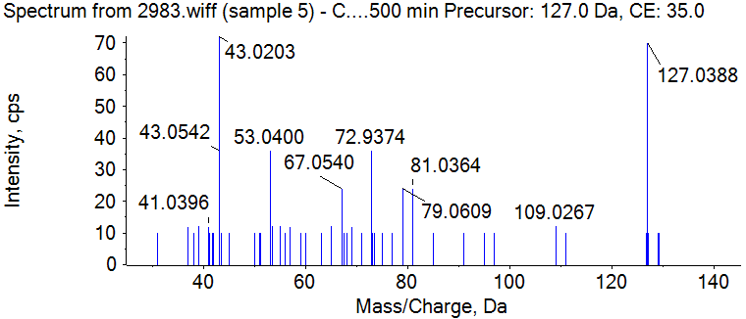
Supplementary Figure S1. Mass spectrum of Maltol
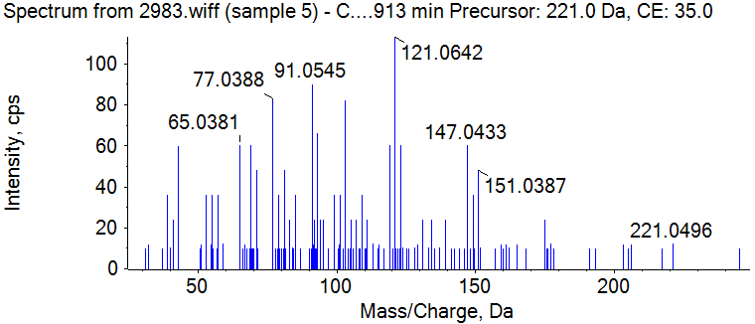
Supplementary Figure S2. Mass spectrum of Syringic acid
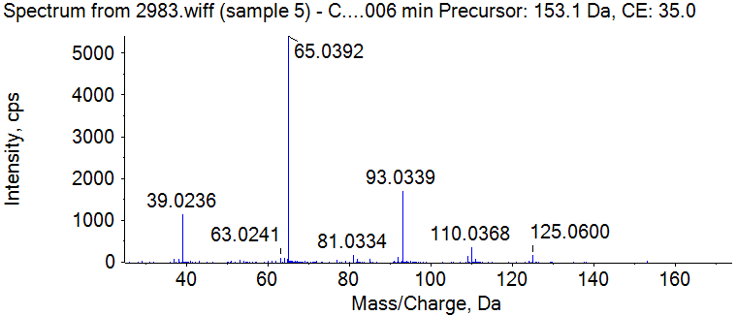
Supplementary Figure S3. Mass spectrum of Vanillin
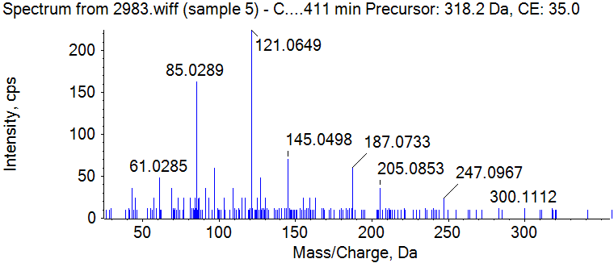
Supplementary Figure S4. Mass spectrum of Salidroside
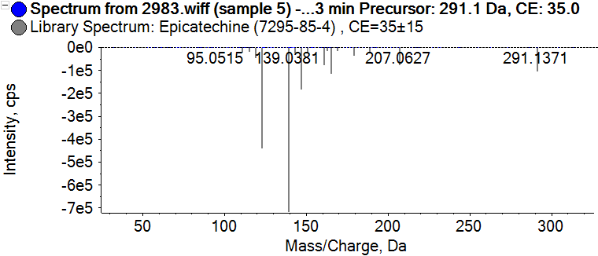
Supplementary Figure S5. Mass spectrum of Catechin
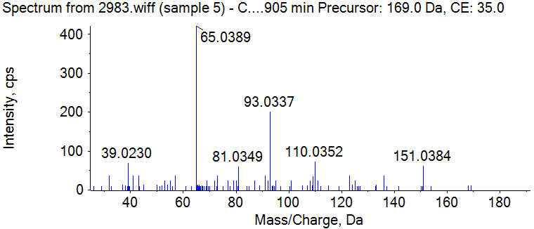
Supplementary Figure S6. Mass spectrum of Vanillic acid
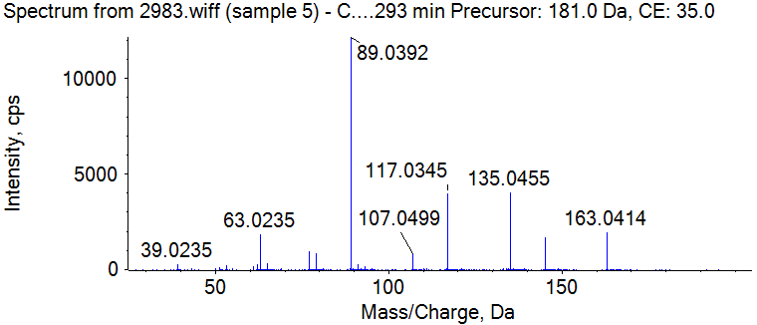
Supplementary Figure S7. Mass spectrum of Caffeic Acid
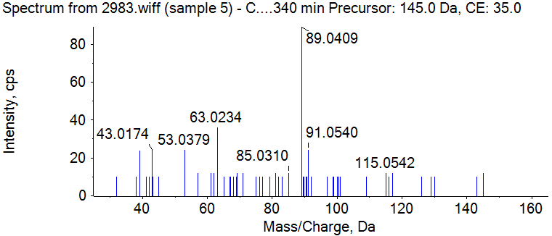
Supplementary Figure S8. Mass spectrum of Benzoic acid
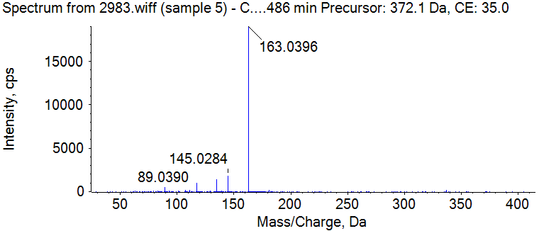
Supplementary Figure S9. Mass spectrum of Chlorogenic Acid
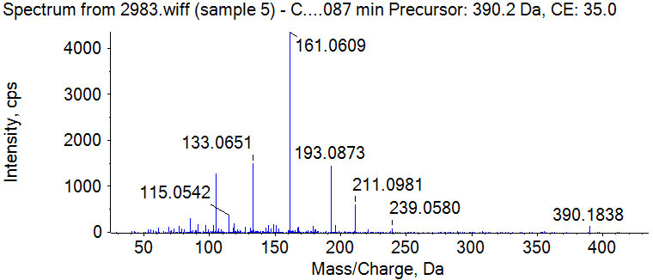
Supplementary Figure S10. Mass spectrum of syringin
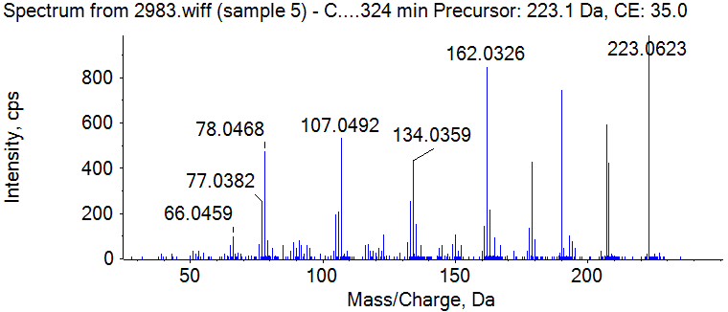
Supplementary Figure S11. Mass spectrum of Isofraxidin
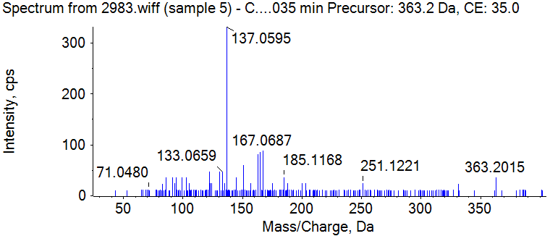
Supplementary Figure S12. Mass spectrum of Secoisolariciresinol
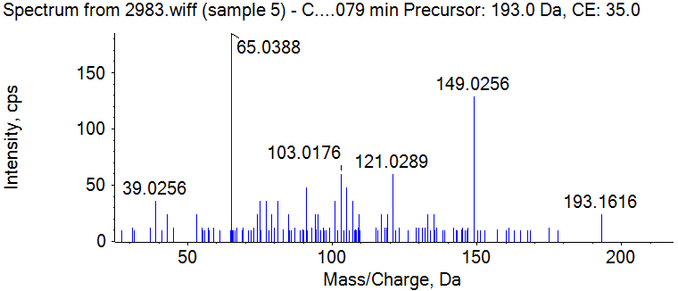
Supplementary Figure S13. Mass spectrum of Scopoletin
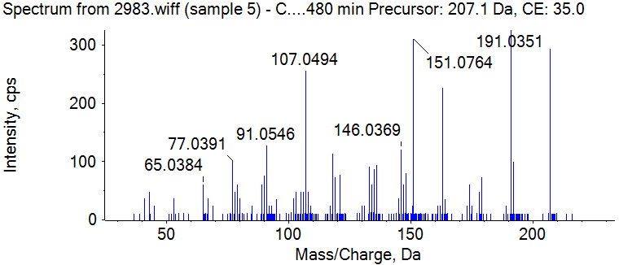
Supplementary Figure S14. Mass spectrum of Scoparone
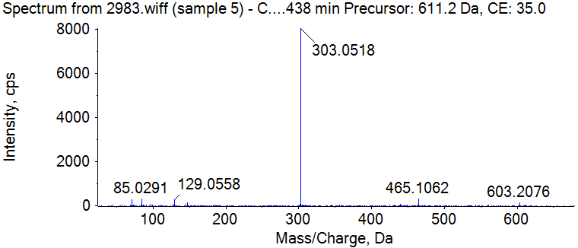
Supplementary Figure S15. Mass spectrum of Rutin
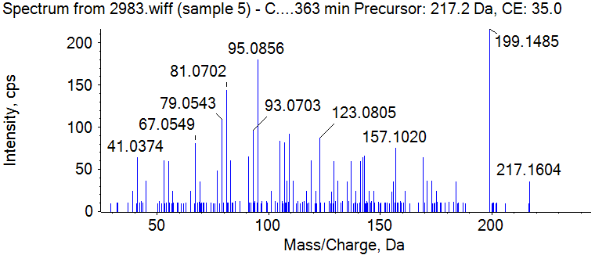
Supplementary Figure S16. Mass spectrum of ferulic acid
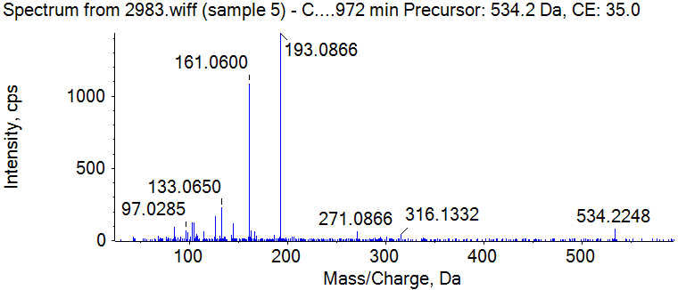
Supplementary Figure 1-17. Mass spectrum of Gomisin D
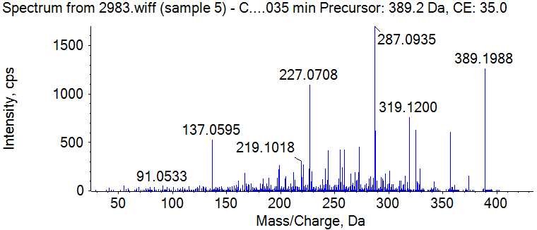
Supplementary Figure S18. Mass spectrum of Gomisin J
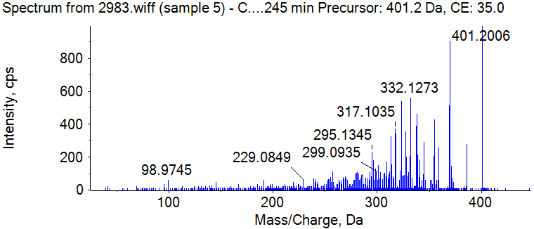
Supplementary Figure S19. Mass spectrum of Schisandrin B
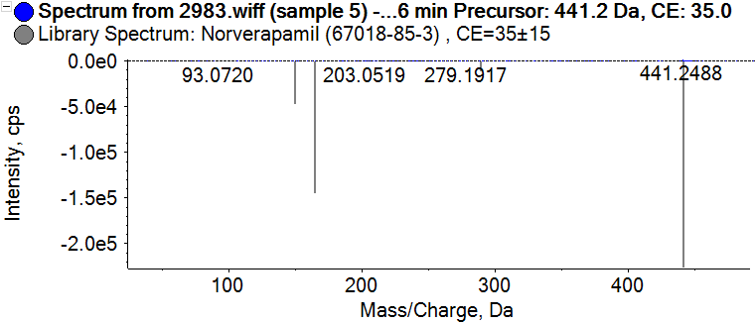
Supplementary Figure S20. Mass spectrum of Gomisin H
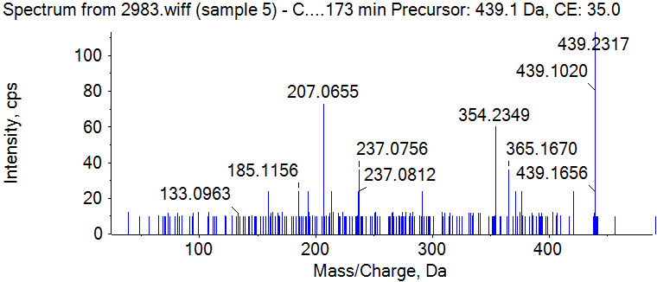
Supplementary Figure S21. Mass spectrum of Puerarin
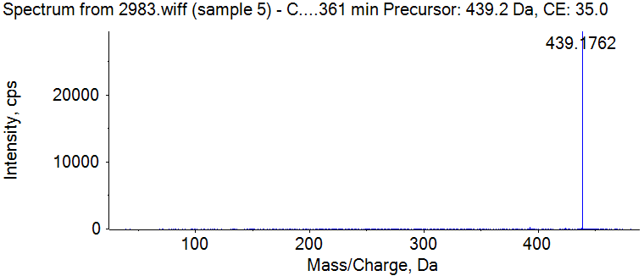
Supplementary Figure S22. Mass spectrum of Magnolin

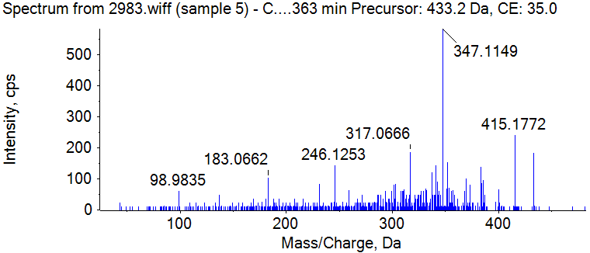
Supplementary Figure S23. Mass spectrum of Schizandrin
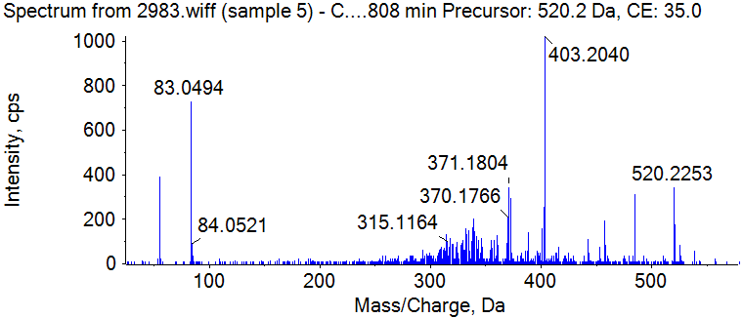
Supplementary Figure S24. Mass spectrum of Benzoylgomisin O
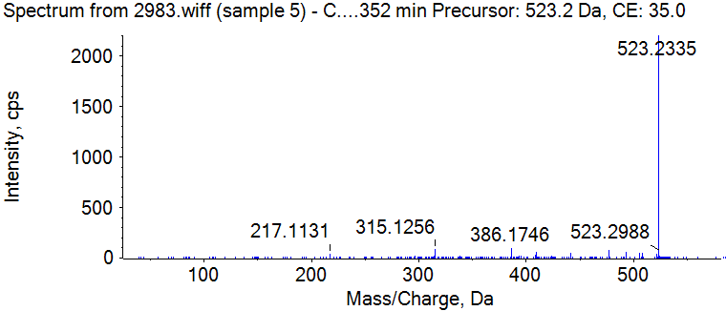
Supplementary Figure S25. Mass spectrum of Angeloylgomisin H
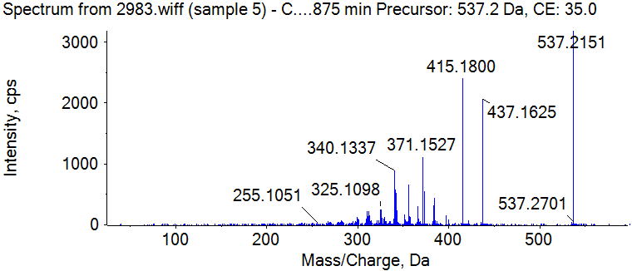
Supplementary Figure S26. Mass spectrum of Gomisin G
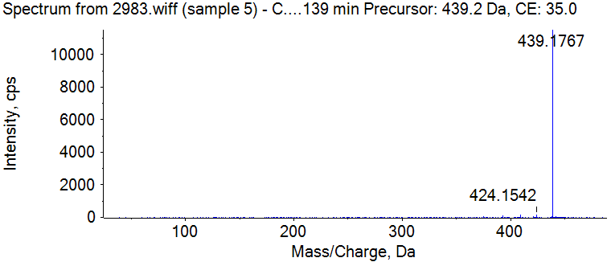
Supplementary Figure S27. Mass spectrum of Gomisin O
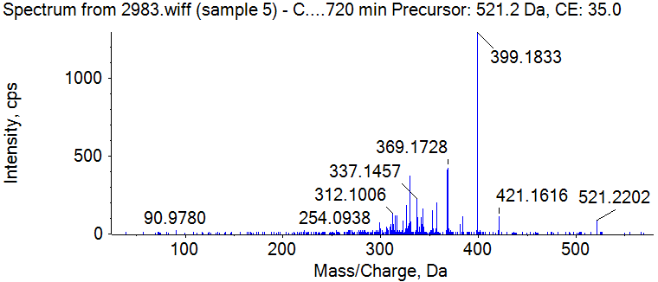
Supplementary Figure S28. Mass spectrum of Angeloylgomisin O
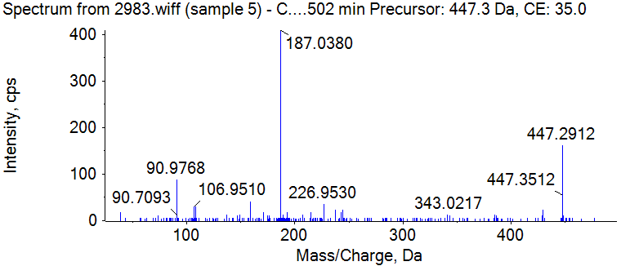
Supplementary Figure S29. Mass spectrum of Stearic acid
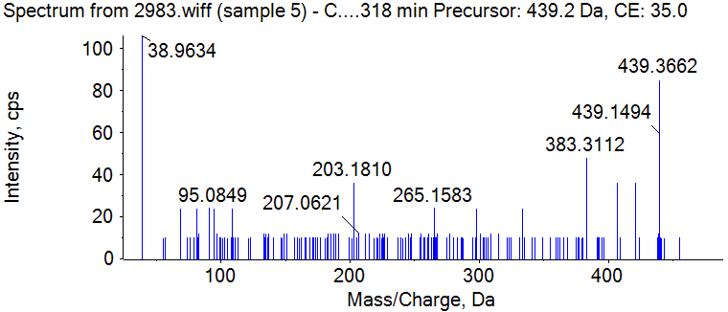
Supplementary Figure S30. Mass spectrum of Ursolic acid
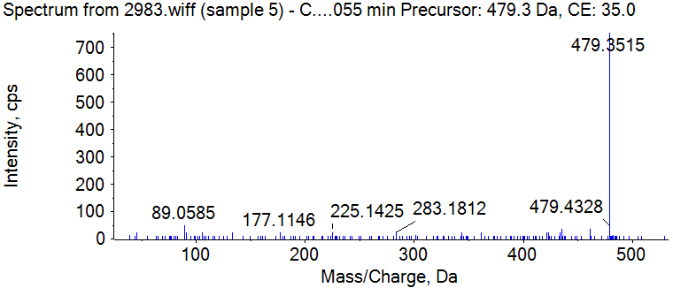
Supplementary Figure S31. Mass spectrum of oleanolic acid
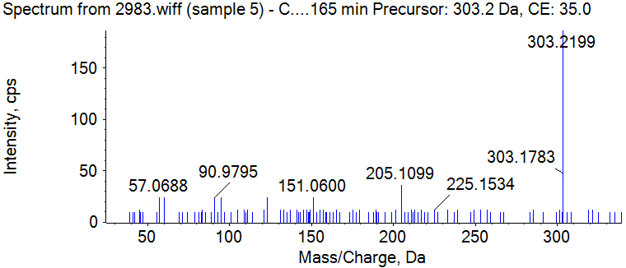
Supplementary Figure S32. Mass spectrum of Linoleic acid
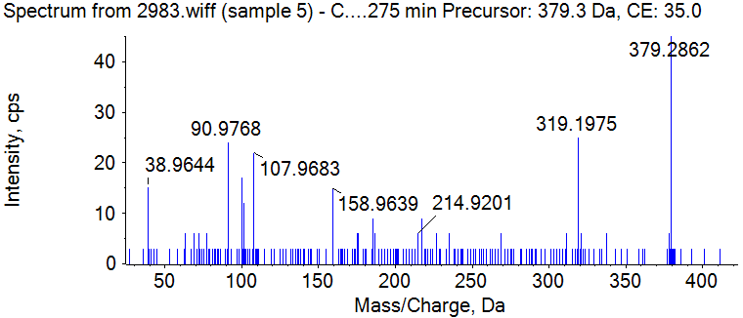
Supplementary Figure S33. Mass spectrum of Ergosterol
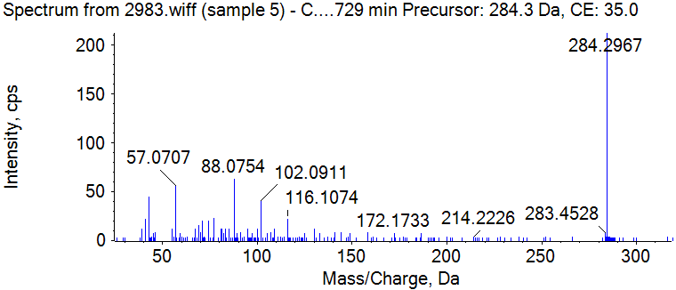
Supplementary Figure S34. Mass spectrum of Stearamide

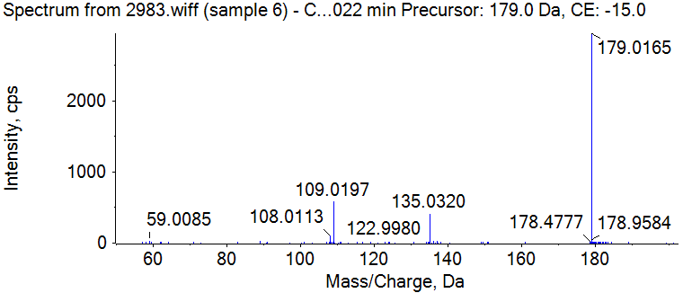
Supplementary Figure S35. Mass spectrum of Caffeic Acid
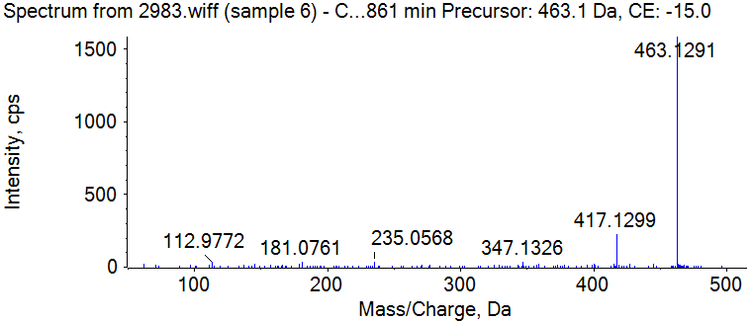
Supplementary Figure S36. Mass spectrum of Isoquercitrin
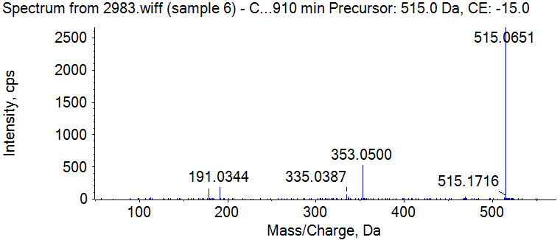
Supplementary Figure S37. Mass spectrum of 1,3-Dicaffeoylquinic acid
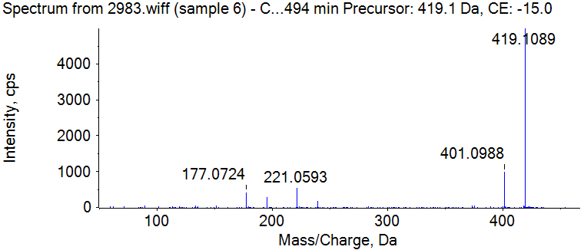
Supplementary Figure S38. Mass spectrum of Mangiferin
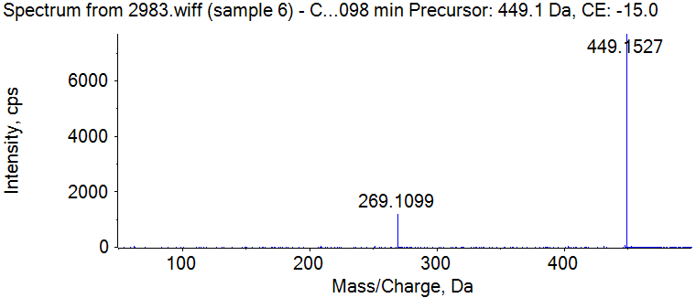
Supplementary Figure S39. Mass spectrum of kaempferol-3-O-glucoside
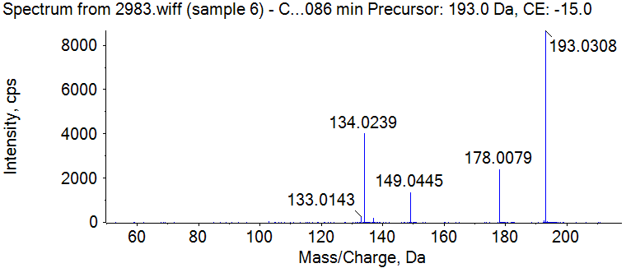
Supplementary Figure S40. Mass spectrum of ferulic acid
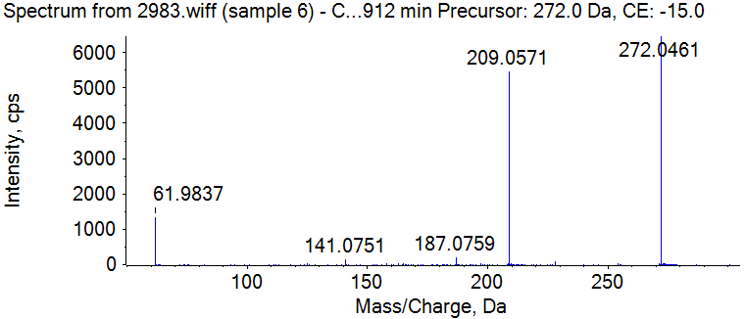
Supplementary Figure S41. Mass spectrum of Naringenin

