Supplemental materials
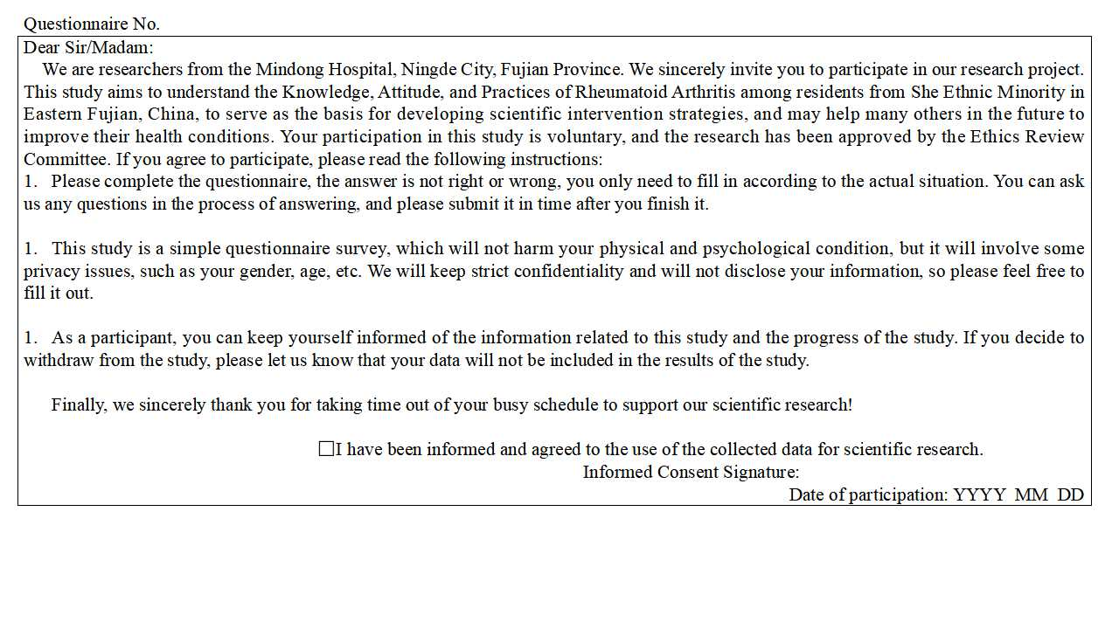
Supplemental Figure 1A. Informed consent form for the questionnaire
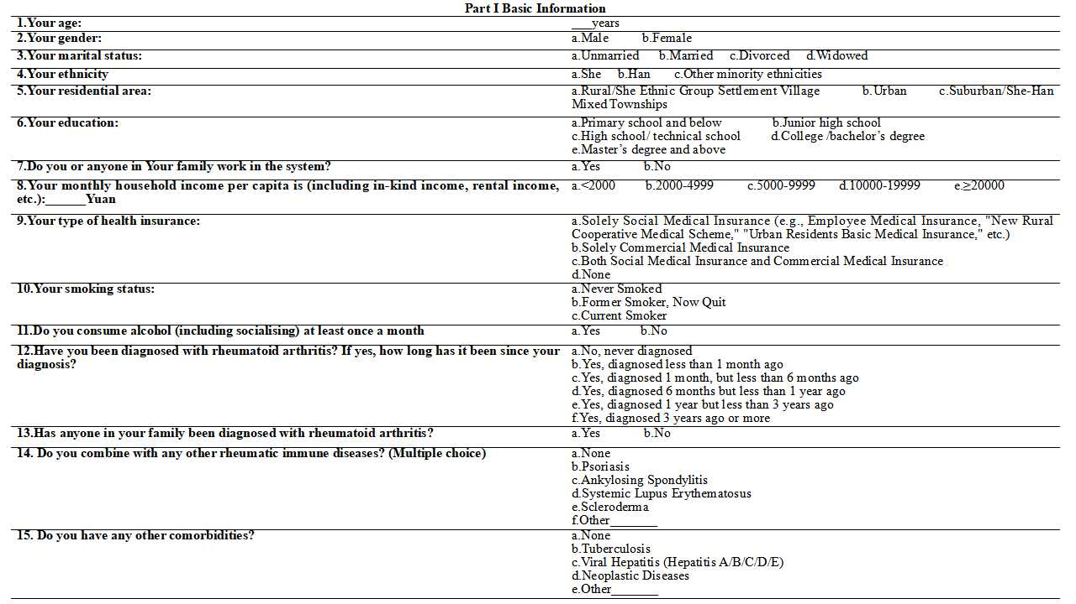
Supplemental Figure 1B. Part 1 of the questionnaire

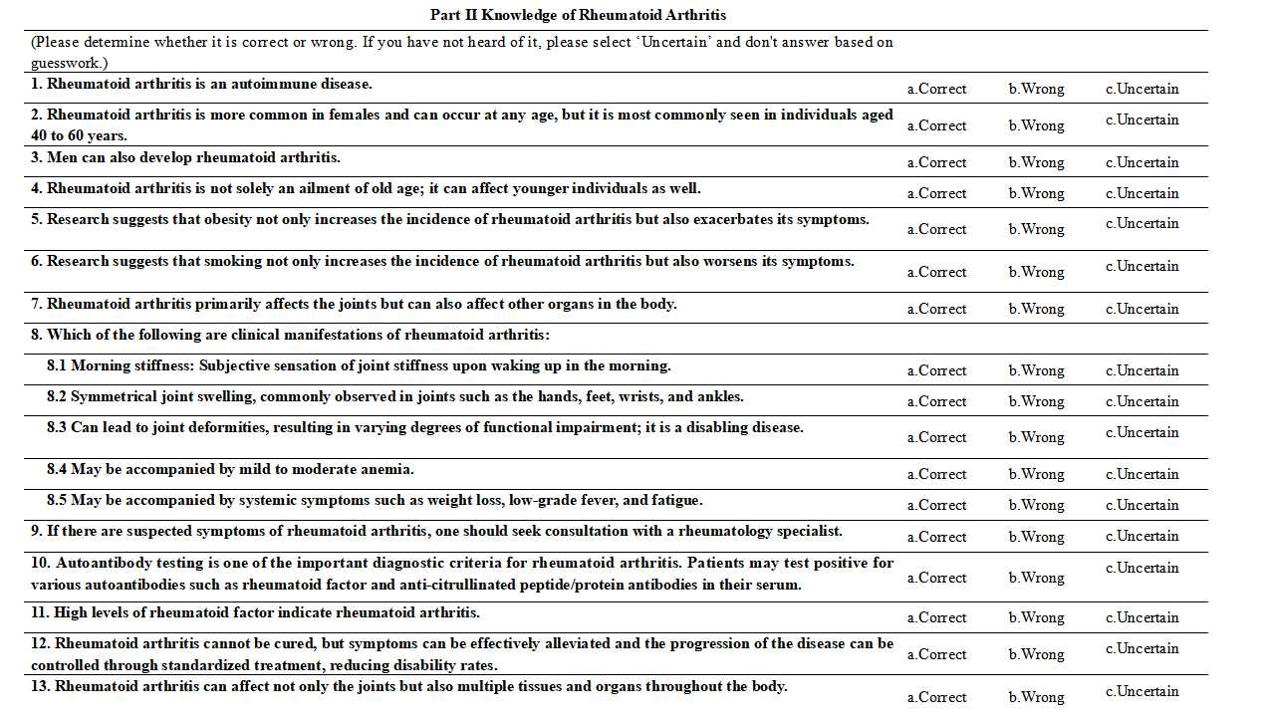
Supplemental Figure 1C. Part 2 of the questionnaire

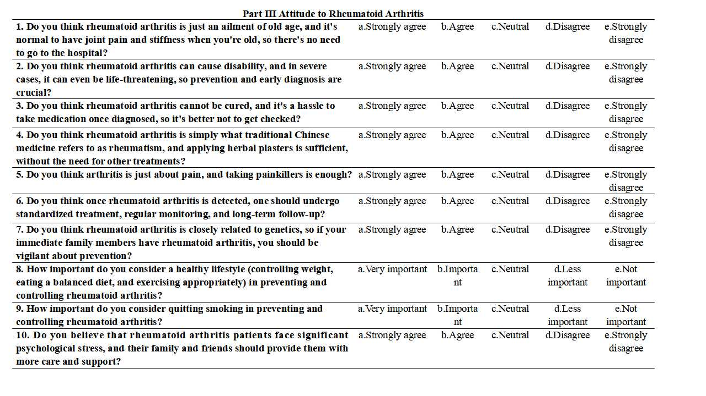
Supplemental Figure 1D. Part 3 of the questionnaire

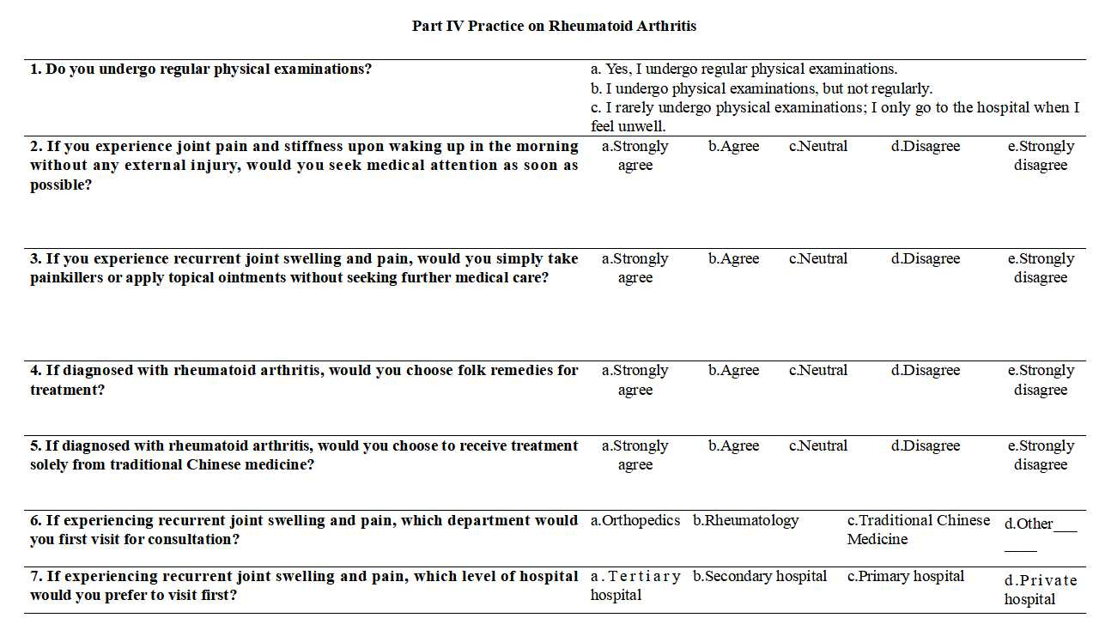
Supplemental Figure 1E. Part 4 of the questionnaire

Supplemental Table 1. Item-total correlation coefficients of knowledge, attitudes, and practices
K1 | 0.462
K2 | 0.523
K3 | 0.545
K4 | 0.554
K5 | 0.579
K6 | 0.650
K7 | 0.615
K81 | 0.588
K82 | 0.582
K83 | 0.624
K84 | 0.602
K85 | 0.605
K9 | 0.477
K10 | 0.644
K11 | 0.336
K12 | 0.569
A1 | 0.503
A2 | 0.476
A3 | 0.483
A4 | 0.370
A5 | 0.547
A6 | 0.543
A7 | 0.373
A8 | 0.636
A9 | 0.542
A10 | 0.578
P1 | 0.168
P2 | 0.261
P3 | 0.447
P4 | 0.503
P5 | 0.369

Supplemental Table 2. Post-hoc power analysis for the primary between-group comparisons
Outcome | Cohen’s d | 95% CI | Power
Knowledge | 0.207 | (-0.012, 0.426) | 0.459
Attitudes | -0.553 | (-0.774, -0.332) | 0.999
Practices | -0.299 | (-0.518, -0.079) | 0.765

Supplemental Table 3. Effect size of knowledge, attitudes, and practices
 | Knowledge | Attitudes | Practices
 | Cohen’s d/η² | Cohen’s d/η² | Cohen’s d/η²
Gender | 0.187 | 0.186 | 0.133
Male
Female
Marital status | 0.297 | 0.194 | 0.080
Unmarried/Divorced/Widowed
Married
Ethnicity | 0.207 | 0.553 | 0.299
She
Han
Residential area | 0.003 | 0.002 | 0.012
Rural/She Ethnic Group Settlement Village
Urban
Suburban/She-Han Mixed Townships
Education | 0.119 | 0.034 | 0.017
Primary school and below
Junior high school
High school/ technical school
College /bachelor’s degree
Master’s degree and above
With family member working in the medical system | 0.431 | 0.072 | 0.326
Yes
No
Monthly household income per capita, Yuan | 0.073 | 0.029 | 0.051
<2000
2000-5000
5000-10000
10000-20000
>20000
Type of health insurance | 0.030 | 0.049 | 0.023
Solely Social Medical Insurance (e.g., Employee Medical Insurance, "New Rural Cooperative Medical Scheme," "Urban Residents Basic Medical Insurance," etc.)
Solely Commercial Medical Insurance
Both Social Medical Insurance and Commercial Medical Insurance
None
Smoking
Never Smoked
Former Smoker, Now Quit
Current Smoker
Alcohol consumption | 0.036 | 0.169 | -.085
Yes
No
Diagnosis and duration of rheumatoid arthritis | 0.003 | 0.014 | 0.020
No, Never Diagnosed
Yes, Diagnosed Within the Last Year
Yes, Diagnosed Over 1 Year But Less Than 3 Years Ago
Yes, Diagnosed 3 Years Ago or More
Family history of rheumatoid arthritis | 0.062 | 0.134 | 0.169
Yes
No
Effect sizes were calculated for all group comparisons. Cohen’s d was used for t-tests and interpreted as small (0.2), medium (0.5), and large (0.8), while eta squared (η²) was used for ANOVA and interpreted as small (0.01), medium (0.06), and large (0.14).

Supplemental Table 4. Distribution of knowledge dimension responses
Knowledge | N (%)
Knowledge | Correct | Incorrect | Uncertain
1. Rheumatoid arthritis is an autoimmune disease. | 228(41.76) | 48(8.79) | 270(49.45)
2. Rheumatoid arthritis is more common in females and can occur at any age, but it is most commonly seen in individuals aged 40 to 60 years. | 278(50.92) | 44(8.06) | 224(41.03)
3. Men can also develop rheumatoid arthritis. | 11(2.01) | 384(70.33) | 151(27.66)
4. Rheumatoid arthritis is not solely an ailment of old age; it can affect younger individuals as well. | 21(3.85) | 378(69.23) | 147(26.92)
5. Research suggests that obesity not only increases the incidence of rheumatoid arthritis but also exacerbates its symptoms. | 282(51.65) | 31(5.68) | 233(42.67)
6. Research suggests that smoking not only increases the incidence of rheumatoid arthritis but also worsens its symptoms. | 263(48.17) | 33(6.04) | 250(45.79)
7. Rheumatoid arthritis primarily affects the joints but can also affect other organs in the body. | 21(3.85) | 313(57.33) | 212(38.83)
8. Which of the following are clinical manifestations of rheumatoid arthritis:
8.1 Morning stiffness: Subjective sensation of joint stiffness upon waking up in the morning. | 347(63.55) | 48(8.79) | 151(27.66)
8.2 Symmetrical joint swelling, commonly observed in joints such as the hands, feet, wrists, and ankles. | 363(66.48) | 49(8.97) | 134(24.54)
8.3 Can lead to joint deformities, resulting in varying degrees of functional impairment; it is a disabling disease. | 333(60.99) | 44(8.06) | 169(30.95)
8.4 May be accompanied by mild to moderate anemia. | 243(44.51) | 59(10.81) | 244(44.69)
8.5 May be accompanied by systemic symptoms such as weight loss, low-grade fever, and fatigue. | 247(45.24) | 64(11.72) | 235(43.04)
9. If there are suspected symptoms of rheumatoid arthritis, one should seek consultation with a rheumatology specialist. | 408(74.73) | 16(2.93) | 122(22.34)
10. Autoantibody testing is one of the important diagnostic criteria for rheumatoid arthritis. Patients may test positive for various autoantibodies such as rheumatoid factor and anti-citrullinated peptide/protein antibodies in their serum. | 297(54.4) | 6(1.1) | 243(44.51)
11. High levels of rheumatoid factor indicate rheumatoid arthritis. | 171(31.32) | 103(18.86) | 272(49.82)
12. Rheumatoid arthritis cannot be cured, but symptoms can be effectively alleviated and the progression of the disease can be controlled through standardized treatment, reducing disability rates. | 331(60.62) | 26(4.76) | 189(34.62)
13. Rheumatoid arthritis can affect not only the joints but also multiple tissues and organs throughout the body. | 334(61.17) | 10(1.83) | 202(37)

Supplemental Table 5. Distribution of attitude dimension responses
Attitude | Very agree | Agree | Neutral | Disagree | Very disagree
1. Do you think rheumatoid arthritis is just an ailment of old age, and it's normal to have joint pain and stiffness when you're old, so there's no need to go to the hospital? | 37(6.78) | 28(5.13) | 77(14.1) | 119(21.79) | 285(52.2)
2. Do you think rheumatoid arthritis can cause disability, and in severe cases, it can even be life-threatening, so prevention and early diagnosis are crucial? | 341(62.45) | 104(19.05) | 74(13.55) | 12(2.2) | 15(2.75)
3. Do you think rheumatoid arthritis cannot be cured, and it's a hassle to take medication once diagnosed, so it's better not to get checked? | 53(9.71) | 29(5.31) | 77(14.1) | 101(18.5) | 286(52.38)
4. Do you think rheumatoid arthritis is simply what traditional Chinese medicine refers to as rheumatism, and applying herbal plasters is sufficient, without the need for other treatments? | 57(10.44) | 52(9.52) | 178(32.6) | 98(17.95) | 161(29.49)
5. Do you think arthritis is just about pain, and taking painkillers is enough? | 20(3.66) | 23(4.21) | 78(14.29) | 151(27.66) | 274(50.18)
6. Do you think once rheumatoid arthritis is detected, one should undergo standardized treatment, regular monitoring, and long-term follow-up? | 335(61.36) | 112(20.51) | 73(13.37) | 12(2.2) | 14(2.56)
7. Do you think rheumatoid arthritis is closely related to genetics, so if your immediate family members have rheumatoid arthritis, you should be vigilant about prevention? | 183(33.52) | 124(22.71) | 177(32.42) | 41(7.51) | 21(3.85)
 | Very important | Important | Neutral | Less important | Not important
8. How important do you consider a healthy lifestyle (controlling weight, eating a balanced diet, and exercising appropriately) in preventing and controlling rheumatoid arthritis? | 321(58.79) | 111(20.33) | 102(18.68) | 8(1.47) | 4(0.73)
9. How important do you consider quitting smoking in preventing and controlling rheumatoid arthritis? | 285(52.2) | 117(21.43) | 125(22.89) | 15(2.75) | 4(0.73)
 | Very agree | Agree | Neutral | Disagree | Very disagree
10. Do you believe that rheumatoid arthritis patients face significant psychological stress, and their family and friends should provide them with more care and support? | 326(59.71) | 119(21.79) | 89(16.3) | 7(1.28) | 5(0.92)

Supplemental Table 6. Distribution of practice dimension responses
Practice
1. Do you undergo regular physical examinations?
a. Yes, I undergo regular physical examinations. | 180(32.97)
b. I undergo physical examinations, but not regularly. | 213(39.01)
c. I rarely undergo physical examinations; I only go to the hospital when I feel unwell. | 153(28.02)
 | a. strongly agree | b. agree | c. neutral | d. disagree | e. strongly disagree
2. If you experience joint pain and stiffness upon waking up in the morning without any external injury, would you seek medical attention as soon as possible? | 208(38.1) | 122(22.34) | 156(28.57) | 41(7.51) | 19(3.48)
3. If you experience recurrent joint swelling and pain, would you simply take painkillers or apply topical ointments without seeking further medical care? | 54(9.89) | 113(20.7) | 134(24.54) | 118(21.61) | 127(23.26)
4. If diagnosed with rheumatoid arthritis, would you choose folk remedies for treatment? | 47(8.61) | 79(14.47) | 190(34.8) | 126(23.08) | 104(19.05)
5. If diagnosed with rheumatoid arthritis, would you choose to receive treatment solely from traditional Chinese medicine? | 81(14.84) | 93(17.03) | 215(39.38) | 84(15.38) | 73(13.37)
6. If experiencing recurrent joint swelling and pain, which department would you first visit for consultation?
a. Orthopedics | 152(27.84)
b. Rheumatology | 344(63)
c. Traditional Chinese Medicine | 48(8.79)
d. Other_______ | 2(0.37)
7. If experiencing recurrent joint swelling and pain, which level of hospital would you prefer to visit first?
a. Tertiary hospital | 352(64.47)
b. Secondary hospital | 87(15.93)
c. Primary hospital | 97(17.77)
d. Private hospital | 10(1.83)

Supplemental Table 7. Unadjusted SEM model fit
Indicators | Reference | Results
RMSEA | <0.08 Good | 0.067
SRMR | <0.08 Good | 0.023
TLI | >0.8 Good | 0.801
CFI | >0.8 Good | 0.947

Supplemental Table 8. Unadjusted SEM model
Structural |  | Estimate | P>|z|
Asum <-
 | Ksum | 0.39 | <0.001
 | Ethnicity | 3.98 | <0.001
 | Education | -0.13 | 0.634
 | Type of Medical Insurance | -0.38 | 0.148
 | With family member working in the medical system | 0.66 | 0.289
 | Income | 0.08 | 0.792
 | Smoking | -0.79 | 0.052
 | Diagnosis duration of Rheumatoid Arthritis | 0.35 | 0.076
Psum <-
 | Asum | 0.25 | <0.001
 | Ksum | 0.08 | 0.005
 | Ethnicity | 0.20 | 0.598
 | Type of Medical Insurance | 0.22 | 0.143
 | With family member working in the medical system | -0.70 | 0.045
 | Income | 0.58 | <0.001
 | Diagnosis duration of Rheumatoid Arthritis | 0.18 | 0.093
Ksum <-
 | Gender | 1.01 | 0.049
 | Education | 1.36 | <0.001
 | Type of Medical Insurance | -0.41 | 0.086
 | With family member working in the medical system | -1.52 | 0.007
 | Income | 0.36 | 0.196
 | Smoking | -0.80 | 0.045
 | Marital Status | -0.60 | 0.235
The bolded P values indicate statistical significance at the threshold of less than 0.05.

