Appendix: Nicotine Metabolism and Chronic Obstructive Pulmonary Disease: Mendelian randomization and phenotypic characterization analysis

Supplementary Table 1. Two-sample Mendelian randomization instrument variables for FINN_COPD........................................................................................................... 3

Supplementary Table 2. Two-sample Mendelian randomization instrument variables for MVP_COPD............................................................................................................ 5

Supplementary Table 3. Egger regression and MR-PRESSO analyses for horizontal pleiotropy....................................................................................................................... 7

Supplementary Table 4. Details of the reverse Mendelian Randomization (MR).......8

Supplementary Table 5. Egger regression and MR-PRESSO analyses for horizontal pleiotropy for Early-and Later-Onset COPD.................................................................8

Supplementary Table 6. Stratified Mendelian Randomization Estimates for Early- and Later-Onset COPD............................................................................................... 9

Supplementary Table 7. Results of colocalization analysis showing evidence for shared causal variants (PPH₄) in the main analysis..................................................... 10

Supplementary Figure 1. Mendelian randomization scatter plots of SNP-specific associations with NMR and COPD……………………............................................. 11

Supplementary Figure 2. Forest plot of single-nucleotide polymorphisms (SNPs) associated with NMR and risk of FINN_COPD......................................................... 12

Supplementary Figure 3. Forest plot of single-nucleotide polymorphisms (SNPs) associated with NMR and risk of MVP_COPD.......................................................... 12

Supplementary Figure 4. Leave-one-out analysis plot of inverse-variance weighted two-sample Mendelian randomization between NMR and FINN_COPD.................. 13

Supplementary Figure 5. Leave-one-out analysis plot of inverse-variance weighted two-sample Mendelian randomization between NMR and MVP_COPD................... 13

Supplementary Figure 6. Funnel plot from single SNP analysis of the two-sample MR............................................................................................................................... 14

Supplementary Figure 7. Colocalization analysis of NMR and COPD……........... 14

Supplementary Figure 8. Trends in COPD prevalence across equivalent levels of smoking exposure by nicotine metabolism phenotype…………………….…........... 15

Supplementary Table 1. Two-sample Mendelian randomization instrument variables for FINN_COPD
SNP | effect_allele | other_allele | EAF | SE | P | F
rs10408639 | G | A | 0.945521 | 0.04525 | 4.7e-08 | 31
rs1042389 | C | T | 0.213763 | 0.024473 | 1.25e-08 | 32
rs10425738 | A | G | 0.733445 | 0.022267 | 2.79e-50 | 219
rs112292570 | T | A | 0.021651 | 0.069676 | 2.42e-53 | 249
rs112298060 | C | T | 0.050106 | 0.066057 | 7.77e-09 | 68
rs112298484 | G | A | 0.01738 | 0.07883 | 7.57e-19 | 83
rs11538385 | T | C | 0.248017 | 0.022779 | 5.41e-23 | 93
rs11667982 | A | G | 0.15805 | 0.028224 | 3.27e-12 | 51
rs11672825 | G | T | 0.451918 | 0.020408 | 3.87e-08 | 31
rs11673605 | A | G | 0.119934 | 0.030212 | 1.78e-16 | 65
rs117284921 | C | T | 0.03577 | 0.054341 | 3.66e-16 | 67
rs117398851 | A | G | 0.01741 | 0.105556 | 8.5e-12 | 88
rs118038652 | C | T | 0.050229 | 0.044011 | 1.7e-25 | 100
rs11881522 | A | G | 0.025432 | 0.066956 | 1.02e-08 | 36
rs12976199 | A | C | 0.235391 | 0.023634 | 6.1e-11 | 42
rs13115399 | T | C | 0.294029 | 0.027519 | 7.94e-09 | 52
rs138807235 | T | C | 0.069963 | 0.055346 | 1.59e-09 | 72
rs141250326 | A | G | 0.033467 | 0.068343 | 2.55e-09 | 52
rs143353161 | T | C | 0.054728 | 0.062457 | 1.21e-09 | 73
rs143483572 | T | C | 0.01907 | 0.116153 | 2.85e-11 | 111
rs144074015 | T | C | 0.021744 | 0.08346 | 2.41e-08 | 45
rs145384113 | T | C | 0.019641 | 0.094517 | 1.45e-08 | 54
rs147915270 | C | A | 0.05323 | 0.054072 | 8.62e-12 | 68
rs148103807 | T | C | 0.031348 | 0.059319 | 9.57e-11 | 44
rs149293272 | A | G | 0.069591 | 0.040275 | 2.59e-09 | 36
rs149812270 | C | A | 0.022827 | 0.066099 | 2.08e-37 | 160
rs1645678 | G | A | 0.739326 | 0.023567 | 1.79e-09 | 38
rs17726493 | T | C | 0.161841 | 0.0276 | 8.22e-19 | 80
rs190003323 | A | T | 0.01689 | 0.076272 | 4.47e-09 | 32
rs191070943 | T | C | 0.058102 | 0.060189 | 3.07e-11 | 87
rs2042936 | A | G | 0.370021 | 0.020346 | 9.76e-47 | 201
rs2075304 | G | C | 0.118286 | 0.032313 | 1.77e-09 | 38
rs234368 | G | T | 0.438954 | 0.024079 | 6.92e-12 | 66
rs2561537 | G | A | 0.528694 | 0.019734 | 5.28e-20 | 80
rs2604905 | C | A | 0.059254 | 0.041753 | 3.29e-11 | 42
rs3181842 | T | C | 0.601612 | 0.020665 | 7.97e-35 | 156
rs34638591 | C | T | 0.570088 | 0.02457 | 1.26e-12 | 74
rs34801664 | T | C | 0.138926 | 0.045959 | 1.66e-08 | 80
rs36012476 | C | G | 0.045018 | 0.047831 | 7.26e-16 | 63
rs3760923 | C | T | 0.15179 | 0.027407 | 3.98e-08 | 28
rs3844449 | C | T | 0.830212 | 0.026735 | 6.9e-34 | 149
rs4802082 | T | C | 0.046961 | 0.046837 | 2.62e-27 | 115
rs4803356 | G | C | 0.057548 | 0.042994 | 2.62e-33 | 146
rs4803408 | T | C | 0.016753 | 0.087059 | 9.55e-13 | 63
rs530366 | G | A | 0.170702 | 0.026673 | 2.27e-10 | 40
rs55978439 | A | T | 0.208258 | 0.024937 | 6.62e-57 | 266
rs56113850 | C | T | 0.552548 | 0.019773 | 5.54e-261 | 1457
rs56185718 | C | T | 0.267062 | 0.022731 | 6.57e-36 | 159
rs62107913 | T | C | 0.220432 | 0.023608 | 6.59e-23 | 92
rs62117431 | G | A | 0.072323 | 0.055831 | 7.26e-11 | 88
rs6413474 | C | T | 0.021795 | 0.082359 | 9.81e-16 | 93
rs68191109 | C | T | 0.395548 | 0.022225 | 1.88e-08 | 37
rs71358941 | G | C | 0.045601 | 0.050249 | 3.71e-10 | 42
rs7255817 | G | A | 0.452455 | 0.019702 | 1.31e-18 | 74
rs7257854 | C | T | 0.379552 | 0.020238 | 2.02e-64 | 286
rs73034456 | T | C | 0.089991 | 0.042532 | 1.63e-16 | 100
rs73042681 | C | G | 0.020986 | 0.084931 | 4.52e-08 | 44
rs73045487 | C | G | 0.169429 | 0.026378 | 4.38e-19 | 77
rs73048936 | G | A | 0.039663 | 0.063135 | 2.28e-08 | 47
rs74429191 | C | T | 0.048082 | 0.056616 | 7.58e-10 | 55
rs74723889 | T | C | 0.028486 | 0.092862 | 1.74e-11 | 108
rs7507400 | T | G | 0.356392 | 0.02981 | 8.95e-36 | 331
rs75762823 | T | C | 0.053053 | 0.054094 | 1.31e-08 | 47
rs78148277 | A | G | 0.027775 | 0.061826 | 1.12e-14 | 61
rs7937 | T | C | 0.596432 | 0.019807 | 6.65e-82 | 363
rs79436912 | G | A | 0.081885 | 0.03636 | 3.93e-21 | 88
rs8107329 | T | C | 0.363641 | 0.021918 | 8.89e-27 | 127
rs8113056 | A | G | 0.209292 | 0.024115 | 7.81e-37 | 156

Supplementary Table 2. Two-sample Mendelian randomization instrument variables for MVP_COPD
SNP | effect_allele | other_allele | EAF | SE | P | F
rs10408639 | G | A | 0.945521 | 0.04525 | 4.7e-08 | 31
rs1042389 | C | T | 0.213763 | 0.024473 | 1.25e-08 | 32
rs10425738 | A | G | 0.733445 | 0.022267 | 2.79e-50 | 219
rs112292570 | T | A | 0.021651 | 0.069676 | 2.42e-53 | 249
rs112298060 | C | T | 0.050106 | 0.066057 | 7.77e-09 | 68
rs112298484 | G | A | 0.01738 | 0.07883 | 7.57e-19 | 83
rs113421706 | G | A | 0.129579 | 0.030429 | 2.01e-12 | 51
rs11538385 | T | C | 0.248017 | 0.022779 | 5.41e-23 | 94
rs11667982 | A | G | 0.15805 | 0.028224 | 3.27e-12 | 51
rs117284921 | C | T | 0.03577 | 0.054341 | 3.66e-16 | 67
rs117398851 | A | G | 0.01741 | 0.105556 | 8.5e-12 | 88
rs117824460 | G | A | 0.037001 | 0.067626 | 4.03e-52 | 396
rs118038652 | C | T | 0.050229 | 0.044011 | 1.7e-25 | 100
rs11881522 | A | G | 0.025432 | 0.066956 | 1.02e-08 | 36
rs12151196 | G | A | 0.303326 | 0.02201 | 2.2e-45 | 208
rs12976199 | A | C | 0.235391 | 0.023634 | 6.1e-11 | 42
rs13115399 | T | C | 0.294029 | 0.027519 | 7.94e-09 | 52
rs138807235 | T | C | 0.069963 | 0.055346 | 1.59e-09 | 72
rs143353161 | T | C | 0.054728 | 0.062457 | 1.21e-09 | 74
rs143483572 | T | C | 0.01907 | 0.116153 | 2.85e-11 | 111
rs144074015 | T | C | 0.021744 | 0.08346 | 2.41e-08 | 45
rs145384113 | T | C | 0.019641 | 0.094517 | 1.45e-08 | 55
rs148103807 | T | C | 0.031348 | 0.059319 | 9.57e-11 | 44
rs149293272 | A | G | 0.069591 | 0.040275 | 2.59e-09 | 36
rs149812270 | C | A | 0.022827 | 0.066099 | 2.08e-37 | 160
rs190003323 | A | T | 0.01689 | 0.076272 | 4.47e-09 | 33
rs191070943 | T | C | 0.058102 | 0.060189 | 3.07e-11 | 87
rs2042936 | A | G | 0.370021 | 0.020346 | 9.76e-47 | 202
rs2075304 | G | C | 0.118286 | 0.032313 | 1.77e-09 | 39
rs2561537 | G | A | 0.528694 | 0.019734 | 5.28e-20 | 81
rs2604905 | C | A | 0.059254 | 0.041753 | 3.29e-11 | 42
rs28399433 | C | A | 0.09386 | 0.033614 | 5.32e-96 | 441
rs3181842 | T | C | 0.601612 | 0.020665 | 7.97e-35 | 156
rs34638591 | C | T | 0.570088 | 0.02457 | 1.26e-12 | 74
rs34801664 | T | C | 0.138926 | 0.045959 | 1.66e-08 | 80
rs36012476 | C | G | 0.045018 | 0.047831 | 7.26e-16 | 63
rs3844449 | C | T | 0.830212 | 0.026735 | 6.9e-34 | 149
rs4802082 | T | C | 0.046961 | 0.046837 | 2.62e-27 | 115
rs4803356 | G | C | 0.057548 | 0.042994 | 2.62e-33 | 146
rs4803408 | T | C | 0.016753 | 0.087059 | 9.55e-13 | 63
rs530366 | G | A | 0.170702 | 0.026673 | 2.27e-10 | 39
rs55978439 | A | T | 0.208258 | 0.024937 | 6.62e-57 | 266
rs56113850 | C | T | 0.552548 | 0.019773 | 5.54e-261 | 1457
rs56185718 | C | T | 0.267062 | 0.022731 | 6.57e-36 | 159
rs62107913 | T | C | 0.220432 | 0.023608 | 6.59e-23 | 92
rs62117431 | G | A | 0.072323 | 0.055831 | 7.26e-11 | 88
rs6413474 | C | T | 0.021795 | 0.082359 | 9.81e-16 | 92
rs68191109 | C | T | 0.395548 | 0.022225 | 1.88e-08 | 37
rs71358941 | G | C | 0.045601 | 0.050249 | 3.71e-10 | 42
rs7257854 | C | T | 0.379552 | 0.020238 | 2.02e-64 | 286
rs73045487 | C | G | 0.169429 | 0.026378 | 4.38e-19 | 77
rs73048936 | G | A | 0.039663 | 0.063135 | 2.28e-08 | 47
rs74429191 | C | T | 0.048082 | 0.056616 | 7.58e-10 | 55
rs74723889 | T | C | 0.028486 | 0.092862 | 1.74e-11 | 108
rs75762823 | T | C | 0.053053 | 0.054094 | 1.31e-08 | 47
rs78148277 | A | G | 0.027775 | 0.061826 | 1.12e-14 | 61
rs7937 | T | C | 0.596432 | 0.019807 | 6.65e-82 | 363
rs8107329 | T | C | 0.363641 | 0.021918 | 8.89e-27 | 128
rs8113056 | A | G | 0.209292 | 0.024115 | 7.81e-37 | 156

Supplementary Table 3. Egger regression and MR-PRESSO analyses for horizontal pleiotropy
Dataset | Egger-intercept | Egger-SE | Egger P-value | MR-PRESSO Global Test
FINN_COPD | -0.0024 | 0.0044 | 0.58 | 0.18
MVP_COPD | -0.0045 | 0.0028 | 0.12 | 0.79

Supplementary Table 4. Details of the reverse Mendelian Randomization (MR)
Datasets | IV Thresholds | Methods | IVs | P-value
FINN_COPD | 5×10⁻⁸ | Inverse variance weighted | 44 | 0.709
 |  | Maximum likelihood |  | 0.702
 |  | MR-Egger |  | 0.542
 |  | MR-RAPS |  | 0.809
 |  | MR-PRESSO |  | 0.892
MVP_COPD | 5×10⁻⁸ | Inverse variance weighted | 169 | 0.151
 |  | Maximum likelihood |  | 0.027
 |  | MR-Egger |  | 0.110
 |  | MR-RAPS |  | 0.425
 |  | MR-PRESSO |  | 0.272

Supplementary Table 5. Stratified Mendelian Randomization Estimates for Early- and Later-Onset COPD
Methods | FINN_EARLY_COPD |  |  | FINN_LATER_COPD
Methods | IVs | OR (95%CI) | P-value | IVs | OR (95%CI) | P-value
Inverse variance weighted | 69 | 1.118(1.099,1.136) | ＜0.001 | 60 | 1.026(1.009,1.042) | 0.001
Maximum likelihood |  | 1.122(1.103,1.143) | ＜0.001 |  | 1.025(1.010,1.041) | 0.001
MR-Egger |  | 1.118(1.099,1.137) | ＜0.001 |  | 1.031(0.997,1.067) | 0.081
MR-RAPS |  | 1.118(1.100,1.136) | ＜0.001 |  | 1.025(1.009,1.042) | ＜0.001
MR-PRESSO |  | 1.138(1.097,1.180) | ＜0.001 |  | 1.025(1.011,1.040) | ＜0.001

Supplementary Table 6. Egger regression and MR-PRESSO analyses for horizontal pleiotropy for Early-and Later-Onset COPD
Dataset | Egger-intercept | Egger-SE | Egger P-value | MR-PRESSO Global Test
FINN_EARLY | -0.0064 | 0.0059 | 0.28 | 0.59
FINN_LATER | -0.0019 | 0.0054 | 0.73 | 0.90

Supplementary Table 7. Results of colocalization analysis showing evidence for shared causal variants (PPH₄) in the main analysis.
Dataset | nSNPs | PP.H0.abf | PP.H1.abf | PP.H2.abf | PP.H3.abf | PP.H4.abf | SNP | Located_Gene
FINN_COPD | 2406 | 2.549E-92 | 2.038E-03 | 7.989E-91 | 6.295E-02 | 9.350E-01 | rs8102683 | EGLN2(downstream), CYP2A6(upstream)
MVP_COPD | 1235 | 7.670E-259 | 2.590E-09 | 4.043E-251 | 1.357E-01 | 8.643E-01 | rs56113850 | CYP2A6
 | 1408 | 3.444E-95 | 2.935E-06 | 6.383E-92 | 4.444E-03 | 9.956E-01 | rs12610432 | EGLN2(downstream), CYP2A6(upstream)
 | 1202 | 6.573E-76 | 2.793E-02 | 3.361E-76 | 1.332E-02 | 9.588E-01 | rs7937 | RAB4B-EGLN2

Supplementary Figure 1. Mendelian randomization scatter plots of SNP-specific associations with NMR and COPD. Note: (A) FinnGen dataset (B) MVP dataset
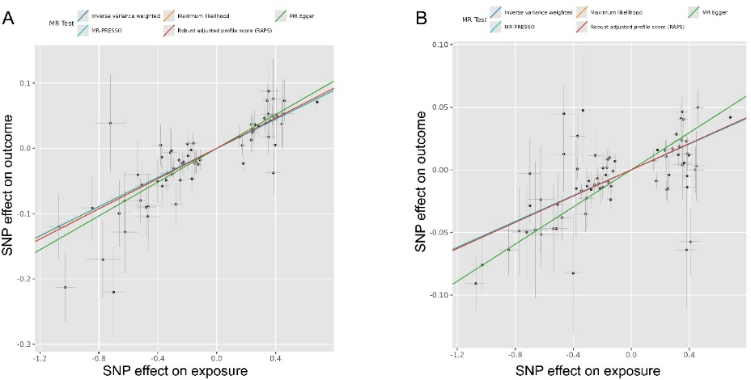

Supplementary Figure 2. Forest plot of single-nucleotide polymorphisms (SNPs) associated with NMR and risk of FINN_COPD.
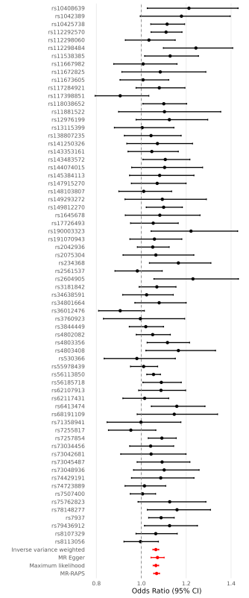
Supplementary Figure 3. Forest plot of single-nucleotide polymorphisms (SNPs) associated with NMR and risk of MVP_COPD.
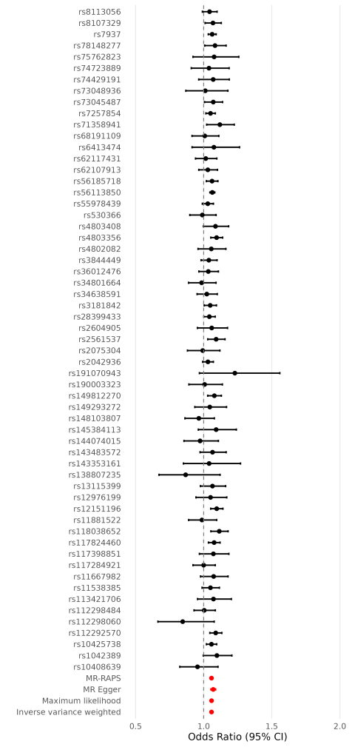
Supplementary Figure 4. Leave-one-out analysis plot of inverse-variance weighted two-sample Mendelian randomization between NMR and FINN_COPD.
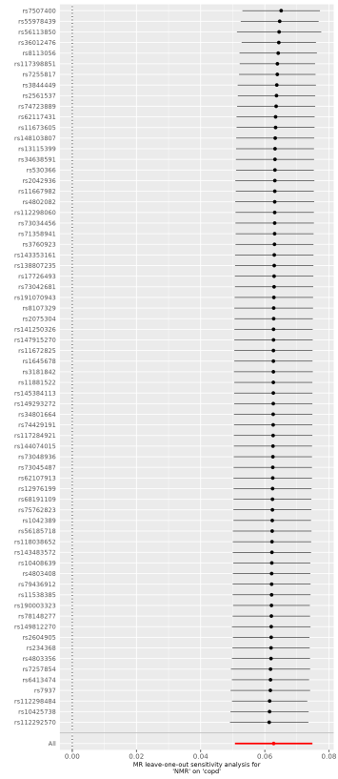
Supplementary Figure 5. Leave-one-out analysis plot of inverse-variance weighted two-sample Mendelian randomization between NMR and MVP_COPD.
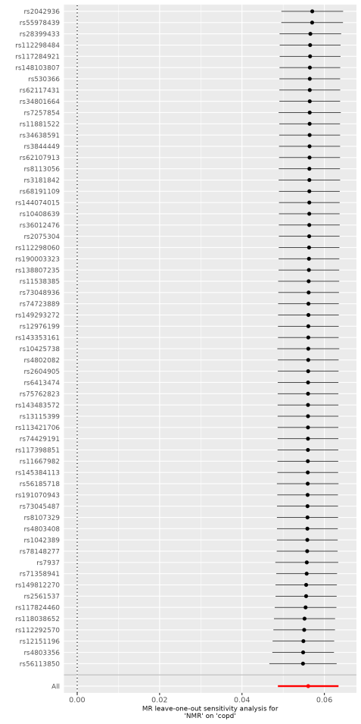
Supplementary Figure 6. Funnel plot from single SNP analysis of the two-sample Mendelian Randomization (MR). Note: (A) FinnGen dataset (B) MVP dataset
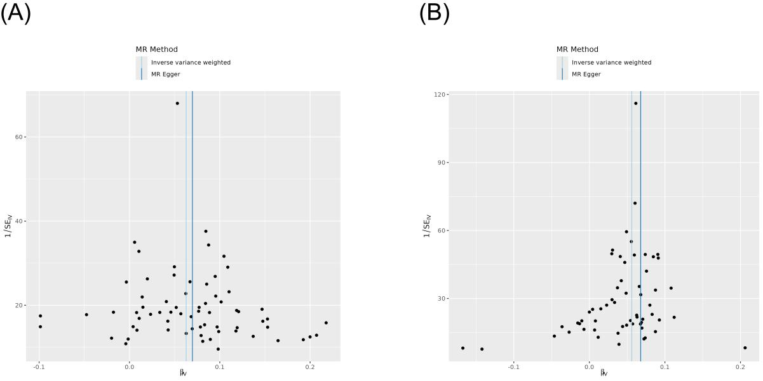

Supplementary Figure 7. Colocalization analysis of NMR and COPD.
Note: Colocalization plots for the CYP2A6–EGLN2 locus across multiple COPD GWAS datasets, highlighting lead SNPs (rs8102683, rs7937, rs56113850, and rs12610432) with high posterior probability of colocalization (PPH4). (A) FinnGen dataset; (B-D) MVP dataset.
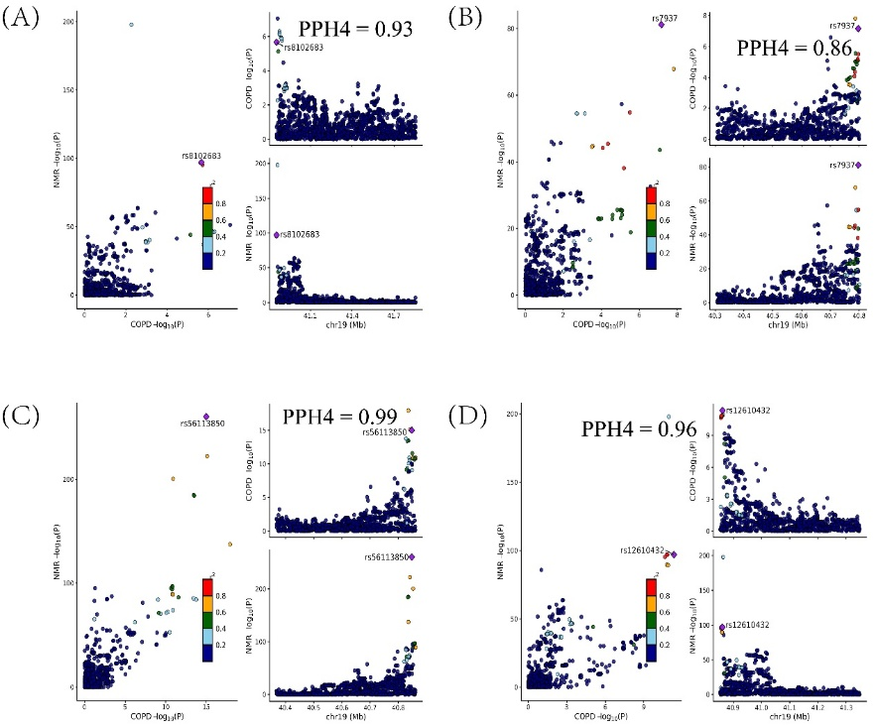

Supplementary Figure 8. Trends in COPD prevalence across equivalent levels of smoking exposure by nicotine metabolism phenotype.
