Supplementary Files

Table S1. Sensitivity, Specificity, Positive Predictive Value (PPV), and Negative Predictive Value (NPV) of the Quantitative-CERT (Q-CERT).
Q-CERT Total Scores | Sensitivity, % | Specificity, % | PPV, % | NPV, %
1 | 100 | 59.2 | 75.2 | 100
2 | 100 | 63.1 | 77.0 | 100
3 | 100 | 70.8 | 80.9 | 100
4 | 96.9 | 74.6 | 82.5 | 95.1
5 | 89.4 | 83.8 | 87.3 | 86.5
6 | 78.9 | 93.1 | 93.4 | 78.1
7 | 69.6 | 95.4 | 94.9 | 71.7
8 | 59.6 | 100 | 100 | 66.7
9 | 45.3 | 100 | 100 | 59.6
10 | 36.6 | 100 | 100 | 56.0
11 | 31.7 | 100 | 100 | 54.2
12 | 23.6 | 100 | 100 | 51.4
13 | 17.4 | 100 | 100 | 49.4
14 | 7.5 | 100 | 100 | 46.6
15 | 3.7 | 100 | 100 | 45.6

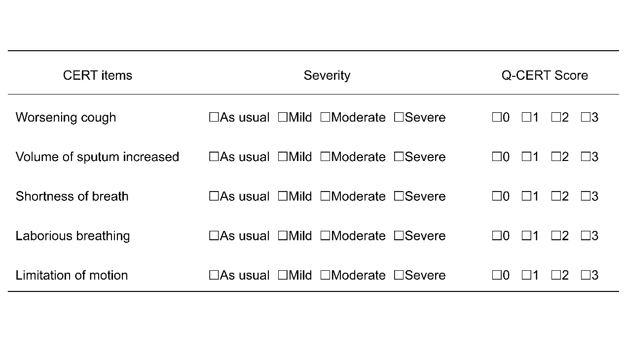
Figure S1. CERT and Q-CERT Items for Recognizing COPD Exacerbations. COPD, Chronic obstructive pulmonary disease; CERT, Clinical COPD exacerbation recognition tool; Q-CERT, Quantitative-CERT.

