Association of the Systemic Inflammation Response Index (SIRI) with the One-Year All-Cause Mortality in Elderly Patients with Acute Coronary Syndrome: A Retrospective Cohort Study

Supplementary Table S1. The incidence and distribution of MACCE
Type of MACCE | Low SIRI Group (n, %) | High SIRI Group (n, %)
all-cause mortality | 45 (9.34) | 87 (18.10)
recurrent myocardial infarction | 20 (4.15) | 13 (2.70)
ischemic stroke | 24 (4.98) | 31 (6.44)
heart failure rehospitalization | 12 (2.49) | 28 (5.82)
revascularization or in-stent thrombosis of the same vessel | 2 (0.42) | 2 (0.42)
malignant arrhythmia | 5 (1.04) | 13 (2.70)
Abbreviations: MACCE, major adverse cardiovascular and cerebrovascular events; SIRI, systemic inflammation response index.

Supplementary Table S2. Association between SIRI and one-year all-cause mortality in patients aged ≥ 65 years (N = 769)
Groups | Medel 0ª  HR (95% CI) | Model 1^{b}  HR (95% CI) | Model 2^{c}  HR (95% CI) | Model 3^{d}  HR (95% CI)
Continuous SIRI (per 1.0 × 10⁹/L increase) | 1.051 (1.036-1.067) *** | 1.046 (1.030-1.063) *** | 1.044 (1.028-1.061) *** | 1.027 (1.009-1.045) **
Low SIRI group (SIRI≤2.93× 10⁹/L) | 1.0 (ref) | 1.0 (ref) | 1.0 (ref) | 1.0 (ref)
High SIRI group (SIRI>2.93× 10⁹/L) | 1.902 (1.307-2.768) *** | 1.725 (1.179-2.524) ** | 1.666 (1.130-2.456) ** | 1.524 (1.031-2.253) *
Notes: ***P< 0.001, **P< 0.01, *P< 0.05. ªModel 0: unadjusted. ^{b}Model 1: adjusted for demographics (age, sex, body mass index, smoking). ^{c}Model 2: adjusted for demographic, type of acute coronary syndrome, and comorbidities (hypertension, dyslipidemia, diabetes). ^{d}Model 3: adjusted for demographics, type of acute coronary syndrome, comorbidities, and treatments (PCI, aspirin, beta‑blockers, and statins).
Abbreviations: CI, confidence interval; HR, hazard ratio; ref, reference; SIRI, systemic inflammation response index.

Supplementary Table S3. Baseline characteristics of the cohort with missing and known outcomes
Characteristics | Patients with known outcomes (N = 963) | Patients with missing outcome data (N=21) | P-value
Age (years) | 73.0 (66.0, 80.0) | 77.1 (9.2) | 0.05
Sex |  |  | 1
Female | 294 (31.0%) | 6 (28.6%)
Male | 669 (69.0%) | 15 (71.4%)
BMI |  |  | 0.007
Missing | 562 (58.4%) | 19 (90.5%)
＜25 (kg/m²) | 293 (30.4%) | 1 (4.8%)
≥25 (kg/m²) | 108 (11.2%) | 1 (4.8%)
Smoking |  |  | 0.3
Yes | 186 (19.3%) | 6 (28.6%)
No | 777 (80.7%) | 15 (71.4%)
Drinking |  |  | 1
Yes | 57 (5.9%) | 1 (4.8%)
No | 906 (94.1%) | 20 (95.2%)
Previous ACS |  |  | 1
Yes | 25 (2.6%) | 0
No | 938 (97.4%) | 21 (100%)
Hypertension |  |  | 0.8
Yes | 476 (49.4%) | 11 (52.4%)
No | 487 (50.6%) | 10 (47.6%)
Dyslipidemia |  |  | 1
Yes | 185 (19.2%) | 4 (19%)
No | 778 (80.8%) | 17 (81%)
Diabetes |  |  | 0.2
Yes | 284 (29.5%) | 3 (14.3%)
No | 679 (70.5%) | 18 (85.7%)
Stroke |  |  | 0.6
Yes | 40 (4.2%) | 1 (4.8%)
No | 923 (95.8%) | 20 (95.2%)
HF |  |  | 0.6
Yes | 61 (6.3%) | 2 (9.5%)
No | 902 (93.7%) | 19 (90.5%)
AF |  |  | 0.07
Yes | 102 (10.6%) | 5 (23.8%)
No | 861 (89.4%) | 16 (76.2%)
Type of ACS |  |  | 0.5
STEMI | 441 (45.8%) | 9 (42.9%)
NSTEMI | 446 (46.3%) | 12 (57.1%)
UA | 76 (7.9%) | 0
WBC (×10⁹/L) | 9.3 (7.4, 11.7) | 11.26 (4.4) | 0.2
RBC (×10¹²/L) | 4.44 (3.99, 4.91) | 4.44 (0.73) | 0.9
Lymphocyte (×10⁹/L) | 1.33 (0.93, 1.88) | 1.41 (0.68-1.74) | 0.3
Monocyte (×10⁹/L) | 0.60 (0.43, 0.83) | 0.64 (0.26) | 0.9
Neutrophils (×10⁹/L) | 6.8 (5.0, 9.5) | 8.15 (5.67-10.64) | 0.1
PLT (×10⁹/L) | 230 (192, 272) | 250.38 (77.28) | 0.4
TC (mmol/L) | 4.74 (3.89, 5.61) | 4.88 (1.14) | 0.7
TG (mmol/L) | 1.21 (0.91, 1.64) | 1.09 (0.87-1.45) | 0.6
HDL-C (mmol/L) | 1.08 (0.91, 1.27) | 1.21 (0.4) | 0.4
LDL-C (mmol/L) | 3.00 (2.24, 3.81) | 3.01 (1.07) | 0.9
FPG (mmol/L) | 6.3 (5.2, 8.5) | 6.71 (5.5-9.56) | 0.6
PCI |  |  | 0.8
Yes | 622 (64.6%) | 13 (61.9%)
No | 341 (35.4%) | 8 (38.1%)
Aspirin |  |  | 0.07
Yes | 433 (45.0%) | 5 (23.8%)
No | 530 (55.0%) | 16 (76.2%)
Clopidogrel/ ticagrelor |  |  | <0.001
Yes | 818 (84.9%) | 9 (42.9%)
No | 145 (15.1%) | 12 (57.1%)
Nitric acid ester |  |  | 0.4
Yes | 65 (6.7%) | 0
No | 898 (93.3%) | 21 (100%)
ACEI |  |  | 1
Yes | 6 (0.6%) | 0
No | 957 (99.4%) | 21 (100%)
ARB |  |  | 0.4
Yes | 73 (7.6%) | 0
No | 890 (92.4%) | 21 (100%)
CCB |  |  | 0.4
Yes | 69 (7.2%) | 0
No | 894 (92.8%) | 21 (100%)
Beta-blockers |  |  | 0.3
Yes | 372 (38.6%) | 5 (23.8%)
No | 591 (61.4%) | 16 (76.2%)
Statins |  |  | <0.001
Yes | 790 (82.0%) | 9 (42.9%)
No | 173 (18.0%) | 12 (57.1%)
Ezetimibe |  |  | 0.3
Yes | 136 (14.1%) | 1 (4.8%)
No | 827 (85.9%) | 20 (95.2%)
Notes: Continuous variables are presented as mean ± SD or median (first quartile to third quartile). Categorical variables are presented as number (percentage, %).
Abbreviations: ACEI, angiotensin-converting enzyme inhibitor; ACS, acute coronary syndrome; AF, atrial fibrillation; ARB, angiotensin II receptor blocker; BMI, body mass index; CCB, calcium channel blocker; FPG, fasting plasma glucose; HDL-C, high-density lipoprotein cholesterol; HF, heart failure; LDL-C, low-density lipoprotein cholesterol; PCI, percutaneous coronary intervention; PLT, platelet; RBC, red blood cell; SIRI, systemic inflammation response index; STEMI, ST elevation myocardial infarction; TC, total cholesterol; TG, triglyceride; UA, unstable angina; NSTEMI, non-ST elevation myocardial infarction; WBC, white blood cell.

Supplementary Figure S1. Diagnostic plots for multiple imputation.
Abbreviations: FPG, fasting plasma glucose; HDL, high-density lipoprotein; LDL, low-density lipoprotein; TC, total cholesterol; TG, triglycerides.

Supplementary Figure S2. The association of SIRI with all-cause mortality visualized by restricted cubic spline.
Abbreviations: CI, confidence interval; HR, hazard ratio; SIRI, systemic inflammation response index.

Supplementary Figure S3. The association of SIRI with MACCE visualized by restricted cubic spline.
Abbreviations: CI, confidence interval; HR, hazard ratio; MACCE, major adverse cardiovascular and cerebrovascular events; SIRI, systemic inflammation response index.
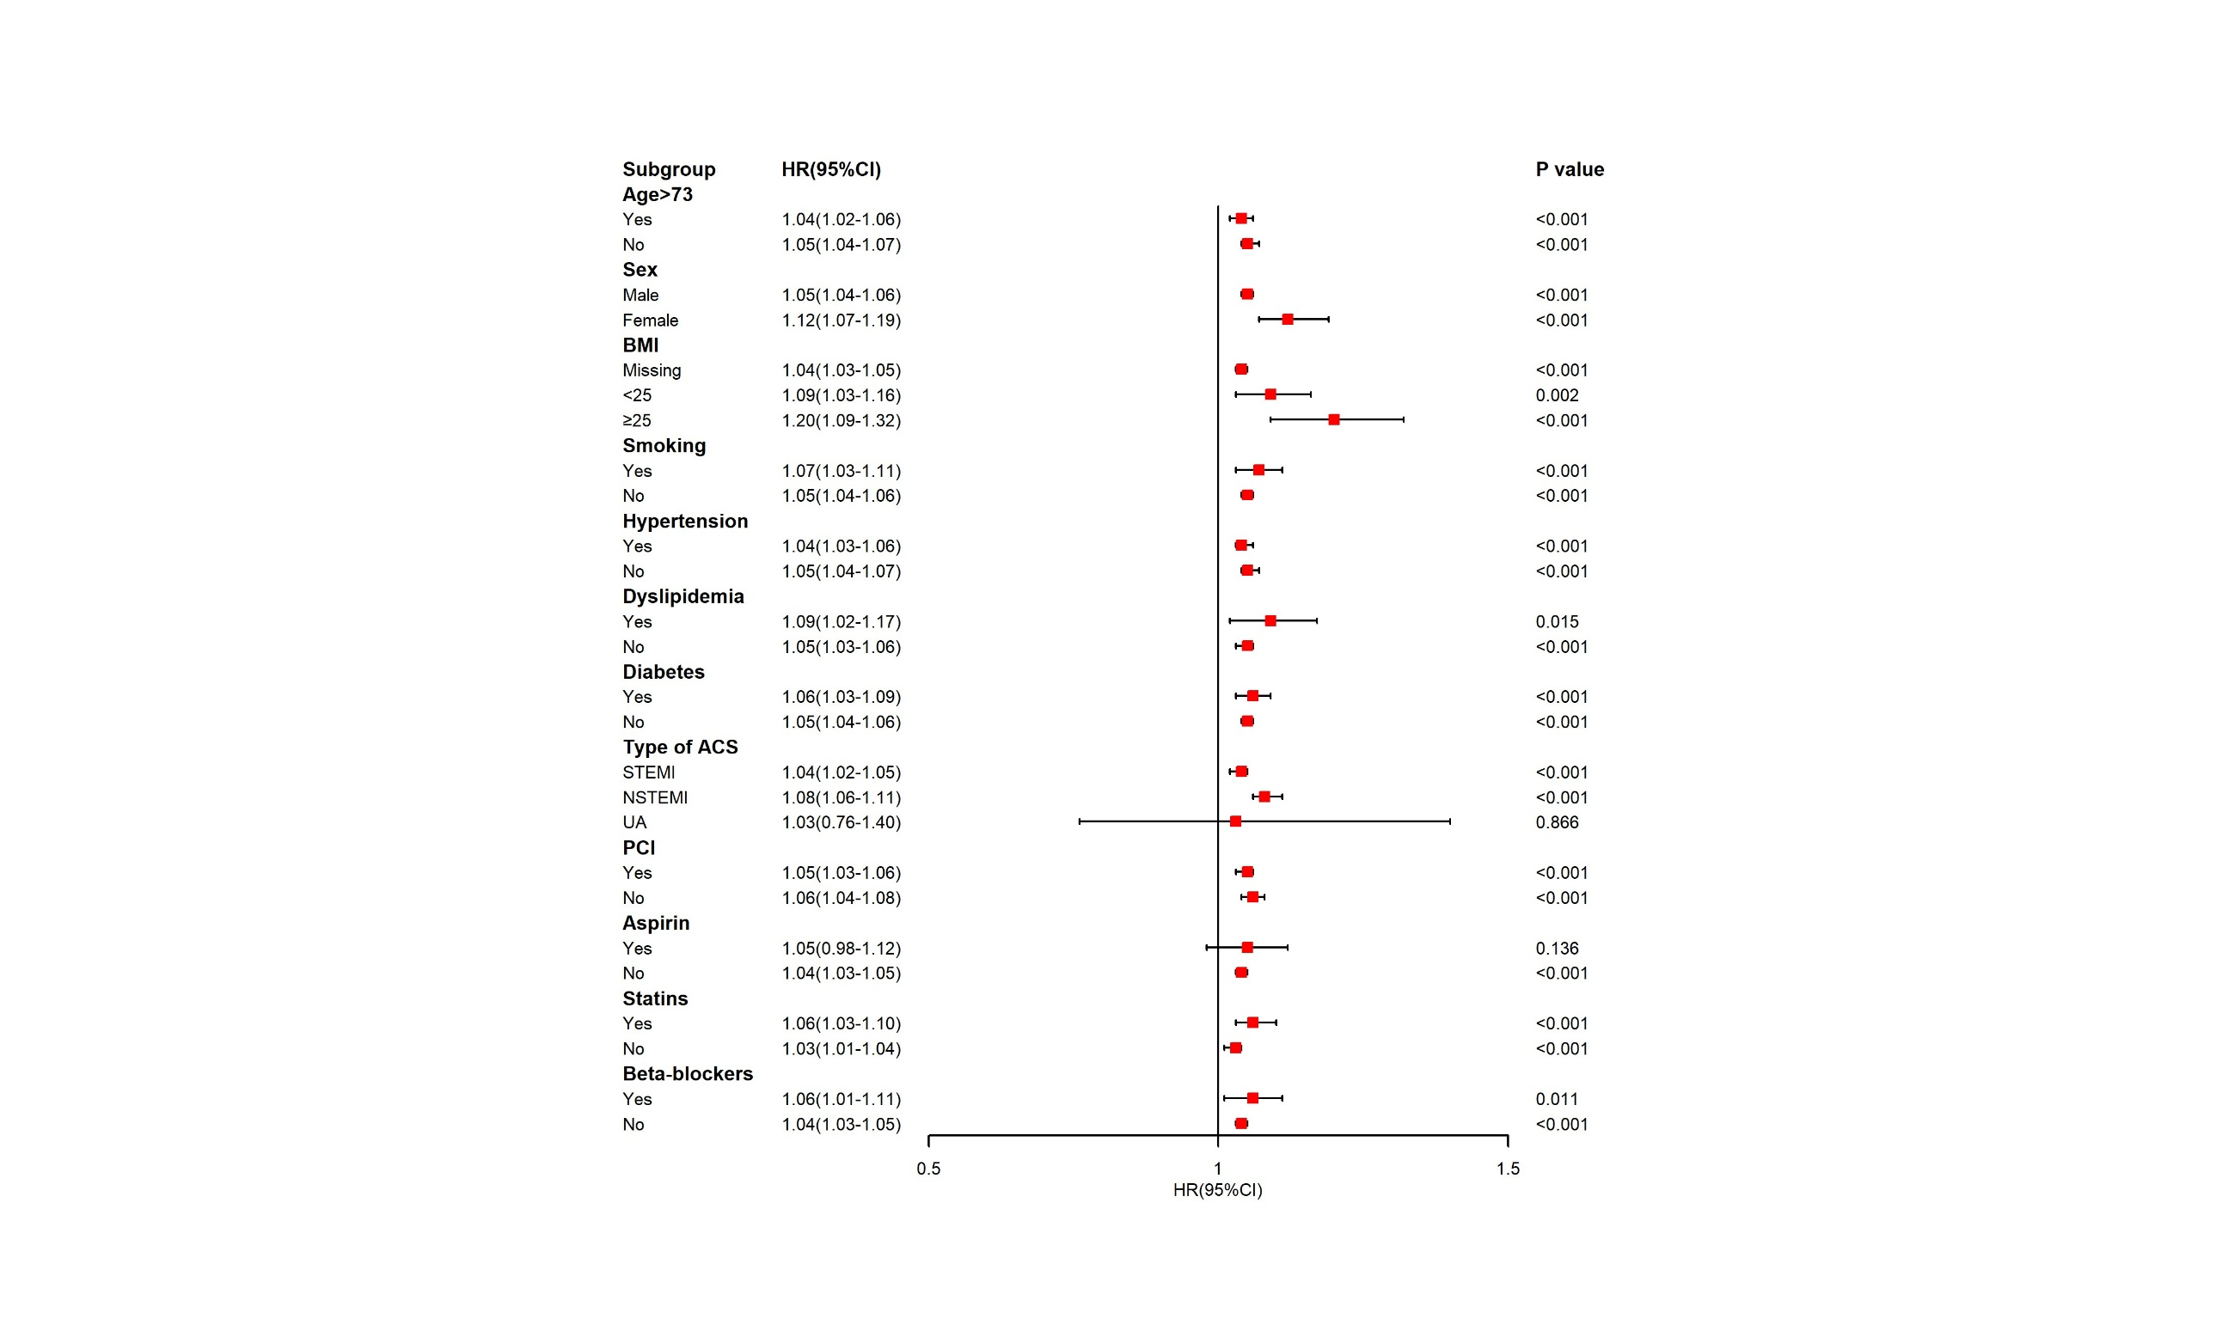

Supplementary Figure S4. Association between SIRI and one-year all-cause mortality in subgroups.
Abbreviations: ACS, acute coronary syndrome; BMI, body mass index; CI, confidence interval; HR, hazard ratio; PCI, percutaneous coronary intervention; STEMI, ST elevation myocardial infarction; UA, unstable angina; NSTEMI, non-ST elevation myocardial infarction.

