Supplementary Material
Manuscript title: Combined versus sequential surgery in lamellar macular holes: a multicenter observational study
Manuscript ID: 593498

Supplementary Table S1. OCT-based criteria for lamellar macular hole diagnosis and subtype classification

Category | Description
Mandatory criteria | 1. Irregular foveal contour with abnormal, non-linear morphology of the foveal depression.  2. Foveal cavity with undermined edges.  3. Presence of at least one additional sign indicative of foveal tissue loss (e.g., pseudoperculum or thinning of the foveal center or surrounding area).  4. Absence of a full-thickness retinal defect involving all retinal layers, distinguishing LMHs from full-thickness macular holes.
Associated features (may be present) | 1. Epiretinal proliferation.  2. Foveal bump.  3. Disruption of the ellipsoid zone.
Tractional subtype | Splitting (schisis) of the retinal layers, typically between the outer nuclear and outer plexiform layers, with a characteristic “moustache-shaped” configuration. This subtype is usually associated with an epiretinal membrane (ERM) exerting traction on the retinal surface. Ellipsoid zone involvement is less frequent than in degenerative LMHs.
Degenerative subtype | Deep foveal cavitation with a “top-hat” configuration and smooth, rounded edges. It is typically associated with the presence of homogeneous, medium-reflective ectopic foveal tissue in direct contact with the retinal surface, without evidence of traction. Disruption of the ellipsoid zone is common.
Mixed subtype | Foveal invagination with a steep cavitation toward the fovea. Both ERM and ectopic tissue may coexist. These cases usually present a foveal opening with nearly normal retinal thickness, in contrast to degenerative LMHs, which show greater tissue loss. The term lamellar macular pseudohole is sometimes used to describe similar morphological features.
Notes: The diagnostic and subtype-classification criteria summarized in this table were based on previously published OCT definitions and morphological criteria._{12–18}
Bold text indicates table headings and labels only.

Supplementary Table S2. Availability of 1-year BCVA by surgical modality
Surgical modality | Eyes included, n | 1-year BCVA available, n (%) | 1-year BCVA missing, n (%)
Combined surgery (phacovitrectomy) | 101 | 73 (72.3) | 28 (27.7)
Sequential: PPV → phacoemulsification | 30 | 29 (96.7) | 1 (3.3)
PPV in pseudophakic eyes | 39 | 22 (56.4) | 17 (43.6)
PPV without phacoemulsification | 5 | 2 (40.0) | 3 (60.0)
Total | 175 | 126 (72.0) | 49 (28.0)
Notes: Percentages are calculated within each surgical modality. The primary outcome was 1-year BCVA; eyes without a recorded 1-year BCVA were considered missing outcome data and were excluded from analyses requiring that outcome. Bold text indicates table headings and labels only.

Supplementary Table S3. Multivariable mixed-effects model for BCVA
(logMAR) at 1 year
Outcome: 1-year best-corrected visual acuity (logMAR)
Predictor | Estimate | 95% CI | p-value
Intercept | -0.32 | -0.80 to 0.16 | 0.189
Pre-PPV BCVA (logMAR) | 0.60 | 0.32 to 0.89 | <0.001
Age | 0.00 | -0.00 to 0.01 | 0.334
Lens status [Cataract] | 0.15 | -0.09 to 0.39 | 0.207
Lens status [Pseudophakia] | 0.18 | -0.08 to 0.44 | 0.171
Lens status [Nuclear sclerosis] | 0.16 | -0.05 to 0.38 | 0.138
LMH subtype [Mixed] | -0.06 | -0.21 to 0.09 | 0.433
LMH subtype [Degenerative] | -0.08 | -0.25 to 0.09 | 0.359
Surgery sequence [PPV followed by phacoemulsification] | 0.14 | -0.06 to 0.35 | 0.157
Surgery sequence [PPV without phacoemulsification] | 0.30 | -0.22 to 0.82 | 0.258

Random effects and model performance
Parameter | Value
Residual variance (σ²) | 0.03
Between-patient variance (τ00) | 0.08
Intraclass correlation coefficient (ICC) | 0.71
Patients, n | 119
Observations, n | 123
Marginal R² / Conditional R² | 0.154 / 0.754

Notes: Linear mixed-effects model with 1-year BCVA (logMAR) as the dependent variable and a random intercept for patient. Estimates are beta coefficients (β) with 95% confidence intervals. Reference categories were tractional LMH for subtype and clear lens for lens status. The analysis was based on complete cases. Bold text indicates table headings and labels only.

Supplementary Table S4. Comparison between patients followed up and lost to follow-up
Variable | Category | Followed up | Lost to follow-up | p-value
Sex | Male | 53 (42.4) | 20 (40.8) | 0.984
Sex | Female | 72 (57.6) | 29 (59.2) | 0.984
Age | Mean (SD) | 68.3 (10.4) | 73.2 (8.8) | 0.004
Epimacular tissue | No | 15 (12.1) | 4 (8.2) | 0.525
Epimacular tissue | ERM | 90 (72.6) | 34 (69.4) | 0.525
Epimacular tissue | Ectopic tissue | 13 (10.5) | 6 (12.2) | 0.525
Epimacular tissue | ERM + Ectopic | 6 (4.8) | 5 (10.2) | 0.525
Pre-PPV BCVA (logMAR) | Mean (SD) | 0.4 (0.2) | 0.5 (0.3) | 0.016
LMH subtype | Tractional | 76 (60.3) | 30 (61.2) | 0.982
LMH subtype | Mixed | 30 (23.8) | 11 (22.4) | 0.982
LMH subtype | Degenerative | 20 (15.9) | 8 (16.3) | 0.982
Preoperative metamorphopsia | No | 10 (21.3) | 0 (0.0) | 0.152
Preoperative metamorphopsia | Yes | 36 (76.6) | 9 (90.0) | 0.152
Preoperative metamorphopsia | Scotoma | 1 (2.1) | 1 (10.0) | 0.152
Lens status | Clear lens | 23 (18.7) | 3 (6.1) | 0.010
Lens status | Cataract | 43 (35.0) | 23 (46.9) | 0.010
Lens status | Pseudophakia | 22 (17.9) | 16 (32.7) | 0.010
Lens status | Nuclear sclerosis | 35 (28.5) | 7 (14.3) | 0.010
Surgery sequence | Combined | 73 (57.9) | 28 (57.1) | 0.001
Surgery sequence | PPV followed by phacoemulsification | 29 (23.0) | 1 (2.0) | 0.001
Surgery sequence | PPV in pseudophakic eyes | 22 (17.5) | 17 (34.7) | 0.001
Surgery sequence | PPV without phacoemulsification | 2 (1.6) | 3 (6.1) | 0.001
Postoperative BCVA at 3 to 12 months after PPV (logMAR) | Mean (SD) | 0.4 (0.3) | 0.4 (0.3) | 0.472
Notes: Data are presented as n (%) unless otherwise indicated. Continuous variables are presented as mean (SD). P-values compare patients followed up versus those lost to follow-up. Bold text indicates table headings and labels only.

Supplementary Table S5. Comparison of characteristics across centers
Variable | Category | University Hospital of Navarra | Reina Sofía University Hospital of Murcia | General University Hospital of Castellón | Bellvitge University Hospital (Barcelona) | p-value
LMH subtype | Tractional | 85 (64.4) | 15 (50.0) | 4 (44.4) | 2 (50.0) | 0.191
LMH subtype | Mixed | 29 (22.0) | 10 (33.3) | 2 (22.2) | 0 (0.0)
LMH subtype | Degenerative | 18 (13.6) | 5 (16.7) | 3 (33.3) | 2 (50.0)
Surgery sequence | Combined | 79 (59.8) | 17 (56.7) | 3 (33.3) | 2 (50.0) | <0.001
Surgery sequence | PPV followed by phacoemulsification | 24 (18.2) | 6 (20.0) | 0 (0.0) | 0 (0.0)
Surgery sequence | PPV in pseudophakic eyes | 27 (20.5) | 7 (23.3) | 3 (33.3) | 2 (50.0)
Surgery sequence | PPV without phacoemulsification | 2 (1.5) | 0 (0.0) | 3 (33.3) | 0 (0.0)
Pre-PPV BCVA (logMAR) | Mean (SD) | 0.5 (0.2) | 0.4 (0.2) | 0.4 (0.2) | 0.5 (0.2) | 0.750
Notes: Data are presented as n (%) unless otherwise indicated. Continuous variables are presented as mean (SD). P-values compare characteristics across centers. Bold text indicates table headings and labels only.

Supplementary Figure S1. STROBE flow diagram of study inclusion and follow-up
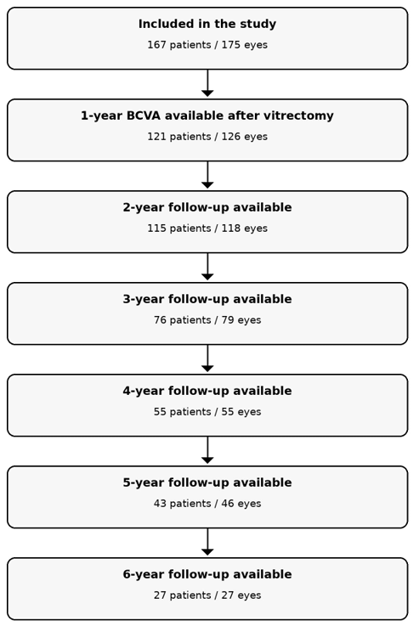
Notes: The unit of analysis for ophthalmic outcomes was the eye. Because some participants contributed both eyes, the number of eyes differs from the number of patients shown in the flow diagram. The decreasing sample size over time reflects follow-up availability at each postoperative time point.

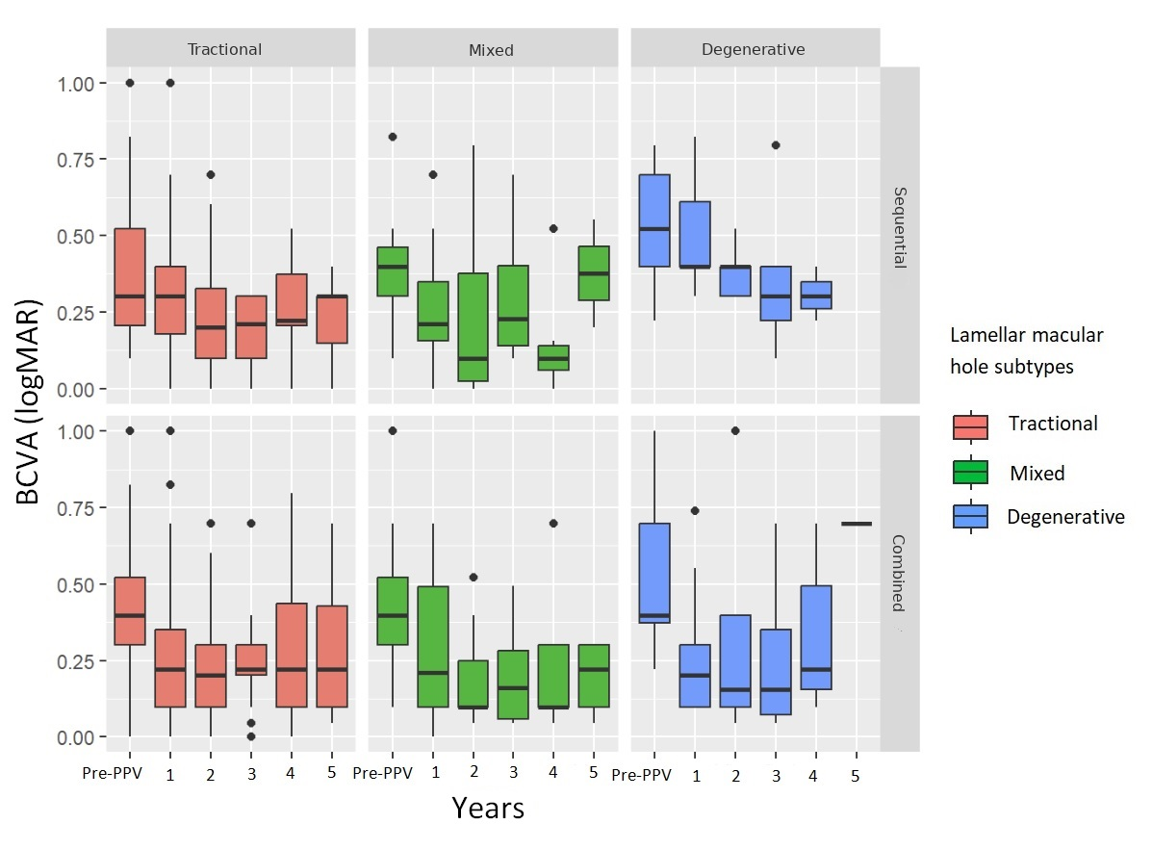
Supplementary Figure S2. BCVA over time according to LMH subtype and surgical sequence

Notes: Boxplots showing BCVA (logMAR) from the preoperative visit (Pre-PPV) to years 1 through 5 after PPV, stratified by lamellar macular hole (LMH) subtype and surgical sequence. Columns represent LMH subtype (tractional, mixed, and degenerative), and rows represent surgical sequence (sequential and combined). Horizontal lines within boxes indicate the median, boxes represent the interquartile range, whiskers indicate the range up to 1.5 times the interquartile range, and dots represent outliers. Lower logMAR values indicate better BCVA.

