Supplementary Figure

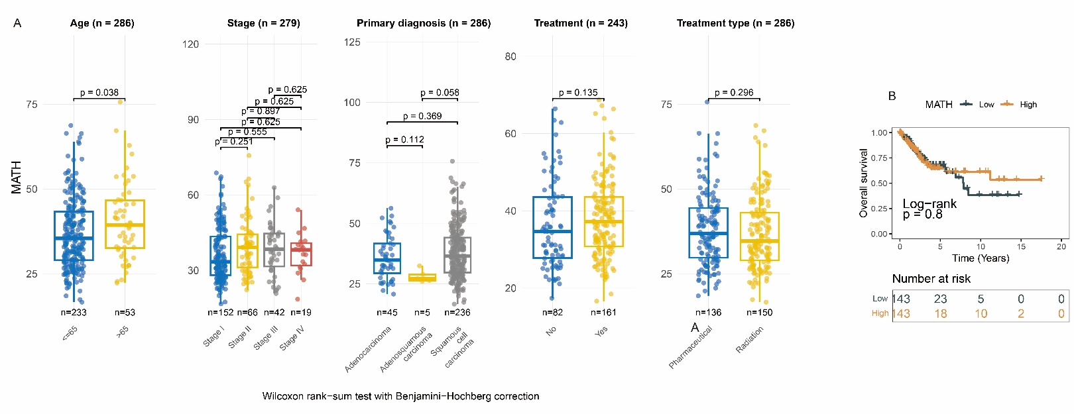
Fig. S1 Clinical correlation analysis of MATH score. (A) Association between MATH score and clinicopathological characteristics. (B) Association between MATH score and overall survival prognosis in CESC. MATH: Mutant-Allele Tumor Heterogeneity. CESC: Cervical Squamous Cell Carcinoma and Endocervical Adenocarcinoma.

