Text S1. Data collection
Regular general health check-ups, as a part of the government's health literacy policy, have been implemented for decades in China. These check-ups are offered as comprehensive health packages that include routine screenings for multiple diseases in a single visit. All examinations are performed by trained medical personnel following standardized protocols. Demographic information, including age and sex, is recorded for all participants through an appointment-based registration system. Participants also report any previous physician-diagnosed chronic conditions, including hypertension, diabetes, dyslipidemia, hyperuricemia, cardiovascular disease, and cancer, during face-to-face interviews with medical staff. Medication use in the past 6 months, including antihypertensive, antidiabetic, lipid-lowering, and uric acid–lowering agents, was also recorded.

Prior to measurements, participants were asked to fast for at least 8 hours. Height and weight were measured using an Omron electronic scale (Omron Healthcare Co., Kyoto, Japan), with participants wearing light clothing and no shoes. Body mass index (BMI) was calculated as weight in kilograms divided by height in meters squared.

Blood pressure was measured on the right arm using a calibrated electronic sphygmomanometer (Omron HBP–1300, Omron Healthcare Co., Ltd., Kyoto, Japan) with a cuff size of 14-48 cm supplied to all sites. Measurements were taken after the participant was seated for at least 5 min and not having smoked, exercised, eaten or climbed stairs in the last 30 min. Blood pressure was taken twice, with a 5–min interval between measurements, with the participant sitting upright and his/her right arm supported at heart level. The mean of the two measures was used in the analysis.

Fasting venous blood samples were collected in the morning and analyzed at central laboratories certified by the national quality control program. Biomarkers measured included fasting plasma glucose, glycated hemoglobin A1c, total cholesterol, triglycerides, high-density lipoprotein cholesterol (HDL-C), low-density lipoprotein cholesterol (LDL-C), and serum uric acid. All laboratory measurements were conducted using standardized procedures with automated biochemical analyzers (eg, Hitachi, Roche), and were subject to rigorous internal and external quality control.

Table S1. Association between age and metabolic multimorbidity, by sex
Variable | OR (95% CI) | P Value
Male (per 1-year increase in age) | 1.04 (1.03–1.04) | <0.001
Female (per 1-year increase in age) | 1.09 (1.09–1.09) | <0.001
Age × Sex interaction | — | <0.0001
OR indicates odds ratio; CI, confidence interval. Odds ratios represent the change in odds of metabolic multimorbidity per 1-year increase in age. The significant age-by-sex interaction indicates differential age-related accumulation of metabolic multimorbidity between men and women.

Table S2. Prevalence of common combinations of metabolic diseases and their associations with all-cause, cardiovascular, and cancer mortality
No. of diseases | Combination | N (%) | HR for all-cause mortality (95% CI) | HR for CVD mortality (95% CI) | HR for cancer mortality (95% CI)
0 | None | 56,043 (45.3) | 1.00 (Reference) | 1.00 (Reference) | 1.00 (Reference)
2 | Dyslipidaemia + NAFLD | 10,922 (8.8) | 1.22 (0.88–1.68) | 1.49 (0.75–2.93) | 1.13 (0.65–1.98)
 | Hypertension + NAFLD | 2,898 (2.3) | 1.68 (1.18–2.41) | 2.49 (1.25–4.95) | 1.65 (0.91–2.98)
 | Obesity + NAFLD | 2,823 (2.3) | 1.18 (0.65–2.14) | 1.45 (0.43–4.86) | 1.12 (0.40–3.15)
 | Hypertension + Dyslipidaemia | 2,055 (1.7) | 1.83 (1.22–2.75) | 2.74 (1.27–5.90) | 1.74 (0.88–3.44)
 | Dyslipidaemia+Obesity | 752 (0.6) | 2.25 (0.99–5.13) | 7.1 (2.42–20.82) | /
 | Diabetes+Dyslipidaemia | 629 (0.5) | 2.24 (1.23–4.1) | 4.31 (1.61–11.59) | 1.01 (0.24–4.22)
3 | Dyslipidaemia + Obesity + NAFLD | 4,689 (3.8) | 1.66 (1.09–2.54) | 2.38 (1.05–5.40) | 1.29 (0.57–2.90)
 | Hypertension + Dyslipidaemia + NAFLD | 3,624 (2.9) | 1.40 (0.96–2.03) | 1.72 (0.80–3.69) | 1.11 (0.56–2.19)
 | Diabetes + Dyslipidaemia + NAFLD | 1,475 (1.2) | 1.75 (1.07–2.87) | 3.45 (1.51–7.87) | 1.02 (0.36–2.86)
 | Hypertension + Obesity + NAFLD | 1,351 (1.1) | 3.00 (1.96–4.60) | 6.79 (3.37–13.70) | 2.41 (1.12–5.21)
4 | Hypertension + Dyslipidaemia + Obesity + NAFLD | 2,874 (2.3) | 1.97 (1.29–2.99) | 4.30 (2.13–8.66) | 1.21 (0.51–2.88)
 | Hypertension + Diabetes + Dyslipidaemia + NAFLD | 1,125 (0.9) | 2.19 (1.42–3.39) | 2.72 (1.14–6.49) | 2.68 (1.38–5.21)
 | Diabetes + Dyslipidaemia + Obesity + NAFLD | 819 (0.7) | 3.03 (1.73–5.31) | 4.12 (1.40–12.08) | 5.43 (2.61–11.32)
5 | Hypertension + Diabetes + Dyslipidaemia + Obesity + NAFLD | 908 (0.7) | 3.08 (1.92–4.95) | 5.43 (2.38–12.42) | 4.04 (1.99–8.19)
CI= confidence interval; CVD= cardiovascular disease; HR= hazard ratio; NAFLD, non-alcoholic fatty liver disease
Hazard ratios were estimated using Cox proportional hazards models (all-cause mortality) and Fine–Gray subdistribution hazard models (CVD and cancer mortality). All models were adjusted for age and sex.
Cancer mortality was not estimable for some combinations because of insufficient events

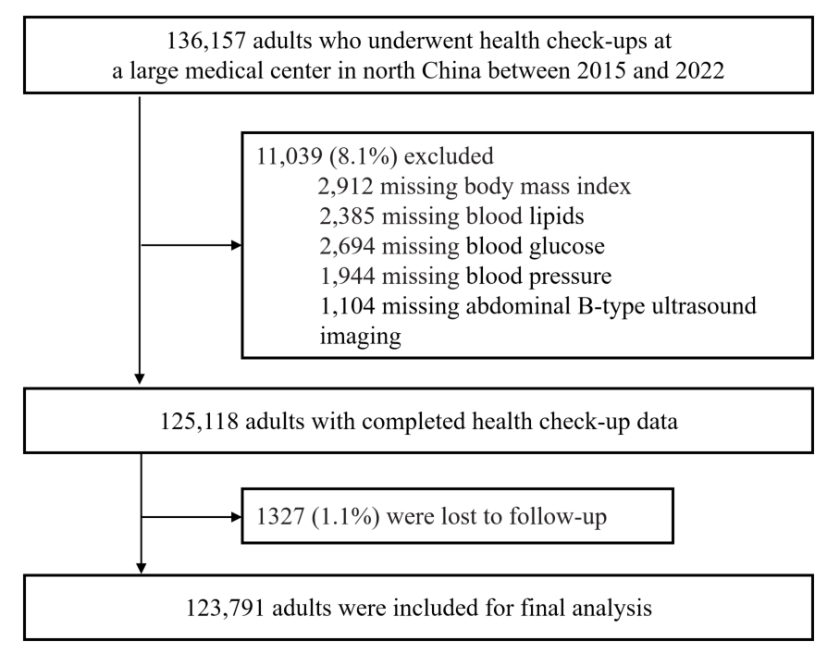

Figure S1. Participant flow diagram

