Supplementary materials

Gut Microbiota Associated with Type 2 Diabetes and Dietary Balance in Older Adults: a Community-based Cohort in China

This supplementary file contains the following:
Supplementary Methods：
Method S1 Fecal microbial DNA extraction and 16S rRNA gene sequencing

Genomic DNA was extracted from the samples using the CTAB or SDS method. The purity and concentration of the extracted DNA were evaluated via agarose gel electrophoresis. Appropriate amounts of DNA were diluted with sterile water to a final concentration of 1 ng/μl.
The diluted genomic DNA served as a template for PCR amplification using region-specific primers with barcodes. Phusion® High-Fidelity PCR Master Mix with GC Buffer and a high-efficiency, high-fidelity enzyme (New England Biolabs) were employed to ensure amplification efficiency and accuracy.
The PCR products were analyzed on a 2% agarose gel via electrophoresis. Based on the concentration of the PCR products, equal amounts were pooled and thoroughly mixed. The pooled products were then purified using 2% agarose gel electrophoresis in 1×TAE buffer, followed by excision and recovery of the target bands. The purification process was performed using the GeneJET Gel Extraction Kit (Thermo Scientific).
Library construction was carried out using the Ion Plus Fragment Library Kit (48 rxns; Thermo Fisher Scientific). The constructed libraries were quantified using Qubit and validated for quality. Sequencing was performed on the Ion S5™ XL system (Thermo Fisher Scientific).
Low-quality regions of the reads were trimmed using Cutadapt (v1.9.1). Reads were demultiplexed based on barcodes, and barcode and primer sequences were removed to obtain the raw reads. Chimera sequences were detected and removed using the UCHIME algorithm, resulting in clean reads for downstream analysis.
Clean reads from all samples were clustered into Operational Taxonomic Units (OTUs) at a 97% identity threshold using Uparse software (v7.0.1001). Representative sequences for each OTU were selected based on their frequency within the OTU.
Taxonomic annotation of OTU sequences was performed using the Mothur method against the SILVA SSU rRNA database with a threshold of 0.8–1. Taxonomic information was classified at various levels: kingdom, phylum, class, order, family, genus, and species. The community composition of each sample was statistically analyzed at these taxonomic levels.
Phylogenetic relationships of all OTU sequences were constructed using the MUSCLE software (v3.8.31)for rapid multiple sequence alignment. Data from all samples were normalized to the sample with the lowest read count, ensuring consistency for downstream analyses.

Supplementary Figures:
Figure S1 shows the relative abundance of the top 10 gut microbial phyla in the type 2 diabetes (t2d1) and non- type 2 diabetes (t2d0) groups. Firmicutes was the most abundant phylum in both groups, followed by Bacteroidetes. Minor contributions were observed from phyla such as Actinobacteria, Proteobacteria, Verrucomicrobia, and Fusobacteria, with relatively consistent proportions between groups. Subtle differences in the relative abundance of certain phyla, such as a slight reduction in Firmicutes in the type 2 diabetes group, may reflect gut dysbiosis associated with diabetes.
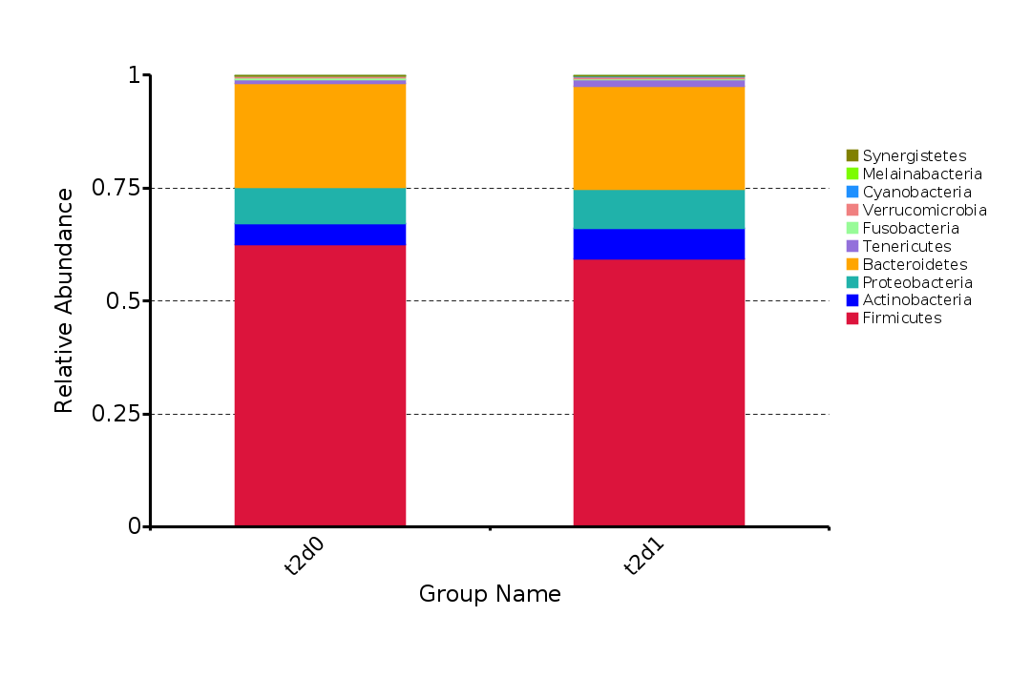
Figure S1 Relative Abundance of Top 10 Gut Microbiota at Genus Level in Baseline type 2 diabetes(t2d0) and Non- type 2 diabetes (t2d1)

