Supporting Information

Transferrin-Functionalized Conjugated Polymer Nanoparticles for Enhanced Photodynamic Therapy of Glioblastoma

Matías Daniel Caverzan^{1,2}, Bruno Agustín Cesca³, Rodrigo Emiliano Palacios¹, Carlos Alberto Chesta¹, Luis Exequiel Ibarra^{3,*}

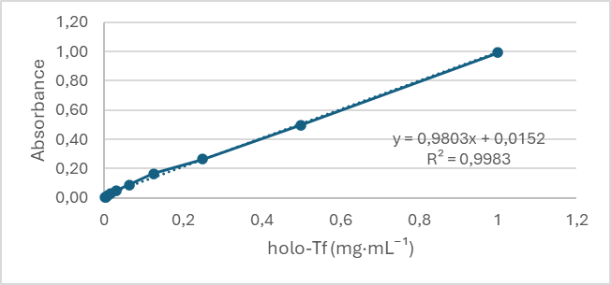
Figure S1. Calibration curve for holo-transferrin (holo-Tf) constructed for the quantification of holo-Tf concentration in aqueous samples using the Bicinchoninic Acid (BCA) protein assay. Data in the plot are presented as absorbance (A₅₇₀) vs holo-Tf concentration (mg·mL⁻¹). Linear regression yielded the equation y = 0.9803x + 0.0152 with an associated coefficient of determination (R² = 0.9983), indicating excellent linearity over the tested range. The slope of the calibration curve (0.9803) was used to estimate the concentration of unknown samples according to:CTf= A / slope, where A is the absorbance at 570 nm after blank correction. Concentrations are expressed in mg·mL⁻¹.

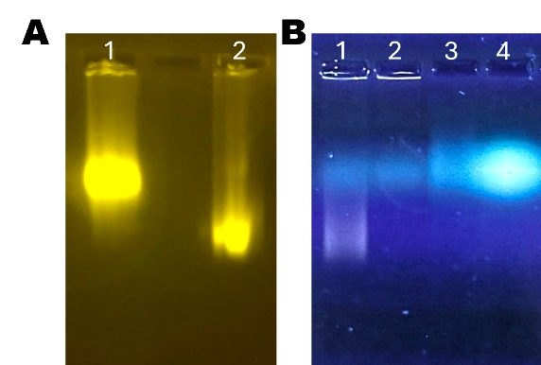
Figure S2. Electrophoretic mobility of F8BT CPNs before and after holo-Tf conjugation. (A) Electrophoretic mobility of holo-Tf functionalized F8BT CPNs (1) and non-functionalized F8BT CPNs (2), visualized under a blue LED transilluminator (λex = 460–470 nm, λem = 520–550 nm). (B) Electrophoretic mobility of F8BT CPNs incubated with holo-Tf and fluorescamine without EDC/NHS catalyst (1); the same nanoparticles conjugated with holo-Tf using EDC/NHS and stained with fluorescamine (2); and fluorescamine-stained holo-Tf controls at 0.1 mg/mL (3) and 1 mg/mL (4). Visualization was performed using a UV LED transilluminator (λ_ex = 365–395 nm; λ_em = 430–540 nm), which simultaneously excites the fluorescamine–protein adducts (blue–green emission) and the F8BT CPNs (green emission), enabling detection of both components within the gel.

Figure S3. Immunohistochemical detection of transferrin receptor 1 (TfR1/CD71) in human brain tissues retrieved from the Human Protein Atlas database. Representative images illustrate TfR1 protein expression in normal cerebral cortex (left), low-grade glioma (center), and glioblastoma (right). Minimal staining is observed in normal brain tissue, whereas increased TfR1 immunoreactivity is detected in glioma samples, with the strongest signal observed in glioblastoma. These images support the relevance of TfR1 as a molecular target in malignant gliomas. Images were obtained from the Human Protein Atlas (https://www.proteinatlas.org) according to the database usage policy.
Figure S4. Assessment of photodynamic therapy (PDT) efficacy in U87MG cells by phase-contrast morphology and propidium iodide (PI) staining 24 h post-irradiation. Representative images of U87MG cells subjected to different treatment conditions are shown: F8BT-PtOEP-Tf CPNs -treated followed by PDT illumination (top row), F8BT-PtOEP CPNs-treated followed by PDT illumination (middle row), and light illumination-treated cells (bottom row). For each condition, phase-contrast micrographs (left column) depict cell morphology, Hoechst-stained nuclei (center column, blue) confirm total cell number, and PI staining (right column, red) indicates membrane-compromised, non-viable cells. Cells exposed to PDT show pronounced cytotoxic effects, including loss of cell–cell contacts, rounding, detachment, and a marked increase in PI-positive nuclei compared with controls and non-irradiated CPN groups. Scale bars = 100 µm.

Figure S5. Assessment of PDT efficacy in T98G cells by phase-contrast morphology and PI staining 24 h post-irradiation. Representative images of T98G cells subjected to different treatment conditions are shown: F8BT-PtOEP-Tf CPNs -treated followed by PDT illumination (top row), F8BT-PtOEP CPNs-treated followed by PDT illumination (middle row), and light illumination-treated cells (bottom row). For each condition, phase-contrast micrographs (left column) depict cell morphology, Hoechst-stained nuclei (center column, blue) confirm total cell number, and PI staining (right column, red) indicates membrane-compromised, non-viable cells. Cells exposed to PDT show pronounced cytotoxic effects, including loss of cell–cell contacts, rounding, detachment, and a marked increase in PI-positive nuclei compared with controls and non-irradiated CPN groups. Scale bars = 100 µm.

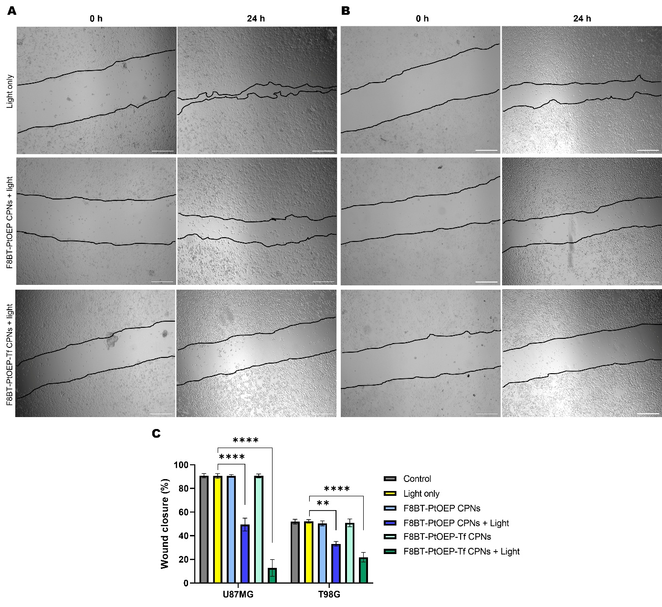
Figure S6. Effect of CPNs-mediated PDT on GBM cell migration evaluated by wound healing assay. Representative phase-contrast images of wound closure in U87MG (A) and T98G (B) cells immediately after scratch generation (0 h) and after 24 h. Cells were treated with a sublethal concentration of nanoparticles (2.5 mg·L⁻¹) followed by PDT under the irradiation conditions described in the Methods section. The wound edges are outlined for clarity. Scale bars: 500 μm. (C) Quantification of wound closure expressed as percentage of wound closure relative to the initial wound area. Data represent mean ± SD (n = 3). Statistical significance was determined using one-way ANOVA followed by post hoc multiple comparison test. **p < 0.01, ****p < 0.0001.

Figure S7. Clonogenic survival of GBM cells following PDT mediated by F8BT-PtOEP CPNs. (A) Representative images of crystal violet-stained colonies formed by U87MG and T98G cells after treatment with F8BT-PtOEP CPNs or F8BT-PtOEP-Tf CPNs (10 mg·L⁻¹) followed by PDT (40 J·cm⁻²). Cells treated with light only were included as irradiated controls. Colonies were allowed to grow for 7 days after treatment before fixation and staining. (B) Quantification of colony number for each experimental condition. PDT mediated by F8BT-PtOEP-Tf CPNs significantly reduced clonogenic survival in U87MG cells compared with non-functionalized nanoparticles, whereas a more moderate effect was observed in T98G cells. Data are presented as mean ± SD. Statistical significance was determined by one-way ANOVA followed by appropriate post hoc analysis (***p < 0.001; ns: not significant).

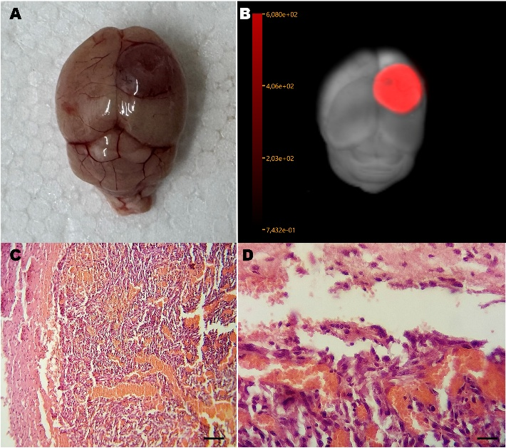
Figure S8. Orthotopic GBM model established by stereotactic implantation of human U87MG-tdiRFP cells. Tumor cells were injected into the right cerebral hemisphere under stereotaxic guidance. (A) Macroscopic view of an excised mouse brain showing a developed tumor 15 days after implantation of U87MG-tdiRFP cells. (B) Corresponding near-infrared fluorescence image documenting the presence and location of the tumor mass derived from U87G-tdiRFP cells. (C) Representative hematoxylin–eosin (H&E) micrograph of the tumor at 10× magnification. Scale bars = 10 µm. (D) Higher-magnification (40×) H&E image highlighting the prominent vascular proliferation characteristic of GBM. Brains were fixed in 4% buffered formaldehyde, dehydrated, paraffin-embedded, and sectioned at 5 µm prior to H&E staining. Scale bars = 100 µm.

