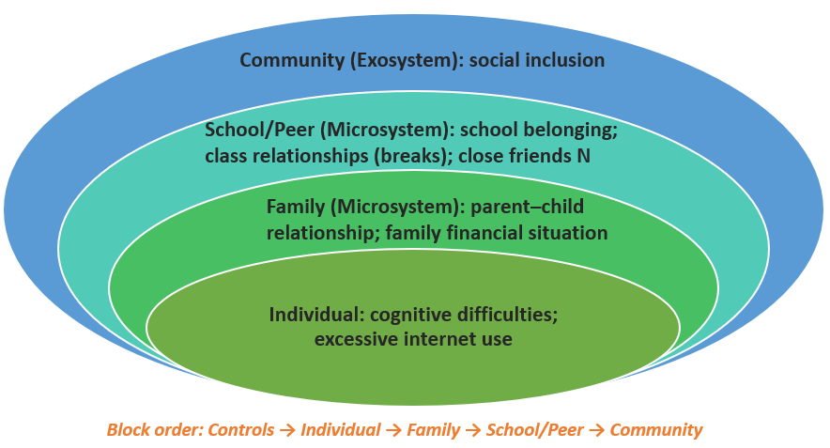
Supplementary Figure 1 Conceptual Framework and Sequential Analytic Domains
Note. This figure summarizes the conceptual framework used in the study and the sequential domain entry applied in the blockwise OLS regression models. Right arrows (→) indicate the order in which the five analytic domains were entered: demographic background, individual, family, school and peer, and perceived community social inclusion. Arrow direction denotes analytic entry order only and does not imply causal direction or developmental sequence.

Supplementary Table 1 Missing Data Patterns by Variable (N = 87,215)
Variable | Valid N | Missing N | Missing % | Rank
Age | 87,103 | 112 | 0.10% | 14
Gender | 87,026 | 189 | 0.20% | 13
School belonging | 86,521 | 694 | 0.80% | 12
Loneliness | 86,221 | 994 | 1.10% | 11
Recess experiences | 85,920 | 1,295 | 1.50% | 9
Number of close friends | 85,920 | 1,295 | 1.50% | 9
Cognitive difficulties | 85,164 | 2,051 | 2.40% | 8
Depressive symptoms (BDI-6) | 84,631 | 2,584 | 3.00% | 6
Anxiety symptoms (GAD-7) | 84,611 | 2,604 | 3.00% | 7
Parent-child relationship | 83,403 | 3,812 | 4.40% | 5
Family financial situation | 82,840 | 4,375 | 5.00% | 4
Life satisfaction | 82,767 | 4,448 | 5.10% | 3
Excessive internet use | 80,319 | 6,896 | 7.90% | 2
Social inclusion (ESIS) | 79,354 | 7,861 | 9.00% | 1
Complete on all variables | 69,800 | 17,415 | 20.00% | —
Note. Missing % calculated as proportion of total initial sample (N = 87,215). Variables ranked by missing rate from lowest (Rank 14) to highest (Rank 1).

Supplementary Table 2 Primary Missing Data Patterns (N = 87,215)
Pattern | N | % | Variables with Missing Data | Description
1 | 69,800 | 80.00% | None | Complete data
2 | 2,373 | 2.70% | Social inclusion only | Single-variable missingness
3 | 2,109 | 2.40% | Parent relationship, Family finances, Life satisfaction, Internet use, Social inclusion | Systematic cluster missingness
4 | 1,727 | 2.00% | Life satisfaction only | Single-variable missingness
5 | 1,295 | 1.50% | Anxiety (GAD-7) only | Single-variable missingness
6 | 1,193 | 1.40% | Depression (BDI-6) only | Single-variable missingness
7 | 1,008 | 1.20% | Cognitive difficulties only | Single-variable missingness
Other | 7,710 | 8.80% | Various combinations | Multiple smaller patterns
Note. Patterns displayed account for 91.2% of the sample. Pattern 3 suggests systematic survey administration differences or participant refusal clusters. Little's MCAR test: χ²(4421) = 9995.99, p < .001, indicating data are not missing completely at random.

Supplementary Table 3 Comparison of Participants With Complete Versus Incomplete Data
Variable | Complete (n = 69,800) | Incomplete (n = 17,415)
 | M (SD) | M (SD) | t | p | Cohen's d
Mental health outcomes
Depressive symptoms (BDI-6, 0-18) | 2.32 (3.39) | 2.63 (3.96) | 9.87 | <.001 | 0.09
Anxiety symptoms (GAD-7, 0-21) | 4.09 (4.80) | 4.02 (5.21) | -1.71 | 0.088 | -0.02
Loneliness (0-4) | 1.18 (1.03) | 1.12 (1.11) | -6.13 | <.001 | -0.05
Life satisfaction (1-5) | 3.95 (0.95) | 3.94 (1.03) | -1.65 | 0.1 | -0.02
Demographics
Age (years) | 15.54 (0.58) | 15.54 (0.68) | 1.21 | 0.228 | 0.01
Gender (% boys) | 39.50% | 60.50% | χ²(1) = 1064.62 | <.001 | φ = .11
Note. Complete = participants with valid data on all 14 study variables. Incomplete = participants missing data on one or more variables. Cohen's d interpreted as: 0.20 = small, 0.50 = medium, 0.80 = large effect. Positive d indicates higher scores in complete group. Boys were significantly overrepresented in the incomplete group (60.5% vs 39.5%).

Supplementary Table 4 Exploratory Cross-Level Moderation Analyses: Protective Factors Buffering Cognitive Difficulties
 | Outcome | Model 5 R² | Model 6 R² | ΔR² | F change | p | β (interaction) | B | 95% CI
Social Inclusion × Cognitive Difficulties
 | Depressive symptoms | 0.519 | 0.538 | 0.019 | 2799.817 | <.001 | 0.152*** | -0.006 | [-.006, -.006]
 | Anxiety symptoms | 0.460 | 0.465 | 0.005 | 695.584 | <.001 | -0.082*** | -0.004 | [-.005, -.004]
 | Loneliness | 0.413 | 0.413 | 0.000 | 0.012 | 0.913 | 0.000 | 0.000 | [.000, .000]
 | Life satisfaction | 0.518 | 0.518 | 0.001 | 75.578 | <.001 | 0.026*** | 0.000 | [.000, .000]
School Belonging × Cognitive Difficulties
 | Depressive symptoms | 0.519 | 0.533 | 0.014 | 2073.060 | <.001 | -.128*** | -0.117 | [-.122, -.112]
 | Anxiety symptoms | 0.460 | 0.464 | 0.004 | 551.907 | <.001 | -0.071*** | -0.092 | [-.099, -.084]
 | Loneliness | 0.413 | 0.413 | 0.000 | 0.973 | 0.324 | -0.003 | -0.001 | [-.003, .001]
 | Life satisfaction | 0.518 | 0.518 | 0.000 | 42.881 | <.001 | 0.019** | 0.005 | [.003, .006]
Parent-Child Relationship × Cognitive Difficulties
 | Depressive symptoms | 0.519 | 0.530 | 0.011 | 1566.501 | <.001 | -0.110*** | -0.113 | [-.118, -.107]
 | Anxiety symptoms | 0.460 | 0.462 | 0.003 | 377.627 | <.001 | -0.058*** | -0.084 | [-.092, -.075]
 | Loneliness | 0.413 | 0.413 | 0.000 | 2.603 | 0.107 | 0.005 | 0.002 | [.000, .003]
 | Life satisfaction | 0.518 | 0.518 | 0.000 | 33.017 | <.001 | 0.016*** | 0.005 | [.003, .006]
Note. N = 69,800. B = unstandardized regression coefficient; β = standardized regression coefficient. 95% CI refers to the confidence interval for B. VIF < 2.0 for all predictors. **p < .01. ***p < .001.

Supplementary Table 5 Correlations Among Study Variables
Variable | 1 | 2 | 3 | 4 | 5 | 6 | 7 | 8 | 9 | 10 | 11 | 12 | 13
1. Depressive symptoms | —
2. Anxiety | 0.72 | —
3. Loneliness | 0.56 | 0.50 | —
4. Life satisfaction | -0.68 | -0.56 | -0.54 | —
5. Cognitive difficulties | 0.58 | 0.58 | 0.43 | -0.46 | —
6. Excessive internet use | 0.25 | 0.26 | 0.21 | -0.20 | 0.29 | —
7. Parent-child relationship | -0.44 | -0.37 | -0.34 | 0.47 | -0.36 | -0.21 | —
8. Family financial situation | -0.29 | -0.26 | -0.27 | 0.36 | -0.29 | -0.11 | 0.27 | —
9. School belonging | -0.42 | -0.35 | -0.39 | 0.42 | -0.38 | -0.10 | 0.30 | 0.23 | —
10. Recess experiences | -0.27 | -0.22 | -0.34 | 0.21 | -0.25 | -0.18 | 0.15 | 0.13 | 0.62 | —
11. Number of close friends | -0.24 | -0.18 | -0.35 | 0.26 | -0.24 | -0.06 | 0.21 | 0.16 | 0.27 | 0.22 | —
12. Social inclusion | -0.61 | -0.49 | -0.48 | 0.67 | -0.50 | -0.15 | 0.49 | 0.34 | 0.52 | 0.21 | 0.29 | —
13. Age | 0.04 | 0.06 | 0.04 | -0.02 | 0.04 | 0.02 | -0.03 | 0.04 | 0.00 | -0.01 | -0.04 | -0.03 | —
14. Gender (Boy) | -0.14 | -0.23 | -0.20 | 0.14 | -0.12 | 0.13 | 0.17 | 0.10 | 0.16 | 0.13 | 0.22 | 0.16 | 0.03
Note. All correlations ≥ |.01| are significant at p < .001 (two-tailed) given the large sample.

