TABLE OF CONTENTS

Supporting figures
Figure S1 S2
Figure S2 S3
Figure S3 S4
Figure S4 S5
Figure S5 S6
Figure S6 S7
Figure S7 S8
Figure S8 S9
Figure S9 S10
Figure S10 S11
Figure S11 S12
Figure S12 S13
Figure S13 S14

Supporting tables
Table S1 S15

Supporting figures
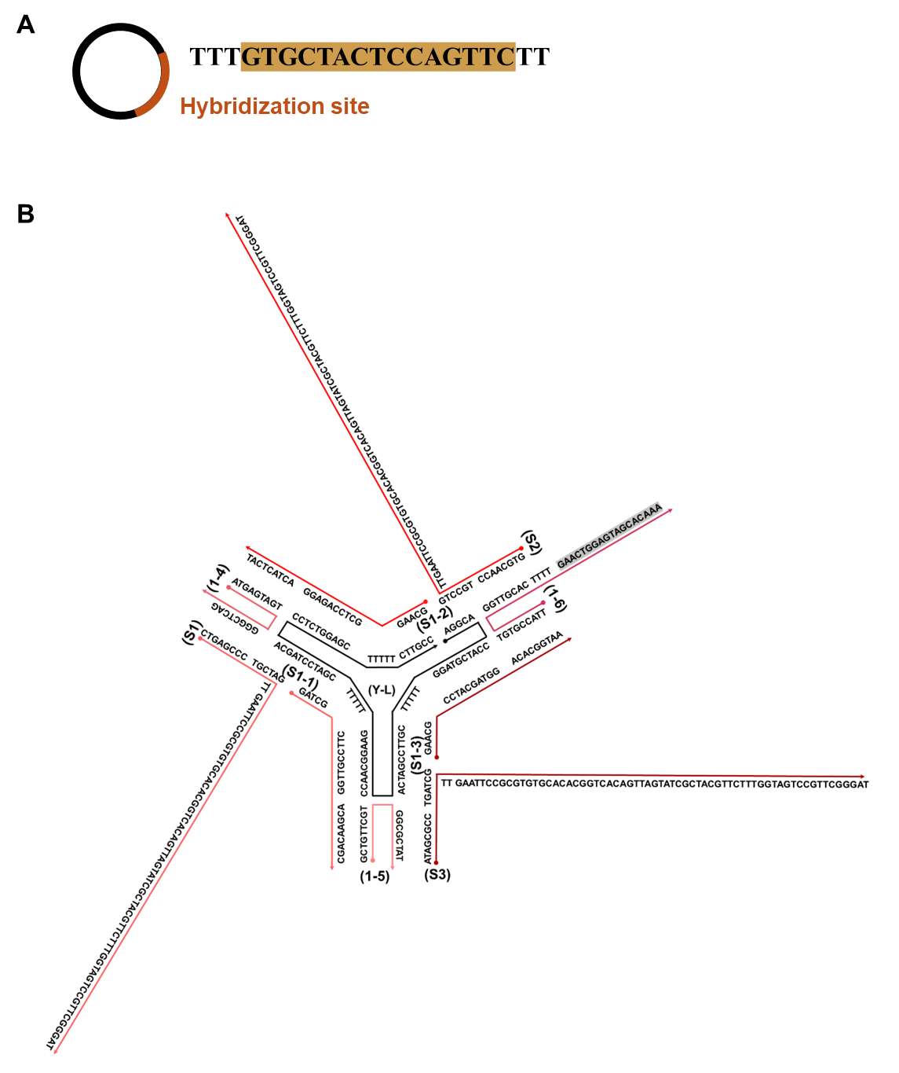
Figure S1. Illustration and sequence of the (A) template for RCA and (B) T structure. Highlighted sequence represents the hybridization site.

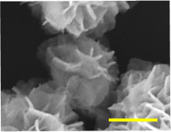
Figure S2. Scanning electron microscopy (SEM) imaging of the DNA Nano Flower. Scale bar: 100 nm.

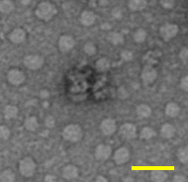
Figure S3. Transmission electron microscope (TEM) imaging of the TNF@Gin. Scale bar: 100 nm.

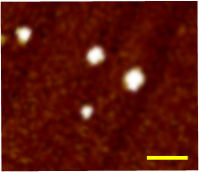
Figure S4. Atomic force microscope (AFM) imaging of the DNA Nano Flower under ScanAsyst-Air mode. Scale bar: 500 nm.

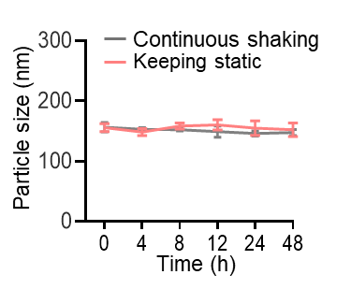
Figure S5. Particle size of TNF@Gin cultured under continuous shaking or static conditions.

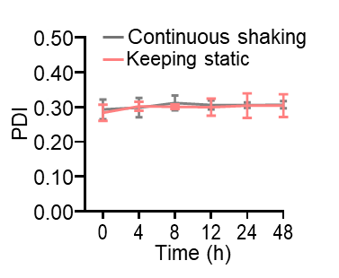
Figure S6. Polydispersity (PDI) of TNF@Gin cultured under continuous shaking or static conditions.

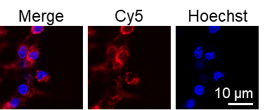
Figure S7. CLSM images of BV2 cells treated with Cy5-labeled TNF@Gin. Scale bar: 10 µm.

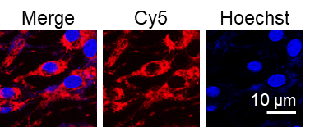
Figure S8. CLSM images of HT22 cells treated with Cy5-labeled TNF@Gin. Scale bar: 10 µm.

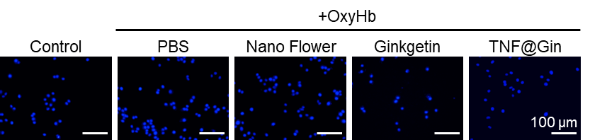
Figure S9. CLSM images of BV2 cells after different treatments. Scale bar: 100 µm.

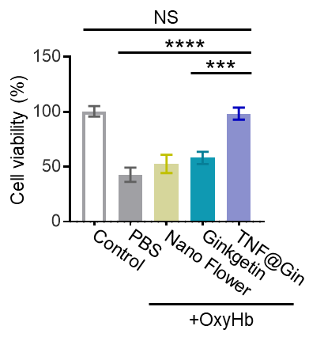
Figure S10. Cell viability of HT22 cells treated with different components 24 h after OxyHb intervention. The data are presented as mean ± SEM (n=3). Statistical significance was calculated by one-way analysis of variance (ANOVA) with the Tukey post hoc test, NS indicates not significant, *** p < 0.001, **** p < 0.0001.

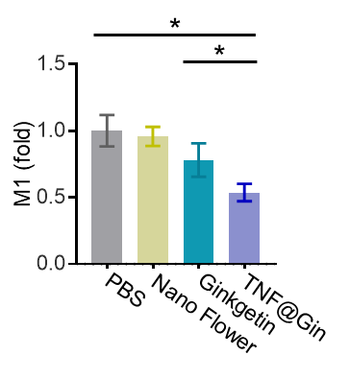
Figure S11. Level of M1 cell in various groups. The data are presented as mean ± SEM (n=3). Statistical significance was calculated by one-way analysis of variance (ANOVA) with the Tukey post hoc test, * p < 0.05.

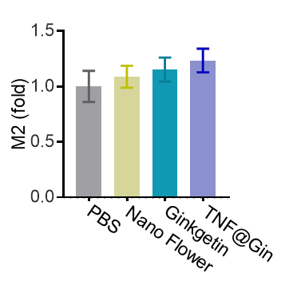
Figure S12. Level of M2 cells in various groups. The data are presented as mean ± SEM (n=3).

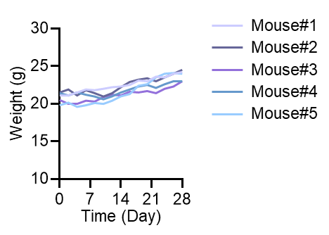
Figure S13. Body weight curves of the mice during the treatment of TNF@Gin.

Supporting tables

Table S1. DNA sequences in this study.
Name | Sequence (5’-3’)
Template | Phosphate-TTTGTGCTACTCCAGTTCTT
L | AGGCACCATCGTAGGTTTTTCGTTCCGATCACCAACGGAAGTTTTTCGATCCTAGCACCTCTGGAGCTTTTTCTTGCC
S1-1 | GATCGCTTCCGTTGGACGAACAGCCCGA
S1-2 | AAGCAAG GCTCCAGAGGACTACTCATCCGT
S1-3 | GAACG CCTACGATGGACACGGTAACGAC
S1 | CTGAGCCCTGCTAGTTGAATTCCGCGTGTGCACACGGTCACAGTTAGTATCGCTACGTTCTTTGGTAGTCCGTTCGGGAT
S2 | GTGCAACCTGCCTGTTGAATTCCGCGTGTGCACACGGTCACAGTTAGTATCGCTACGTTCTTTGGTAGTCCGTTCGGGAT
S3 | ATAGCGCCTGATCGTTGAATTCCGCGTGTGCACACGGTCACAGTTAGTATCGCTACGTTCTTTGGTAGTCCGTTCGGGAT
1-4 | ATGAGTAGTGGGCTCAG
1-5 | GCTGTTCGTGGCGCTAT
1-6 | TTACCGTGTGGTTGCACTTTTGAACTGGAGTAGCACAAA

