SUPPLEMENTARY MATERIALS
Supplementary Box 1. Data sources.
Supplementary Table 1. Codes used in the Danish National Patient Registry, the Danish National Prescription Registry, and the Danish Register of Causes of Death.
Supplementary Table 2. Codes used for inflammatory bowel disease medical treatment.
Supplementary Table 3. Modified Charlson Comorbidity Index excluding any previous colorectal cancer and including atrial fibrillation/flutter and obesity before or on the date of total colectomy.
Supplementary Table 4. 0-90-day risk of venous thromboembolism in patients with inflammatory bowel disease who underwent total colectomy in Denmark, 1996-2021.
Supplementary Table 5. Characteristics of patients with inflammatory bowel disease who underwent total colectomy, based on corticosteroid treatment within 90 days before surgery, Denmark, 1996-2021.
Supplementary Table 6. 0-30-day and 0-90-day risk of venous thromboembolism in patients with inflammatory bowel disease undergoing total colectomy, based on corticosteroid treatment within 90 days before surgery.
Supplementary Figure 1. 0-90-day risk of venous thromboembolism in patients with inflammatory bowel disease undergoing total colectomy in Denmark, 1996-2021, by risk factors.
Supplementary Figure 2. Analysis of risk factors for venous thromboembolism in patients with inflammatory bowel disease during the 31-90-day period following total colectomy in Denmark. Supplementary Figure 3. Risk of venous thromboembolism at 0–90 days post-surgery in patients with inflammatory bowel disease undergoing total colectomy, based on corticosteroid treatment within 90 days before surgery.
Supplementary Figure 4. Hazard ratios with 95% confidence intervals associating corticosteroid use with risk of venous thromboembolism in patients with inflammatory bowel disease who underwent total colectomy, during 31-90-day follow-up.

Supplementary Box 1. Data sources
The Danish National Patient Registry contains information on all non-psychiatric hospitalizations since 1977 and on all outpatient hospital clinic and emergency room contacts since 1995. Each record contains data on civil registration number, dates of hospital admission and discharge, codes for surgeries, procedures, and treatments, and one primary diagnosis and potentially several secondary diagnoses coded according to International Classification of Diseases Eighth Revision until the end of 1993 and the Tenth Revision thereafter.

The Danish National Prescription Registry includes data on all prescriptions redeemed at Danish community pharmacies since 1995. Data in the prescription registry include the patient’s civil registration number and the dosage, type, and quantity of all prescription medications. The medications are coded according to the Anatomical Therapeutic Chemical Classification System.

The Danish Register of Causes of Death contains information on all deaths in Denmark since 1943. Each record includes the civil registration number, date of death, and medical causes of death, including underlying cause of death, as well as the immediate cause and any contributing causes of death. Causes of death have been coded according to the International Classification of Diseases, Eighth Revision until the end of 1993, and the Tenth Revision thereafter.

Supplementary Table 1. Codes used in the Danish National Patient Registry, The Danish National Prescription Registry, and The Danish Register of Causes of Death
Danish National Patient Registry | ICD-8 | ICD-10ª
IBD diagnosis codes
UC | 56319, 56904 | K51
CD | 56300, 56301, 56308, 56309 | K50
Colorectal cancer codes |  | C18-C20
Surgical procedure codes (NOMESCO ) ^{c}
Total colectomy |  | KJFH
Approach
Open |  | KJFH00, KJFH10, KJFH20, KJFH22, KJFH23, KJFH30, KJFH33, KJFH40, KJFH96
Laparoscopic |  | KJFH01, KJFH11, KJFH21, KJFH24, KJFH25, KJFH31, KJFH34
Type
Colectomy with ileorectal anastomosis |  | KJFH00, KJFH01
Colectomy with ileostomy |  | KJFH10, KJFH11
Proctocolectomy with ileostomy |  | KJFH20, KJFH21
Restorative proctocolectomy +/- ileostomy |  | KJFH30, KJFH31, KJFH33, KJFH34
Proctocolectomy with Koch reservoir |  | KJFH40
Other form of colectomy |  | KJFH96
Danish National Patient Registry and The Danish Register of Causes of Death |  | ICD-10ª
VTE diagnosis codes
Deep vein thrombosis |  | I801-I803
Pulmonary embolism |  | I26
Splanchnic vein thrombosis |  | I81, I82.0, K55.0H
Other definitions | Description
Preoperative admission length of stay | Defined as the number of days from the date of initial hospital admission to the date of total colectomy. If the colectomy occurred during a sequence of directly linked hospital contacts (e.g., transfer between departments), the length of stay was calculated from the date of admission to the first department until the date of surgery.
Admission type | Defined as the admission type for the hospitalization in which the total colectomy was performed. If any hospital contact contributing to the above definition of preoperative admission length of stay was registered as an emergency admission, the admission type was classified as emergency; otherwise, it was classified as elective.
Indication for total colectomy | Defined as either colorectal cancer or medically refractory IBD. The indication was classified as colorectal cancer if a colorectal cancer diagnosis was recorded within 90 days prior to colectomy (see ICD-10 codes above); otherwise, the indication was classified as medically refractory IBD.
ª The listed ICD codes contain all subgroups of codes.
Abbreviations: CD, Crohn’s disease; IBD, inflammatory bowel disease; ICD-10, International Classification of Diseases, Tenth Revision; NOMESCO, Nordic Medico-Statistical Committee; VTE, venous thromboembolism; UC, ulcerative colitis.

Supplementary Table 2. Codes used for inflammatory bowel disease medical treatment
IBD medical treatment ª |  | ATC codes | ICD-10 procedure codes
Corticosteroids | Local glucocorticoids | A07EA | BIHA11
 | Systemic glucocorticoids | H02AB | BBHF3
Immunosuppressive treatments | Azathioprine | L04AX01 | BWHB83
 | 6-mercaptopurine | L01BB02 | -
 | Methotrexate | L01BA01 (before 2017)  L04AX03 | BWHA115  BWHA117  BWHA122  BWHA130  BWHA219
 | 5-ASA | A07EC | BIHA10
Biological treatments
TNF-alpha inhibitors | Any TNF-alpha inhibitor | L04AB | BOHJ18A
 | Infliximab | L04AB02 | BOHJ18A1
 | Certolizumab pegol | L04AB05 | BOHJ18A5
 | Adalimumab | L04AB04  L04AA17 | BOHJ18A3
 | Golimumab | L04AB06 | BOHJ18A4
Anti-α4β7 integrin Antibody | Vedolizumab | L04AA33 | BOHJ19H4
Anti-IL12p40/IL-23 Inhibitor | Ustekinumab | L04AC05 | BOHJ18B3
JAK1/JAK3 Inhibitor | Tofacitinib | L04AA29 | BOHJ28D
Anti-α4-integrin antibody | Natalizumab | L04AA23 | BOHJ26
Combination therapy
Treatment with both biologic and an immunosuppressive medication
ª ATC codes were obtained from the Danish National Prescription Registry and ICD-10 codes from the Danish National Patient Registry. The listed codes contain all subgroups of codes.
Abbreviations: ATC, Anatomical Therapeutic Chemical; IBD, inflammatory bowel disease; ICD-10, International Classification of Diseases, Tenth Revision

Supplementary Table 3. Modified Charlson Comorbidity Index excluding any previous colorectal cancer and including atrial fibrillation/flutter and obesity before or on the date of total colectomy
 | Diseases | ICD-8ª | ICD-10ª | Score
1 | Myocardial infarction | 410 | I21;I22;I23 | 1
2 | Congestive heart failure | 427.09; 427.10; 427.11; 427.19; 428.99; 782.49 | I50; I11.0; I13.0; I13.2 | 1
3 | Peripheral vascular disease | 440; 441; 442; 443; 444; 445 | I70; I71; I72; I73; I74; I77 | 1
4 | Cerebrovascular disease | 430-438 | I60-I69; G45; G46 | 1
5 | Dementia | 290.09-290.19; 293.09 | F00-F03; F05.1; G30 | 1
6 | Chronic pulmonary disease | 490-493; 515-518 | J40-J47; J60-J67; J68.4; J70.1;  J70.3; J84.1; J92.0; J96.1; J98.2; J98.3 | 1
7 | Connective tissue disease | 712; 716; 734; 446; 135.99 | M05; M06; M08; M09; M30; M31; M32; M33; M34; M35; M36; D86 | 1
8 | Ulcer disease | 530.91; 530.98; 531-534 | K22.1; K25-K28 | 1
9 | Mild liver disease | 571; 573.01; 573.04 | B18; K70.0-K70.3; K70.9; K71; K73; K74; K76.0; DB18 | 1
10 | Diabetes type 1  Diabetes type 2 | 249.00; 249.06; 249.07; 249.09  250.00; 250.06; 250.07; 250.09 | E10.0, E10.1; E10.9  E11.0; E11.1; E11.9 | 1
11 | Hemiplegia | 344 | G81; G82 | 2
12 | Moderate to severe renal disease | 403; 404; 580-583; 584; 590.09; 593.19; 753.10-753.19; 792 | I12; I13; N00-N05; N07; N11; N14; N17-N19; Q61 | 2
13 | Diabetes with end-organ damage type 1  type 2 | 249.01-249.05; 249.08  250.01-250.05; 250.08 | E10.2-E10.8  E11.2-E11.8 | 2
14 | Any tumor (except colorectal cancer | 140-194 (excluding 153.xx, 154.09-19) | C00-C75 (excluding C18-C20) | 2
15 | Leukemia | 204-207 | C91-C95 | 2
16 | Lymphoma | 200-203; 275.59 | C81-C85; C88; C90; C96 | 2
17 | Moderate to severe liver disease | 070.00; 070.02; 070.04; 070.06; 070.08; 573.00; 456.00-456.09 | B15.0; B16.0; B16.2; B19.0; K70.4; K72; K76.6; I85 | 3
18 | Metastatic solid tumor | 195-198; 199 | C76-C80 | 6
19 | AIDS | 079.83 | B21-B24 | 6
 | Additions to the original definition
20 | Atrial fibrillation/flutter | 427.93 | I489 | 1
21 | Obesity | 277 | E66 | 1
ª The listed ICD codes contain all subgroups of codes.
Abbreviation: ICD, International Classification of Diseases
Supplementary Table 4. 0-90-day risk of venous thromboembolism in patients with inflammatory bowel disease who underwent total colectomy in Denmark, 1996-2021
Characteristics | 0-90-day VTE risk, % (95% CI)
Overall | 1.8 (1.5–2.2)
Sex
Male | 2.1 (1.6–2.7)
Female | 1.5 (1.1–2.0)
Age, years
0–40 | 0.8 (0.5–1.2)
41–60 | 2.4 (1.6–3.1)
60+ | 3.2 (2.2–4.2)
Year of surgery
1996–2001 | 0.9 (0.3–1.4)
2002–2007 | 1.6 (0.9–2.3)
2008–2013 | 1.5 (0.9–2.2)
2014–2021 | 3.0 (2.1–3.8)
IBD subtype
CD | 1.3 (0.6–2.0)
UC | 2.0 (1.6–2.4)
Admission type
Elective | 1.7 (1.2–2.3)
Emergency | 1.9 (1.4–2.4)
Surgical approach
Open colectomy | 1.6 (1.2–2.0)
Laparoscopic colectomy | 2.2 (1.5–2.9)
Type of colectomy
Restorative proctocolectomy ± ileostomy | 1.9 (0.4–3.4)
Proctocolectomy with Koch reservoir | 0.0 (0.0–0.0)
Proctocolectomy with ileostomy | 1.5 (0.5–2.5)
Colectomy with ileostomy | 1.9 (1.5–2.4)
Colectomy with ileorectal anastomosis | 1.1 (0.0–2.3)
Other form of colectomy | 1.0 (0.0–2.9)
Preoperative admission length, days
0–3 | 1.7 (1.3–2.2)
4–7 | 1.9 (1.0–2.8)
>7 | 2.0 (1.3–2.7)
Indication for colectomy
CRC | 4.2 (1.5–6.9)
Medically refractory IBD | 1.7 (1.4–2.1)
IBD duration, years
<1 | 2.5 (1.8–3.3)
1–5 | 1.0 (0.5–1.5)
>5 | 1.9 (1.3–2.5)
IBD treatment before surgery
No treatment | 1.2 (0.5–1.8)
Any treatment | 2.0 (1.6–2.4)
Corticosteroids
No | 1.4 (1.0–1.8)
Yes | 2.3 (1.7–2.8)
Immunosuppressive treatment
No | 1.8 (1.3–2.4)
Yes | 1.8 (1.4–2.3)
Biological treatment
No | 1.7 (1.3–2.1)
Yes | 2.3 (1.5–3.1)
Combination therapy
No | 1.7 (1.3–2.1)
Yes | 2.4 (1.4–3.5)
Comorbidity burden ª
Low | 1.2 (0.8–1.6)
Medium | 2.4 (1.6–3.2)
High | 4.6 (2.8–6.4)
ª Based on Charlson Comorbidity Index (CCI) scores (low: score of 0, medium: score of 1-2, high: score ≥3). We applied a modified CCI excluding any previous colorectal cancer and including codes for atrial fibrillation/flutter and obesity.
Abbreviations: CCI, Charlson Comorbidity Index; CD, Crohn’s disease; CI, confidence interval; CRC, colorectal cancer; IBD, inflammatory bowel disease; VTE, venous thromboembolism; UC, ulcerative colitis.
Supplementary Table 5. Characteristics of patients with inflammatory bowel disease who underwent total colectomy, based on corticosteroid treatment within 90 days before surgery, Denmark, 1996-2021
Characteristics | Corticosteroid treatment (N=2147, 100%) | No corticosteroid treatment (N=3156, 100%)
IBD subtype
CD | 360 (16.8%) | 791 (25.1%)
UC | 1787 (83.2%) | 2365 (74.9%)
Sex
Male | 1116 (52%) | 1568 (49.7%)
Female | 1031 (48%) | 1588 (50.3%)
Age, years
0–40 | 1079 (50.3%) | 1413 (44.8%)
41–60 | 580 (27%) | 949 (30.1%)
60+ | 488 (22.7%) | 794 (25.2%)
Median (IQR) | 40 (27–58) | 43 (29–60)
Year of surgery
1996–2001 | 484 (22.5%) | 676 (21.4%)
2002–2007 | 542 (25.2%) | 711 (22.5%)
2008–2013 | 502 (23.4%) | 817 (25.9%)
2014–2021 | 619 (28.8%) | 952 (30.2%)
Admission type
Elective | 930 (43.3%) | 1492 (47.3%)
Emergency | 1217 (56.7%) | 1664 (52.7%)
Surgical approach
Open colectomy | 1436 (66.9%) | 2125 (67.3%)
Laparoscopic colectomy | 711 (33.1%) | 1031 (32.7%)
Type of colectomy
Restorative proctocolectomy ± ileostomy | 100 (4.7%) | 219 (6.9%)
Proctocolectomy with Koch reservoir | <5 | <5
Proctocolectomy with ileostomy | 187 (8.7%) | 404 (12.8%)
Colectomy with ileostomy | 1730 (80.6%) | 2279 (72.2%)
Colectomy with ileorectal anastomosis | 89 (4.1%) | 187 (5.9%)
Other form of colectomy | 37 (1.7%) | 65 (2.1%)
Preoperative admission length, days
0–3 | 1228 (57.2%) | 1805 (57.2%)
4–7 | 415 (19.3%) | 444 (14.1%)
>7 | 504 (23.5%) | 907 (28.7%)
Median (IQR) | 3 (1–7) | 3 (1–9)
Indication for colectomy
CRC | 33 (1.5%) | 182 (5.8%)
Medically refractory IBD | 2114 (98.5%) | 2974 (94.2%)
IBD duration, years
<1 | 717 (33.4%) | 893 (28.3%)
1–5 | 710 (33.1%) | 953 (30.2%)
>5 | 720 (33.5%) | 1310 (41.5%)
Median (IQR) | 2 (1–7) | 3 (1–10)
IBD treatment before surgery
Any treatment | 2147 (100%) | 1958 (62%)
No treatment |  | 1198 (38%)
Corticosteroids | 2147 (100%)
Immunosuppressive Treatment | 1614 (75.2%) | 1608 (51%)
Biological Treatment | 582 (27.1%) | 805 (25.5%)
Combination Therapy | 410 (19.1%) | 455 (14.4%)
Comorbidity burdenª
Low | 1427 (66.5%) | 2035 (64.5%)
Medium | 530 (24.7%) | 809 (25.6%)
High | 190 (8.8%) | 312 (9.9%)
Specific CCI conditions
Myocardial Infarction | 62 (2.9%) | 65 (2.1%)
Congestive Heart Failure | 42 (2%) | 65 (2.1%)
Peripheral Vascular Disease | 45 (2.1%) | 80 (2.5%)
Cerebrovascular Disease | 89 (4.1%) | 110 (3.5%)
Dementia | 8 (0.4%) | 13 (0.4%)
Chronic Pulmonary Disease | 189 (8.8%) | 279 (8.8%)
Connective Tissue Disease | 96 (4.5%) | 94 (3%)
Ulcer Disease | 69 (3.2%) | 93 (2.9%)
Mild Liver Disease | 48 (2.2%) | 77 (2.4%)
Diabetes I And II | 110 (5.1%) | 170 (5.4%)
Hemiplegia | 6 (0.3%) | 11 (0.3%)
Moderate To Severe Renal Disease | 40 (1.9%) | 74 (2.3%)
Diabetes With End Organ Damage | 50 (2.3%) | 55 (1.7%)
Any Tumor | 151 (7%) | 317 (10%)
Leukemia | <5 | 7 (0.2%)
Lymphoma | 14 (0.7%) | 15 (0.5%)
Moderate To Severe Liver Disease | 9 (0.4%) | 27 (0.9%)
Metastatic Solid Tumor | 20 (0.9%) | 33 (1%)
Aids | <5 | 6 (0.2%)
Atrial Fibrillation Flutter | 69 (3.2%) | 113 (3.6%)
Obesity | 101 (4.7%) | 169 (5.4%)
ª Based on Charlson Comorbidity Index (CCI) scores (low: score of 0, medium: score of 1-2, high: score ≥3). We applied a modified CCI excluding any previous colorectal cancer and including codes for atrial fibrillation/flutter and obesity.
Abbreviations: CCI, Charlson Comorbidity Index; CD, Crohn’s disease; CRC, colorectal cancer; IBD, inflammatory bowel disease; IQR, interquartile range; UC, ulcerative colitis; VTE, venous thromboembolism.

Supplementary Table 6. 0-30-day and 0-90-day risk of venous thromboembolism in patients with inflammatory bowel disease undergoing total colectomy, based on corticosteroid treatment within 90 days before surgery.
Characteristics | 0-30-day VTE risk, % (95% CI) |  | 0-90-day VTE risk, % (95% CI)
Characteristics | No Corticosteroids | Corticosteroids | No Corticosteroids | Corticosteroids
Overall | 0.9 (0.5–1.2) | 1.5 (1.0–2.1) | 1.5 (1.0–1.9) | 2.4 (1.7–3.0)
IBD subtype
CD | 0.6 (0.1–1.2) | 0.6 (0.0–1.3) | 1.4 (0.6–2.2) | 1.1 (0.0–2.2)
UC | 0.9 (0.5–1.3) | 1.7 (1.1–2.3) | 1.5 (1.0–2.0) | 2.6 (1.9–3.4)
Sex
Male | 1.0 (0.5–1.5) | 2.0 (1.2–2.8) | 1.7 (1.1–2.4) | 2.7 (1.7–3.6)
Female | 0.7 (0.3–1.1) | 1.1 (0.4–1.7) | 1.2 (0.7–1.7) | 2.0 (1.2–2.9)
Age, years
0–40 | 0.4 (0.0–0.7) | 0.5 (0.1–0.9) | 0.5 (0.1–0.9) | 1.2 (0.6–1.9)
41–60 | 0.9 (0.3–1.6) | 3.1 (1.7–4.5) | 1.5 (0.7–2.2) | 3.8 (2.2–5.3)
60+ | 1.6 (0.8–2.5) | 2.0 (0.8–3.3) | 3.1 (1.9–4.4) | 3.3 (1.7–4.9)
Year of surgery
1996–2001 | 0.3 (0.0–0.7) | 0.6 (0.0–1.3) | 0.6 (0.0–1.2) | 1.2 (0.3–2.2)
2002–2007 | 1.0 (0.3–1.7) | 1.1 (0.2–2.0) | 1.3 (0.4–2.1) | 2.0 (0.8–3.2)
2008–2013 | 0.9 (0.2–1.5) | 1.4 (0.4–2.4) | 1.3 (0.6–2.1) | 1.8 (0.6–3.0)
2014–2021 | 1.2 (0.5–1.8) | 2.7 (1.5–4.0) | 2.3 (1.4–3.3) | 4.0 (2.5–5.6)
Admission type
Elective | 0.7 (0.3–1.1) | 1.4 (0.6–2.2) | 1.4 (0.8–2.0) | 2.3 (1.3–3.2)
Emergency | 1.0 (0.5–1.5) | 1.6 (0.9–2.4) | 1.5 (0.9–2.1) | 2.5 (1.6–3.3)
Surgical approach
Open colectomy | 0.9 (0.5–1.3) | 1.3 (0.7–1.8) | 1.4 (0.9–1.9) | 1.9 (1.2–2.7)
Laparoscopic colectomy | 0.8 (0.2–1.3) | 2.1 (1.1–3.2) | 1.6 (0.8–2.3) | 3.2 (1.9–4.5)
Type of colectomy
Restorative proctocolectomy ± ileostomy | 0.0 (0.0–0.0) | 1.0 (0.0–3.0) | 0.9 (0.0–2.2) | 4.0 (0.2–7.8)
Proctocolectomy with Koch reservoir | 0.0 (0.0–0.0) | 0.0 (0.0–0.0) | 0.0 (0.0–0.0) | 0.0 (0.0–0.0)
Proctocolectomy with ileostomy | 0.7 (0.0–1.6) | 2.1 (0.1–4.2) | 1.2 (0.2–2.3) | 2.1 (0.1–4.2)
Colectomy with ileostomy | 1.0 (0.6–1.4) | 1.5 (0.9–2.1) | 1.6 (1.1–2.1) | 2.4 (1.7–3.1)
Colectomy with ileorectal anastomosis | 0.0 (0.0–0.0) | 2.2 (0.0–5.3) | 0.5 (0.0–1.6) | 2.2 (0.0–5.3)
Other form of colectomy | 1.5 (0.0–4.5) | 0.0 (0.0–0.0) | 1.5 (0.0–4.5) | 0.0 (0.0–0.0)
Preoperative admission length, days
0–3 | 0.8 (0.4–1.2) | 1.2 (0.6–1.8) | 1.5 (0.9–2.1) | 2.1 (1.3–2.9)
4–7 | 0.9 (0.0–1.8) | 1.4 (0.3–2.6) | 1.4 (0.3–2.4) | 2.4 (0.9–3.9)
>7 | 0.9 (0.3–1.5) | 2.4 (1.0–3.7) | 1.4 (0.7–2.2) | 3.0 (1.5–4.5)
Indication for colectomy
CRC | 1.6 (0.0–3.5) | 9.1 (0.0–18.9) | 3.3 (0.7–5.9) | 9.1 (0.0–18.9)
Medically refractory IBD | 0.8 (0.5–1.1) | 1.4 (0.9–1.9) | 1.3 (0.9–1.8) | 2.3 (1.6–2.9)
IBD duration, years
<1 | 1.0 (0.4–1.7) | 2.2 (1.2–3.3) | 1.9 (1.0–2.8) | 3.3 (2.0–4.7)
1–5 | 0.6 (0.1–1.1) | 0.7 (0.1–1.3) | 0.8 (0.3–1.4) | 1.3 (0.4–2.1)
>5 | 0.9 (0.4–1.4) | 1.7 (0.7–2.6) | 1.6 (0.9–2.3) | 2.5 (1.4–3.6)
IBD treatment within 90 days before surgery
Immunosuppressive treatment
No | 1.0 (0.5–1.5) | 1.7 (0.6–2.8) | 1.4 (0.8–1.9) | 3.2 (1.7–4.7)
Yes | 0.7 (0.3–1.2) | 1.5 (0.9–2.1) | 1.6 (1.0–2.2) | 2.1 (1.4–2.8)
Biological treatment
No | 1.0 (0.6–1.4) | 1.2 (0.6–1.7) | 1.5 (1.0–2.0) | 1.9 (1.2–2.6)
Yes | 0.5 (0.0–1.0) | 2.6 (1.3–3.9) | 1.4 (0.6–2.2) | 3.6 (2.1–5.1)
Combination therapy
No | 1.0 (0.6–1.3) | 1.3 (0.7–1.8) | 1.5 (1.0–1.9) | 2.1 (1.4–2.7)
Yes | 0.2 (0.0–0.7) | 2.7 (1.1–4.2) | 1.3 (0.3–2.4) | 3.7 (1.8–5.5)
Comorbibity burdenª
Low | 0.7 (0.3–1.0) | 0.9 (0.4–1.4) | 1.1 (0.7–1.6) | 1.3 (0.7–1.9)
Medium | 0.5 (0.0–1.0) | 2.5 (1.1–3.8) | 1.2 (0.5–2.0) | 4.2 (2.5–5.8)
High | 2.9 (1.0–4.7) | 3.7 (1.0–6.4) | 4.2 (1.9–6.4) | 5.3 (2.1–8.4)
ª Based on Charlson Comorbidity Index (CCI) scores (low: score of 0, medium: score of 1-2, high: score ≥3). We applied a modified CCI excluding any previous colorectal cancer and including codes for atrial fibrillation/flutter and obesity.
Abbreviations: CCI, Charlson Comorbidity Index; CD, Crohn’s disease; CI, confidence interval, CRC, colorectal cancer; IBD, inflammatory bowel disease; IQR, interquartile range; UC, ulcerative colitis; VTE, venous thromboembolism.

Supplementary Figure 1. 0-90-day risk of venous thromboembolism in patients with inflammatory bowel disease undergoing total colectomy in Denmark, 1996-2021, by risk factors.
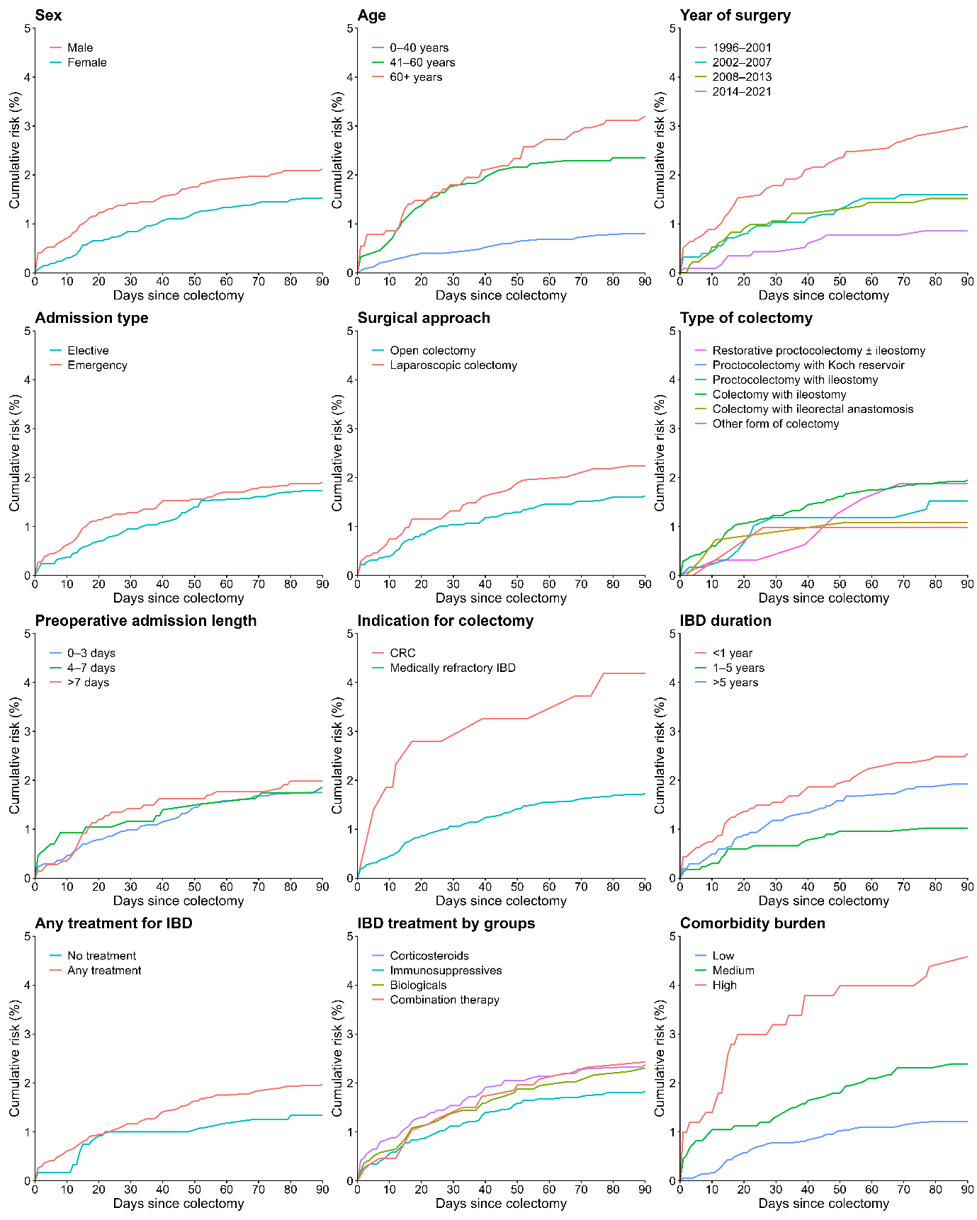
Abbreviations: CRC, colorectal cancer; IBD, inflammatory bowel disease.

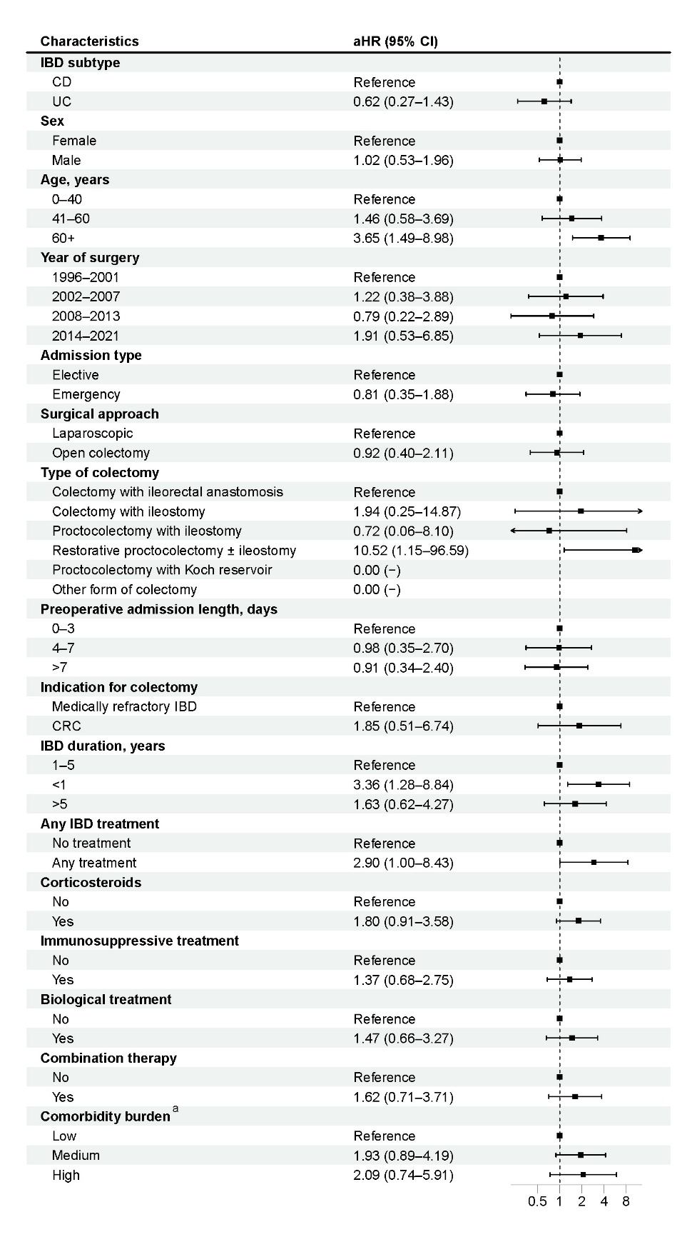
Supplementary Figure 2. Analysis of risk factors for venous thromboembolism in patients with inflammatory bowel disease during the 31-90-day period following total colectomy in Denmark.
Notes: Hazard ratios were adjusted for sex, age, year of total colectomy, admission type, surgical approach, colectomy type, preoperative length of stay, colectomy indication, IBD duration, IBD medical treatment, and comorbidity burden.
ª Based on Charlson Comorbidity Index (CCI) scores (low: score of 0, medium: score of 1-2, high: score ≥3). The CCI was modified to exclude any previous colorectal cancer and include codes for atrial fibrillation/flutter and obesity.
Abbreviations: aHR, adjusted hazard ratio; CCI, Charlson Comorbidity Index; CD, Crohn’s disease; CI, confidence interval; CRC, colorectal cancer; IBD, inflammatory bowel disease; UC, ulcerative colitis.
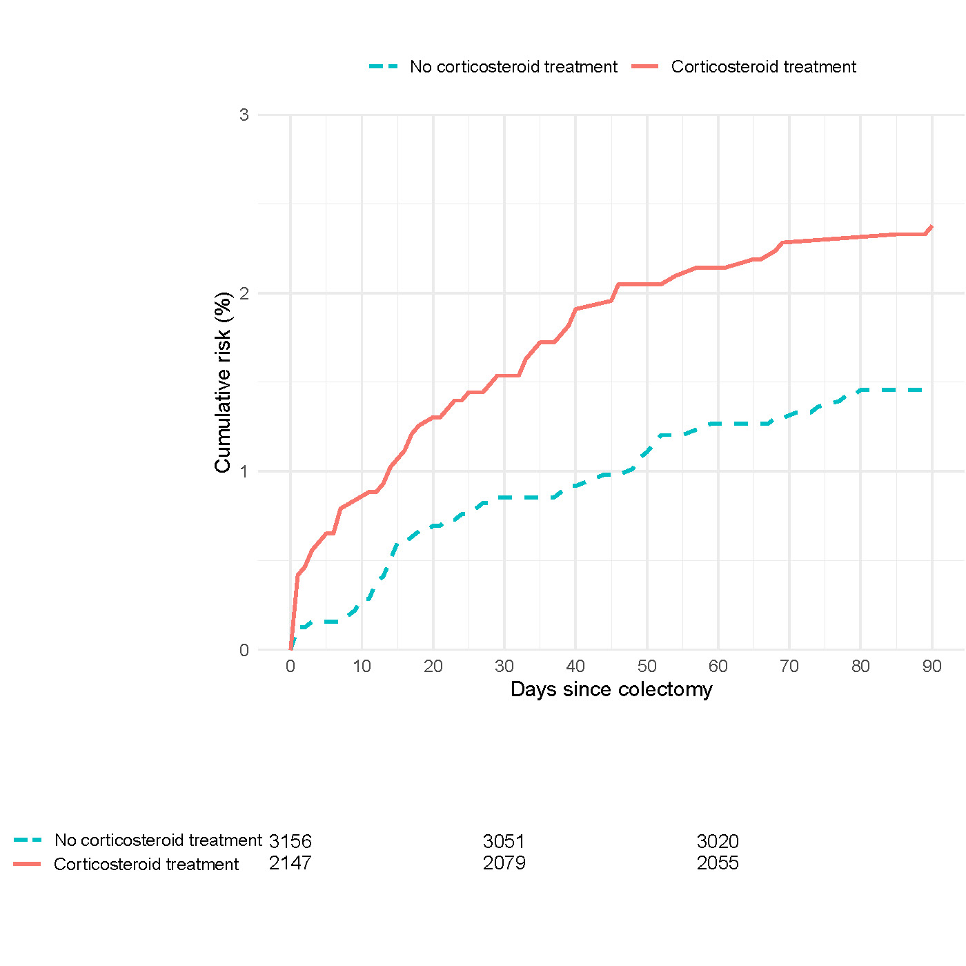
Supplementary Figure 3. Risk of venous thromboembolism at 0–90 days post-surgery in patients with inflammatory bowel disease undergoing total colectomy, based on corticosteroid treatment within 90 days before surgery.

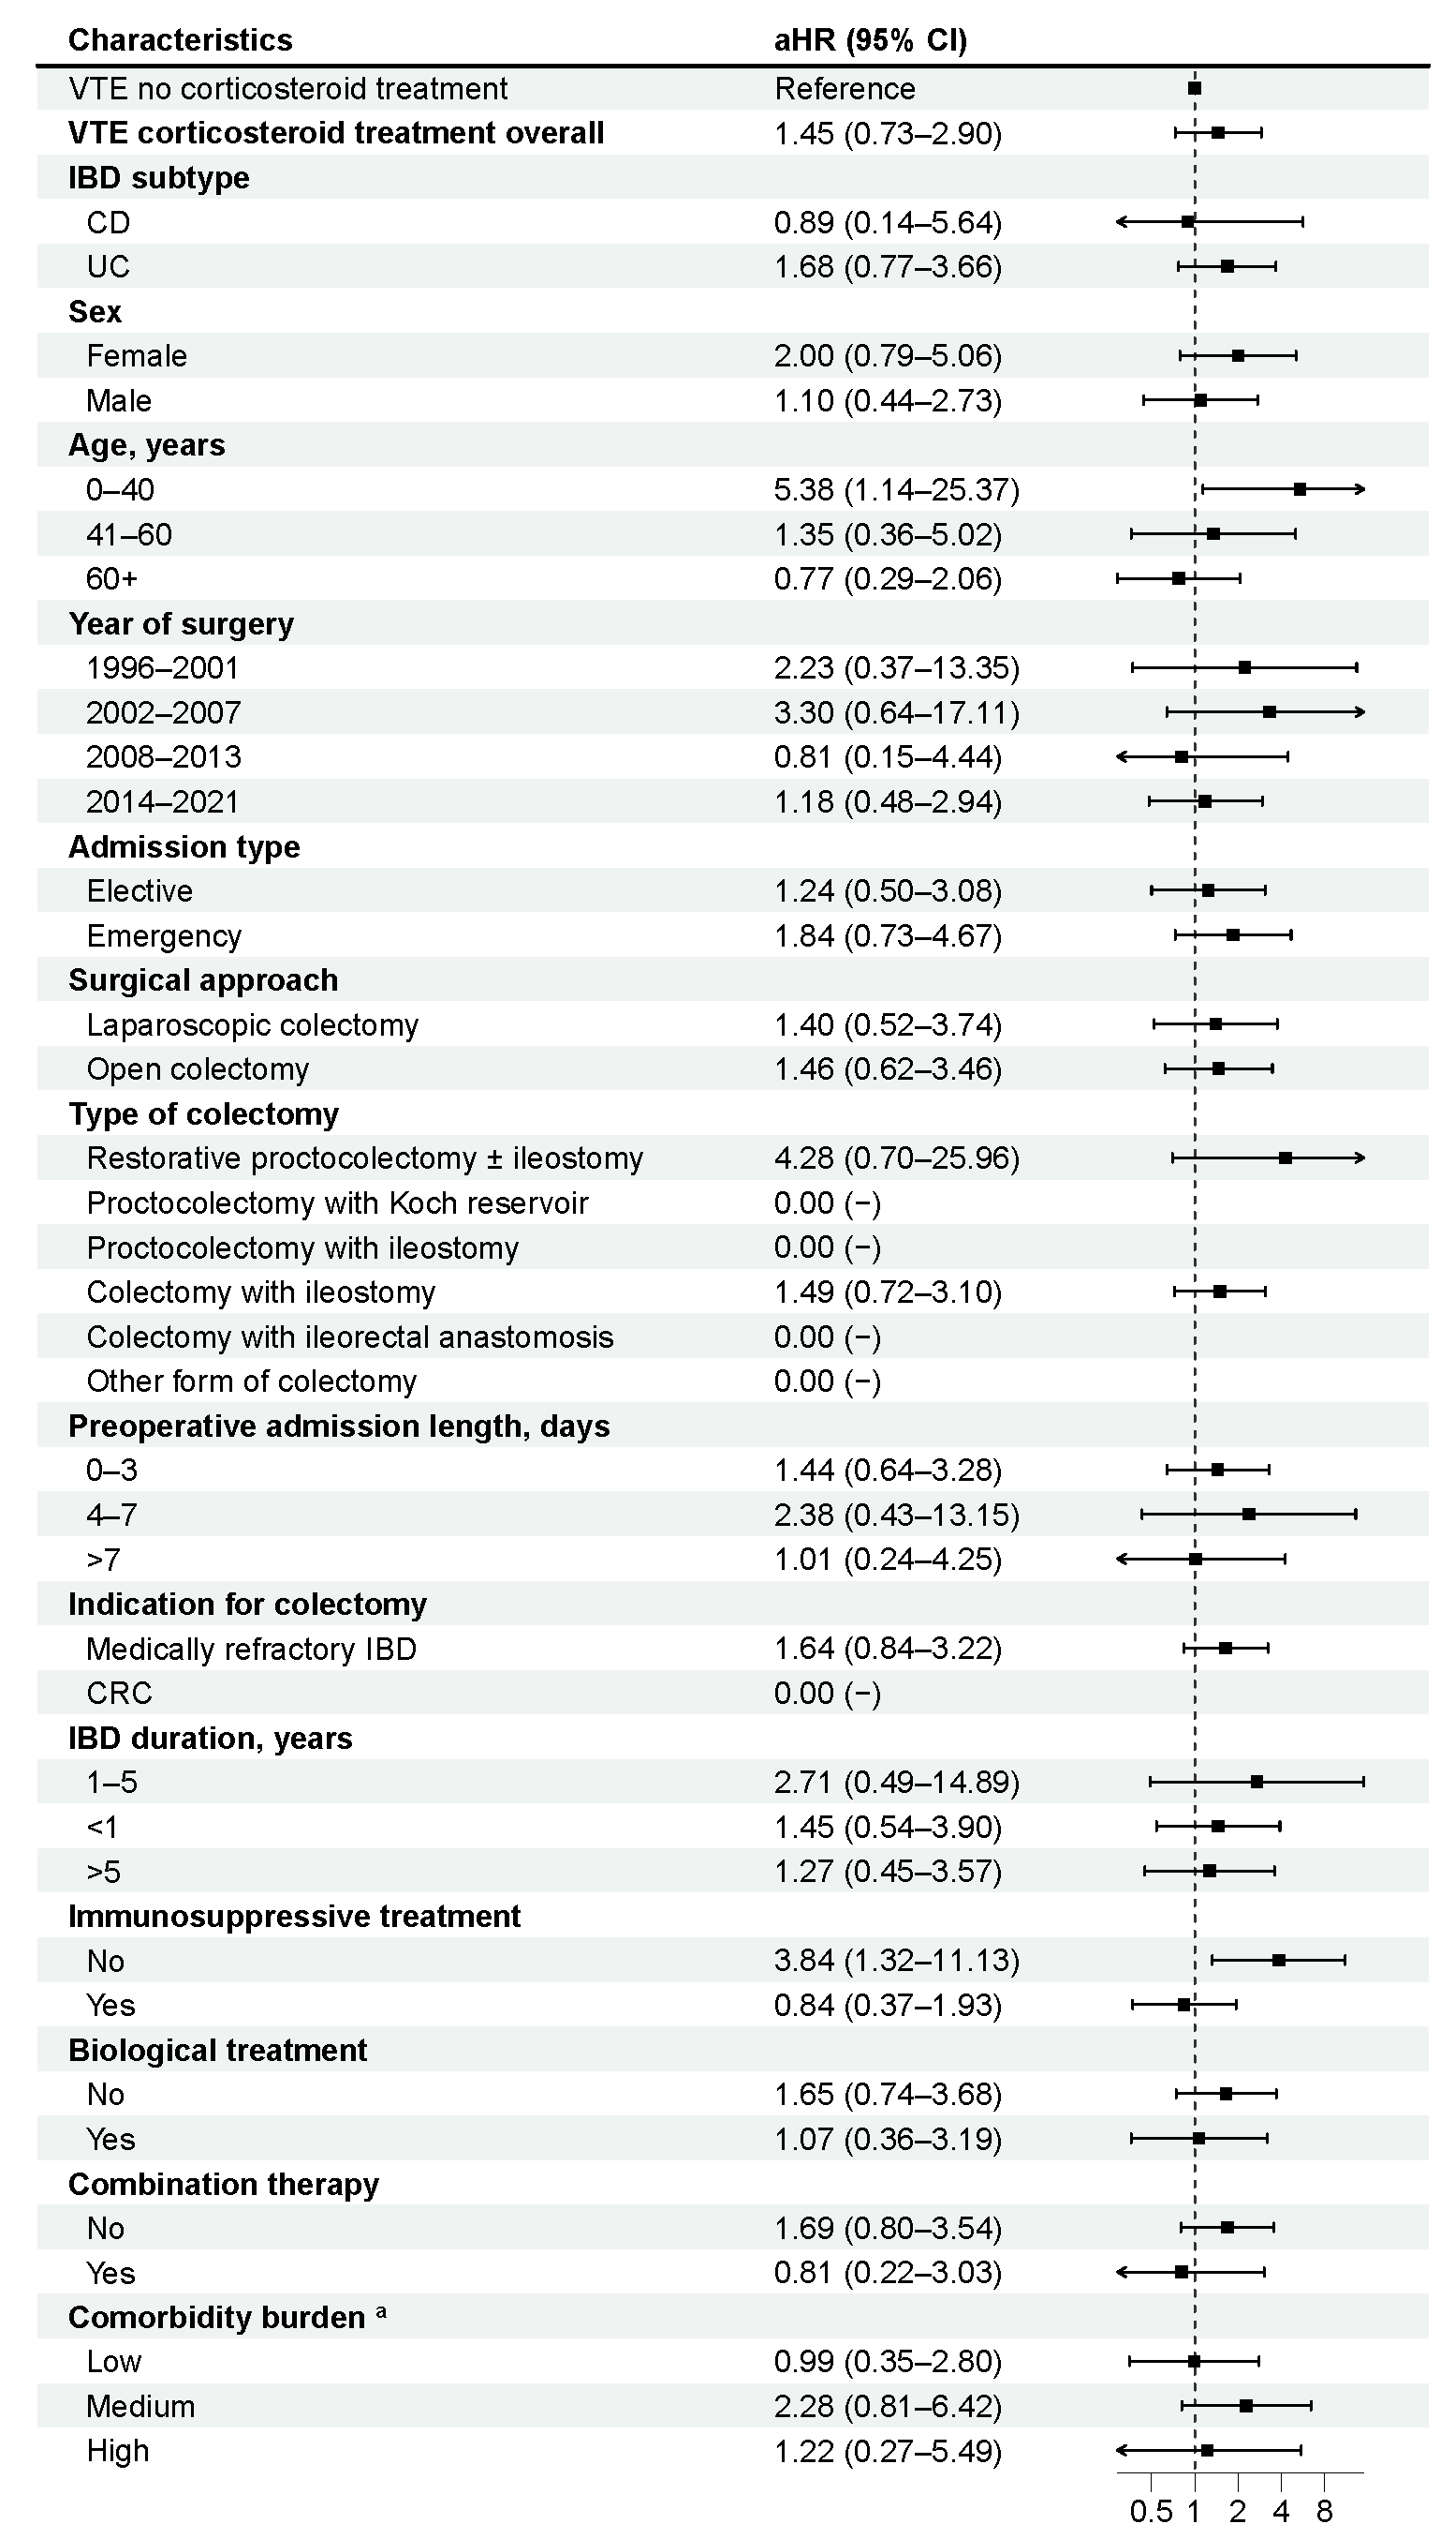
Supplementary Figure 4. Hazard ratios with 95% confidence intervals associating corticosteroid use with risk of venous thromboembolism in patients with inflammatory bowel disease who underwent total colectomy, during 31-90-day follow-up.
Notes: Hazard ratios were adjusted for sex, age, year of total colectomy, admission type, surgical approach, colectomy type, preoperative length of stay, colectomy indication, IBD duration, IBD medical treatment, and comorbidity burden.
ª Based on Charlson Comorbidity Index (CCI) scores (low: score of 0, medium: score of 1-2, high: score ≥3). The CCI was modified to exclude any previous colorectal cancer and include codes for atrial fibrillation/flutter and obesity.
Abbreviations: aHR, adjusted hazard ratio; CD, Crohn’s disease; CI, confidence interval; CRC, colorectal cancer; IBD, inflammatory bowel disease; UC, ulcerative colitis; VTE, venous thromboembolism.

