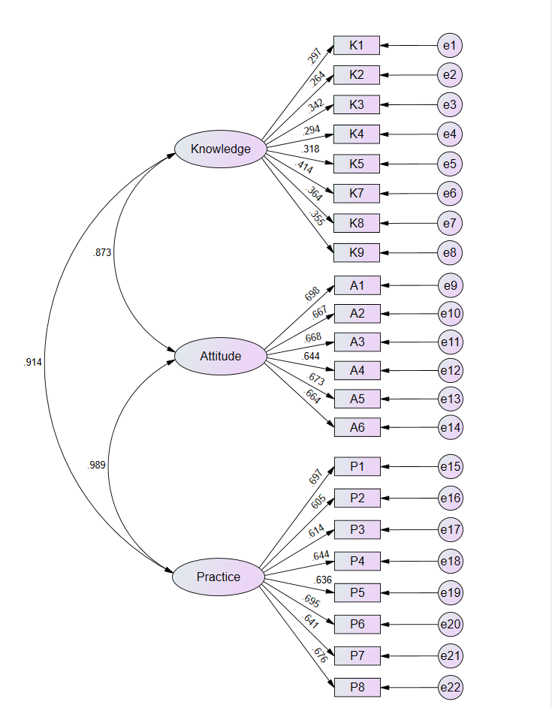

Supplementary Figure 1. Measurement Model of the Confirmatory Factor Analysis.
K6 was an attention-check item and was therefore not included in the CFA measurement model.
Supplementary Table 1. Model Fit Indices of the Confirmatory Factor Analysis (CFA).
Indicators | Reference | Actual
CMIN/DF | 1-3: Excellent, 3-5: Good | 1.223
RMSEA | <0.08: Good | 0.021
IFI | >0.9: Good | 0.986
TLI | >0.9: Good | 0.984
CFI | >0.9: Good | 0.986

Supplementary Table 2. Standardized and Unstandardized Estimates of the CFA Model.
 |  |  | Estimate | Standardized Estimate | S.E. | C.R. | P
K1 | <--- | Knowledge | 1.000 | 0.297
K2 | <--- | Knowledge | 0.887 | 0.264 | 0.215 | 4.130 | <0.001
K3 | <--- | Knowledge | 1.190 | 0.342 | 0.251 | 4.741 | <0.001
K4 | <--- | Knowledge | 1.029 | 0.294 | 0.234 | 4.389 | <0.001
K5 | <--- | Knowledge | 1.067 | 0.318 | 0.233 | 4.579 | <0.001
K7 | <--- | Knowledge | 1.510 | 0.414 | 0.293 | 5.146 | <0.001
K8 | <--- | Knowledge | 1.219 | 0.364 | 0.250 | 4.879 | <0.001
K9 | <--- | Knowledge | 1.196 | 0.355 | 0.248 | 4.829 | <0.001
A1 | <--- | Attitude | 1.000 | 0.698
A2 | <--- | Attitude | 0.939 | 0.667 | 0.066 | 14.119 | <0.001
A3 | <--- | Attitude | 0.930 | 0.668 | 0.066 | 14.144 | <0.001
A4 | <--- | Attitude | 0.925 | 0.644 | 0.068 | 13.645 | <0.001
A5 | <--- | Attitude | 0.911 | 0.673 | 0.064 | 14.238 | <0.001
A6 | <--- | Attitude | 0.884 | 0.664 | 0.063 | 14.049 | <0.001
P1 | <--- | Practice | 1.000 | 0.697
P2 | <--- | Practice | 0.923 | 0.605 | 0.072 | 12.895 | <0.001
P3 | <--- | Practice | 0.906 | 0.614 | 0.069 | 13.076 | <0.001
P4 | <--- | Practice | 0.980 | 0.644 | 0.072 | 13.702 | <0.001
P5 | <--- | Practice | 0.943 | 0.636 | 0.070 | 13.533 | <0.001
P6 | <--- | Practice | 1.030 | 0.695 | 0.070 | 14.721 | <0.001
P7 | <--- | Practice | 0.931 | 0.641 | 0.068 | 13.638 | <0.001
P8 | <--- | Practice | 1.004 | 0.676 | 0.070 | 14.353 | <0.001

Supplementary Table 3. Comparison of Demographics and KAP Scores based on PCSK9 Inhibitor Research Participation.
Demographics & KAP | Had taken part in PCSK9i research |  | P*
Demographics & KAP | Yes (N=340) | No (N=172) | P*
Knowledge | 10.02±2.58 | 10.10±2.69 | 0.799
Attitude | 23.79±4.99 | 23.74±5.13 | 0.858
Practice | 31.61±6.34 | 31.91±6.52 | 0.484
Respondent Gender |  |  | 0.540
Male | 130 (38.24) | 61 (35.47)
Female | 210 (61.76) | 111 (64.53)
Age |  |  | 0.190
≤ 32 years | 195 (57.35) | 109 (63.37)
>32 years | 145 (42.65) | 63 (36.63)
Education Level |  |  | 0.535
Bachelor's degree or below | 122 (35.88) | 62 (36.05)
Master’s degree | 158 (46.47) | 86 (50.00)
Doctoral degree | 60 (17.65) | 24 (13.95)
Professional Title |  |  | 0.008
Junior | 16 (4.71) | 20 (11.63)
Intermediate | 131 (38.53) | 58 (33.72)
Associate Senior | 139 (40.88) | 63 (36.63)
Senior | 44 (12.94) | 19 (11.05)
No professional title | 10 (2.94) | 12 (6.98)
Department |  |  | 0.864
Neurology | 137 (40.29) | 67 (38.95)
Cardiology | 108 (31.76) | 53 (30.81)
General Practice | 95 (27.94) | 52 (30.23)
Position |  |  | 0.345
Physician | 135 (39.71) | 82 (47.67)
Nurse | 108 (31.76) | 44 (25.58)
Technician | 31 (9.12) | 15 (8.72)
Pharmacist | 66 (19.41) | 31 (18.02)
Years in Practice |  |  | 0.139
Less than 1 year | 59 (17.35) | 39 (22.67)
1-5 years | 136 (40.00) | 74 (43.02)
More than 6 years | 145 (42.65) | 59 (34.30)
Hospital Classification |  |  | 0.091
Primary-level public hospital | 82 (24.12) | 38 (22.09)
Secondary-level public hospital | 100 (29.41) | 48 (27.91)
Tertiary-level public hospital | 64 (18.82) | 50 (29.07)
Specialized hospital | 34 (10.00) | 15 (8.72)
Private medical institution | 60 (17.65) | 21 (12.21)
*: The Independent-Samples Mann-Whitney U Test was used for comparisons of continuous variables, and the Pearson Chi-Square Test was used for comparisons of categorical variables

Supplementary Table 4. Distribution Across Domains
Knowledge |  |  | N (%)
 |  |  | Very familiar |  |  | Heard of |  |  |  | Unfamiliar
- PCSK9, or proprotein convertase subtilisin/kexin type 9, also known as neural apoptosis-regulated convertase-1, is a secreted soluble serine protease composed of 692 amino acids with a molecular weight of 72 kDa. |  |  | 193 (37.7) |  |  | 247 (48.24) |  |  |  | 72 (14.06)
- Current PCSK9 inhibitors primarily include monoclonal antibodies (e.g., evolocumab, alirocumab) and RNA interference-based agents (e.g., inclisiran). |  |  | 201 (39.26) |  |  | 242 (47.27) |  |  |  | 69 (13.48)
- When LDL-C levels remain above target after statin therapy, combination treatment with a PCSK9 inhibitor (or a cholesterol absorption inhibitor) should be considered. |  |  | 228 (44.53) |  |  | 211 (41.21) |  |  |  | 73 (14.26)
- PCSK9 inhibitors are mainly indicated for three groups: patients at very high cardiovascular risk, patients with familial hypercholesterolemia (FH) without established atherosclerotic cardiovascular disease (ASCVD), and patients from either category who are intolerant to statins. |  |  | 223 (43.55) |  |  | 213 (41.6) |  |  |  | 76 (14.84)
- Mechanism of action: PCSK9 is a liver-derived, secreted serine protease that binds to LDL receptors (LDLR) and promotes their degradation, thereby reducing the clearance of LDL-C from the circulation. Inhibition of PCSK9 prevents LDLR degradation and enhances LDL-C clearance. The mechanism of action of PCSK9 monoclonal antibodies involves direct targeting of the PCSK9 protein. |  |  | 206 (40.23) |  |  | 239 (46.68) |  |  |  | 67 (13.09)
- The capital of China is Shanghai.
- PCSK9 inhibitors, when added to statin therapy, further reduce the incidence of major adverse cardiovascular events, reinforcing the concept that more intensive LDL-C lowering confers additional cardiovascular protection. |  |  | 192 (37.5) |  |  | 218 (42.58) |  |  |  | 102 (19.92)
- PCSK9 inhibitors are covered under the national health insurance reimbursement system. |  |  | 205 (40.04) |  |  | 240 (46.88) |  |  |  | 67 (13.09)
- PCSK9 inhibitors may have additional effects, including anti-inflammatory activity, antiplatelet effects, and stabilization of atherosclerotic plaques. |  |  | 197 (38.48) |  |  | 244 (47.66) |  |  |  | 71 (13.87)
Attitude |  |  |  |  | N (%)
 |  |  |  |  | Strongly agree |  | Agree |  | Neutral |  |  | Disagree |  | Strongly Disagree
- I believe the safety profile of PCSK9 inhibitors is trustworthy. |  |  |  |  | 221 (43.16) |  | 146 (28.52) |  | 80 (15.63) |  |  | 36 (7.03) |  | 29 (5.66)
- I believe PCSK9 inhibitors are effective in treating hypercholesterolemia and preventing cardiovascular events. |  |  |  |  | 206 (40.23) |  | 161 (31.45) |  | 86 (16.8) |  |  | 28 (5.47) |  | 31 (6.05)
- I believe PCSK9 inhibitors will become a primary therapeutic option for hypercholesterolemia in the future. |  |  |  |  | 207 (40.43) |  | 166 (32.42) |  | 82 (16.02) |  |  | 27 (5.27) |  | 30 (5.86)
- I believe the current use of PCSK9 inhibitors is subject to controversy and should be approached with caution. |  |  |  |  | 209 (40.82) |  | 151 (29.49) |  | 88 (17.19) |  |  | 32 (6.25) |  | 32 (6.25)
- I believe existing clinical guidelines on the use of PCSK9 inhibitors require further clarification. |  |  |  |  | 186 (36.33) |  | 192 (37.5) |  | 78 (15.23) |  |  | 27 (5.27) |  | 29 (5.66)
- I support broader implementation of PCSK9 inhibitors in current clinical practice. |  |  |  |  | 223 (43.55) |  | 158 (30.86) |  | 87 (16.99) |  |  | 19 (3.71) |  | 25 (4.88)
 |  |  |  |  | High cost |  | Inconvenience of scheduled injections |  | Elevated risk of adverse effects |  |  | Lack of long-term supporting data
- In your opinion, what are the main challenges associated with the clinical use of PCSK9 inhibitors? (Select all that apply) |  |  |  |  | 312 (60.94) |  | 259 (50.59) |  | 242 (47.27) |  |  | 199 (38.87)
 |  |  |  |  | Clinical guidelines and consensus recommendations |  | Patient’s cholesterol level |  | Patient’s cardiovascular risk |  |  | Scope of medical insurance coverage |  | Patient’s financial status
8. In your opinion, which factors should influence the clinical application of PCSK9 inhibitors? (Select all that apply) |  |  |  |  | 308 (60.16) |  | 187 (36.52) |  | 248 (48.44) |  |  | 149 (29.1) |  | 158 (30.86)
Practice | N (%)
Practice | Always | Often |  | Sometimes |  |  |  | Rarely |  |  | Never
- I conduct a thorough assessment before initiating PCSK9 inhibitor therapy in patients. | 205 (40.04) | 174 (33.98) |  | 81 (15.82) |  |  |  | 27 (5.27) |  |  | 25 (4.88)
- I engage in multidisciplinary discussions and consultations before initiating PCSK9 inhibitor therapy. | 213 (41.6) | 152 (29.69) |  | 83 (16.21) |  |  |  | 34 (6.64) |  |  | 30 (5.86)
- I perform regular evaluations of treatment efficacy and safety in patients receiving PCSK9 inhibitors. | 195 (38.09) | 158 (30.86) |  | 104 (20.31) |  |  |  | 27 (5.27) |  |  | 28 (5.47)
- I routinely monitor cholesterol levels in patients treated with PCSK9 inhibitors. | 217 (42.38) | 137 (26.76) |  | 104 (20.31) |  |  |  | 22 (4.3) |  |  | 32 (6.25)
- I monitor the incidence of cardiovascular events in patients receiving PCSK9 inhibitors. | 199 (38.87) | 162 (31.64) |  | 95 (18.55) |  |  |  | 27 (5.27) |  |  | 29 (5.66)
- I closely observe potential adverse effects associated with PCSK9 inhibitors and respond proactively. | 240 (46.88) | 139 (27.15) |  | 78 (15.23) |  |  |  | 30 (5.86) |  |  | 25 (4.88)
- I schedule regular follow-up visits for patients receiving PCSK9 inhibitor therapy. | 216 (42.19) | 144 (28.13) |  | 100 (19.53) |  |  |  | 30 (5.86) |  |  | 22 (4.3)
- I stay up to date with clinical guidelines and literature related to PCSK9 inhibitors. | 206 (40.23) | 167 (32.62) |  | 76 (14.84) |  |  |  | 37 (7.23) |  |  | 26 (5.08)
 | Patient’s cholesterol level | Patient’s cardiovascular risk |  | Tolerability and efficacy of other lipid-lowering therapies |  |  |  | Patient’s age and sex
- What factors do you consider when formulating a treatment plan involving PCSK9 inhibitors? (Select all that apply) | 233 (45.51) | 243 (47.46) |  | 275 (53.71) |  |  |  | 300 (58.59)
Note: To ensure data quality, an attention-check item (K6, "The capital of China is Shanghai") was embedded within knowledge domain; responses to this item were strictly used for data screening and were excluded from the final knowledge score calculation.

Supplementary Table 5. Model fit of Structural Equation Model
Model Fit Indices | Ref. | Measured results
CMIN/DF | 1-3 excellent, 3-5 good | 1.223
RMSEA | <0.08 good | 0.021
IFI | >0.8 good | 0.986
TLI | >0.8 good | 0.984
CFI | >0.8 good | 0.986

