Supplementary materials

Supplementary figures

Supplementary Figure 1. Summary of exacerbations (as defined by asthma-related ED visits, asthma-related hospital admissions or oral/IV corticosteroid use) by GBTM adherence clusters during the 12-month follow-up period among patients who remained on the same biologic during follow-up (N=2531).
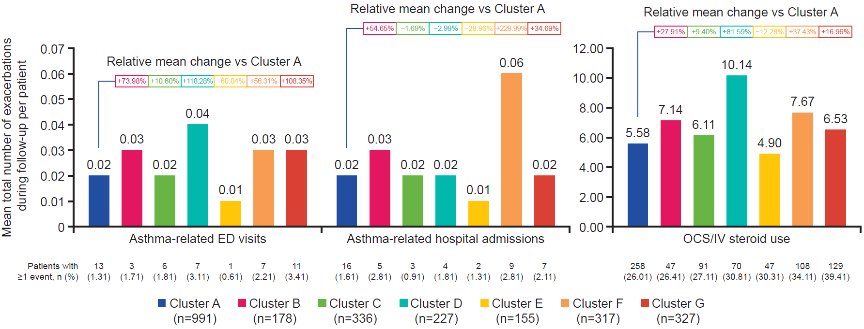
Exacerbations requiring OCS/IV steroid use included OCS prescriptions lasting ≥3–≤28 days within the month of, or the month before asthma diagnosis, and any IV steroid used during or prior to the month of diagnosis
ED, emergency department; GBTM, group-based trajectory modeling; IV, intravenous; OCS, oral corticosteroid.

Supplementary Figure 2. Summary of all-cause (A) and asthma-related (B) HCRU by GBTM adherence clusters during the 12-month follow-up period among patients who remained on the same biologic during follow-up (N=2531).
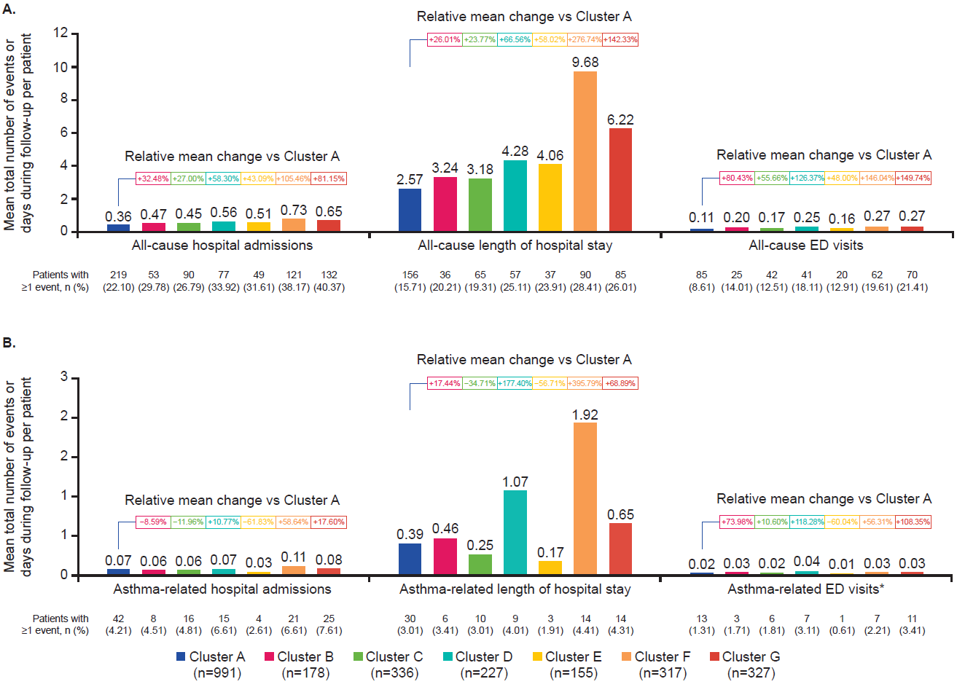
*The results for asthma-related ED visits were identical to those for asthma-related ED visits used in the exacerbation outcome analysis.
ED, emergency department; GBTM, group-based trajectory modeling; HCRU, healthcare resource utilization.

Supplementary Figure 3. Summary of all-cause (A) and asthma-related (B) pharmacy costs by GBTM adherence clusters during the 12-month follow-up period among patients who remained on the same biologic during follow-up (N=2531)
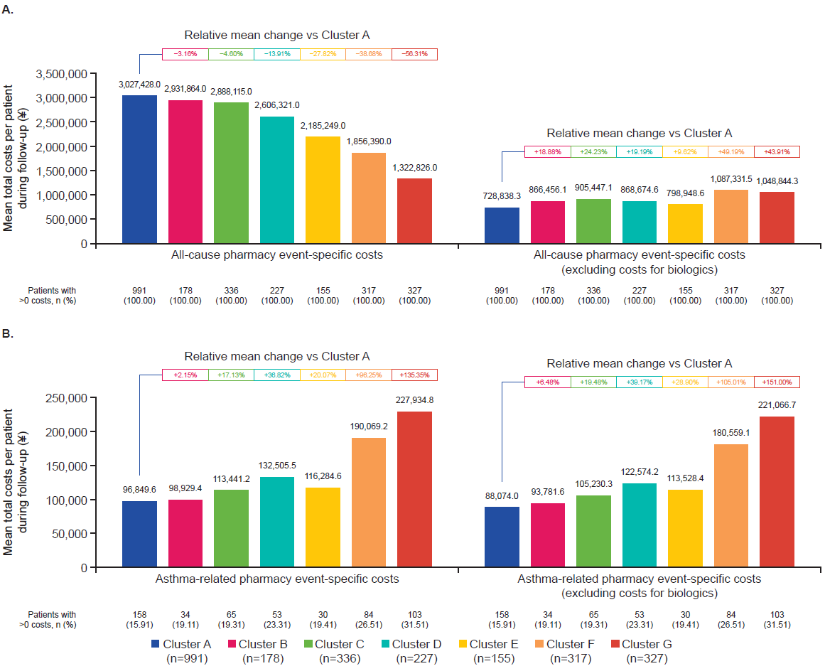
GBTM, group-based trajectory modeling.

Supplementary Figure 4. Summary of oral and IV corticosteroid use by GBTM adherence clusters during the 12-month follow-up period (N=2531)
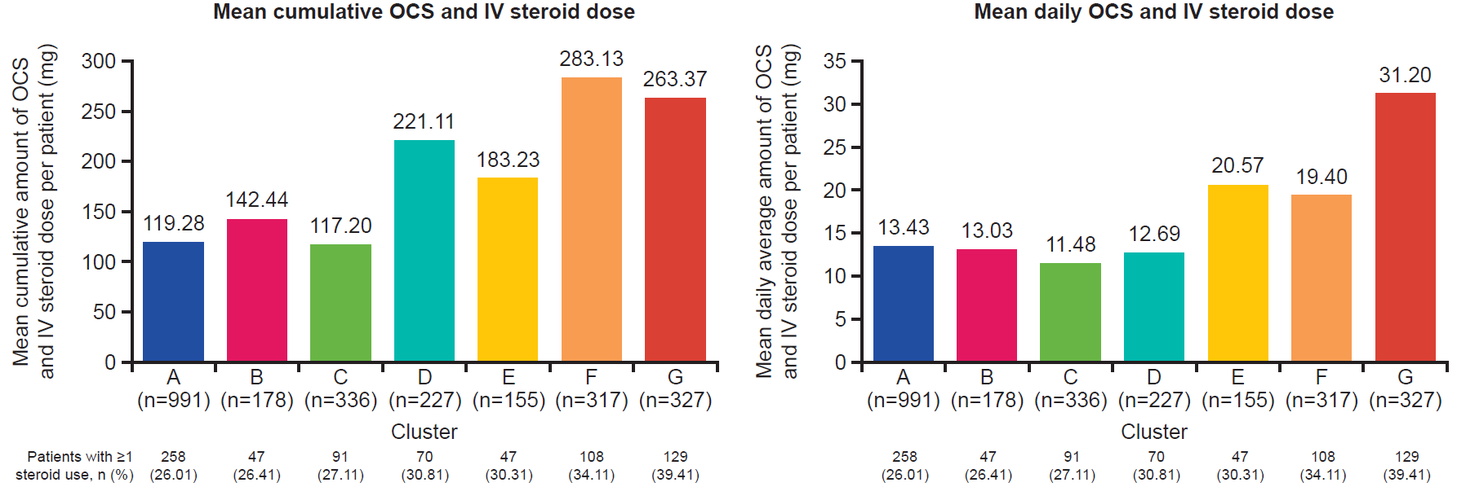
The mean daily OCS and IV steroid dose was calculated only over the days that patients received OCS and IV steroids (i.e. it did not cover the full 12-month follow-up period).
GBTM, group-based trajectory modeling; IV, intravenous; OCS, oral corticosteroid.

Supplementary tables

Supplementary Table 1. Rate ratio or effect size of outcomes during periods of adherence versus non-adherence to asthma biologics: results from simple regression models
Outcome | Result typeª | Result value | 1- Exp (RR)^{b} | Exp (-RR) – 1^{c} | P-value
Asthma-related ED visits | RR | -0.490 | 38.74% lower | 63.24% higher | <0.001
Asthma-related hospitalization visits | RR | -0.362 | 30.36% lower | 43.61% higher | <0.001
Oral and IV corticosteroid usage | RR | -0.356 | 29.94% lower | 42.74% higher | <0.001
All-cause hospital visits | RR | -0.501 | 39.44% lower | 65.11% higher | <0.001
All-cause length of hospital stays | Effect size | -1.026 | NA | NA | NA
All-cause ED visits | RR | -0.534 | 41.37% lower | 70.56% higher | <0.001
Asthma-related hospital visits | RR | -0.313 | 26.87% lower | 36.74% higher | <0.001
Asthma-related length of hospital stays | Effect size | -0.142 | NA | NA | NA
Asthma-related ED visits | RR | -0.490 | 38.74% lower | 63.24% higher | <0.001
All-cause pharmacy event-specific costs | Effect size | 176,704 | NA | NA | NA
All-cause pharmacy event-specific costs (excluding biologics) | Effect size | -50,842 | NA | NA | NA
Asthma-related pharmacy event-specific costs | Effect size | -17,071 | NA | NA | NA
Asthma-related pharmacy event-specific costs (excluding biologics) | Effect size | -17,250 | NA | NA | NA

ªAll count outcomes from the simple regression analysis were reported as RRs, while the outcomes for continuous variables were reported as effect sizes; ^{b}the expression 1−exp(RR) provides the percentage change in the rate of cumulative event visits during periods of treatment adherence compared with periods of non-adherence, as determined by the RR; ^{c}the expression exp(-RR)-1 provides the percentage change in the rate of cumulative event visits during periods of treatment non-adherence compared with periods of adherence, as determined by the negative of RR.
ED, emergency department; IV, intravenous; NA, not applicable; RR, rate ratio.

