Supplementary Material
eTable 1. PRISMA 2020 Checklist
Section and Topic | Item # | Checklist item | Location where item is reported
TITLE
Title | 1 | Identify the report as a systematic review. | Page 1
ABSTRACT
Abstract | 2 | See the PRISMA 2020 for Abstracts checklist. | Page 1
INTRODUCTION
Rationale | 3 | Describe the rationale for the review in the context of existing knowledge. | Page 1-2
Objectives | 4 | Provide an explicit statement of the objective(s) or question(s) the review addresses. | Page 2
METHODS
Eligibility criteria | 5 | Specify the inclusion and exclusion criteria for the review and how studies were grouped for the syntheses. | Page 2
Information sources | 6 | Specify all databases, registers, websites, organisations, reference lists and other sources searched or consulted to identify studies. Specify the date when each source was last searched or consulted. | Page 2
Search strategy | 7 | Present the full search strategies for all databases, registers and websites, including any filters and limits used. | Page 2 and Supplementary Material
Selection process | 8 | Specify the methods used to decide whether a study met the inclusion criteria of the review, including how many reviewers screened each record and each report retrieved, whether they worked independently, and if applicable, details of automation tools used in the process. | Page 2
Data collection process | 9 | Specify the methods used to collect data from reports, including how many reviewers collected data from each report, whether they worked independently, any processes for obtaining or confirming data from study investigators, and if applicable, details of automation tools used in the process. | Page 2-3
Data items | 10a | List and define all outcomes for which data were sought. Specify whether all results that were compatible with each outcome domain in each study were sought (e.g. for all measures, time points, analyses), and if not, the methods used to decide which results to collect. | Page 2-3
Data items | 10b | List and define all other variables for which data were sought (e.g. participant and intervention characteristics, funding sources). Describe any assumptions made about any missing or unclear information. | Page 2-3
Study risk of bias assessment | 11 | Specify the methods used to assess risk of bias in the included studies, including details of the tool(s) used, how many reviewers assessed each study and whether they worked independently, and if applicable, details of automation tools used in the process. | Page 3
Effect measures | 12 | Specify for each outcome the effect measure(s) (e.g. risk ratio, mean difference) used in the synthesis or presentation of results. | Page 3
Synthesis methods | 13a | Describe the processes used to decide which studies were eligible for each synthesis (e.g. tabulating the study intervention characteristics and comparing against the planned groups for each synthesis (item #5)). | Page 3
Synthesis methods | 13b | Describe any methods required to prepare the data for presentation or synthesis, such as handling of missing summary statistics, or data conversions. | Page 3
Synthesis methods | 13c | Describe any methods used to tabulate or visually display results of individual studies and syntheses. | Page 3
Synthesis methods | 13d | Describe any methods used to synthesize results and provide a rationale for the choice(s). If meta-analysis was performed, describe the model(s), method(s) to identify the presence and extent of statistical heterogeneity, and software package(s) used. | Page 3
Synthesis methods | 13e | Describe any methods used to explore possible causes of heterogeneity among study results (e.g. subgroup analysis, meta-regression). | Subgroup or meta-regression analyses were not conducted due to the limited number of studies.
Synthesis methods | 13f | Describe any sensitivity analyses conducted to assess robustness of the synthesized results. | Sensitivity analyses were not performed because of the small number of studies included in each synthesis.
Reporting bias assessment | 14 | Describe any methods used to assess risk of bias due to missing results in a synthesis (arising from reporting biases). | Publication bias was not formally assessed due to the small number of studies contributing to each meta-analysis, which limits the reliability of funnel plot asymmetry tests.
Certainty assessment | 15 | Describe any methods used to assess certainty (or confidence) in the body of evidence for an outcome. | The certainty of evidence was not formally assessed using GRADE due to the limited number of studies per outcome and substantial heterogeneity across included trials.
RESULTS
Study selection | 16a | Describe the results of the search and selection process, from the number of records identified in the search to the number of studies included in the review, ideally using a flow diagram. | Page 3
Study selection | 16b | Cite studies that might appear to meet the inclusion criteria, but which were excluded, and explain why they were excluded. | Page 3
Study characteristics | 17 | Cite each included study and present its characteristics. | Page 3-4
Risk of bias in studies | 18 | Present assessments of risk of bias for each included study. | Page 4
Results of individual studies | 19 | For all outcomes, present, for each study: (a) summary statistics for each group (where appropriate) and (b) an effect estimate and its precision (e.g. confidence/credible interval), ideally using structured tables or plots. | Page 4-9
Results of syntheses | 20a | For each synthesis, briefly summarise the characteristics and risk of bias among contributing studies. | Page 4-9
Results of syntheses | 20b | Present results of all statistical syntheses conducted. If meta-analysis was done, present for each the summary estimate and its precision (e.g. confidence/credible interval) and measures of statistical heterogeneity. If comparing groups, describe the direction of the effect. | Page 4-9
Results of syntheses | 20c | Present results of all investigations of possible causes of heterogeneity among study results. | Not conducted because the limited number of studies precluded reliable exploration of heterogeneity.
Results of syntheses | 20d | Present results of all sensitivity analyses conducted to assess the robustness of the synthesized results. | Not conducted due to the small number of studies available for each synthesis.
Reporting biases | 21 | Present assessments of risk of bias due to missing results (arising from reporting biases) for each synthesis assessed. | Not assessed because fewer than ten studies were available for each outcome.
Certainty of evidence | 22 | Present assessments of certainty (or confidence) in the body of evidence for each outcome assessed. | The certainty of evidence was not formally assessed using GRADE due to the limited number of studies per outcome and substantial heterogeneity across included trials.
DISCUSSION
Discussion | 23a | Provide a general interpretation of the results in the context of other evidence. | Page 9-11
Discussion | 23b | Discuss any limitations of the evidence included in the review. | Page 10-11
Discussion | 23c | Discuss any limitations of the review processes used. | Page 10-11
Discussion | 23d | Discuss implications of the results for practice, policy, and future research. | Page 10-11
OTHER INFORMATION
Registration and protocol | 24a | Provide registration information for the review, including register name and registration number, or state that the review was not registered. | Page 2
Registration and protocol | 24b | Indicate where the review protocol can be accessed, or state that a protocol was not prepared. | The protocol for this systematic review has been registered with PROSPERO (CRD420251274607) and is publicly accessible at https://www.crd.york.ac.uk/PROSPERO/view/CRD420251274607.
Registration and protocol | 24c | Describe and explain any amendments to information provided at registration or in the protocol. | No substantive amendments were made to the registered protocol (PROSPERO: CRD420251274607).
Support | 25 | Describe sources of financial or non-financial support for the review, and the role of the funders or sponsors in the review. | Page 11
Competing interests | 26 | Declare any competing interests of review authors. | Page 12
Availability of data, code and other materials | 27 | Report which of the following are publicly available and where they can be found: template data collection forms; data extracted from included studies; data used for all analyses; analytic code; any other materials used in the review. | Page 11

eTable 2. Search strings tailored to three databases and the number of extracted studies
Database | Hits | Search terms
PubMed | 275 | #1 Pharmacists [Mesh] OR Pharmaceutical Services [Mesh] OR pharmacist*[Title/Abstract] OR pharmaceutical care [Title/Abstract] OR pharmaceutical services[Title/Abstract] OR pharmaceutical intervention [Title/Abstract] OR pharmacy practice [Title/Abstract] OR medication education [Title/Abstract] OR medication therapy management[Title/Abstract] OR MTM[Title/Abstract] OR pharmacy[Title/Abstract] OR Medication Adherence [Title/Abstract] OR inhaler technique [Title/Abstract] OR Patient Education [Title/Abstract] OR medication counseling[Title/Abstract] OR pharmacist-led intervention*[Title/Abstract] OR drug therapy management[Title/Abstract] OR inhaler training[Title/Abstract]  #2 (Pulmonary Disease, Chronic Obstructive [Mesh]) OR COPD[Title/Abstract] OR chronic obstructive pulmonary disease [Title/Abstract] OR chronic obstructive lung disease[Title/Abstract] OR emphysema[Title/Abstract] OR chronic bronchitis[Title/Abstract]  #3 #1 And #2
Embase | 424 | #1 'pharmacists':ti,ab,kw OR 'pharmacist*':ti,ab,kw OR 'pharmaceutical care':ti,ab,kw OR 'pharmaceutical services':ti,ab,kw OR 'pharmaceutical intervention':ti,ab,kw OR 'pharmacy practice':ti,ab,kw OR 'medication education':ti,ab,kw OR 'medication therapy management':ti,ab,kw OR 'mtm':ti,ab,kw OR 'pharmacy':ti,ab,kw OR 'medication adherence':ti,ab,kw OR 'inhaler technique':ti,ab,kw OR 'patient education':ti,ab,kw OR 'medication counseling':ti,ab,kw OR 'pharmacist-led intervention*':ti,ab,kw OR 'drug therapy management':ti,ab,kw OR 'inhaler training':ti,ab,kw  #2 'copd':ti,ab,kw OR 'chronic obstructive pulmonary disease':ti,ab,kw OR 'chronic obstructive lung disease':ti,ab,kw OR 'emphysema':ti,ab,kw OR 'chronic bronchitis':ti,ab,kw  #3 #1 And #2
WOS | 112 | #1 TS= "pharmacists" OR "pharmacist*" OR "pharmaceutical care" OR "pharmaceutical services" OR "pharmaceutical intervention" OR "pharmacy practice" OR "medication education" OR "medication therapy management" OR "mtm" OR "pharmacy" OR "medication adherence" OR "inhaler technique" OR "patient education" OR "medication counseling" OR "pharmacist-led intervention*" OR "drug therapy management" OR "inhaler training"  #2 TS= "COPD" OR "chronic obstructive pulmonary disease" OR "chronic obstructive lung disease" OR "emphysema" OR "chronic bronchitis"  #3 #1 And #2
Note: # Search set numbers used within database search interfaces.
* The asterisk (*) represents truncation used in database searches.
eTable 3. Effects of pharmaceutical care on clinical measures of COPD patients
Outcomes measures | Research,  measurement approach | Outcomes of intervention group | Number of intervention group | Outcomes of control group | Number of control group | P
Dyspnoea assessed by mMRC | Tommelein2013²⁴, number of patients ≥ 2 | 130 | 346 | 125 | 346 | 0.973
Dyspnoea assessed by mMRC | Nguyen2024³³, number of patients ≥ 2 | 46 | 91 | 65 | 89 | 0.002
COPD-specific health status assessed by CAT | Tommelein2013²⁴, mean (SD) | 15.9 (7.8) | 346 | 15.9 (7.7) | 346 | 0.832
COPD-specific health status assessed by CAT | Liu 2021³⁰, mean (SD) | 9.03(1.75) | 96 | 15.61(2.01) | 97 | < 0.05
COPD-specific health status assessed by CAT | Kebede2022³², median | 25.5 | 16 | 24 | 13 | 0.29
COPD-specific health status assessed by CAT | Nguyen2024³³, median (IQR) | 11 (8–14) | 91 | 12 (8.5–16) | 89 | 0.086
FEV1 | Khdour2009²², mean (95%CI) | 1.19 (1.05, 1.31) | 71 | 1.05 (0.94, 1.17) | 72 | 0.13
FEV1 | Jarab2012²³, mean (95%CI) | 1.15 (1.05–1.26) | 63 | 1.06 (0.94–1.21) | 64 | 0.55
Patients with Severe exacerbations | Tommelein2013²⁴, number of patients | 19 | 371 | 33 | 363 | 0.038
Patients with Severe exacerbations | Xin2016²⁶, number of patients | 14 | 114 | 28 | 113 | 0.024

eTable 4. Effects of pharmaceutical care on healthcare utilization
Outcomes measures | Research,  measurement approach | Outcomes of intervention group | Number of intervention group | Outcomes of control group | Number of control group | P
Hospital admissions for AECOPD | Khdour2009²², number of patients with admissions | 18 | 71 | 32 | 72 | -
Hospital admissions for AECOPD | Jarab2012²³, number of patients with admissions | 3 | 66 | 11 | 67 | 0.031
Hospital admissions for AECOPD | Wei2014²⁵, number of patients with admissions | 16 | 42 | 38 | 45 | 0.01
Hospital admissions for AECOPD | Xin2016²⁶, number of patients with admissions | 11 | 114 | 35 | 113 | 0.015
Hospital admissions for AECOPD | Tommelein2013²⁴, number of patients with admissions | 8 | 371 | 24 | 363 | 0.003
ED visits for AECOPD | Khdour2009²², number of patients with visits | 25 | 71 | 40 | 72 | -
ED visits for AECOPD | Khdour2009²², number of visits | 40 | 71 | 80 | 72 | 0.02
ED visits for AECOPD | Jarab2012²³, number of patients with visits | 10 | 66 | 12 | 67 | 0.79
DDDs of antibacterials | Liu 2021³⁰ | 121 | 96 | 189 | 97 | <0.05
Length of stay | Liu 2021³⁰, mean (SD), d | 11.27(5.28) | 96 | 13.46(3.95) | 97 | <0.05
Costs of hospitalization | Liu 2021³⁰, Mean (SD), RMB | 13405.45(4023.78) | 96 | 14856.51(4521.63) | 97 | <0.05
Cases of adverse drug reactions | Liu 2021³⁰, number of cases | 9 | 96 | 23 | 97 | <0.01
Time to readmission | Kebede2022³², median, d | 41 | 19 | 95 | 20 | 0.16

eTable 5. Effects of pharmaceutical care on quality of life
Outcomes measures | Research,  measurement approach | Outcomes of intervention group | Number of intervention group | Outcomes of control group | Number of control group | P
QoL assessed by SGRQ | Khdour2009²², mean (95% CI) | 61.8(57.9, 65.6) | 71 | 65.3(61.0, 69.6) | 72 | 0.17
QoL assessed by SGRQ | Jarab2012²³, 6-month change (95% CI) | -2.9 (-6.1 to 0.9) | 63 | -2.1 (-5.9 to 0.2) | 64 | 0.51
QoL assessed by SGRQ | Wei2014²⁵, mean (SD) | 48.86(12.54) | 51 | 52.16(13.59) | 53 | 0.139
QoL assessed by SGRQ | Xin2016²⁶, mean (SD) | 42.7(3.2) | 114 | 52.4(5.2) | 113 | 0.024
QoL assessed by SGRQ | Abdulsalim2016²⁷, mean | 60.40 | 104 | 68.50 | 98 | 0.001
QoL assessed by EQ-5D | Tommelein2013²⁴, mean (SD) | 0.72 (0.24) | 346 | 0.73 (0.25) | 346 | 0.190
QoL assessed by WHOQOL | Vastrad 2021³¹, mean (SD) | 64.10 (8.91) | 35 | 46.05 (5.00) | 35 | 0.0001
QoL assessed by validated Vietnamese version of the CCQ | Bui2020²⁹, mean (SD) | 0.81 (0.54) | 73 | 1.24 (0.81) | 68 | 0.001

eTable 6. Effects of pharmaceutical care on medication adherence
Outcomes measures | Research,  measurement approach | Outcomes of intervention group | Number of intervention group | Outcomes of control group | Number of control group | P
Medication adherence assessed by MMAS-4 | Khdour2009²², number of patients exhibited high adherence scores | 55 | 71 | 43 | 72 | 0.019
Medication adherence assessed by MMAS-4 | Jarab2012²³, number of patients exhibited high adherence scores | 45 | 63 | 33 | 64 | 0.017
Medication adherence assessed by MMAS-4 | Abdulsalim2018²⁸, number of patients exhibited high adherence scores | 84 | 104 | 48 | 98 | < 0.001
Medication adherence assessed by MMAS-8 | Liu 2021³⁰, mean (SD) | 7.31(0.46) | 96 | 6.05(0.39) | 97 | < 0.05
Medication adherence assessed by MRA | Tommelein2013²⁴, mean (SD) | 93.9 (21.5) | 292 | 85.7 (26.6) | 307 | <0.0001
Medication adherence assessed by MRA | Xin2016²⁶, mean (SD) | 93.1(14.2) | 114 | 83.2(12.7) | 113 | 0.003
Medication adherence assessed by General Medication Adherence Scale | Nguyen2024³³, median (IQR) | 32 (31–33) | 91 | 31 (29–33) | 89 | <0.001
Medication adherence assessed by pill counts plus direct interview | Wei2014²⁵, mean (SD) | 66.5(8.6) | 42 | 54.4(12.5) | 45 | 0.039

eTable 7. Effects of pharmaceutical care on COPD-related knowledge scores
Outcomes measures | Research,  measurement approach | Outcomes of intervention group | Number of intervention group | Outcomes of control group | Number of control group | P
Knowledge scores assessed by COPD knowledge questionnaire developed by Scherer et al | Khdour2009²², median (IQR) | 75.0 (32.0) | 71 | 59.3 (33.0) | 72 | 0.001
 | Jarab2012²³, median (IQR) | 60.7 (20) | 63 | 43.6 (30) | 64 | 0.007

eTable 8. Effects of pharmaceutical care on inhalation technique
Outcomes measures | Research,  measurement approach | Outcomes of intervention group | Number of intervention group | Outcomes of control group | Number of control group | P
Inhalation technique assessed by checklist | Tommelein2013²⁴, number of patients with correct inhalation technique | 237 | 346 | 114 | 346 | <0.0001
Inhalation technique assessed by checklist | Nguyen2024³³, number of patients with correct inhalation technique | 90 | 91 | 77 | 89 | 0.001

eTable 9. Effects of pharmaceutical care on other secondary outcomes: smoking cessation and body mass index
Outcomes measures | Research,  measurement approach | Outcomes of intervention group | Number of intervention group | Outcomes of control group | Number of control group | P
BMI | Khdour2009²², mean (95%CI) | 28.4 (27.3, 29.8) | 71 | 27.1 (25.8, 28.2) | 72 | 0.09
BMI | Jarab2012²³, median (IQR) | 30.1 (8.1) | 63 | 29.4 (7.8) | 64 | 0.61
Number of quit smoking | Khdour2009²², number of patients who quit smoking | 4 | 18 | 2 | 19 | 0.27
Number of quit smoking | Tommelein2013²⁴, number of patients who quit smoking | 15 | 170 | 9 | 147 | 0.331
Number of quit smoking | Xin2016²⁶, number of patients who quit smoking | 81 | 114 | 59 | 113 | 0.022

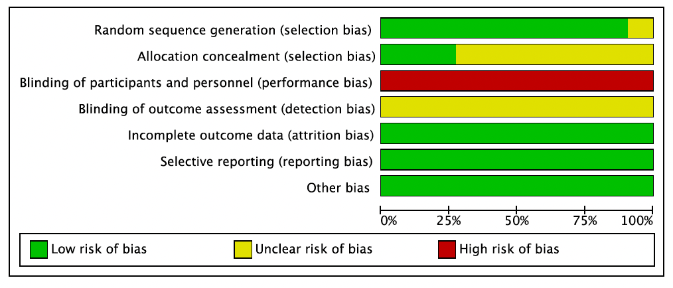
eFigure 1. Risk of bias graph
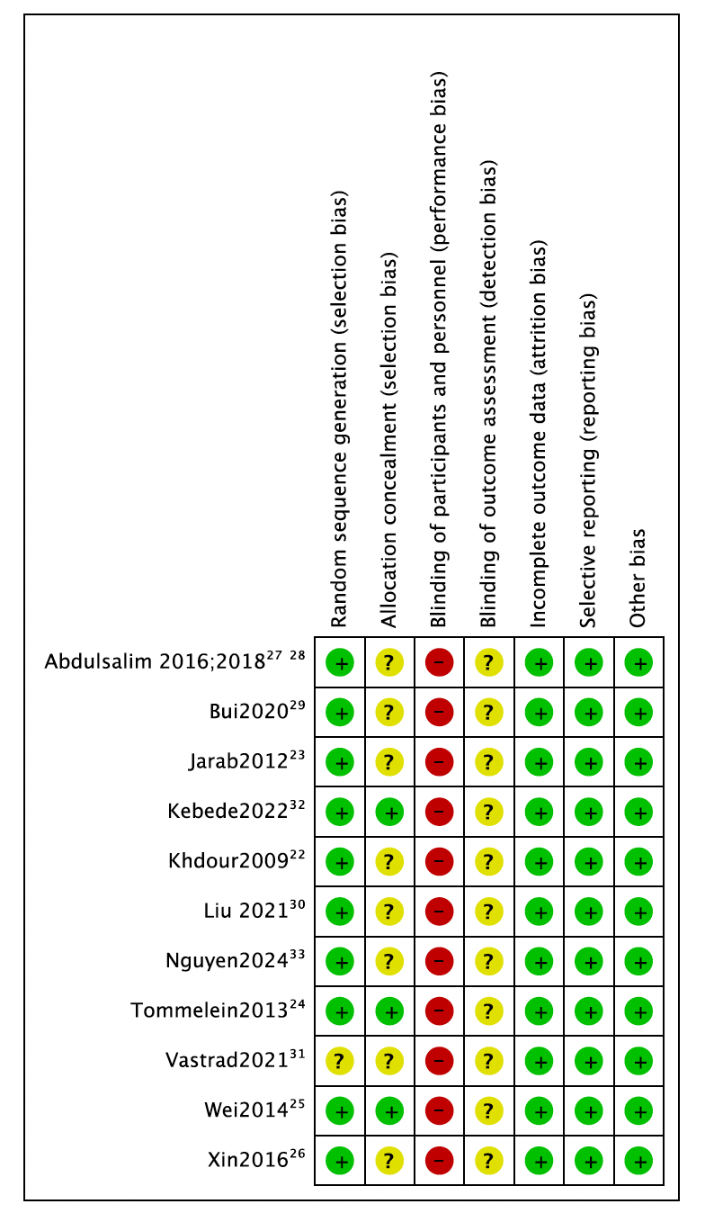
eFigure 2. Risk of bias summary

