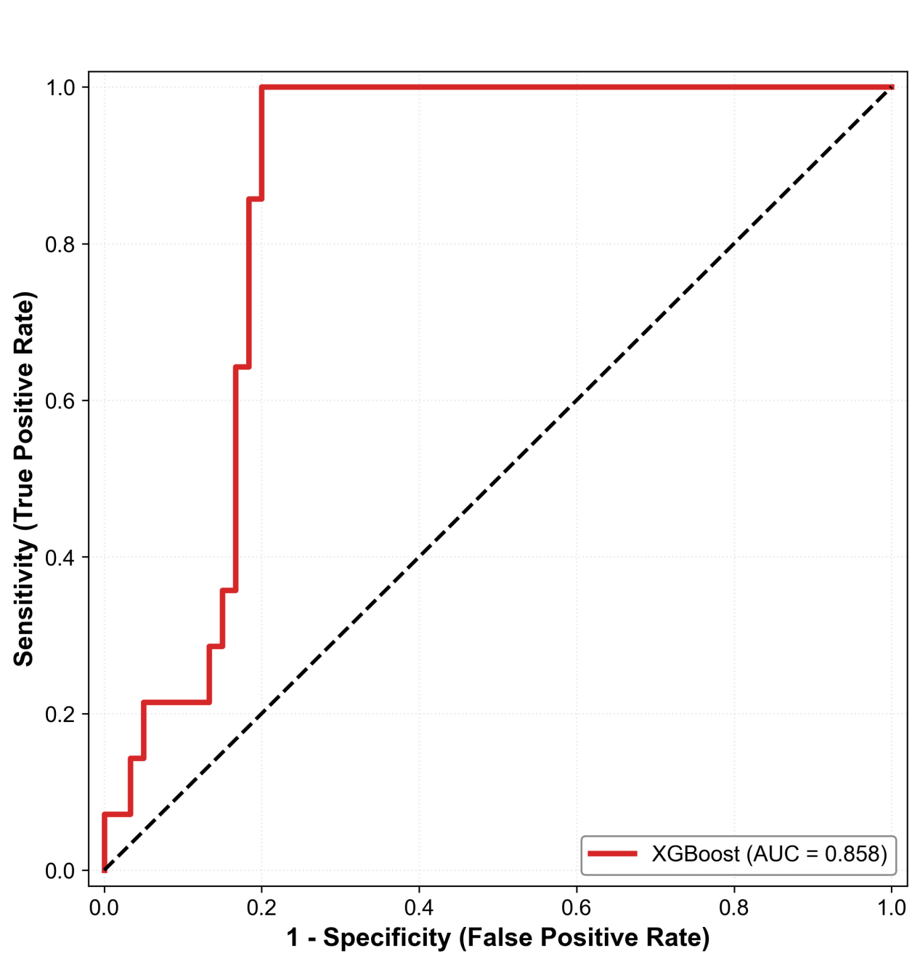

Supplementary Figure S1. Receiver Operating Characteristic (ROC) Curve for the Sensitivity Analysis Using a 0.8 mmol/L Threshold. The solid blue line represents the model ROC curve. The grey dashed diagonal line represents the reference line corresponding to no-discrimination performance (AUC = 0.5). The x-axis indicates the false positive rate (1 − specificity), and the y-axis indicates the true positive rate (sensitivity).

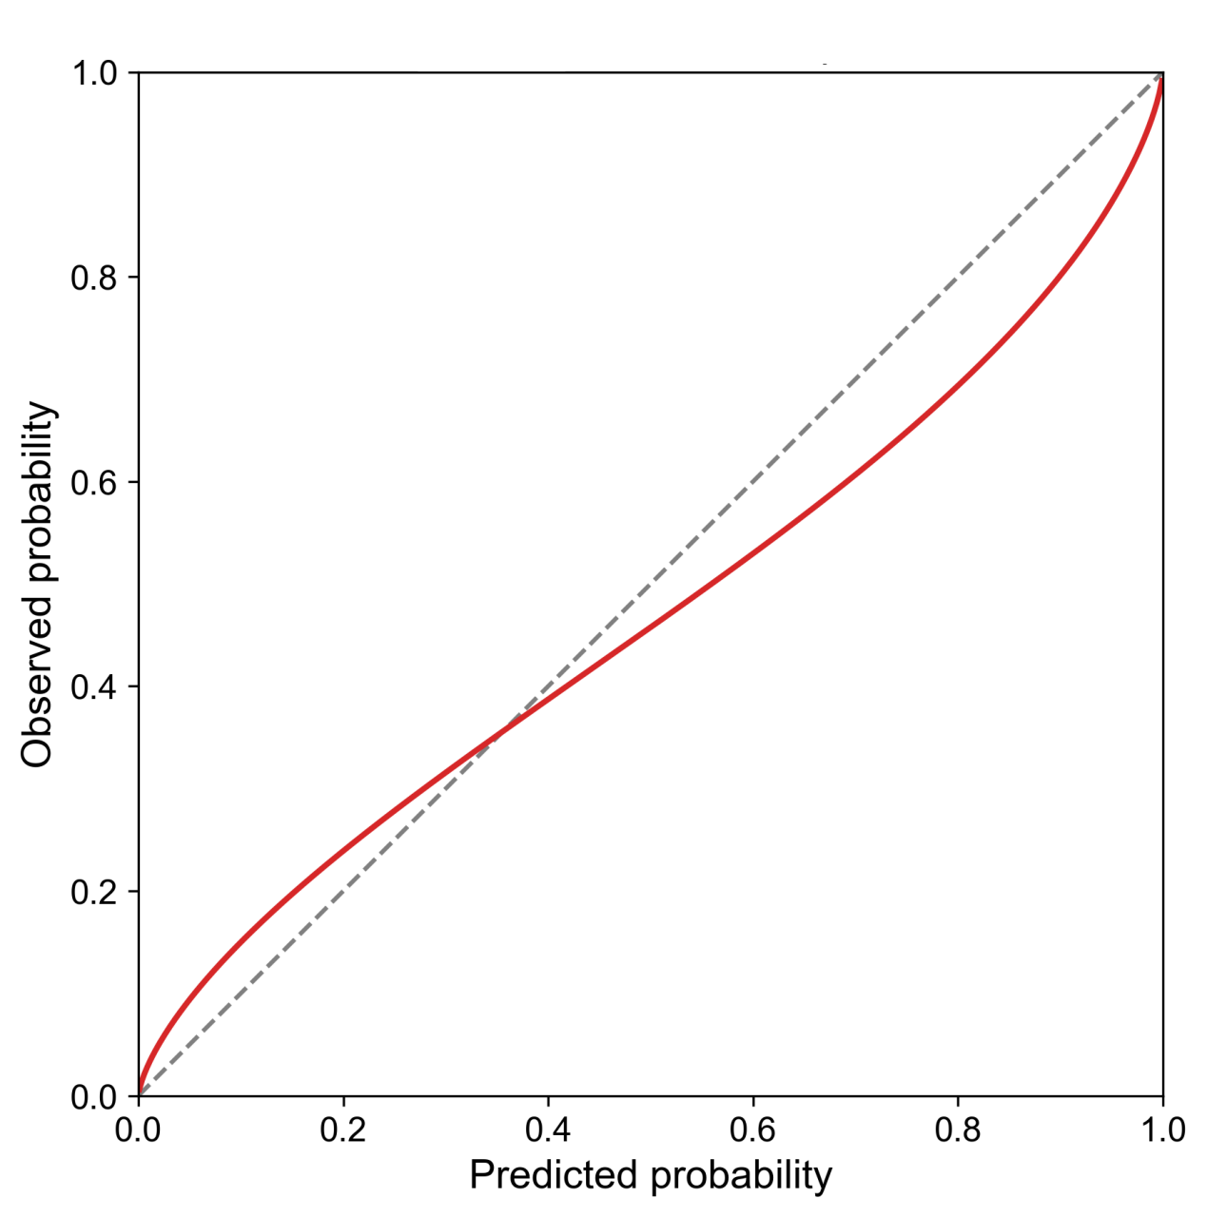Supplementary Figure S2. Calibration Curve (Out-of-Fold) for the Sensitivity Analysis (Threshold >0.8 mmol/L). The x-axis represents predicted probability, and the y-axis represents the observed event rate. The red solid line represents the apparent calibration performance of the model. The grey dashed diagonal line indicates perfect calibration, where predicted probability equals observed probability.

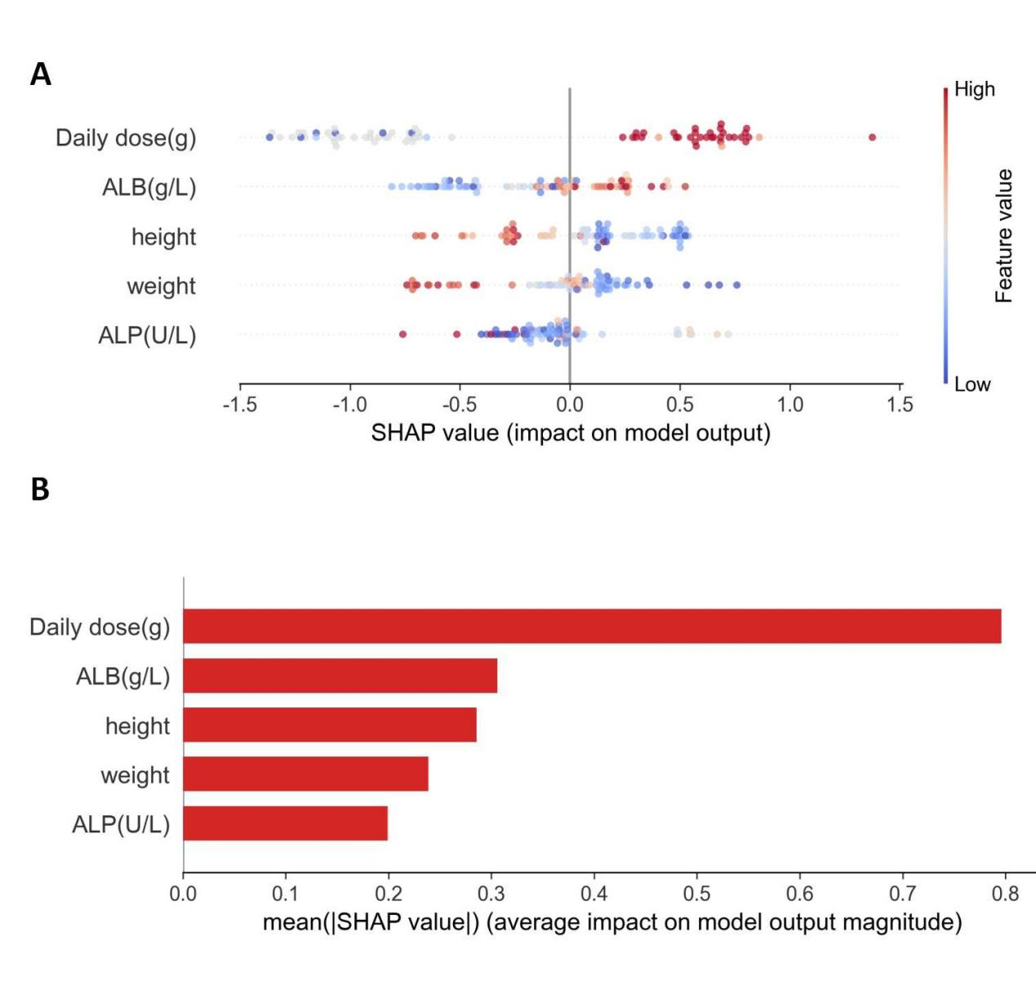Supplementary Figure S3. SHAP Summary Plot for the Sensitivity Analysis (Threshold >0.8 mmol/L). (A) SHAP summary plot. The x-axis shows the SHAP value (impact on model output). Dot color reflects the original feature value (red: high; blue: low). (B) Mean absolute SHAP value ranking. The x-axis represents the mean absolute SHAP value (average impact on model output), and the y-axis lists the corresponding features.

Supplementary Table S1. Hyperparameter search spaces and final optimal values for all evaluated machine learning models.
Model | Hyperparameter | Search Space | Final Optimal Value
Gradient Boosting (GBDT) | n_estimators | [100, 200] | 100
 | learning_rate | [0.05, 0.1] | 0.05
 | max_depth | [3, 5] | 3
Support Vector Machine (SVM) | C | [0.1, 1, 10] | 0.1
Logistic Regression (LR) | C | [0.1, 1, 10] | 0.1
Random Forest (RF) | n_estimators | [100, 200] | 100
 | max_depth | [10, 20] | 10
AdaBoost | n_estimators | [50, 100] | 50
 | learning_rate | [0.1, 1.0] | 0.1
K-Nearest Neighbors (KNN) | n_neighbors | [3, 5, 7] | 3
Gaussian Naive Bayes (GNB) | var_smoothing | [1 × 10⁻⁹, 1 × 10⁻⁸] | 1 × 10⁻⁹
XGBoost | n_estimators | [100, 200] | 100
 | learning_rate | [0.05, 0.1] | 0.05
 | max_depth | [3, 5] | 3
LightGBM | n_estimators | [100, 200] | 100
 | learning_rate | [0.05, 0.1] | 0.05
 | num_leaves | [31, 50] | 31
CatBoost | iterations | [200, 300] | 200
 | depth | [4, 6] | 4
 | learning_rate | [0.05, 0.1] | 0.05
Stacking Meta-Learner | C (Logistic Regression) | [0.1, 1.0, 10.0] | 0.1
Abbreviations: GBDT, Gradient Boosting Decision Tree; SVM, Support Vector Machine; LR, Logistic Regression; RF, Random Forest; KNN, K-Nearest Neighbors; GNB, Gaussian Naïve Bayes.
Note: The final optimal values were determined utilizing a grid search strategy with 10-fold cross-validation on the training set, optimized for the Area Under the Receiver Operating Characteristic Curve (AUC).

