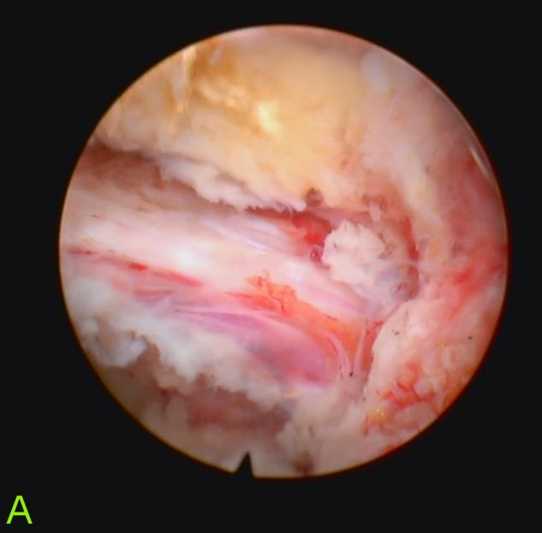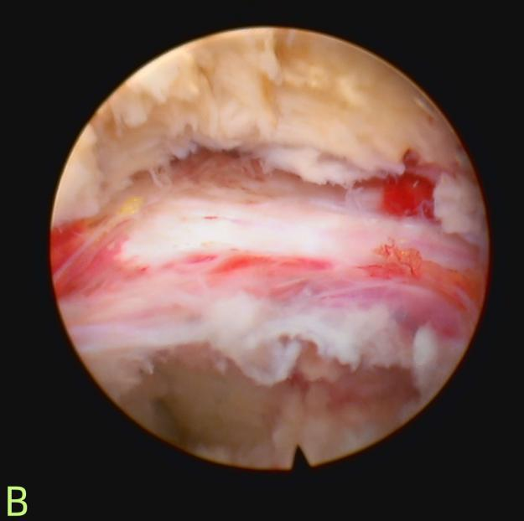
Supplementary Figure S1. Representative intraoperative endoscopic views from an 82-year-old female patient following targeted decompression via percutaneous endoscopic lumbar discectomy under local anesthesia (PELD-LA). (A, B) The images demonstrate the surgical field immediately after the removal of the herniated nucleus pulposus and osteophytes. The neural structures (nerve root) are fully exposed, completely freed from compression, and exhibiting normal tension and vascularization. This visual evidence confirms that the "targeted decompression" strategy achieves thorough and adequate relief of local pathology without necessitating extensive anatomical disruption.

