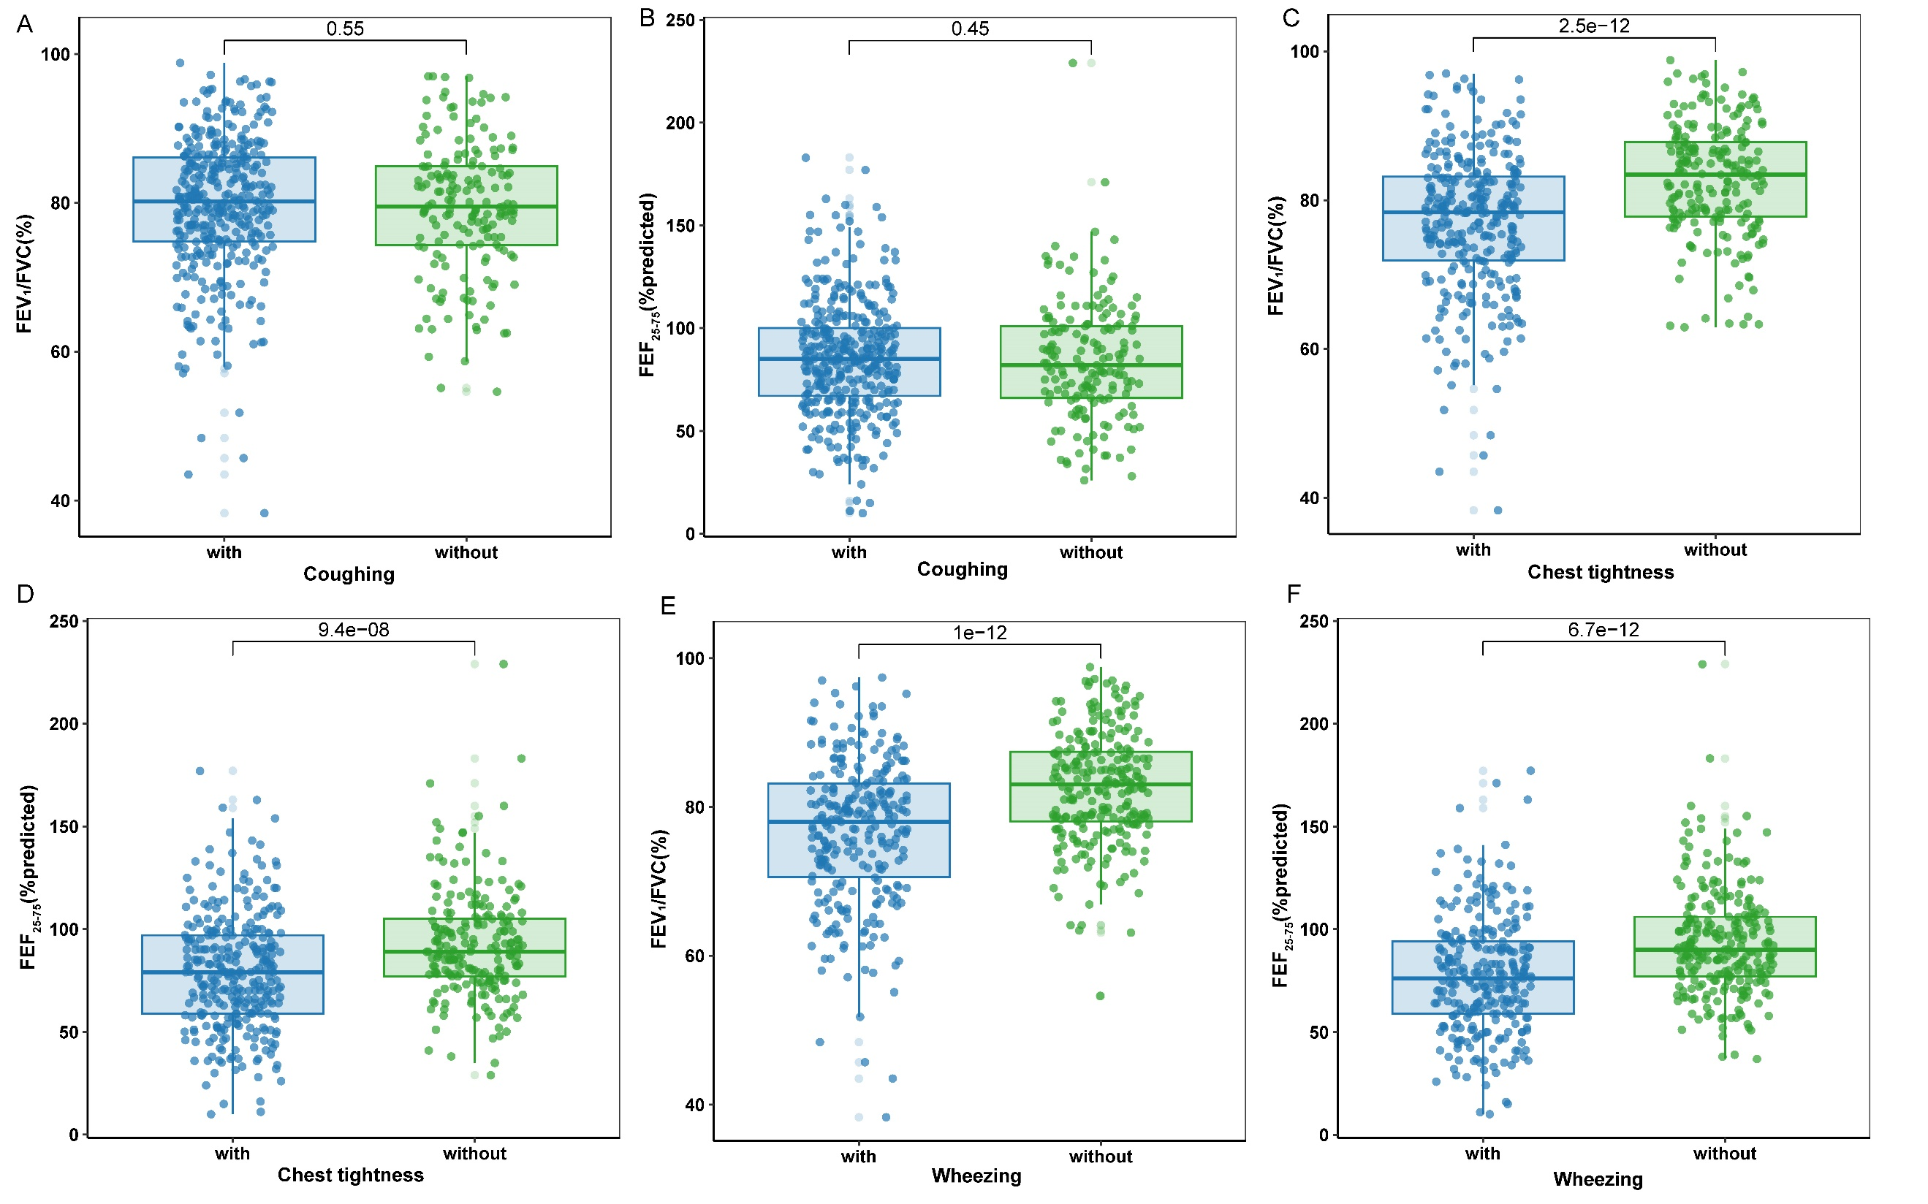
Figure S1. Comparison of FEV₁/FVC, and FEF₂₅₋₇₅ (% predicted) between patients with and without (A-B) coughing, (C-D) chest tightness, and (E-F) wheezing.

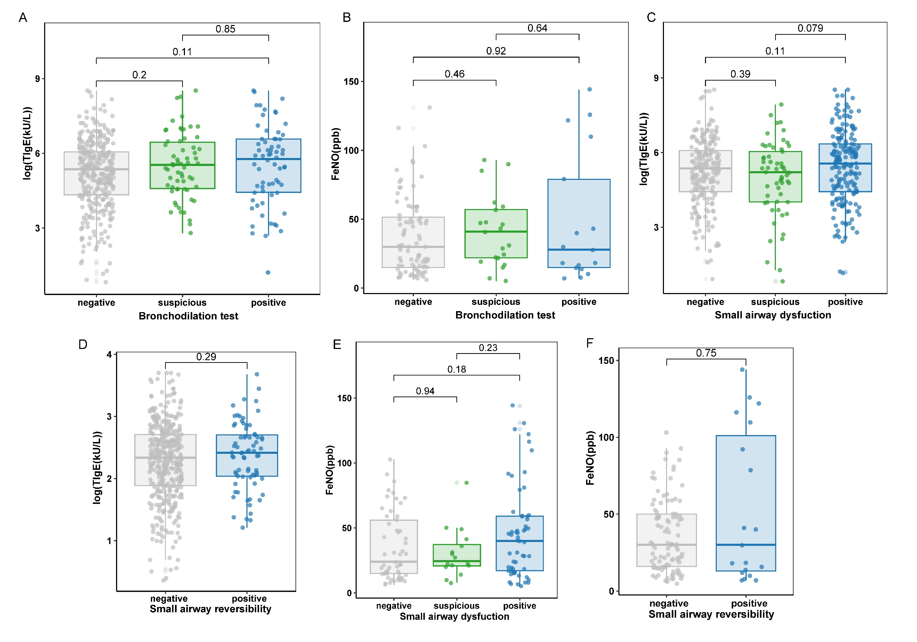
Figure S2. Associations between spirometry results and type 2 imflammation indicators. log₁₀ (Total IgE), and FeNO in patients with different results of bronchodilation test (A-B), small airway dysfunction(C, E), and small airway reversibility (D, F).

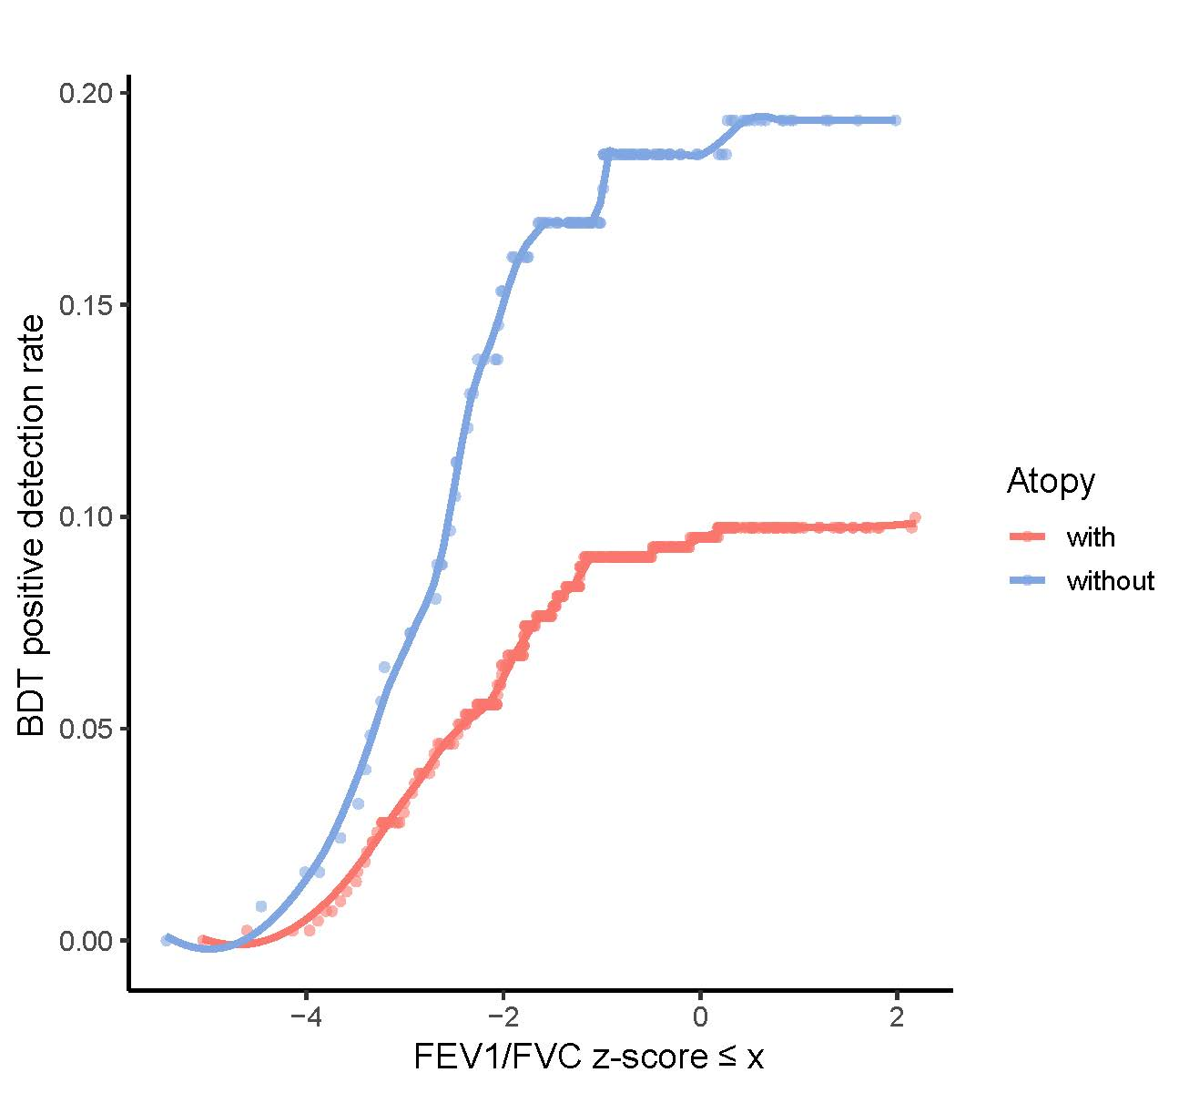
Figure S3. Positive detection rates of the BDT at different cut-off values of FEV₁/FVC z-score in patients with and without atopy.

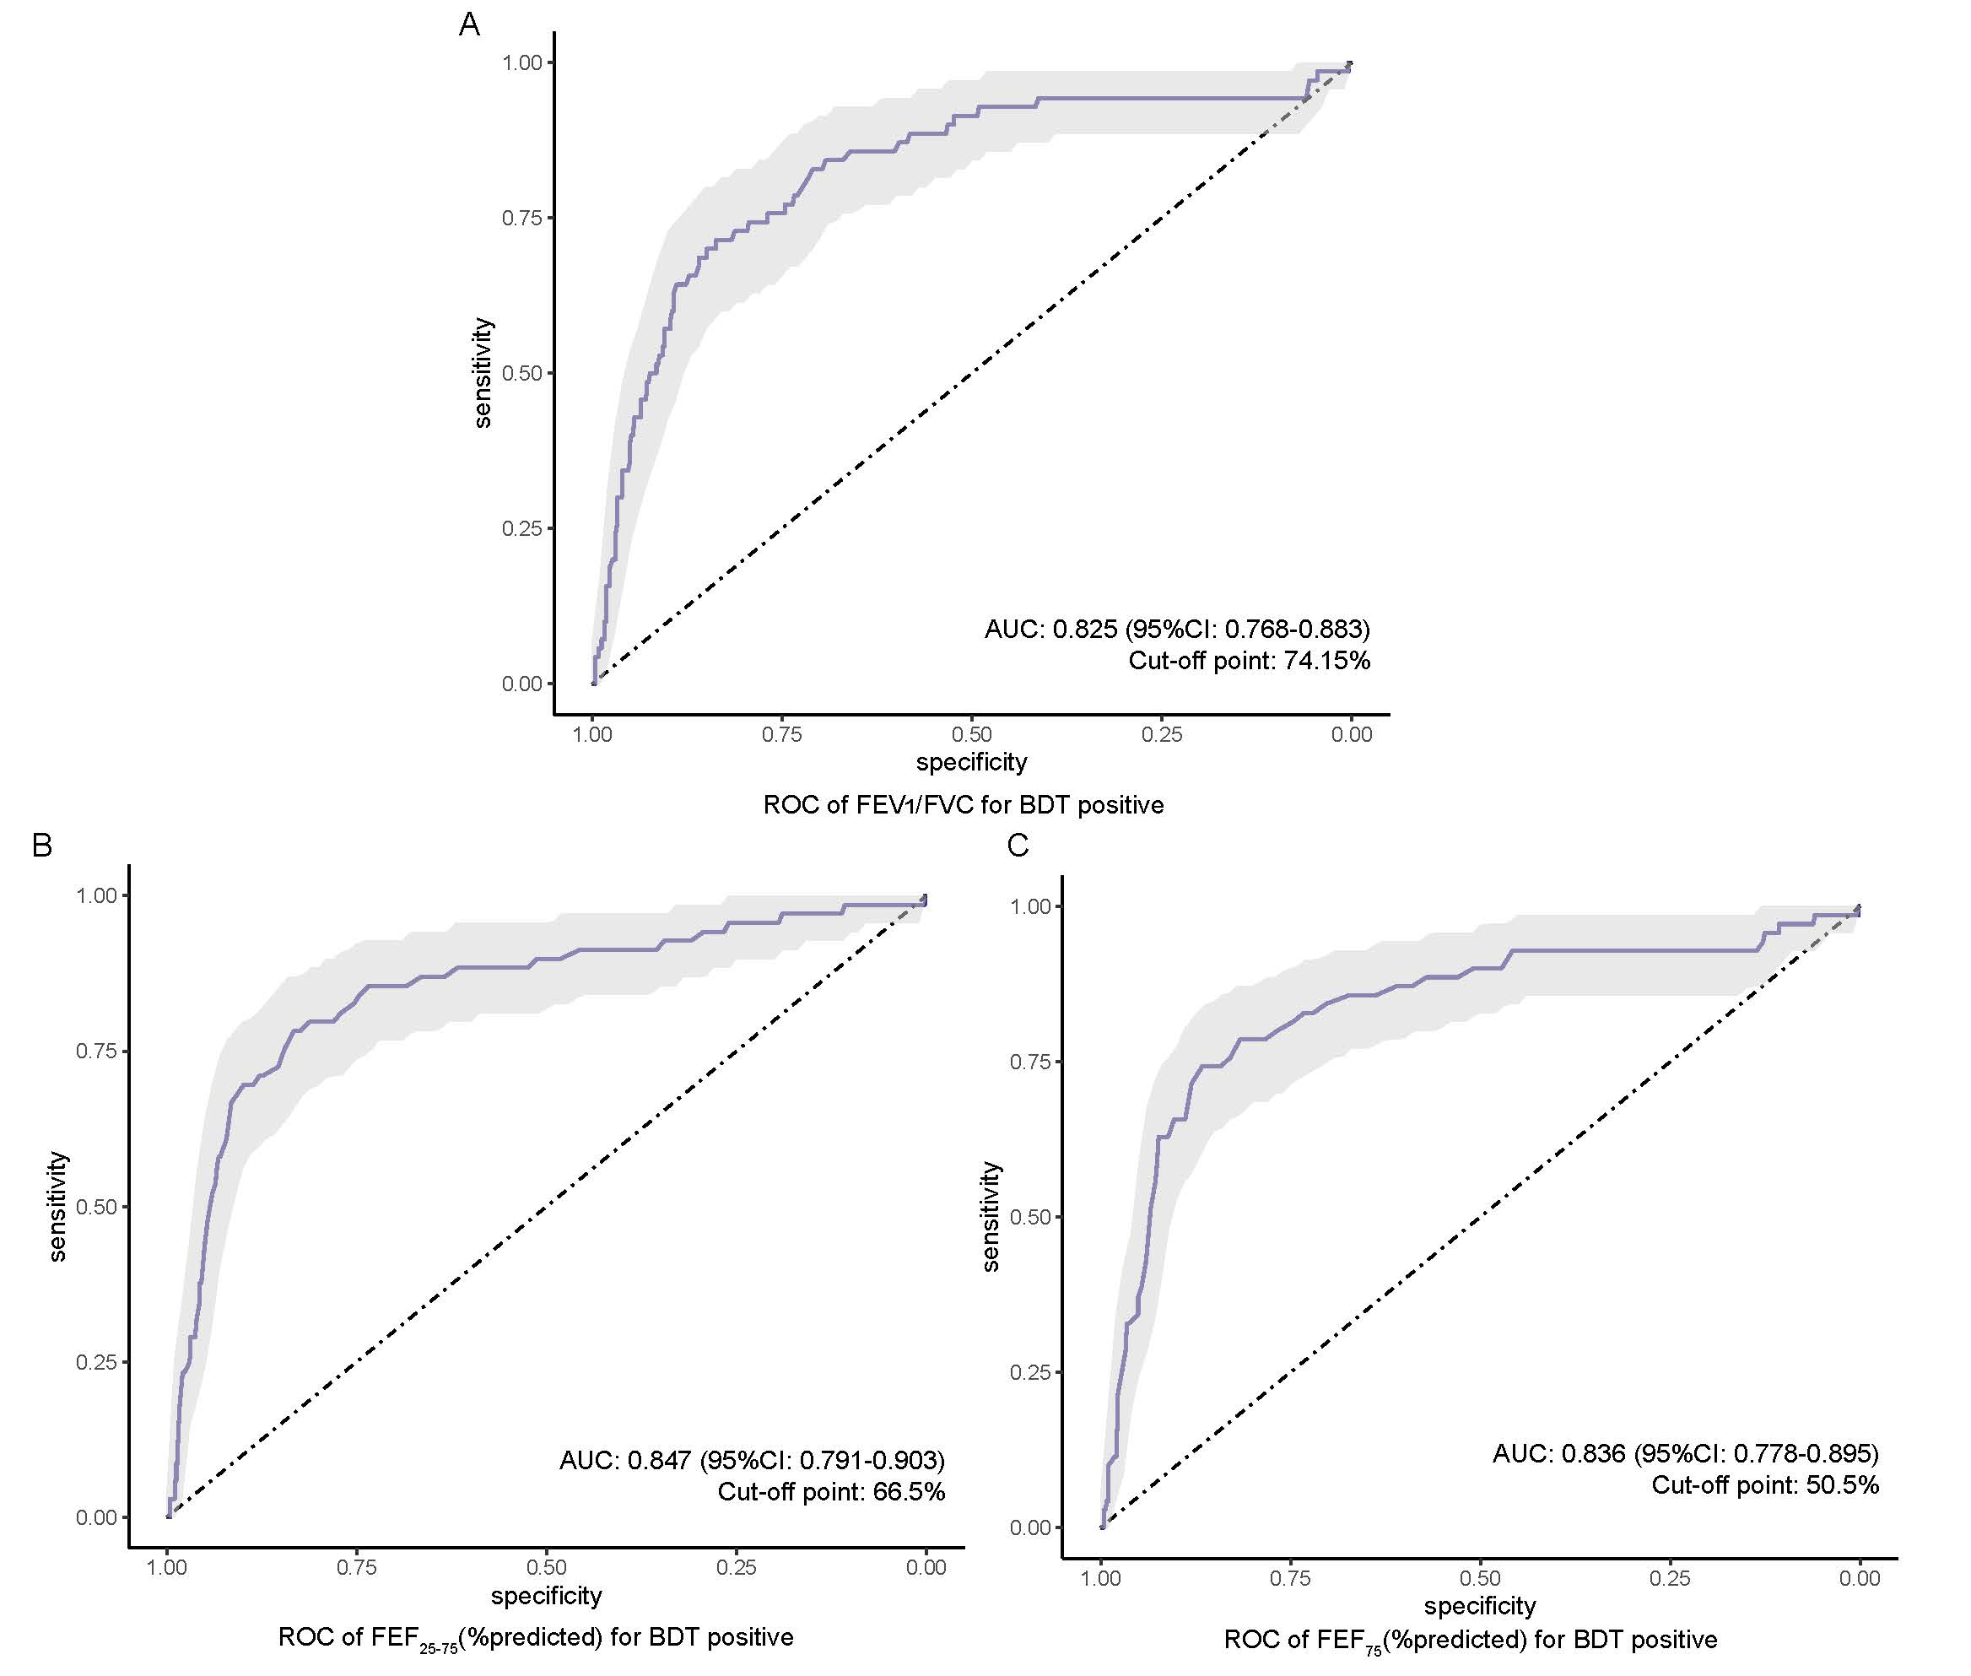
Figure S4. Receiver operating characteristic curves of (A) FEV₁/FVC, (B) FEF₂₅₋₇₅ (% predicted) and (C) FEF₇₅ (% predicted) to predict bronchodilation test positive.

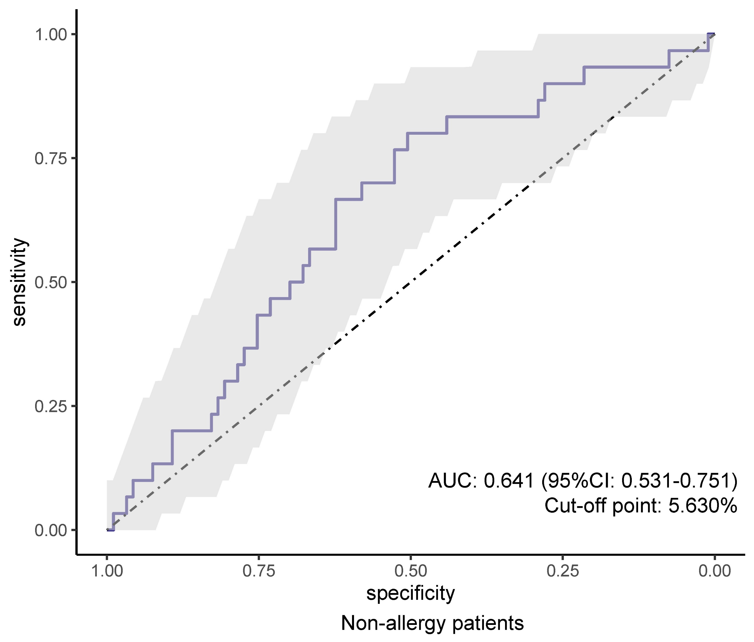
Figure S5. Receiver operating characteristic curve of bronchodilation test percent improvements to predict chest tightness and wheezing symptoms in non-allergic patients.

Supplementary Table 1 Demographic and clinical characteristics of patients in different groups
Characteristic | Patients ≤14 ys (n=115) | Patients >14 ys (n=440) | P-value
Male (%) | 79 (68.7) | 157 (35.7) | <0.001
Age, years, mean (SD) | 9.36 (2.51) | 38.71 (13.61) | <0.001
BMI, kg/m², mean (SD) | 18.94 (3.96) | 23.87 (3.84) | <0.001
Any suspected asthma symptom (%) | 88 (76.5) | 403 (91.8) | <0.001
Coughing (%) | 66 (59.5) | 299 (70.4) | 0.03
Chest tightness (%) | 39 (35.8) | 269 (65.3) | <0.001
Wheezing (%) | 45 (41.3) | 229 (54.8) | 0.01
BMI, body mass index

