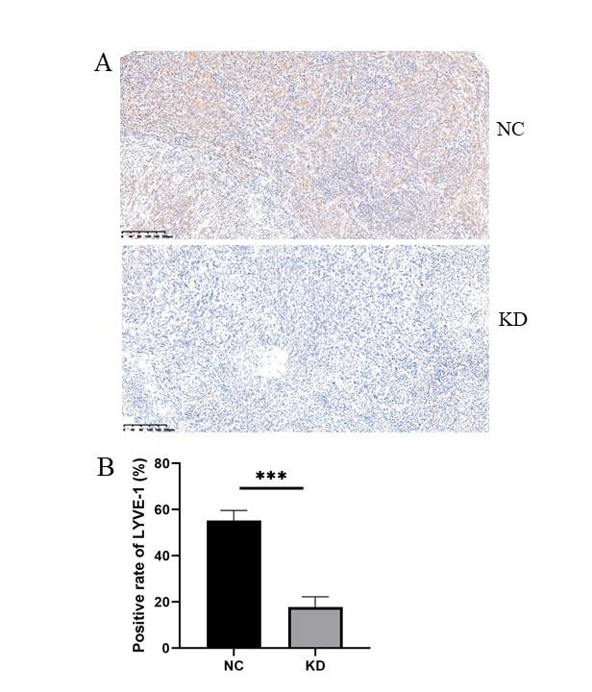
Supplementary Figure 1 (A) Immunohistochemical analysis of LYVE-1 was performed on subcutaneous xenograft tumor specimens to assess lymphatic vessel density. (B) The number of LYVE-1 positive vessels was quantified in five random high-power fields per tumor. *** P < 0.001. NC: Negative control group (non-targeting siRNA). KD: Knockdown group (siRNA targeting PDLIM1).

