Supplementary Information for
CD71-targeted and ROS-responsive micelles for homoharringtonine delivery to enhance therapeutic efficiency against FLT3-ITD acute myeloid leukemia

- Supplementary methods and materials
  - materials
Supplement Table 1. Main reagents and suppliers
Reagents | Suppliers
Homoharringtonine | Must (A0289)
Gilteritinib | MCE (HY-12432)
DSPE-PEG₂₀₀₀-Mal | AVT (474922-22-0)
DSPE-mPEG₂₀₀₀ | AVT (247925-28-6)
DSPE-TK-PEG₂₀₀₀ | Xi’an Ruixi (R-D526-1)
^{D}T7-Cys (_{D}(HRPYIAHC)) peptide | ONTORES (03019)
4-Chlorobenzenesulfonate salt (DiD) | Beyotime Biotechnology (C1039)
FITC anti-human CD45 antibody | BioLegend (304006)
APC Mouse IgG2a, κ Isotype control Antibody | BioLegend (400222)
APC/Cyanine7 anti-human CD34 Antibody | BioLegend (343614)
APC anti-human CD71 Antibody | BioLegend (334108)
Lymphocyte Separation Medium | TBD (LTS1077)
RIPA Lysis Buffer (medium) | Beyotime Biotechnology (P0013C)
BCA Protein Assay Kit | ComWin Biotech (28523)
5×SDS loading buffer | Beyotime Biotechnology (P0285)
Prestained protein marker | Page ruler (26616)
PVDF membrane | Millipore (GVHP29325)
Mouse Anti-CD71 antibody | Proteintech (66180-1-Ig)
Phospho-FLT3 (Tyr589/591) Rabbit mAb | CST (3464)
Rabbit Anti- FLT3 antibody | Proteintech (30297-1-AP)
Phospho-c-Raf (Ser259) Rabbit mAb | CST (9421)
Rabbit Anti-c-Raf antibody | HuaBio (ET1701-21)
Phospho-ERK1/2 (Thr202/204) Rabbit mAb | Proteintech (28733-1-AP)
Rabbit Anti-ERK1/2 antibody | Zenbio (343830)
Phospho-AKT (Ser473) Mouse mAb | Proteintech (66444-1-Ig)
Rabbit Anti-AKT antibody | Zenbio (342529)
Phospho-mTOR (Ser2448) Rabbit mAb | Zenbio (381557)
Rabbit Anti-mTOR antibody | Zenbio (R380411)
Phospho-4E-BP1 (Thr37/46) Rabbit mAb | CST (2855)
Rabbit Anti-4E-BP1 antibody | Zenbio (306002)
Phospho-JAK2 (Tyr1007/1008) Rabbit mAb | HuaBio (ET1607-34)
Rabbit Anti-JAK2 antibody | Zenbio (R24775)
Phospho-STAT5a (Tyr694) Rabbit mAb | CST (4322)
Rabbit Anti-STAT5a antibody | Zenbio (R380706)
Rabbit Anti-c-Myc antibody | CST (5605)
Rabbit Anti-MCL-1 antibody | Proteintech (16225-1-AP)
Rabbit Anti-BCL-2 antibody | Proteintech (26593-1-AP)
Rabbit Anti- BCL-xL antibody | Beyotime (AB126)
Rabbit Anti-BAX antibody | Proteintech (50599-2-Ig)
Rabbit Anti-BAK antibody | Bioss (bs-1284R)
Mouse Anti-β-actin antibody | Proteintech (66009-1-Ig)
Mouse Anti-Tubulin antibody | Proteintech (66240-1-Ig)
MTT | Solarbio (298-93-1)
Annexin V-APC | US Everbright(Y-6026)
PI | US Everbright(Y-6026)

  - Cell culture
KG-1a, MOLM-13, MV4-11, and THP-1 cells were obtained from the American Type Culture Collection (ATCC, Manassas, VA, USA). Human umbilical vein endothelial cells (HUVECs), HEL, HL-60, Kasumi-1, and NB4 cells were obtained from the Cell Bank of the Chinese Academy of Sciences (Shanghai, China). HUVECs were cultured in DMEM medium. HEL, HL-60, Kasumi-1, MOLM-13, THP-1, and U937 cells were cultured in RPMI-1640 medium, while KG-1a, MV4-11, and NB4 cells were cultured in IMDM medium. All media were supplemented with 10% fetal bovine serum (FBS) and 1% penicillin-streptomycin, and cells were maintained at 37 ℃ in a humidified incubator with 5% CO₂.

  - Collection and procession of AML patients bone marrow (BM) samples
BM samples were obtained from primary AML patients at the Department of Hematology, West China Hospital. This study was approved by Biomedical Ethics Committee of West China Hospital, Sichuan University (Approval No. 1182 (2024)), and informed consent had received from all patients. Mononuclear cells were isolated using human lymphocyte separation medium. The interphase layer was collected, washed with PBS, treated with red blood cell lysis buffer for 3-5 min, and then neutralized with an equal volume of PBS. The resulting cell suspension was used for subsequent experiments.

  - Synthesis of DSPE-PEG2000-^{D}T7
DSPE-PEG₂₀₀₀-Mal was dissolved in chloroform, and ^{D}T7-Cys in methanol at half the volume. The molar ratio of DSPE-PEG₂₀₀₀-Mal to ^{D}T7-Cys was 1:1.5. Then ^{D}T7-Cys was slowly added to the DSPE-PEG₂₀₀₀-Mal solution under nitrogen protection and stirred at room temperature for 48 h. Solvents were removed by rotary evaporator, and the residue was dissolved in DMSO and dialyzed against ultrapure water using a 2000 Da MWCO membrane for 72 h. The final product was lyophilized and characterized by ¹H NMR spectroscopy (INOVA-400MHz, Varian, USA) and high-resolution mass spectrometry (HRMS) (Orbitrap Fusion Lumos Tribrid, Thermo, USA).

  - Hematolysis assay
EDTA-anticoagulated peripheral blood from two AML patients was centrifuged to isolate plasma and red blood cells (RBCs). RBCs were diluted to 7% in PBS and incubated with micelles (2 mg/mL) at a 1:1 ratio (v/v). PBS and ultrapure water were used as negative and positive controls, respectively. Samples (200 μL) were collected at 1, 2, 4, and 8 h and the absorbance at 540 nm was measured to assess hemolysis: Hemolysis (%)=(OD_{sample}-OD_{negative})/(OD_{positive}-OD_{negative})×100.

  - Plasma stability
Micelles were mixed with patient-derived plasma at 9:1 and 1:1 (v/v) to a final concentration of 1 mg/mL. Samples (200 μL) were incubated at 37°C with gentle shaking, and absorbance at 750 nm was measured at 0, 1, 2, 4, 8, 12, and 24 h.

  - In vivo biodistribution
Six female BALB/c mice (6 weeks old; purchased from GemPharmatech) were randomly divided into two groups, and shaved prior to imaging. Mice received tail vein injections of DiD-labeled DTP/DiD or TDTP/DiD micelles (200 μg/kg). Fluorescence distribution was monitored using an in vivo imaging system (IVIS, IVIS Spectrum, PerkinElmer, USA), and mice were euthanized under deep anesthesia at the study endpoint.

  - Apoptosis assay
Cells in logarithmic growth phase were collected and seeded in to 12-well plates at a density of 1×10⁵ per well in 1 mL of medium. PBS or various HHT formulations were added to corresponding wells. After 48 h of incubation, cells were collected and washed with PBS. Each sample was stained on ice with 100 μL of buffer containing 1μL Annexin Ⅴ and 0.5 μL propidium iodide (PI) (Y6026S, UE) for 15 min. An additional 200 μL of PBS was added, and samples were analyzed by flow cytometry to determine apoptosis rates.

  - Soft agar clone formation experiment
A 2% agarose solution was prepared and sterilized by autoclaving. Before use, it was melted and equilibrated in a 55 °C water bath alongside 15% FBS-supplemented culture medium. The two components were mixed at a 1:3 volume ratio. For the bottom layer, 1 mL of the mixture was added to each well of a 6-well plate and allowed to solidify at room temperature for 30 min. For the upper layer, cells in logarithmic growth phase were washed with PBS and resuspended in 15% FBS medium. The 2% agarose and culture medium were equilibrated at 42 °C and mixed at a 1:5 ratio. Cell suspension was added to achieve a final density of 4,000 cells/mL. Then, 1 mL of the cell-containing mixture was added to each well and gently swirled to distribute evenly. The plate was left at room temperature for 30 min to allow the gel to solidify. Finally, 1 mL of complete culture medium was added to each well. After 5 days, PBS or HHT-containing formulations were added. Plates were incubated for two weeks, with media refreshed every 3-4 days.

  - Western blot analysis
Cells were collected, washed with PBS, and lysed in RIPA buffer supplemented with PMSF and phosphatase inhibitors. Samples were vortexed and incubated on ice for 20 min, followed by centrifugation at 12,000 g for 20 min at 4 °C. The supernatant was collected, and protein concentrations were determined using a BCA protein assay kit. SDS loading buffer was added to each sample to ensure that 10 µL contained 40 µg of total protein. Equal amounts (40 µg) were loaded per lane for SDS-PAGE.

- Supplementary results
Supplementary Figure 1. CD71 is highly expressed in AML. (A) Gating strategy and representative flow cytometry histograms showing CD71 expression in leukemia cells (LCs), leukemia stem cells (LSCs), lymphocytes (L), granulocytes (G), monocytes (M), and nucleated red blood cells (R). (B) Gating strategy and representative flow cytometry histograms showing CD71 expression in HUVEC, HEL, MOLM-13, and MV4-11 cells selected for subsequent experiments.
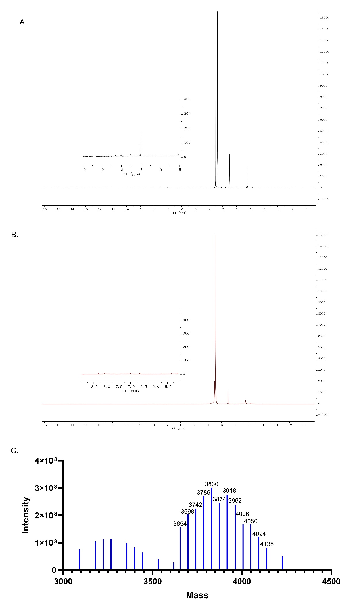
Supplementary Figure 2. Characterization of DSPEG-PEG₂₀₀₀-^{D}T7. (A) ¹H NMR spectrum of DSPE-PEG₂₀₀₀-Mal. A characteristic peak corresponding to the maleimide group was observed at 7.0 ppm, confirming the presence of the maleimide moiety in DSPE-PEG₂₀₀₀-Mal; (B) ¹H NMR spectrum of DSPE-PEG₂₀₀₀-^{D}T7. The disappearance of the maleimide peak in the spectrum of DSPE-PEG₂₀₀₀-^{D}T7 indicates complete conjugation of the maleimide group with the thiol group of ^{D}T7-Cys; (C) High-resolution mass spectrum (HRMS) of DSPE-PEG₂₀₀₀-^{D}T7. DSPE-PEG₂₀₀₀-Mal (MW ~2890) was conjugated with a cysteine-terminated peptide (MW ~996) to yield a product with a theoretical MW of ~3886, consistent with the HRMS result.

Supplementary Figure 3. Cellular uptake of micelles with varying DSPE-PEG₂₀₀₀-^{D}T7 ratios. HEL, MOLM-13, and MV4-11 cells were incubated with DiD-labeled micelles containing different proportions of DSPE-PEG₂₀₀₀-^{D}T7 (w/w) for 2 and 4 h. Flow cytometry analysis of fluorescence intensity revealed that micelle uptake increased with the degree of DSPE-PEG₂₀₀₀-^{D}T7 modification and reached a plateau at around 8%. *, p < 0.05; **, p < 0.01; ****, p < 0.0001; ns, not significant.

Supplementary Figure 4. Characterization of HHT-loaded micelles. The size, PDI, zeta potential and encapsulation rate of DTP/HHT and TDTP/HHT.
Supplementary Figure 5. Morphological changes of HUVEC cells after plasma co-incubation. Compared to the DTP/DiD group, cells in the TDTP/DiD with plasma group exhibited a transition from adherent to suspended morphology, as observed under microscopy.
Supplementary Figure 6. Evidence of ^{D}T7 targeting ability and non-Tf competitive binding. Representative flow cytometry histograms of MV4-11 (A) and HEL (C) in different groups. Quantification of DiD-positive rates from MV4-11 (B) and HEL (D). Confocal microscopy images of MV4-11 (E) and HEL (F) cells treated with DiD-labeled micelles. *, p < 0.05; **, p < 0.01; ***, p < 0.001; ****, p < 0.0001; ns, not significant.

Supplementary Figure 7. Ex vivo fluorescence imaging of tumors and major organs at 48 h in subcutaneous AML mice. Mice treated with TDTP/DiD exhibited stronger fluorescence signals in tumors and major organs compared to the DTP/DiD group. These results suggest that TDTP micelles possess tumor-targeting ability and prolonged circulation time.

Supplementary Figure 8. Superior anti-AML efficacy of TDTP/HHT compared to Free HHT and DTP/HHT in FLT3-ITD AML cells. MTT assays of MOLM-13, and MV4-11 cells incubated with different HHT formulations for 24 or 72 hours. *, p < 0.05; **, p < 0.01; ***, p < 0.001; ****, p < 0.0001; ns, not significant.

Supplementary Table 2. IC₅₀ (nM) of MOLM-13 treated with different HHT formulations.
_{Time (h)} ^{Group} | Free HHT | DTP/HHT | TDTP/HHT
24 | 13.1 | 14.3 | 8.1
48 | 11.8 | 12.6 | 7.5
72 | 12.7 | 12.8 | 7.5

Supplementary Table 3. IC₅₀ (nM) of MV4-11 treated with different HHT formulations.
_{Time (h)} ^{Group} | Free HHT | DTP/HHT | TDTP/HHT
24 | 15.8 | 15.4 | 9.6
48 | 18.0 | 14.6 | 9.8
72 | 19.0 | 17.5 | 12.7

Supplementary Figure 9. TDTP/HHT is the most effective HHT formulation in primary AML cells. (A–G) Cell viability of primary AML samples derived from P1-P7 after 48 h treatment with different HHT formulations. (H) Trends in IC₅₀ values of different HHT formulations across the primary AML samples (P1–P7). *, p < 0.05; **, p < 0.01; ***, p < 0.001; ****, p < 0.0001; ns, not significant.

Supplementary Table 4. IC₅₀ (nM) of primary AML cells treated with different HHT formulations.
_{Patient} ^{Group} | Free HHT | DTP/HHT | TDTP/HHT
P1 | 20.4 | 27.8 | 12.7
P2 | 31.7 | 24.2 | 22.3
P3 | 45.0 | 64.0 | 26.7
P4 | 119.2 | 2.6 | 4.7
P5 | 48.6 | 36.0 | 33.4
P6 | 29.6 | 28.3 | 22.4
P7 | 34.3 | 12.8 | 10.2

Supplementary Figure 10. TDTP/HHT remains the most effective HHT formulation in CD71-high and less sensitive cells. MTT assays of HEL incubated with different HHT formulations for 24 h (A), 48 h (B) and 72 h (C). (D) Apoptosis analysis in HEL treated with different HHT formulations (400 nM) for 48 h. (E) Quantitative analysis of apoptosis data shown in (D) (n=3). (F) Representative images of soft agar colony formation in HEL (100 nM) treated with different HHT formulations. (G) Quantification of colony numbers from (F) (n=3). *, p < 0.05; **, p < 0.01; ***, p < 0.001; ****, p < 0.0001; ns, not significant.

Supplementary Table 5. IC₅₀ (nM) of HEL treated with different HHT formulations.
_{Time(h)} ^{Group} | Free HHT | DTP/HHT | TDTP/HHT
24 | 651.4 | 606.8 | 721.1
48 | 123.6 | 140.9 | 68.6
72 | 120.6 | 123.3 | 73.6

Supplementary Figure 11. Changes of FLT3 signaling and downstream effectors. HEL were treated with different formulations containing 400 nM HHT. C, control; H, free HHT; D, DTP/HHT; T, TDTP/HHT.

Supplementary Figure 12. TDTP/HHT is a no-toxicity drug delivery platform. (A) Representative H&E-stained sections of heart and kidney in treatment groups. (B) Body weight changes in different groups during treatment.

