Supplementary documents

Table S1. Participants’ demographic and histopathological characteristics
Characteristic | dMMR (n = 54) | pMMR  (n= 158) | p-value
Age (mean, SD) | 60.6 (13.8) | 60.4 (12.0) | 0.924
Sex (number of males, %) | 32 (59.2%) | 88 (55.7%) | 0.648
Tumor size  <5 cm  ≥5 cm | 26 (48.2%)  28 (51.8%) | 100 (63.3%)  58 (36.7%) | 0.050
Tumor location |  |  | 0.004
Right colon | 23 (42.6%) | 30 (19%)
Left colon | 9 (16.6%) | 27 (17.1%)
Sigmoid colon | 11 (20.4%) | 40 (25.3%)
Rectum | 11 (20.4%) | 61 (38.6%)
Histopathological types (n, %) |  |  | 0.423
Non-mucinous adenocarcinoma | 48 (88.9%) | 146 (92.4%)
Mucinous adenocarcinoma | 6 (11.1%) | 12 (7.6%)
Lymphovascular Invasion (n, %) | 16 (29.6%) | 75 (47.5%) | 0.022
Perineural Invasion (n, %) | 11 (20.4%) | 37 (23.4%) | 0.644
Vascular invasion (n, %) | 7 (13%) | 49 (31%) | 0.009
Tumor grade (n, %) |  |  | 0.001
I | 7 (13%) | 2 (1.3%)
II | 46 (85.2%) | 154 (97.4%)
III | 1 (1.8%) | 2 (1.3%)
pTNM stage (n, %) |  |  | 0.042
I | 9 (16.7%) | 23 (14.6%)
II | 28 (51.9%) | 55 (34.8%)
III | 14 (25.9%) | 50 (31.6)
IV | 3 (5.5%) | 30 (19%)
Note: MMR = mismatch repair; d-MMR = deficient mismatch repair;

Table S2. The fitted model of predicting dMutS using histopathological characteristics
Coefficient | Estimate | Odds Ratio (95% CIs) | p
(Intercept) | -2.00 | 0.14 (0.04-0.37) | 2.59 x 10⁻⁵
Tumor size (> 5cm) | 1.10 | 3.02 (1.13-8.79) | 0.03
p TNM stage (II) | -1.1 | 0.33 (0.10-1.12) | 0.07
p TNM stage (III) | -0.65 | 0.52 (0.15-1.78) | 0.29
p TNM stage (IV) | -2.69 | 0.07 (0.0005-0.63) | 0.01

Table S3. Concordance between immunohistochemistry and Polymerase Chain Reaction (PCR) results
 | pMMR | dMutL | dMutS | Dual dMutL-dMutS deficiency
MSS | 42 (87.5%) | 3 (6.25%) | 3 (6.25%) | 0
MSI | 0 | 33 (68.75%) | 12 (25%) | 3 (6.25%)
Note: MSS = microsatellite stability; MSI = microsatellite instability; pMMR = Proficient mismatch repair; dMutL = Deficient MutL complex; dMutS = Deficient MutS complex
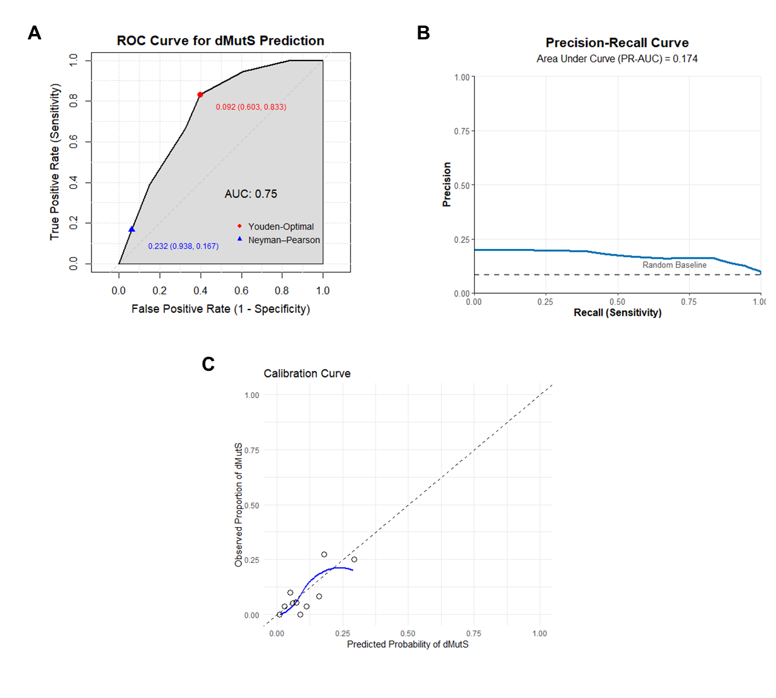
Figure S1. Performances of the model predicting dMutS. (A) The Receiver Operating Characteristic (ROC) curve with the area under the curve (AUC) of the model. (B) The precision-recall curve with the area under the curve (PR-AUC) of the model. (C) The calibration plot of the model.

