Supporting information

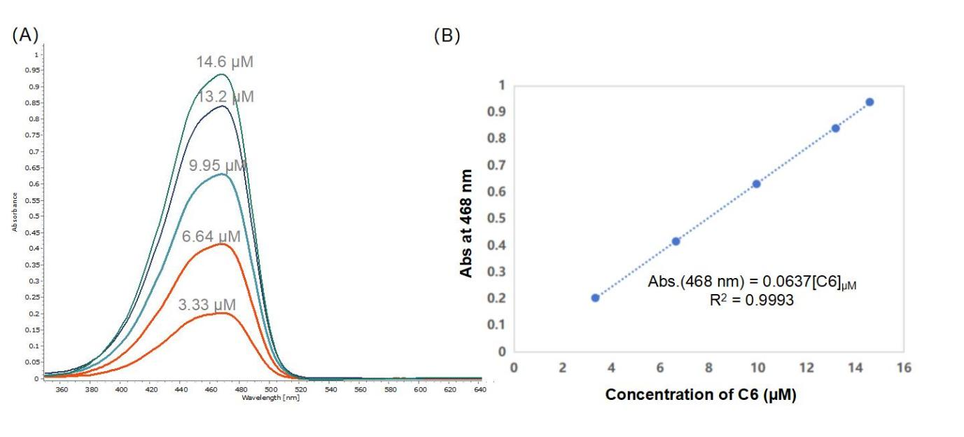
Figure S1. (A) Uv-vis spectra of C6 in DMSO with different concentrations (right) and calibration curve of C6 in DMSO according to the characteristic band at 468 nm (left).

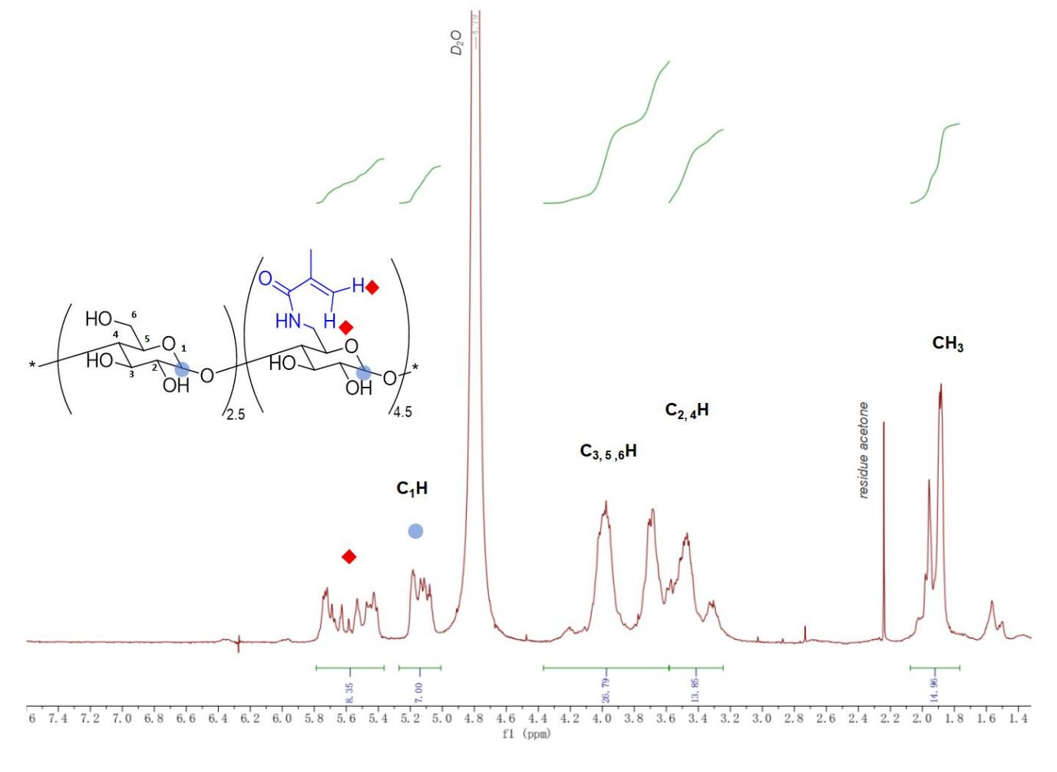
Figure S2. ¹H NMR (400 mHz, D₂O) of MaβCD.

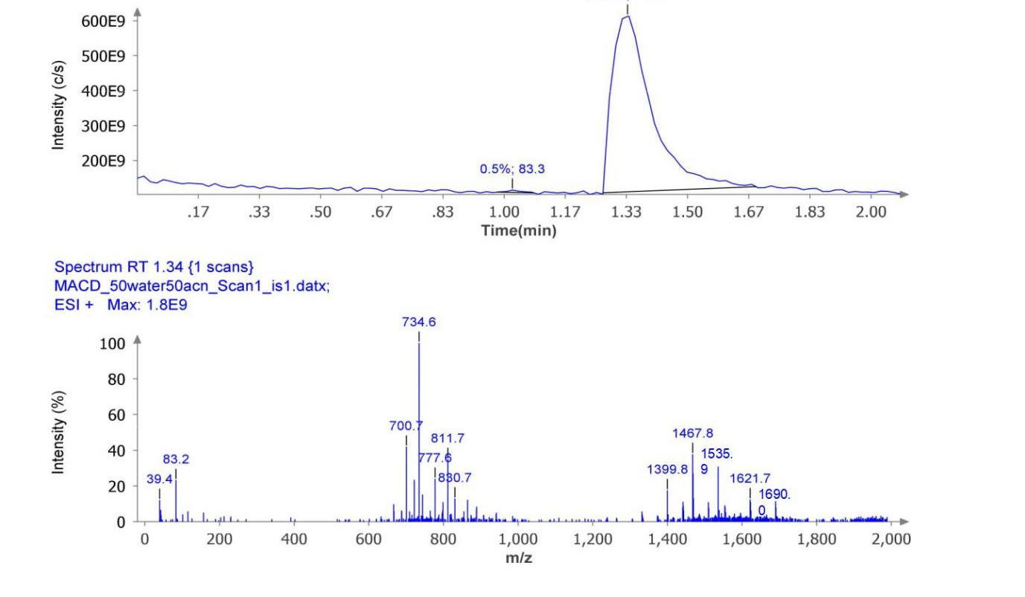Figure S3. LC-MS spectrometer of MAβCD (ESI+ mode, MeCN/H₂O=50/50).

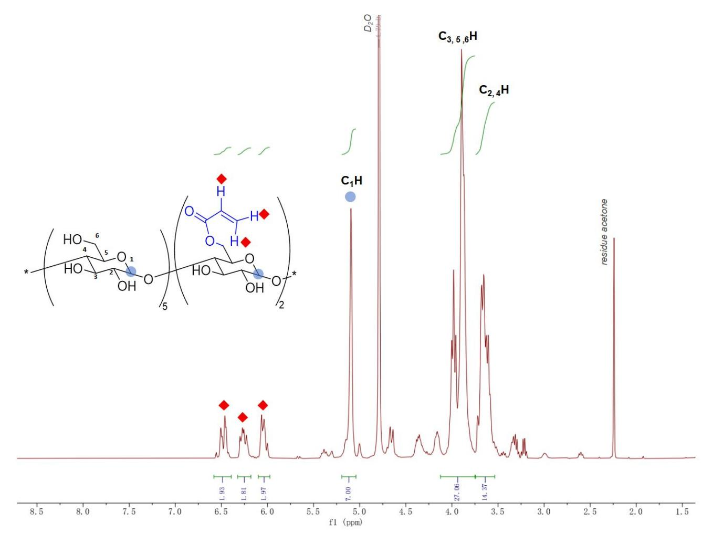
Figure S4. ¹H NMR (400 mHz, D₂O) of ACβCD.

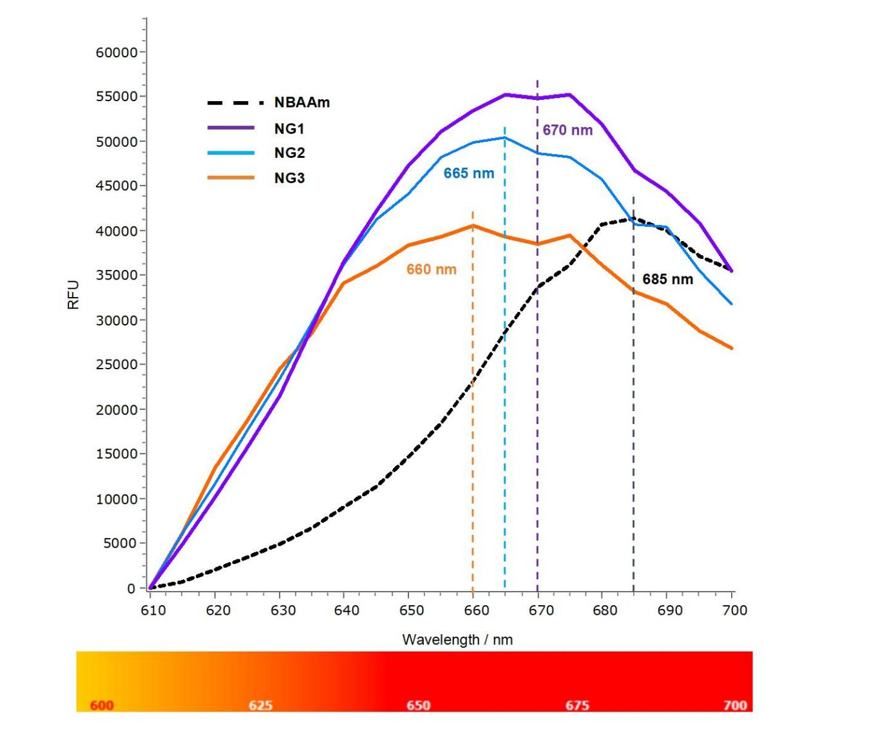
Figure S5. Fluorescence emission spectra of NB-labeled CD-nGel and free NBAAm in H₂O (excitation wavelength = 580 nm).

Figure S6. (A) VPTT measurements of CD-nGels over a temperature range of 20–70 °C. (B) Volumetric swelling ratio of each CD-nGels calculated by comparing the volumes in swollen (20 °C) and collapsed state (70°C).

Figure S7. The average D_{h} of all three CD-nGels over time under (A) physiological and (B) acidic conditions.

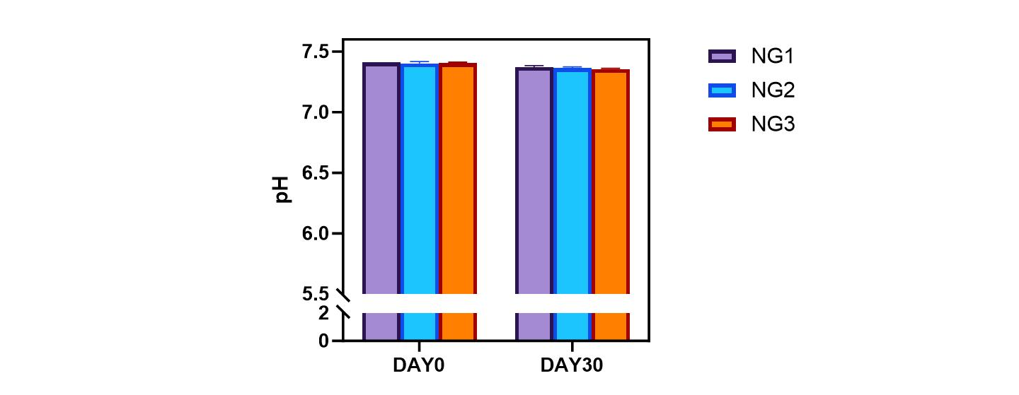
Figure S8. pH changes of three CD-nGels before and after hydrolysis in PBS.

Figure S9. MCF-7 lysate control experiment monitored by UV–vis spectroscopy. (A) Normalized spectra of MCF-7 lysate with phenol red in the absence of CD-nGels. Dashed lines represent the initial spectra at Day 0 (D0), while solid lines correspond to spectra collected at Day 20 (D20). (B) The relative area increases in the 430 nm peak region (360-500 nm range, normalized to the 560 nm reference band) is summarized as bar graph.

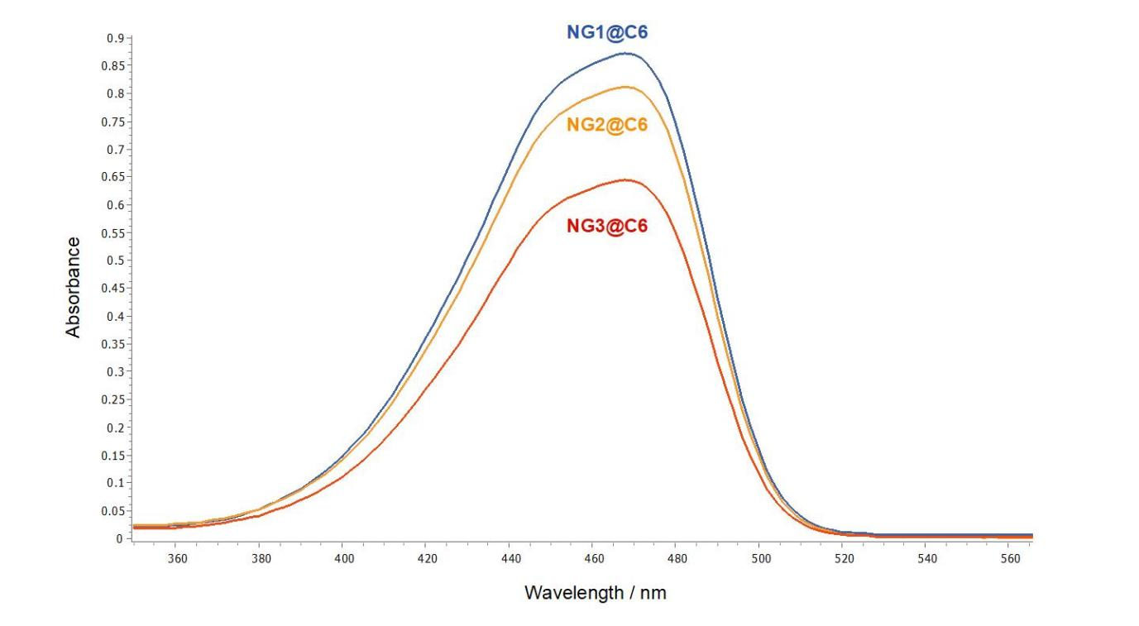
Figure S10. UV-vis spectra of CD-nGels@C6 dispersed in DMSO.

