Supplementary Material
Table S1. Patient Demographic and Clinical Characteristics at Time of Biologic Referral Overall and According to Race.
 | Overall  N=215 | White  N=148 | Black or African American  N=59 | Otherª  N=8
Age at referral (median, IQR) | 48 (26, 60) | 53 (37, 62) | 33 (16, 52) | 41 (21, 47)
Gender, n(%)
Female | 118 (54.9%) | 78 (52.7%) | 33 (55.9%) | 7 (87.5%)
Male | 97 (45.1%) | 70 (47.3%) | 26 (44.1%) | 1 (12.5%)
Ethnicity, n(%)
None of these | 70 (32.6%) | 43 (29.1%) | 25 (42.4%) | 2 (25.0%
Not Hispanic or Latino | 67 (31.2%) | 48 (32.4%) | 17 (28.8%) | 2 (25.0%)
Unknown | 59 (27.4%) | 44 (29.7%) | 14 (23.7%) | 1 (12.5%)
Other | 19 (8.8%) | 13 (8.8%) | 3 (5.1%) | 3 (37.5%)
Asthma severity, n(%)
Moderate-persistent asthma | 113 (52.6%) | 80 (54.1%) | 27 (45.8%) | 6 (75.0%)
Severe-persistent asthma | 102 (47.4%) | 68 (45.9%) | 32 (54.2%) | 2 (25.0%)
Insurance Type
Commercial | 115 (53.5%) | 83 (56.1%) | 27 (45.8%) | 5 (62.5%)
Medicare | 48 (22.3%) | 40 (27.0%) | 8 (13.6%) | -
Medicaid | 35 (16.3%) | 14 (9.5%) | 19 (32.2%) | 2 (25.0%)
Tricare/Other/None | 17 (7.9%) | 11 (7.4%) | 5 (8.5%) | 1 (12.5%)
Smoking Status
Never smoker/Never exposure or Unknown | 129 (60.0%) | 86 (58.1%) | 36 (61.0%) | 7 (87.5%)
Exposure | 21 (9.8%) | 11 (7.43%) | 9 (15.3%) | 1 (12.5%)
Previous | 43 (20.0%) | 36 (24.3%) | 7 (11.9%) | -
Current | 22 (10.2%) | 15 (10.1%) | 7 (11.9%) | -
Deprivation Index, Median (IQR) | 0.37 (0.27, 0.44) | 0.37 (0.25, 0.43) | 0.38 (0.31, 0.50) | 0.35 (0.23, 0.36)
Distance to Care (miles), Median (IQR) | 2.0 (1.0, 5.2) | 2.7 (1.5, 4.5) | 2.0 (1.3, 3.1) | 2.1 (0.9, 5.9)
Air Quality Index (AQI), Median (IQR), N=159
Maximum AQI | 108.0 (84.0, 116.0) | 108.0 (83.0, 116.0) | 116.0 (97.0, 116.0) | 151.0 5(144.5, 151.0)
Nitrogen Dioxide (NO2) | 0.0 (0.0, 6.0) | 0.0 (0.0 - 5.5) | 5.5 (0.0- 6.0) | 6.0 (3.0 - 6.0)
Ozone | 34.7 (26.9, 100.0) | 44.5 (33.2 - 100.0) | 33.2 (20.1 - 34.7) | 33.2 (33.2 - 33.2)
Particulate Matter (PM_{2.5})^{b} | 59.8 (0.0, 100.0) | 51.2 (0.0 - 60.8) | 60.8 (59.8 - 74.7) | 60.8 (60.8 - 60.8)
ª American Indian or Alaska Native, Native Hawaiian or Other Pacific Islander, Guamanian or Chamorro, Middle Eastern, Other, Decline to Answer, Unknown, Null, or None of These
^{b}The percent of days for which this pollutant was the primary pollutant

Table S2. Multiple Linear Regression Summary for ppFEV1 at Follow-Up
 | Estimate (95% Confidence Interval) | p-value
ppFEV1 at Baseline | 0.6 (0.4, 0.8) | <0.001
Black or African American + Other | 0.6 (-8.3, 9.45) | 0.893
Smoking (Reference: Never smoker/Never exposure or Unknown)
Exposure | -4.8 (-18.0, 8.3) | 0.463
Previous | -11.6 (-23.6, 0.4) | 0.057
Current | -11.2 (-27.9, 5.5) | 0.185
Insurance Type (Reference: Commercial)
Medicaid | 1.2 (-9.8, 12.1) | 0.829
Medicare | -6.3 (-19.2, 6.6) | 0.331
Tricare/Other/None | -4.1 (-21.2, 13.0) | 0.634
Deprivation Index (per 0.1 increase) | 2.1 (-1.3,5.5) | 0.230

Table S3. Change in ppFEV1 from Baseline to Follow-up
 | White (N=38) | Black/Other (N=27) | Overall (N=65) | p-value
Change in ppFEV1 PP from baseline to follow-up,  Median (IQR) | 2 (-2,10) | 4 (-6, 24) | 3 (-2, 16) | 0.558

Figure S1. One-year PDC by Race

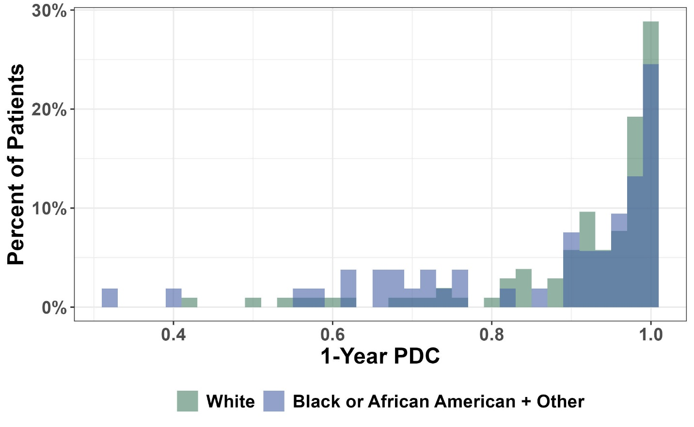
Figure S2. Percent Gap Days by Race
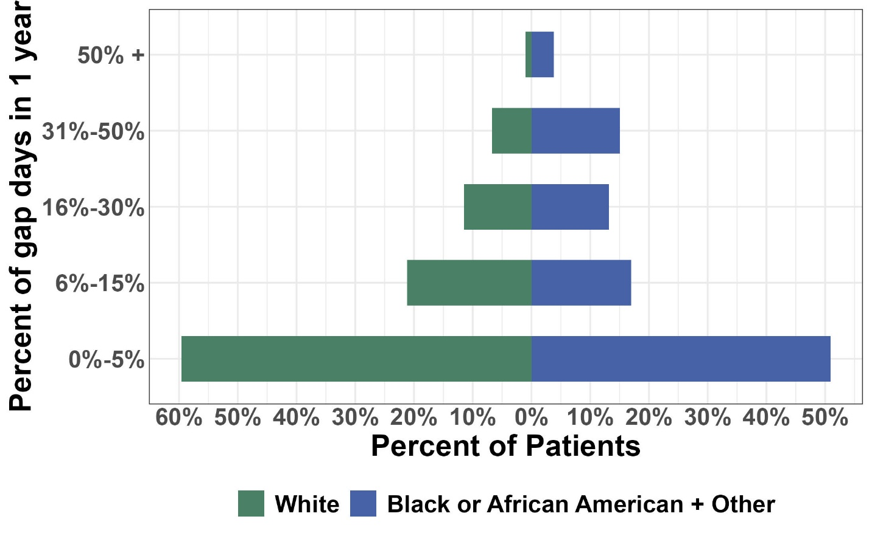

Table S4. Differences in Patient Demographic and Clinical Characteristics for Patients Included in the Baseline Model
 | In analytics dataset for baseline model  N=161 | Not in analytic dataset for baseline model  N=54 | p-valueª
Age at referral (median, IQR) | 48 (23, 59) | 49 (29, 62) | p=0.4
Gender, n(%)
Female | 92 (57.1%) | 26 (48.1) | p=0.3
Male | 69 (42.9%) | 28 (51.9%) | p=0.3
Race, n(%)
White | 110 (68.3%) | 38 (70.4%) | p=0.8
Black or African American/Other | 51 (31.7%) | 16 (29.6%) | p=0.8
Ethnicity, n(%)
Unknown | 55 (34.2%) | 17 (31.5%) | p=0.8
Not Hispanic or Latino | 102 (63.4%) | 35 (64.8%) | p=0.8
Hispanic or Latino | 4 (2.5%) | 2 (3.7%) | p=0.8
Asthma severity, n(%)
Moderate-persistent asthma | 79 (49.1%) | 34 (63%) | p=0.077
Severe-persistent asthma | 82 (50.9%) | 20 (37%) | p=0.077
Insurance Type
Commercial | 86 (53.4%) | 33 (61.1%) | p=0.9
Medicare | 39 (24.2%) | 11 (20.4%) | p=0.9
Medicaid | 27 (16.8%) | 8 (14.8%) | p=0.9
Tricare/Other/None | 9 (5.6%) | 2 (3.7%) | p=0.9
Smoking Status
Never smoker/Never exposure or Unknown | 93 (57.8%) | 36 (66.7%) | p=0.4
Exposure | 17 (10.6%) | 4 (7.4%) | p=0.4
Previous | 36 (22.4%) | 7 (13%) | p=0.4
Current | 15 (9.3%) | 7 (13%) | p=0.4
Distance to Care (miles), Median (IQR) | 2.0 (0.9, 4.9) | 2.6 (1.5, 5.5) | p=0.2
ªContinuous measures were evaluated with Wilcoxon rank sum tests; categorical variables were evaluated with Pearson's Chi-squared tests or Fisher's exact tests

Table S5. Differences in Patient Demographic and Clinical Characteristics for Patients Included in the Follow-up Model
 | In analytics dataset for baseline model  N=65 | Not in analytic dataset for baseline model  N=150 | p-value
Age at referral (median, IQR) | 39 (16, 55) | 51 (33, 62) | p<0.001
Gender, n(%)
Female | 33 (50.8%) | 85 (56.7%) | p=0.4
Male | 32 (49.2%) | 65 (43.3%) | p=0.4
Race, n(%)
White | 38 (58.5%) | 110 (73.3%) | p=0.031
Black or African American/Other | 27 (41.5%) | 40 (26.7%) | p=0.031
Ethnicity, n(%)
Unknown | 24 (58.5%) | 99 (66%) | p=0.4
Not Hispanic or Latino | 24 (36.9%) | 48 (32%) | p=0.4
Hispanic or Latino | 3 (4.6%) | 3 (2%) | p=0.4
Asthma severity, n(%)
Moderate-persistent asthma | 28 (43.1%) | 85 (56.7%) | p=0.067
Severe-persistent asthma | 37 (56.9%) | 65 (43.3%) | p=0.067
Insurance Type
Commercial | 36 (55.4%) | 83 (55.3%) | p=0.14
Medicare | 10 (15.4%) | 40 (26.7%) | p=0.14
Medicaid | 15 (23.1%) | 20 (13.3%) | p=0.14
Tricare/Other/None | 4 (6.2%) | 7 (4.7%) | p=0.14
Smoking Status
Never smoker/Never exposure or Unknown | 37 (56.9%) | 92 (61.3%) | p=0.6
Exposure | 9 (13.8%) | 12 (8%) | p=0.6
Previous | 13 (20%) | 30 (20%) | p=0.6
Current | 6 (9.2%) | 16 (10.7%) | p=0.6
Distance to Care (miles), Median (IQR) | 2.2 (1.0, 6.5) | 2.0 (0.9, 4.9) | p=0.5

