Supporting Information

Supporting tables

Table S1 Comparisons of skin wound healing area in diabetic rats (cm², mean ± SD)
Groups | D0 | D3 | D9 | D12 | D15
CON | 2.00±0.18 | 1.67±0.15 | 1.42±0.29 | 0.98±0.16 | 0.60±0.08
SHA | 1.97±0.22 | 1.46±0.37 | 0.62±0.19 | 0.41±0.19 | 0.15±0.08
SHA-PtNPs | 1.92±0.13 | 1.31±0.19 | 0.71±0.17 | 0.32±0.28 | 0.06±0.02
F-value | 0.267 | 2.499 | 19.865 | 16.098 | 128.295
P-value | 0.770 | 0.124 | 0.000 | 0.000 | 0.000

Table S2 The serum biochemical parameters in diabetic mice from different experimental groups (n=5)
Analyte | CON | SHA | SHA-PtNPs | F value | P value
ALT, U/L | 45.68±6.812 | 50.43±8.827 | 44.8±7.225 | 0.7807 | 0.4800
AST, U/L | 91.42±8.612 | 93.35±8.887 | 90.81±12.19 | 0.1921 | 0.8277
SCr, μmol/L | 38.77±4.660 | 38.07±5.217 | 37.90±7.685 | 0.0292 | 0.9713
Urea, U/L | 6.652±0.500 | 6.354±0.845 | 6.994±1.005 | 0.7997 | 0.4720

Table S3 Summary of the mechanism of wound healing by SHA-PtNPs

Groups | Factor
SHA-PtNPs | IL-1β | Negative on day 3 | Negative on day 9
SHA-PtNPs | IL-4 | Positive on day 3 | High positive on day 9
SHA-PtNPs | TGF-β1 | Detectable on day 3 | Highly elevated on day 9
SHA-PtNPs | CD31 | Elevated on day 3 | Highly elevated on day 9
SHA-PtNPs | α-SMA | Detectable on day 3 | Highly elevated on day 9
 | CD206/CD86 | Highest on day 3 | Highly elevated on day 15

Supporting figures
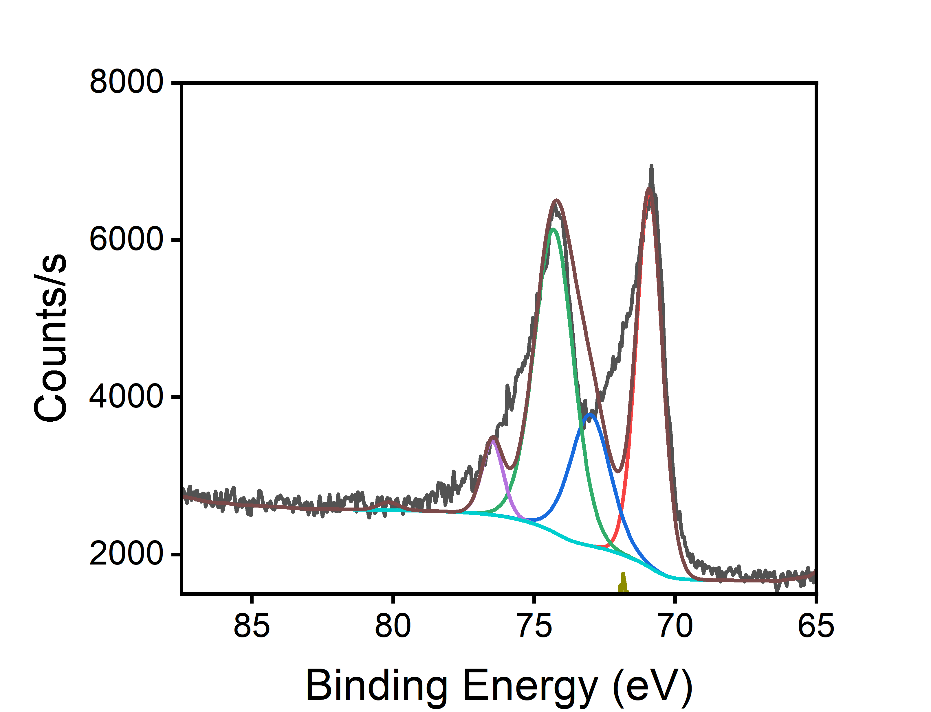
Figure S1. The XPS spectra of Pt.

Figure S2. Wound healing percentage (n=3). Data was presented as the mean ± SD. (****P < 0.0001 compared with repeated measurements).

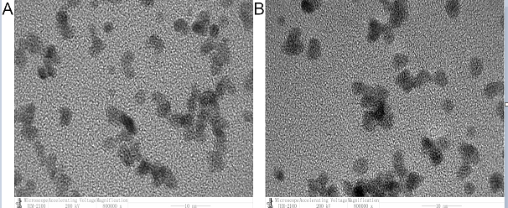

Figure S3. The TEM images of (A) original SHA-PtNPs, (B) SHA-PtNPs after interacting with diabetic wounds.

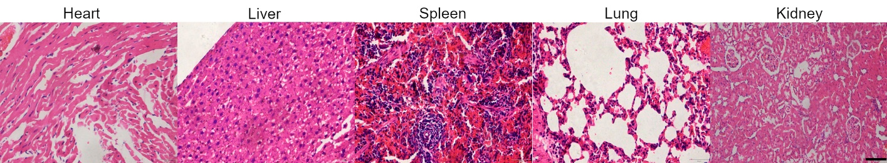

Figure S4. H&E staining of organs including heart, lung, liver, spleen, and kidney of rats treated with SHA-PtNPs. (Scale bar=100 μm)

Figure S5. Assessment of hepatorenal function following SHA-PtNPs treatment (A: ALT; B: AST; C: SCr and D: BUN).
Figure S6. To semi-quantitatively assess inflammatory infiltration, the H&E stained sections were scored (0-3) by two independent, blinded observers. The final score for each sample represents the average from five non-overlapping high-power fields (20×). (****P < 0.0001 compared with one-way ANOVA with Tukey’s post hoc tests)

Figure S7. Representative images of H&E staining of tissues treated with NS, SHA, and SHA-PtNPs on day 9 (4×, Scale bar = 100 μm, 20×, Scale bar = 20 μm).

Figure S8. Representative images of H&E staining of tissues treated with NS, SHA, and SHA-PtNPs on day 28 (4×, Scale bar = 100 μm, 20×, Scale bar = 20 μm).

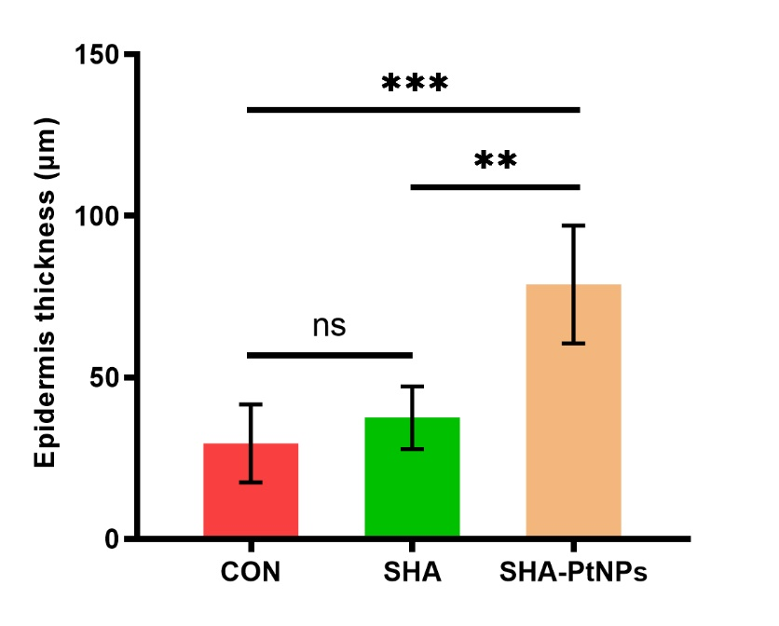
Figure S9. Quantitative analysis of regenerated epithelium thickness on the 28th day. Data are presented as mean ± SD (**P < 0.01, ***P < 0.001 compared with one-way ANOVA with Tukey’s post hoc tests, n=3).
Figure S10. Representative images of immunohistochemistry staining of α-SMA on day 3 and day 9 (Scale bars = 100 μm, n=3).

Figure S11. Quantitative analysis of IHC for α-SMA on the day 3 and day 9 post-treatment. All data are presented as the mean ± SD. (**P < 0.01, ****P < 0.0001 compared with one-way ANOVA with Tukey’s post hoc tests, n=3).

