Supplementary Material
Journal of Multidisciplinary Healthcare
Supplement Table 1. Full Questionnaire including answers
No. | Question | Response options / scale
1 | How old are you? | - <20 years  - 20-30 years  - 30-40 years  - 40-50 years  - 50-60 years  - >60 years
2 | How many years of professional experience do you have? | - <1 year  - 2-4 years  - >5 years  - >10 years
3 | What is your profession? | - Midwifery student / trainee  - Medical student  - Midwife working mainly in a hospital setting  - Midwife working mainly in out-of-hospital care  - Midwife working in a birth center  - Resident physician  - Specialist / board-certified obstetrician-gynecologist  - Senior physician / consultant  - Head of department / chief physician  - Other
4 | Approximately how many births do you personally attend per week on average over the last year? | - <5  - 5-10  - 10-20  - 20-30  - >30
5 | How do you monitor the fetal heart rate during labor? | - Intermittent auscultation  - CTG  - CTG with STAN  - Not at all
6 | According to which criteria do you assess the fetal heart rate during labor? | - DGGG  - NICE  - FIGO  - Fischer  - Physiological CTG  - Internal SOP  - Other
7 | Who trained you in CTG interpretation? (Multiple answers possible) | - Part of my studies / professional training  - Medical colleagues  - Midwifery colleagues  - Learning by doing over time  - Textbook  - I did not receive proper formal training specifically in CTG interpretation
8 | How well prepared did you feel for your first birth managed independently as the physician on duty / responsible midwife? | - Does not apply at all -> fully applies
9 | How many CTG training courses have you attended in the last 5 years? | - None  - 1-2  - 2-4  - >5
10 | In your opinion, is there a need for CTG training courses in Germany? | - Yes  - No
11 | Do you use MBU (fetal blood sampling)? | - Yes  - No
12 | MBU (fetal blood sampling) provides me with a reliable method for assessing fetal well-being. | - Fully agree -> do not agree at all
13 | With the introduction of CTG, it has been shown that... (Multiple answers possible) | - the rate of fetal blood sampling is reduced  - the rate of operative vaginal deliveries is reduced  - the cesarean section rate is increased  - the rate of fetal acidosis is reduced  - the rate of infantile cerebral palsy is reduced  - none of the above
14 | CTG makes me feel confident in assessing fetal well-being during labor. | - Fully agree -> do not agree at all
15 | The classification system I use provides me with clear recommendations for action that I can apply to most situations in the delivery room. | - Fully agree -> do not agree at all
16 | How many births take place annually in your hospital? | - <500  - 500-1000  - 1000-2000  - 2000-3000  - >3000
17 | How many physicians are on duty in your hospital? | - None  - 1  - 2  - 3  - >3
18 | What is the midwife-to-patient ratio during labor? | - 1:1  - 1:2  - 1:3  - >1:3
19 | My workplace is: (brief information in a few key words) | - Perinatal center level 1  - Perinatal center level 2  - Perinatal center with extended care  - Standard maternity unit
20 | Are there regular in-house CTG training sessions in your institution? | - Yes  - No
21 | Is there an internal institutional standard for the management of abnormal CTG findings? | - Yes  - No
22 | When did you first independently manage a birth? | - Already during training (midwives)  - After completing training  - During specialist training: 1st year  - During specialist training: 2nd year  - During specialist training: 3rd year  - During specialist training: 4th year  - During specialist training: 5th year
23 | Is there a systematic onboarding process for the delivery room in your institution? | - Yes  - No  - If yes, duration: 1 week  - If yes, duration: 2 weeks  - If yes, duration: 4 weeks  - If yes, duration: >4 weeks  - CTG training is an important component: Yes  - CTG training is an important component: No
24 | Do you distinguish between high-risk and low-risk patients during labor? | - Yes  - No
25 | Have you ever attended a lecture on physiological CTG? | - Yes  - No
26 | For me personally, CTG interpretation is difficult because... (Multiple answers possible) | - there is often an unexpectedly good outcome  - there is often an unexpectedly poor outcome  - the same CTG is interpreted differently by different colleagues  - the same CTG is interpreted differently after some time  - it gives me a false sense of security  - I do not have any difficulties with CTG interpretation

Supplement Table 2. Choice of evaluation criteria for CTG interpretation depending on years of professional experience.
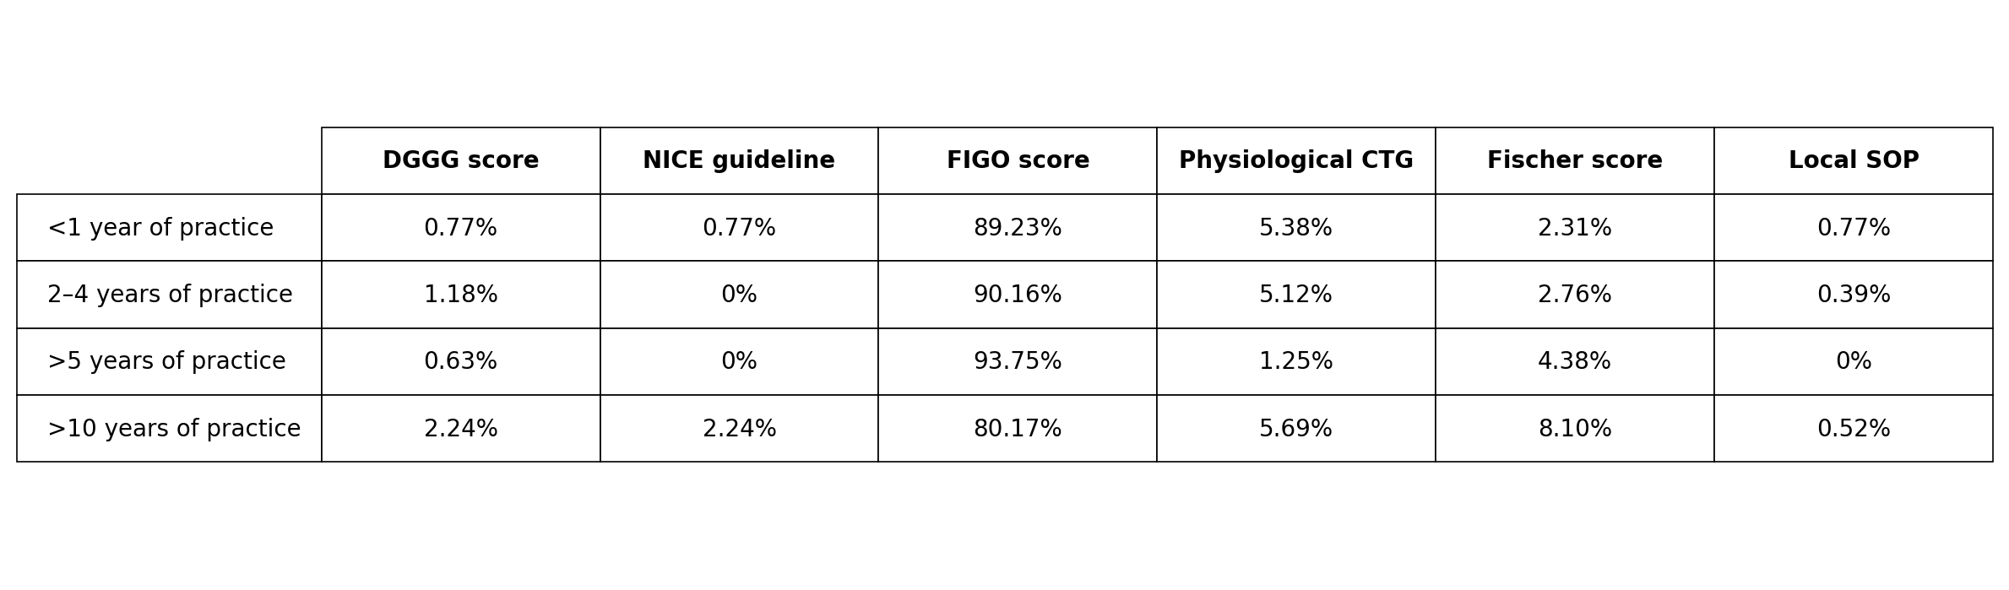
Legend: The FIGO score is used most frequently overall. Additionally, practitioners with longer professional experience use the Fischer score more often. n = 1124/1132.

Supplement Figure 1. Distribution of professions.
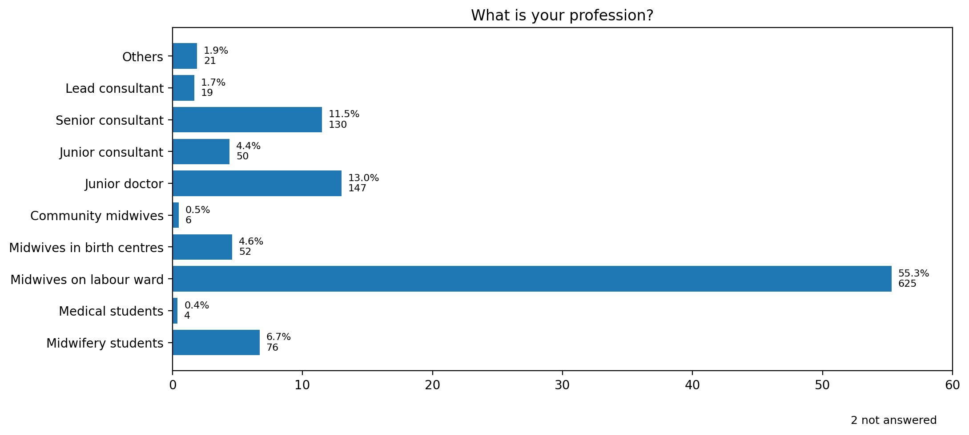
Legend: A total of 1,132 participants responded, including 763 (trainee) midwives and 346 (trainee) physicians. Two respondents did not answer this item.

Supplement Figure 2. Perceived reliability of fetal blood sampling (FBS) in assessing fetal well-being.
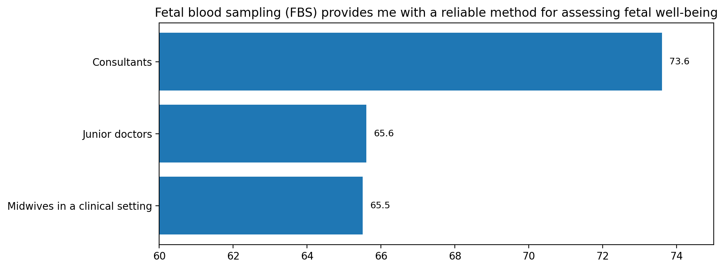
Legend: Participants provided an intuitive rating on a scale from 0 to 100, where 100 indicates “very reliable” and 0 indicates “very unreliable.” The results suggest uncertainty regarding the reliability of fetal blood sampling (FBS). Consultants reported higher confidence than midwives and junior doctors. Total sample: consultants n = 146 (M = 73.6, SD = ±26.0); midwives n = 667 (M = 65.5, SD = ±25.5); junior doctors n = 146 (M = 65.6, SD = ±26.9).
Abbreviations: FBS, fetal blood sampling; M, median; SD, standard deviation.

Supplement Figure 3. Duration of delivery room onboarding.
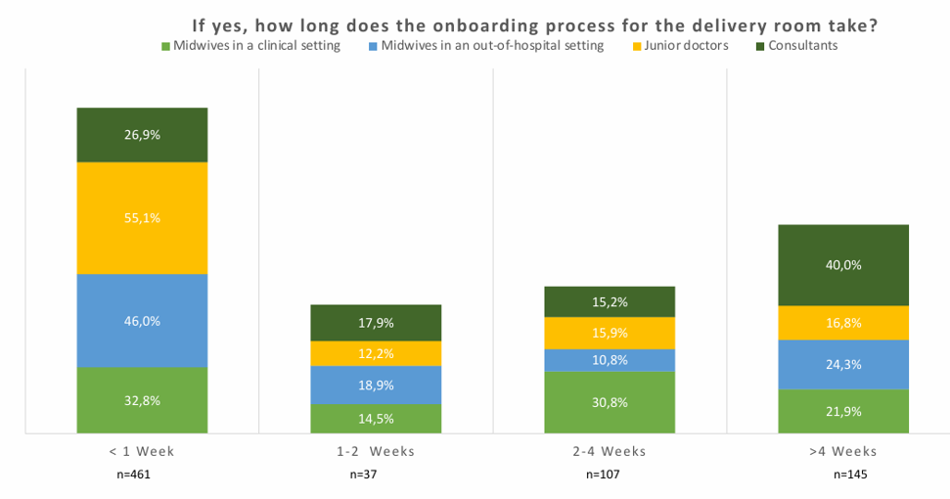
Legend: In cases where onboarding is provided, its duration varies among respondents. An onboarding period of less than one week was reported by 55.1% of junior doctors and 26.9% of consultants. In contrast, training lasting more than four weeks was reported by 16.8% of junior doctors and 40.0% of consultants.

Supplement Figure 4. CTG training as part of onboarding.
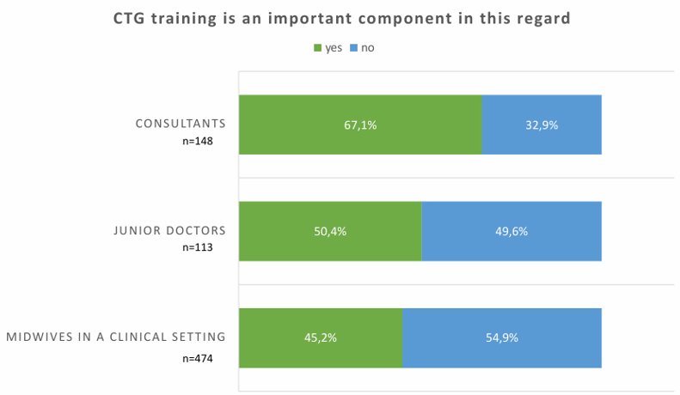
Legend: In cases where onboarding is provided, 50.4% of surveyed junior doctors reported that CTG training is an essential component. Among midwives, this proportion is lower, while it is higher among consultants.

