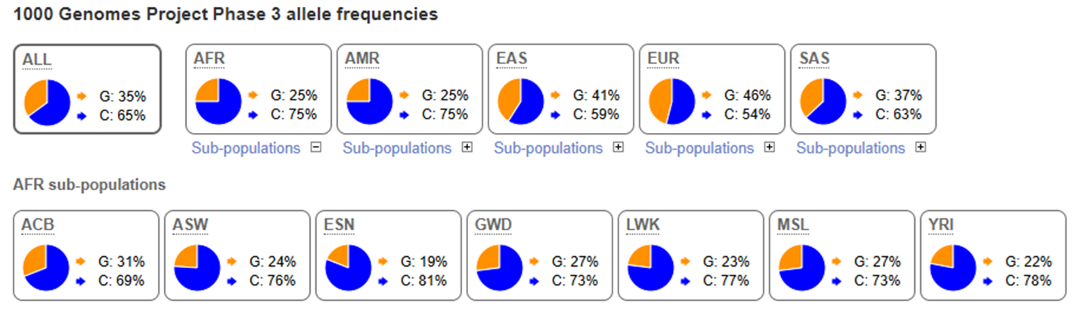
Figure S1. Allele frequencies of the NLRP3 rs10754558 variant across global populations from the 1000 Genomes Project (Phase 3). Pie charts display the distribution of G and C alleles in the overall population (ALL) and within continental groups: African (AFR), American (AMR), East Asian (EAS), European (EUR), and South Asian (SAS). Sub-populations within AFR (ACB, ASW, ESN, GWD, LWK, MSL, YRI) are also shown. Frequencies are represented as percentages (G allele in orange, C allele in blue). The data highlight population-specific differences, with higher G allele frequency observed in European and East Asian cohorts, while the C allele is predominant in African populations.

Table S1. Predicted gain and loss of miRNA binding sites in the 3′UTR of NLRP3 associated with the rs10754558 SNP. The table summarizes predicted miRNA interactions at the 3′UTR region of NLRP3 in the presence of the rs10754558 variant. Binding start and end positions (based on miRmap) are shown along with the predicted thermodynamic stability values: ΔG duplex, ΔG binding, and ΔG open (kCal/mol). Additional prediction parameters include TargetScan score, AU content, and exact probability of binding.
NLRP3 gain of function with SNP in 3UTR (C allele)
miRNA | Binding Start (miRmap) | Binding End (miRmap) | ΔG duplex (kCal/mol) | ΔG binding (kCal/mol) | ΔG open (kCal/mol) | TargetScan score | AU content | Exact probability
hsa-miR-146a-5p | 247448731 | 247448737 | -13.4 | -12.2033 | 12.97811 | 12.97811 | 0.49052 | 0.0262
hsa-miR-146b-5p | 247448731 | 247448737 | -16.2 | -13.6702 | 12.97812 | 12.97812 | 0.49052 | 0.0262
hsa-miR-580-3p | 247448732 | 247448738 | -10.8 | -6.66217 | 12.97999 | 12.97999 | 0.5146 | 0.0487
hsa-miR-589-5p | 247448731 | 247448731 | -16.7 | -15.1327 | 12.97811 | 12.97811 | 0.49052 | 0.0262
hsa-miR-4712-3p | 247448733 | 247448739 | -13.4 | -12.7326 | 12.97998 | 12.97998 | 0.41892 | 0.04852
hsa-miR-4773 | 247448730 | 247448736 | -10.1 | -8.44497 | 12.95994 | 12.95994 | 0.42679 | 0.01449
hsa-miR-7153-5p | 247448731 | 247448737 | -12.5 | -10.9989 | 12.97812 | 12.97812 | 0.49052 | 0.0262
NLRP3 loss of function with SNP in 3UTR (G allele)
hsa-miR-7153-5p | 247448731 | 247448737 | -13.3 | -12.6187 | 17.83572 | 17.83572 | 0.49052 | 0.04156
hsa-miR-3065-5p | 247448729 | 247448735 | -21 | -20.1795 | 17.81761 | 17.81761 | 0.49527 | 0.02619
hsa-miR-425-5p | 247448733 | 247448739 | -18 | -13.782 | 17.83761 | 17.83761 | 0.41892 | 0.06693

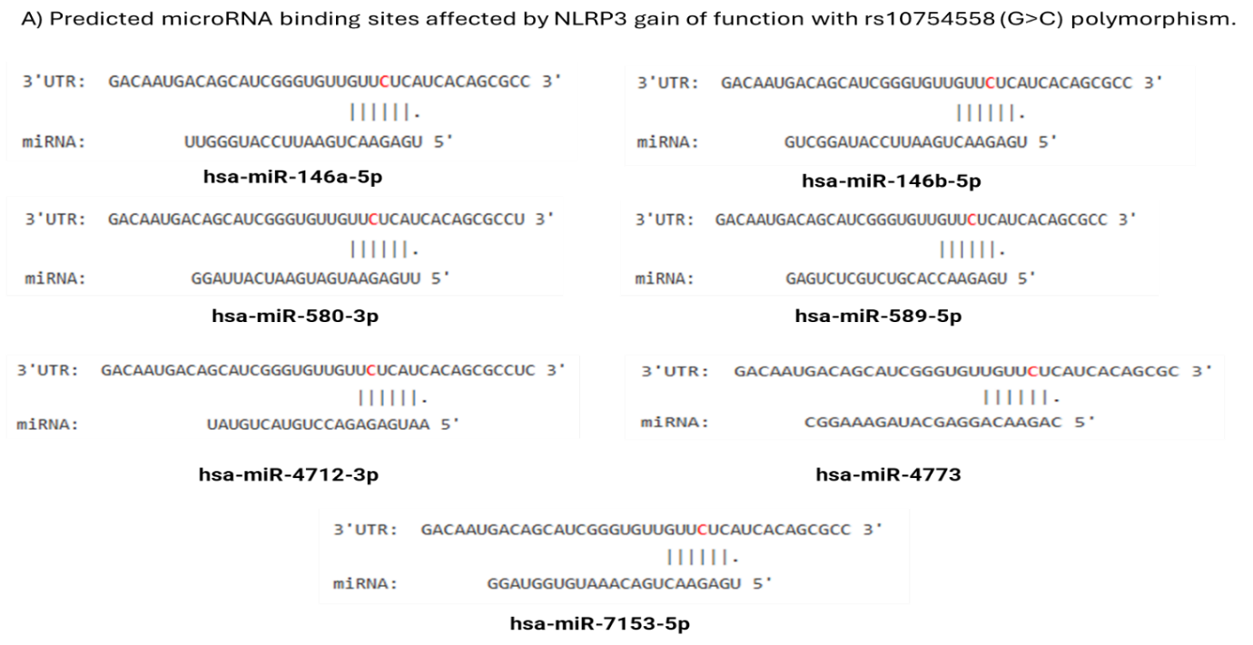

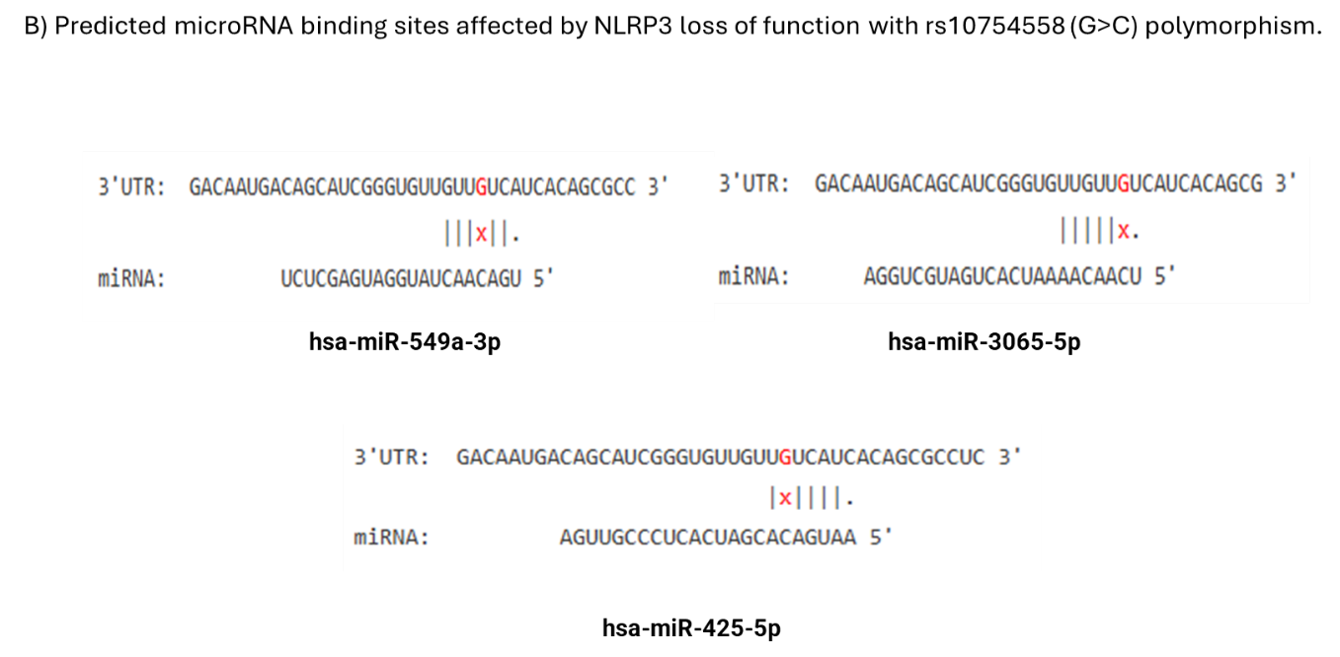

Figure S2. Predicted gain and loss of miRNA binding sites in the NLRP3 3′UTR associated with the rs10754558 SNP. Panels illustrate the predicted interactions between the NLRP3 3′UTR and different miRNAs in the presence of the rs10754558 variant. (A) Gain of miRNA binding sites: multiple miRNAs (e.g., hsa-miR-146a-5p, hsa-miR-146b-5p, hsa-miR-580-3p, hsa-miR-589-5p, hsa-miR-4712-3p, hsa-miR-4773, hsa-miR-7153-5p) show increased complementarity and predicted binding to the altered 3′UTR sequence. (B) Loss of miRNA binding sites: other miRNAs (e.g., hsa-miR-7153-5p, hsa-miR-3065-5p, hsa-miR-425-5p) exhibit disrupted or weakened pairing due to the SNP, resulting in a loss of predicted binding. Vertical bars represent base pairing, while mismatches or disruptions are indicated by gaps or “x.” Together, these analyses suggest that rs10754558 may alter post-transcriptional regulation of NLRP3 by modulating miRNA–mRNA interactions. Red base = polymorphic site; vertical bars = base pairing; “x” = mismatch at variant site.

Table S2: RegulomeDB annotation of the NLRP3 rs10754558 variant. The table presents the genomic position, dbSNP identifier, RegulomeDB functional rank, and corresponding score for the NLRP3 rs10754558 polymorphism located in the 3′UTR region.
Chromosome Location | dbSNP IDs | Rank | Score
chr1:247448733-247448734 | rs10754558 | 1f | 0.55436

