Supporting Information

Fig. S1 Representative melting curves for GRIK4 and MC4R genotyping in the ROX channel. (A-C) GRIK4 C/C (mutant), T/T (wild-type), and C/T (heterozygote). (D–F) MC4R C/C (mutant), A/A (wild-type), and C/A (heterozygote).

Fig. S2 Representative melting curves for DRD2 and FKBP5 genotyping in the CY5 channel. (A-C) DRD2 dupC/dupC (mutant), / (wild-type), and dupC/- (heterozygote). (D–F) FKBP5 G/G (mutant), A/A (wild-type), and G/A (heterozygote).

Fig. S3 Representative melting curves for HTR2A genotyping in the VIC channel. (A) G/G (mutant); (B) A/A (wild-type); (C) G/A (heterozygote).

Fig. S4 Final allocation of the seven target SNPs across four fluorescence channels and their respective allele-specific Tm values in the mFMCA system.(A) HTR1A and ANKK1 variants in the FAM channel; (B) GRIK4 and MC4R variants in the ROX channel; (C) FKBP5 and DRD2 variants in the CY5 channel; (D) HTR2A variant in the VIC channel.

Fig. S5 Evaluation of amplification efficiency for GRIK4 and MC4R genes in the ROX channel. (A) amplification curves of GRIK4 gene using a ten-fold serial dilution of plasmid standards; (B) corresponding standard curve of GRIK4 gene showing the linear relationship between the log of the starting template quantity and the Ct value.(C) amplification curves of MC4R gene; (D) corresponding standard curve of MC4R gene.

Fig. S6 Evaluation of amplification efficiency for FKBP5 and DRD2 genes in the CY5 channel. (A) amplification curves of FKBP5 gene using a ten-fold serial dilution of plasmid standards; (B) corresponding standard curve of FKBP5 gene showing the linear relationship between the log of the starting template quantity and the Ct value.(C) amplification curves of DRD2 gene; (D) corresponding standard curve of DRD2 gene.

Fig. S7 Evaluation of amplification efficiency for HTR2A gene in the VIC channel. (A) amplification curves of HTR2A gene using a ten-fold serial dilution of plasmid standards; (B) corresponding standard curve of HTR2A gene showing the linear relationship between the log of the starting template quantity and the Ct value.

Fig. S8 Performance of the mFMCA system on the Hongshi 96s qPCR instrument. (A) Integrated multiplex melting curves across all four detection channels, demonstrating simultaneous multi-locus detection. (B) Individual melting profiles for each channel: (i) FAM channel: identification of HTR1A and ANKK1 alleles; (ii) ROX channel: identification of GRIK4 and MC4R alleles; (iii) CY5 channel: identification of DRD2 and FKBP5 alleles; (iv) VIC channel: identification of the HTR2A allele.
Fig. S9 Representative melting curves of the DRD2 SNP locus in selected clinical samples. The figure displays the melting curves in the CY5 fluorescence channel, where the orange dashed box highlights the results for the DRD2 SNP. For heterozygous samples, the melting peaks of the two alleles tend to coalesce, resulting in a broadened peak width and a less distinct apex. Nevertheless, the genotype can still be readily determined by the characteristic shape of the melting curve.

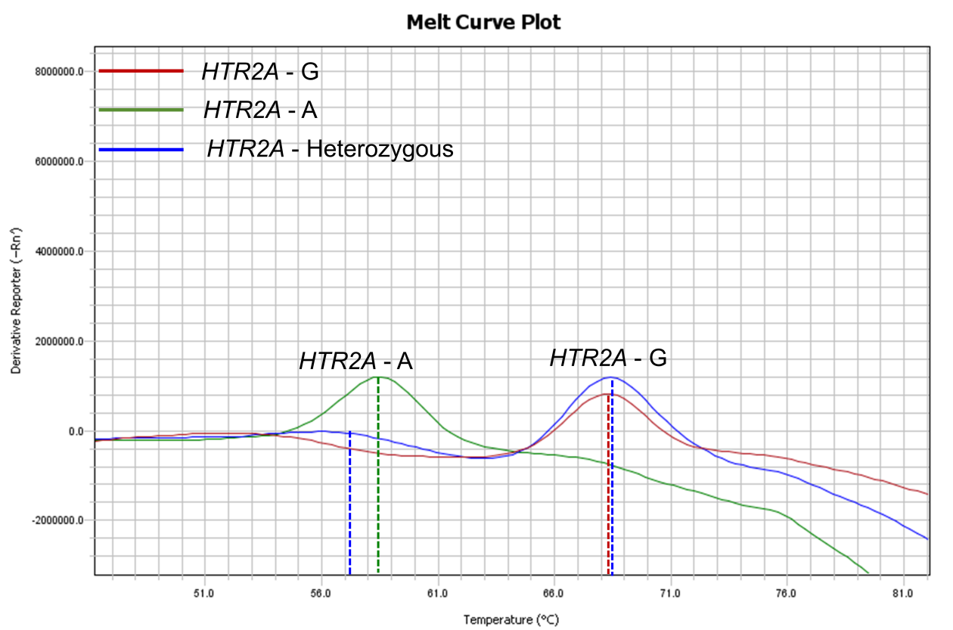
Fig. S10 Representative melting curves of the HTR2A SNP locus in selected clinical samples. The figure displays the melting curves in the VIC fluorescence channel, where the orange dashed box highlights the results for the HTR2A SNP. For heterozygous samples,the melting peaks of the two alleles exhibit partial coalescence. Specifically, the G-allele peak partially masks the A-allele peak, resulting in an atypical melting peak morphology with an indistinct apex for the A-allele.Nevertheless, the genotype can still be readily determined by the characteristic shape of the melting curve.

Fig. S11 Validation of genotyping results for sample No. 201 using the mFMCA assay and Sanger sequencing. (A) Melting curve profiles of the seven target SNPs across four fluorescence channels: (i) FAM channel; (ii) ROX channel; (iii) CY5 channel; and (iv) VIC channel. In each panel, the specific Tm peaks correspond to the genotypes of the dedicated SNPs. (B) Representative Sanger sequencing chromatograms confirming the seven target variants: (i) ANKK1; (ii) DRD2; (iii) FKBP5; (iv) GRIK4; (v) HTR1A; (vi) HTR2A; and (vii) MC4R.

Fig. S12 Validation of genotyping results for sample No. 226 using the mFMCA assay and Sanger sequencing. (A) Melting curve profiles of the seven target SNPs across four fluorescence channels: (i) FAM channel; (ii) ROX channel; (iii) CY5 channel; and (iv) VIC channel. In each panel, the specific Tm peaks correspond to the genotypes of the dedicated SNPs. (B) Representative Sanger sequencing chromatograms confirming the seven target variants: (i) ANKK1; (ii) DRD2; (iii) FKBP5; (iv) GRIK4; (v) HTR1A; (vi) HTR2A; and (vii) MC4R.

Fig. S13 Validation of genotyping results for sample No. 243 using the mFMCA assay and Sanger sequencing. (A) Melting curve profiles of the seven target SNPs across four fluorescence channels: (i) FAM channel; (ii) ROX channel; (iii) CY5 channel; and (iv) VIC channel. In each panel, the specific Tm peaks correspond to the genotypes of the dedicated SNPs. (B) Representative Sanger sequencing chromatograms confirming the seven target variants: (i) ANKK1; (ii) DRD2; (iii) FKBP5; (iv) GRIK4; (v) HTR1A; (vi) HTR2A; and (vii) MC4R.

Fig. S14 Validation of genotyping results for sample No. 279 using the mFMCA assay and Sanger sequencing. (A) Melting curve profiles of the seven target SNPs across four fluorescence channels: (i) FAM channel; (ii) ROX channel; (iii) CY5 channel; and (iv) VIC channel. In each panel, the specific Tm peaks correspond to the genotypes of the dedicated SNPs. (B) Representative Sanger sequencing chromatograms confirming the seven target variants: (i) ANKK1; (ii) DRD2; (iii) FKBP5; (iv) GRIK4; (v) HTR1A; (vi) HTR2A; and (vii) MC4R.

Table S1 Comparison of T_{m} values and ΔT_{m} for each SNP locus across different real-time PCR platforms.
Channel | SNP | ABI ViiATM 7 | Hongshi  SLAN-96S‌ | ΔT_{m}
FAM | HTR1A-G | 47.32 | 46.08 | 1.24
FAM | HTR1A-C | 59.29 | 58.35 | 0.94
FAM | ANKK1-G | 69.24 | 67 | 2.24
FAM | ANKK1-A | 77.26 | 74.32 | 2.94
ROX | GRIK4-T | 47.5 | 47.96 | 0.46
ROX | GRIK4-C | 59 | 59.6 | 0.6
ROX | MC4R-A | 66 | 66.24 | 0.24
ROX | MC4R-C | 72.29 | 72.75 | 0.46
CY5 | FKBP5-A | 47.86 | 48.31 | 0.45
CY5 | FKBP5-G | 59.44 | 60.99 | 1.55
CY5 | DRD2-/ | 70.43 | 70.9 | 0.47
CY5 | DRD2-dup C | 77.11 | 77.28 | 0.17
VIC | HTR2A-A | 57.81 | 58.6 | 0.79
VIC | HTR2A-G | 68.25 | 69.15 | 0.9
Notes: ΔT_{m} represents the absolute difference in mean T_{m} values between the two tested devices; “/ “ represents the DRD2 wild-type allele(non-dup C) .

Table S2 Summary of allele-specific mean T_{m} values and standard deviations stratified by genotypes in both the training and validation cohorts
Gene | Channel | Allele | Training cohort  (n=98) |  | Validation cohort (n=124)
Gene | Channel | Allele | Mean T_{m}, ℃ | SD,℃ | Mean T_{m}, ℃ | SD,℃
HTR1A | FAM | hom C | 57.43 | 0.35 | 58.13 | 0.13
HTR1A | FAM | hom G | 45.66 | 0.3 | 46.17 | 0.23
HTR1A | FAM | het C | 57.68 | 0.31 | 58.33 | 0.14
HTR1A | FAM | het G | 45.52 | 0.26 | 46.06 | 0.22
ANKK1 | FAM | hom A | 73.72 | 0.56 | 73.43 | 0.52
ANKK1 | FAM | hom G | 67.77 | 0.24 | 67.27 | 1.08
ANKK1 | FAM | het A | 74.17 | 0.28 | 73.91 | 0.77
ANKK1 | FAM | het G | 66.91 | 0.88 | 67.06 | 1.19
GRIK4 | ROX | hom T | 48.19 | 0.25 | 48.15 | 0.09
GRIK4 | ROX | hom C | 59.02 | 0.37 | 59.45 | 0.17
GRIK4 | ROX | het T | 47.65 | 0.24 | 48.11 | 0.16
GRIK4 | ROX | het C | 59.12 | 0.37 | 59.52 | 0.20
MC4R | ROX | hom A | 65.67 | 0.42 | 65.89 | 0.16
MC4R | ROX | hom C | 71.85 | 0.55 | 72.31 | 0.20
MC4R | ROX | het A | 65.18 | 0.65 | 65.90 | 0.16
MC4R | ROX | het C | 71.83 | 0.72 | 72.48 | 0.14
DRD2 | CY5 | hom / | 72.9 | 0.11 | 72.91 | 0.23
DRD2 | CY5 | hom dup C | 76.84 | 0.18 | 76.91 | 0.22
DRD2 | CY5 | het / | 73.26 | 0.59 | 72.13 | 0.23
DRD2 | CY5 | het dup C | 76.89 | 0.26 | 77.11 | 0.31
FKBP5 | CY5 | hom A | 47.83 | 0.13 | 48.21 | 0.29
FKBP5 | CY5 | hom G | 59.68 | 0.45 | 60.31 | 0.27
FKBP5 | CY5 | het A | 47.62 | 0.49 | 48.00 | 0.25
FKBP5 | CY5 | het G | 59.96 | 0.65 | 60.68 | 0.23
HTR2A | VIC | hom A | 58.89 | 0.28 | 59.27 | 0.17
HTR2A | VIC | hom G | 69.04 | 0.46 | 69.58 | 0.13
HTR2A | VIC | het A | 56.51 | 1.17 | 57.61 | 0.47
HTR2A | VIC | het G | 68.77 | 0.41 | 69.19 | 0.13

Notes: hom, homozygote; het, heterozygote; “/ “ represents the DRD2 wild-type allele(non-dup C).
Table S3 Diagnostic performance metrics of the mFMCA assay for 7 SNP loci compared with Sanger sequencing in the validation cohort
SNP | Total samples | concordance | sensitivity(95%CI) | Specificity(95%CI) | Cohen’s Kappa (κ)
ANKK1 G>A | 124 | 100.00% | 100% (96.3–100.0) | 100% (96.3–100.0) | 1.0
DRD2 dup C | 124 | 100.00% | 100% (96.3–100.0) | 100% (96.3–100.0) | 1.0
FKBP5 G>A | 124 | 100.00% | 100% (96.3–100.0) | 100% (96.3–100.0) | 1.0
GRIK4 C>T | 124 | 100.00% | 100% (96.3–100.0) | 100% (96.3–100.0) | 1.0
HTR1A G>C | 124 | 100.00% | 100% (96.3–100.0) | 100% (96.3–100.0) | 1.0
HTR2A G>A | 124 | 100.00% | 100% (96.3–100.0) | 100% (96.3–100.0) | 1.0
MC4R C>A | 124 | 100.00% | 100% (96.3–100.0) | 100% (96.3–100.0) | 1.0

Table S4 Distribution of genotypes and allele frequencies for the seven target SNPs in the training cohort (n=98)

SNP | Genotypes | Number of genotype carriers (n) | Genotype Frequency (%) | Alleles | Number of allele carriers (n) | Allele Frequency (%)
ANKK1 | AA | 17 | 17.35% | A | 53 | 35.71%
G>A | AG | 36 | 36.73% | G | 81 | 64.29%
G>A | GG | 45 | 45.92%
DRD2 dup C | / | 6 | 6.12% | / | 22 | 14.29%
DRD2 dup C | Ins C | 16 | 16.33% | C | 92 | 85.71%
DRD2 dup C | Ins CC | 76 | 77.55%
FKBP5 G>A | GG | 53 | 54.08% | G | 94 | 75.00%
FKBP5 G>A | GA | 41 | 41.84% | A | 45 | 25.00%
FKBP5 G>A | AA | 4 | 4.08%
GRIK4 C>T | TT | 2 | 2.04% | T | 32 | 17.35%
GRIK4 C>T | TC | 30 | 30.61% | C | 96 | 82.65%
GRIK4 C>T | CC | 66 | 67.35%
HTR1A G>C | CC | 9 | 9.18% | C | 41 | 25.51%
HTR1A G>C | CG | 32 | 32.65% | G | 89 | 74.49%
HTR1A G>C | GG | 57 | 58.16%
HTR2A G>A | GG | 29 | 29.59% | G | 75 | 53.06%
HTR2A G>A | GA | 46 | 46.94% | A | 69 | 46.94%
HTR2A G>A | AA | 23 | 23.47%
MC4R C>A | AA | 7 | 7.14% | A | 46 | 27.04%
MC4R C>A | AC | 39 | 39.80% | C | 91 | 72.96%
MC4R C>A | CC | 52 | 53.06%
Note: “/ “ represents the DRD2 wild-type allele (non-dup C) ; Allele frequencies were calculated based on the standard co-dominant model according to Mendelian principles.
Table S5 Detailed genotyping results for the four representative clinical samples (No. 201, 226, 243, and 279).
Sample ID | ANKK1  G>A | DRD2  dup C | FKBP5 G>A | GRIK4  C>T | HTR1A  G>C | HTR2A  G>A | MC4R  C>A
201 | GA | CC | AG | CC | GC | AA | CC
226 | GG | CC | AG | CT | GG | AA | CA
243 | GA | CC | AG | CC | GG | GG | CA
279 | AA | CC | GG | CC | GG | GG | CA

