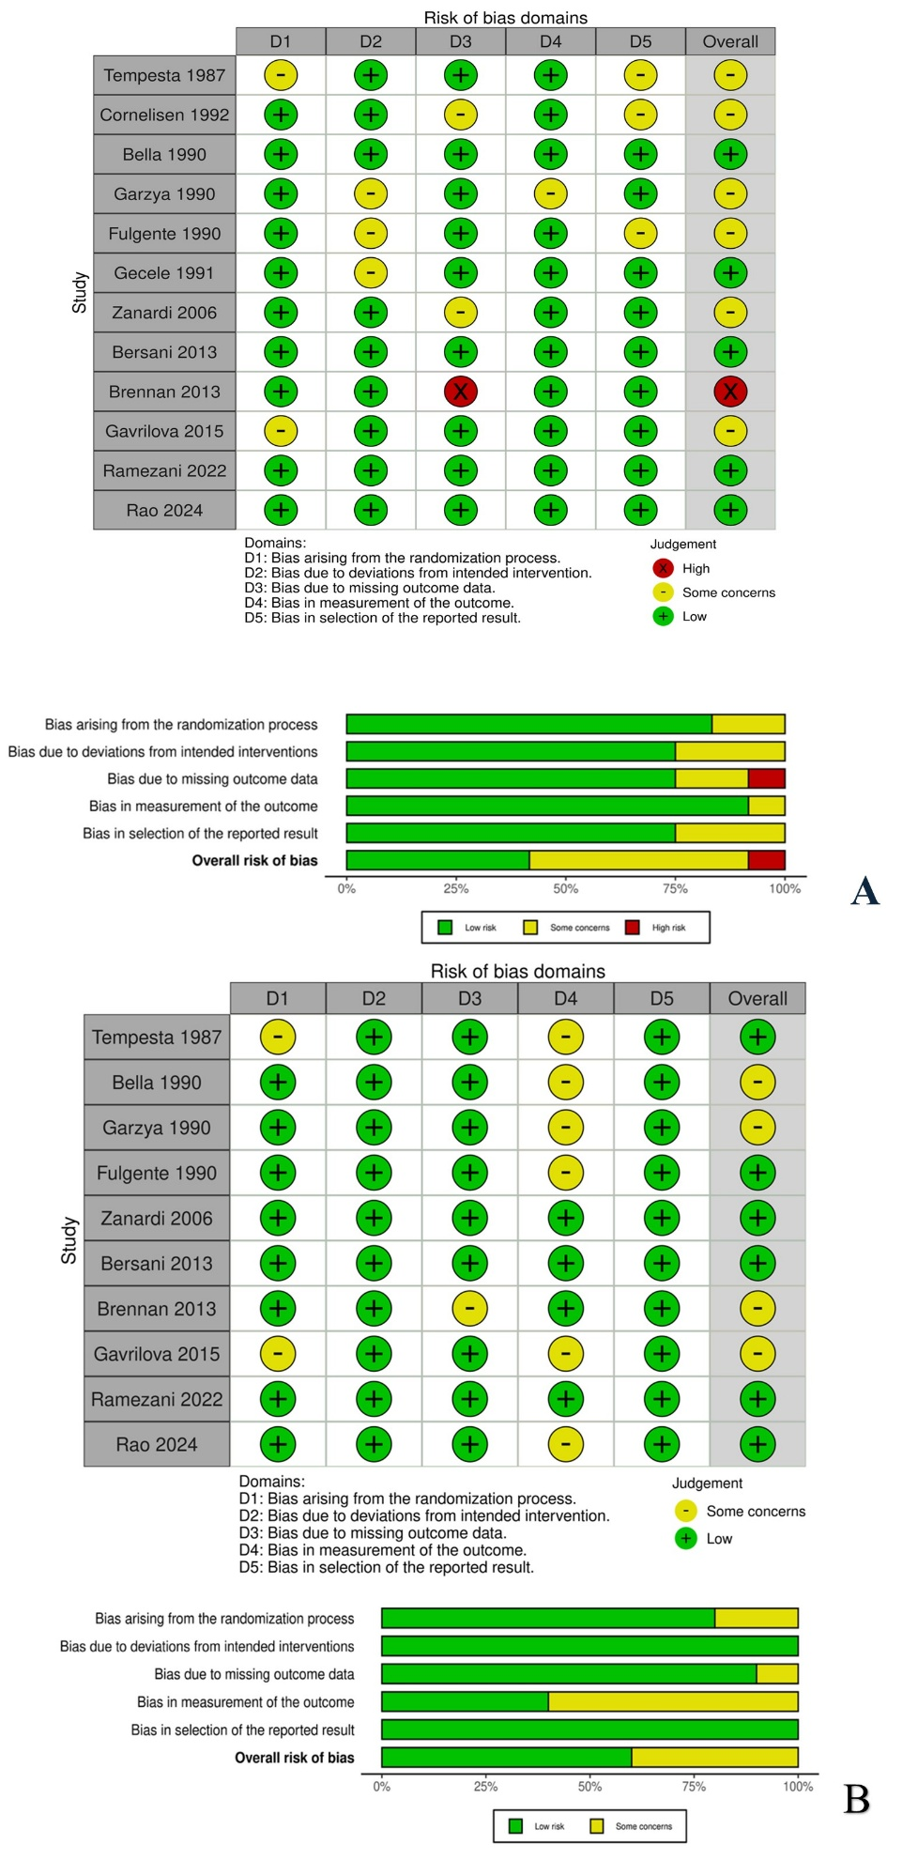

Figure S1: Risk of bias of efficacy outcomes (A) and safety outcomes (B) based on RoB 2 assessments across domains.

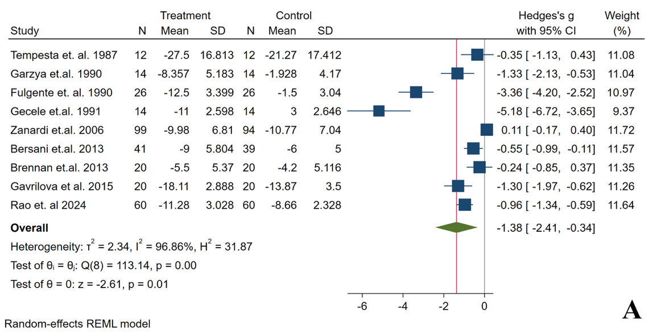
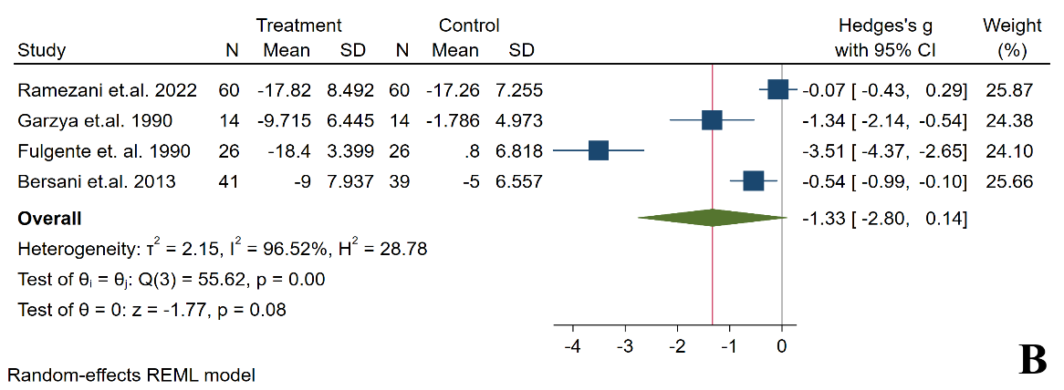
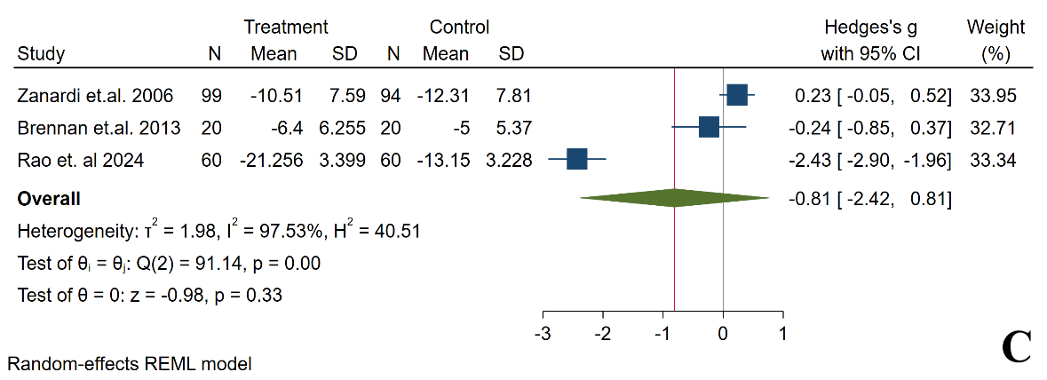
²⁸
²⁹
³²
²⁷
²⁶
⁴¹
¹³
¹⁴
³⁰
³¹
²⁷
²⁶
²⁹
¹³
¹⁴
⁴¹

Figure S2: Forest plots showing the effects of acetyl-L-carnitine on depression severity scores measured by Hamilton Depression Rating Scale (HDRS, A); Beck Depression Inventory (BDI, B); Montgomery–Åsberg Depression Rating Scale (MADRS, C).

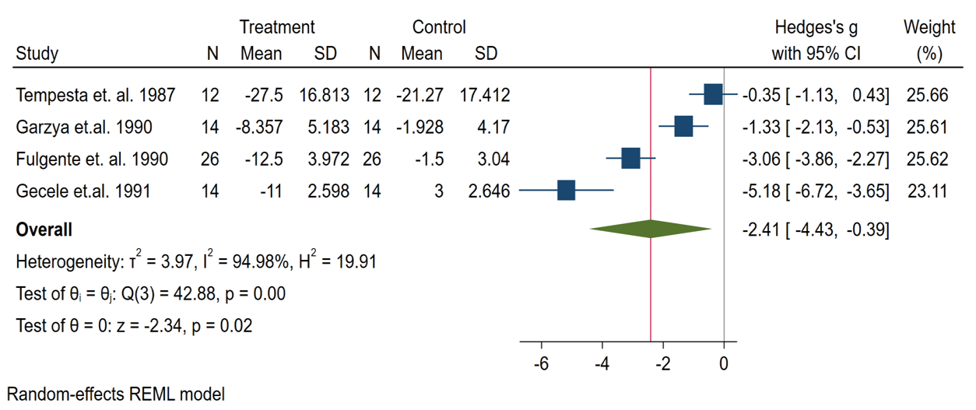
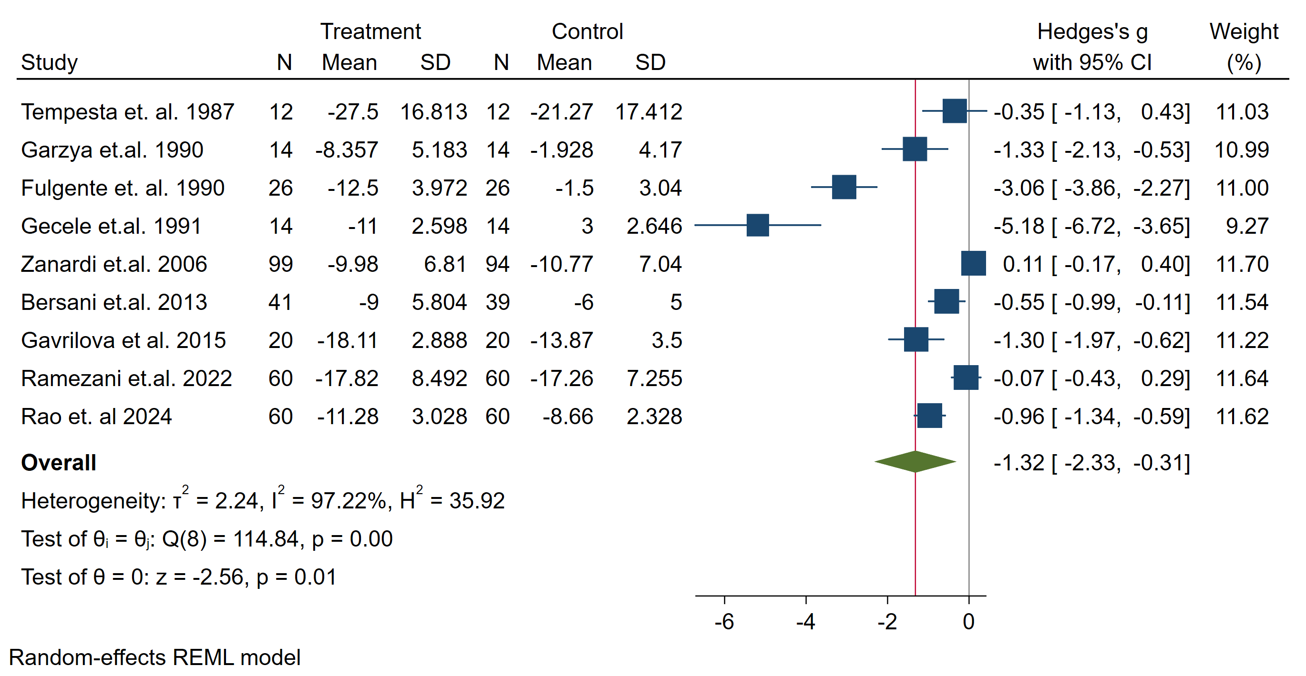
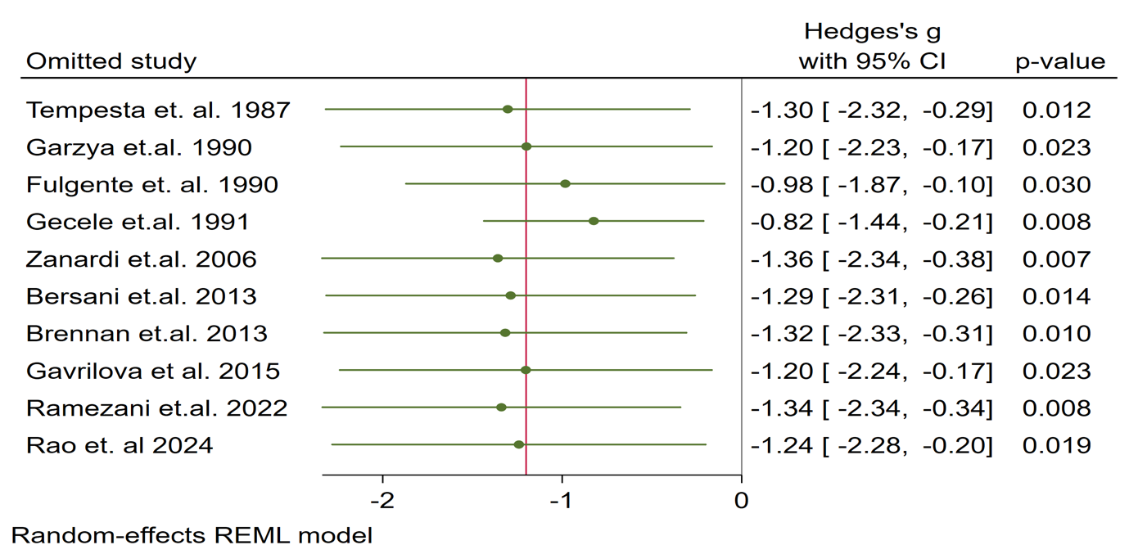
A
B
C

²⁸
²⁹
³²
²⁷
²⁶
⁴¹
³¹
¹³
³⁰
²⁸
²⁹
³²
²⁷
²⁶
⁴¹
³¹
¹³
¹⁴
³⁰
³²
²⁷
²⁶
²⁸

Figure S3: Sensitivity analysis including the studies comparing ALC monotherapy with placebo (A); Sensitivity analysis excluding the study with the high risk of bias (B); Sensitivity analysis using a leave-one-out approach (C).

Table S1a: Inclusion/Exclusion Criteria and Adverse Events
Authors (year) | Inclusion criteria | Exclusion criteria | Treatment/Comparator group | Adverse events
Villardita et. al. ³⁶ (1983) | - Geriatric patients  - Diagnosed with depression (criteria not specified) | - NA | ALC | NA
Villardita et. al. ³⁶ (1983) |  | - NA | Placebo | NA
Tempesta et. al. ³² (1987) | - Geriatric subjects over 70 years of age  - Resident in a nursing home | - Severe mental deterioration or acute stages of organic diseases  - Treatment with drugs acting on the CNS | ALC | No adverse events.
Tempesta et. al. ³² (1987) |  |  | Placebo | No adverse events.
Nasca et al. ³³ (1989) | - Aged population (55-70 years)  - Diagnosed with depression (criteria not specified) | - NA | Mianserine + ALC in the first 20 days then ALC alone | NA
Nasca et al. ³³ (1989) |  | - NA | Placebo + Mianserine for 20 days then placebo alone | NA
Bella et.al. ³⁴ (1990) | - Age range of 60-80  - Symptoms of chronic depression corresponding to those of Dysthymic Disturbances (classified by DSM III) | - Showing organic cerebral syndromes  - Physiological disturbances  - Serious systemic disorders  - Patients being treated with other drugs, potentially active on the central nervous system | ALC | No adverse events.
Bella et.al. ³⁴ (1990) |  |  | Placebo | No adverse events.
Garzya et.al. ²⁷ (1990) | - Aged between 70-80  - Diagnosis of depressive disturbance according to DSM III-R | - Organic cerebral syndromes (i.e. Alzheimer)  - Other organic illnesses  - Serious psychic disturbances undergoing treatment with other drugs, active (or potentially so) on the central nervous system | ALC | No significant difference between AEs in treatment and control group.
Garzya et.al. ²⁷ (1990) |  |  | Placebo
Fulgente et. al. ²⁶ (1990) | - Age range 70-80  - Chronic mood disturbance under the diagnosis of dysthymic disorder with DSM III-R criteria | - Any organic cerebral syndromes  - Severe systemic diseases or psychiatric disturbances other than dysthymic disorder  - Free of all centrally acting medication | ALC | No adverse events.
Fulgente et. al. ²⁶ (1990) |  |  | Placebo | No adverse events.
Gecele et.al. ²⁸ (1991) | - Aged between 66-79  - Meeting DSM III criteria for unipolar depression  - Hamilton Rating Scale for depression higher than 20 | - Not reported | ALC | NA
Gecele et.al. ²⁸ (1991) |  | - Not reported | Placebo | NA
Cornelissen et.al. ³⁵ (1992) | - Aged 66-79 years  - Meeting the DSM III-R criteria for unipolar major depression  - Hamilton Rating Scale for Depression higher than 20 | - Not reported. | ALC | NA
Cornelissen et.al. ³⁵ (1992) |  | - Not reported. | Placebo | NA
Pettegrew et.al. ¹⁵ (2002) | - Geriatric patients  - Major depressive disorder diagnosed according to DSM-IV criteria  - Non-demented  - Folstein Mini-Mental State Exam (MMSE) > 24 | - Not reported. | ALC | - ALC group: 1 patient reported dry mouth (GI); 1 patient reported slightly increased perspiration (skin and subcutaneous tissue)  - AEs not reported in placebo group.
Pettegrew et.al. ¹⁵ (2002) |  | - Not reported. | Placebo
Zanardi et.al. ¹³ (2006) | - Patients of both sexes, aged 18-60  - Dysthymic disorder according to DSM IV (APA 1994) (ICD9 code 300.4)  - HAM-D21 after placebo-run-in period ranging between 18 and 28 and HAM-D21 reduction during placebo-run-in period by 20% | - Patients with a superimposed major depression or any other DSM-IV diagnosis  - History of drug or alcohol abuse/dependence and/or with suicide risk  - Significant severe neurological or medical conditions | ALC | - No treatment-related AEs were reported in the treatment group.  - AEs occurred in ~10% (n=10) of treatment patients and ~30% (n=29) of comparator patients, with 3% (n=3) in the comparator group certainly related to treatment.  - Severe AEs occurred in 1 treatment patient and 3 comparator patients; 1 treatment patient experienced a serious AE (hospitalized due to diabetes complication and judged unrelated to treatment).  AEs reported in ≥ 2% of patients:  - ALC—CNS (n=2; 28%), GI (n=3; 42%), Endocrine (n=2; 28%);  - Amisulpride—CNS (n=4; 13%), GI (n=3; 10%), Endocrine (n=23; 76%).
Zanardi et.al. ¹³ (2006) |  |  | Amisulpride
Bersani et.al. ²⁹ (2013) | - Patients with DSM IV diagnosis of Dysthymic Disorder  - Age > 65 years  - Hamilton Depression Rating Scale total score between 18 and 45  - Absence of clinically significant cognitive impairment (Mini Mental State > 24)  - Elementary school education as minimum | - Diagnosis of schizophrenia or other psychotic disorders  - Diagnosis of organic mental syndromes  - Current suicidal ideation  - Diagnosis of panic disorder  - Obsessive-compulsive and dissociative disorders  - Somatic disorders, such as pathologies of endocrine system or renal failure, heart failure, alterations of liver function, diabetes mellitus, significant cardiac disturbances  - Recent history of drug abuse  - All conditions likely to compromise absorption, metabolism and excretion of drugs | ALC | - AEs occurred in 7 patients (17%) receiving ALC and 18 patients (46%) receiving fluoxetine.  - ALC group—CNS (n=19; 55%), GI (n=11; 32%), CVS (n=1; 2%), Skin (n=1; 2%), Other (n=2; 5%).  - Fluoxetine group—CNS (n=30; 53%), GI (n=19; 34%), CVS (n=2; 3%), Skin (n=2; 3%), Other (n=3; 5%); 3 patients (7%) experienced moderate/severe AEs.
Bersani et.al. ²⁹ (2013) |  |  | Fluoxetine
Brennan et.al. ¹⁴ (2013) | - Aged 18 to 55 years  - Meeting (DSM-IV) criteria for bipolar disorder (type I or II)  - Currently depressed  - Scoring greater than or equal to 20 on the MADRS at screening and baseline | - Inability to provide written informed consent  - History of schizophrenia or obsessive-compulsive disorder  - Active psychosis  - Active suicidality  - Alcohol or substance dependence (other than nicotine) within 3 months of enrollment  - Electroconvulsive therapy within 3 months of enrollment  - Positive urine drug screen for substances of abuse  - History of mitochondrial disorder  - Current pregnancy or lactating  - History of seizure disorder, organic brain disease, or clinically significant medical disease | ALC + Alpha-Lipoic Acid | - Treatment group AEs: GI (n=10; 52%), Urinary system (n=5; 26%), Skin (n=4; 21%).  - Control group AEs: GI (n=4; 66%), Urinary system (n=1; 16%), Other—acute chest pain, unrelated to cardiovascular system (n=1; 16%).  - Serious AEs: 1 in the treatment group (abdominal pain due to small bowel obstruction; unrelated to therapy); 1 in the control group (acute chest pain unrelated to CVS and placebo).
Brennan et.al. ¹⁴ (2013) |  |  | Placebo
Gavrilova et al. ³⁰ (2015) | - Aged >= 60 years [60-79]  - Mild to moderate depression with a major depressive episode (according to DSM-IV-TR, ICD-10 classification)  - Higher or secondary specialized education | - History of other mental disorders  - primary organic diseases | Venlafaxine, Agomelatine, Fluvoxamine, with ALC | - AEs reported in 7 patients (35%) in the treatment group and 9 patients (45%) in the placebo group.  - Treatment group AEs: CNS (n=8; 88%), CVS (n=1; 11%).  - Placebo group AEs: CNS (n=11; 57%), GI (n=1; 5%), CVS (n=7; 36%).  - No serious AEs reported.
Gavrilova et al. ³⁰ (2015) |  |  | Venlafaxine, Agomelatine, Fluvoxamine
Ramezani et.al. ³¹ (2022) | - Age ≥18 years  - Diagnosis of MDD based on DSM-5 diagnostic criteria through a clinical interview with a psychiatrist | - Presence of serious somatic disorders  - Substance abuse except for cigarettes and caffeine  - History of high mood (mania or hypomania), mental dysfunction, dementia, and acute psychiatric disorders according to the psychiatrist  - Medication that causes depression in the patient | ALC + Sertraline | - AEs were reported in 3 patients (10%). All were CNS AEs—restlessness, headache, insomnia (2 in the control group; 1 in the treatment group).
Ramezani et.al. ³¹ (2022) |  |  | Sertraline + Placebo
Rao et. al ⁴¹ (2024) | - Aged 18-65 years  - HAM-D17 scores ≥17 and diagnosed with mild to severe depression | - Bipolar affective disorder  - Schizophrenia,  - Pregnancy  - Significant medical disorders. | ALC + Agmatine + Standard of care | - A total of 39 AEs were reported in the treatment group: CNS (n=15; 38%), GI (n=23; 58%), Reproductive system (n=1; 2%).  - A total of 32 AEs were reported in the control group: CNS (n=11; 34%), GI (n=14; 43%), Reproductive system (n=7; 21%).
Rao et. al ⁴¹ (2024) |  |  | Standard of care
Adverse event (AE) systems were specified in advance, and trial-reported terms were standardized to those systems. Central nervous system (CNS): headache, dizziness, depression, anxiety, tremor, change in motor activity, agitation, sleeping disorders, asthenia, akathisia; Cardiovascular (CVS): hypotension, hypertension, tachycardia, peripheral edema; Urinary: Foul-smelling urine; Skin and subcutaneous tissue: rash, hyperhidrosis, sweating; Endocrine/metabolic: lactation, increased prolactin, weight gain; Gastrointestinal (GI): nausea, constipation, diarrhea, anorexia, dyspepsia, abdominal fulness, gastric discomfort, abdominal obstruction, xerostomia; Reproductive system: erectile dysfunction; Other: eye (cloady vista), acute chest pain unrelated to CVS, nasal congestion. Percentages are patient-level where available (patients with ≥1 AE divided by arm size); when only event counts were reported, percentages reflect the within-arm distribution of events. Abbreviations: ALC: acetyl-L-carnitine; DSM: Diagnostic and Statistical Manual of Mental Disorders; HAM-D: Hamilton Depression Rating Scale; NA: not available.

Appendix-1: Search Strategy
Original Searches performed October 24, 2022. Update performed December 10, 2024.
OVID
Database(s): Ovid MEDLINE(R) 1946 to Present and Epub Ahead of Print, In-Process & Other Non-Indexed Citations and Ovid MEDLINE(R) Daily, APA PsycInfo 1967 to October Week 3 2022 (Update December 2024 Week) , EBM Reviews - Cochrane Central Register of Controlled Trials September 2022 (Update November 2024), EBM Reviews - Cochrane Database of Systematic Reviews 2005 to October 19, 2022 (Update December 4, 2024), Embase 1974 to 2022 October 21 (Update 2024 Week 49)
Search Strategy:
# | Searches
1 | ("acetyl-l-carnitine" or "l-acetylcarnitine" or acetylcarnitine or (carnitine* adj1 acetyl*)).ti,ab,kf.
2 | acetylcarnitine/
3 | 1 or 2
4 | exp Depressive Disorder/
5 | exp Depression/
6 | Mood Disorders/
7 | *Antidepressive Agents/
8 | (depression or depressiv* or dysphoria or dysphoric or dysthymi*).ti,ab,kf.
9 | or/4-8
10 | 3 and 9
11 | (exp animals/ or exp nonhuman/) not exp humans/
12 | ((alpaca or alpacas or algae* or amphibian or amphibians or animal or animals or antelope or armadillo or armadillos or avian or baboon or baboons or bats or beagle or beagles or bee or bees or bird or birds or bison or bovine or buffalo or buffaloes or buffalos or "c elegans" or "Caenorhabditis elegans" or camel or camels or canine or canines or canis or carp or cats or catfish or cattle or chamaeleo* or chameleon* or chick or chicken or chickens or chicks or chimp or chimpanze or chimpanzees or chimps or cow or cows or "D melanogaster" or "dairy calf" or "dairy calves" or deer or dog or dogs or donkey or donkeys or drosophila or "Drosophila melanogaster" or duck or duckling or ducklings or ducks or equid or equids or equine or equines or feline or felines or ferret or ferrets or finch or finches or fish or flatworm or flatworms or fox or foxes or frog or frogs or "fruit flies" or "fruit fly" or "G mellonella" or "Galleria mellonella" or geese or gerbil or gerbils or goat or goats or goose or gorilla or gorillas or groundhog or groundhogs or hamster or hamsters or hare or hares or heifer or heifers or horse or horses or iguana or iguanas or insect or insects or jellyfish or kangaroo or kangaroos or kitten or kittens or "laboratory animal*" or lagomorph or lagomorphs or lamb or lambs or lemur or lemurs or lemuridae or llama or llamas or macaque or macaques or macaw or macaws or marmoset or marmosets or mice or minipig or minipigs or mink or minks or monkey or monkeys or mouse or mule or mules or muskrat or muskrats or nematode or nematodes or newt or newts or octopus or octopuses or orangutan or "orang-utan" or orangutans or "orang-utans" or oxen or parrot or parrots or pig or pigeon or pigeons or piglet or piglets or pigs or porcine or primate or primates or poultry or quail or rabbit or rabbits or rat or rats or reptile or reptiles or rodent or rodents or ruminant or ruminants or salmon or sheep or shrimp or slug or slugs or swine or tamarin or tamarins or tilapia or tilapias or toad or toads or trout or urchin or urchins or vole or voles or waxworm or waxworms or weasel or weasels or wolf or wolves or worm or worms or wrass* or xenopus or "zebra fish" or zebrafish) not (human or humans or patient or patients)).ti,ab,hw,kw.
13 | (rat or rats or mice or mouse or murine or pig or pigs or porcine or swine or dog or dogs).ti.
14 | or/11-13
15 | 10 not 14
16 | (conference abstract or conference review or editorial or erratum or note or addresses or autobiography or bibliography or biography or blogs or comment or dictionary or directory or interactive tutorial or interview or lectures or legal cases or legislation or news or newspaper article or patient education handout or periodical index or portraits or published erratum or video-audio media or webcasts).mp. or conference abstract.st.
17 | 15 not 16
18 | limit 17 to english language [Limit not valid in CDSR; records were retained]
19 | remove duplicates from 18

SCOPUS
1 | - TITLE-ABS-KEY (depression or depressiv* or dysphoria or dysphoric or dysthymi*)
2 | TITLE-ABS-KEY ("acetyl-l-carnitine" or "l-acetylcarnitine" or acetylcarnitine or (carnitine* W/1 acetyl*))
3 | 1 and 2
4 | INDEX(embase) OR INDEX(medline) OR PMID(0* OR 1* OR 2* OR 3* OR 4* OR 5* OR 6* OR 7* OR 8* OR 9*)
5 | 3 not 4
6 | DOCTYPE(ed) OR DOCTYPE(bk) OR DOCTYPE(er) OR DOCTYPE(no) OR DOCTYPE(sh) OR DOCTYPE(ch)
7 | 5 not 6
8 | LIMIT-TO ( LANGUAGE , "English" )

Web of Science
1 | TS=(depression or depressiv* or dysphoria or dysphoric or dysthymi*)
2 | TS=("acetyl-l-carnitine" or "l-acetylcarnitine" or acetylcarnitine or (carnitine* NEAR/1 acetyl*))
3 | 1 and 2
4 | PMID=(0* or 1* or 2* or 3* or 4* or 5* or 6* or 7* or 8* or 9*)
5 | 3 not 4
6 | Refined By:Languages: English and Refined By: Document Types: Article

