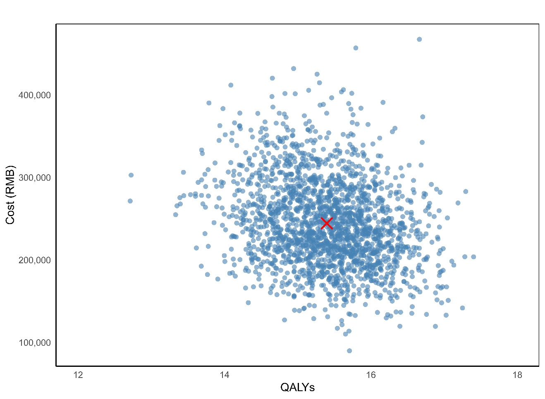
Figure S1. Probability sensitivity analysis result

Table S1. Markov Cost Analysis of Three-Tier Screening for CHD in Children in High-Altitude Regions.
 | Cost(RMB) | QALYs | ΔC(RMB) | ΔQALYs(RMB) | ICUR
Three-tier screening | 2604 | 0.060 | / | / | /
Rescreening + Diagnosis | 2694 | 0.055 | 90 | 0.00 | -20870
Diagnosis | 15400 | 0.001 | 12706 | -0.05 | -234137

Table S2. Markov Cost Analysis Parameters
Parameter | Base Value | Distribution | Distribution Parameters | Source
Screening test sensitivity | 0.92 | Beta | α=92, β=8 | Model assumption
Screening test specificity | 0.89 | Beta | α=89, β=11 | Model assumption
Probability of early detection | 0.30 | Beta | α=30, β=70 | Model assumption
Probability of late detection | 0.10 | Beta | α=10, β=90 | Model assumption
Annual transition: Symptomless→ Early-stage | 0.10 | Beta | α=10, β=90 | Literature^{[1]}
Annual transition: Symptomless → Late-stage | 0.05 | Beta | α=5, β=95 | Literature^{[1]}
Annual transition: Early → Late-stage | 0.20 | Beta | α=20, β=80 | Literature^{[1]}
Cost: Healthy | 200 | Gamma | shape=200²/40², scale=40²/200 | Local data
Cost: Early detection | 2,000 | Gamma | shape=2000²/400², scale=400²/2000 | Local data
Cost: Late detection | 20,000 | Gamma | shape=20000²/4000², scale=4000²/20000 | Local data
Utility: Healthy | 0.95 | Beta | α=95, β=5 | Literature^{[2]}
Utility: Early detection | 0.85 | Beta | α=85, β=15 | Literature^{[3]}
Utility: Late detection | 0.65 | Beta | α=65, β=35 | Literature^{[4]}
WTP threshold | 50,000 | Uniform | 0~50,000 | Literature^{[5]}

[1] SU Z H, LI S J, CHEN H W, et al. [Comparison of Trends in Congenital Heart Disease Mortality from 1990 to 2017 Between China and North America] [J]. 2021, 49(3):269-275.
[2] MILLER A, RIEHLE-COLARUSSO T, SIFFEL C, et al. Maternal age and prevalence of isolated congenital heart defects in an urban area of the United States [J]. 2011, 155(9):2137-2145.
[3] SANDBERG C, ENGSTROM K G, DELLBORG M, et al. The Level of Physical Exercise is Associated with Self-Reported Health Status (EQ-5D) in Adults with Congenital Heart Disease [J]. 2015, 22(2).
[4] GöHLER A, GEISLER B P, MANNE J M, et al. Utility Estimates for Decision–Analytic Modeling in Chronic Heart Failure—Health States Based on New York Heart Association Classes and Number of Rehospitalizations [J]. Value in Health, 2009, 12(1):185-187.
[5] LOU Y, WU Y, LI X, et al. Cost-effectiveness of Qiliqiangxin in HFrEF: adjunctive therapy vs. standard care from a Chinese healthcare perspective [J]. BMC Complement Med Ther, 2025, 25(1):437.

