Supplementary materials
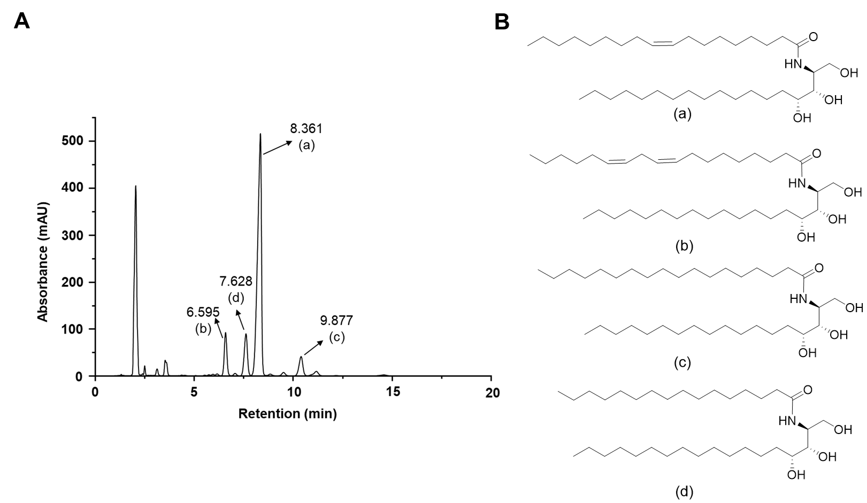
Supplementary Figures S1. HPLC analysis of MO-CER NPs. (A) HPLC chromatogram of MO-CER NPs. The retention times for N-linoleoyl-phytosphingosine (b), N-palmitoyl-phytosphingosine (d), N-oleoyl-phytosphingosine (a), and N-stearoyl-phytosphingosine (c) were 6.595, 7.628, 8.361 and 9.877 min, respectively. (B) Chemical structures of major CER NPs in MO-CER NPs.

Supplementary Figures S2. Impact of MO-CER NPs concentration on HaCaT cell viability. (A) Representative images of HaCaT cells treated with gradient diluted MO-CER NPs. (B) Measurement of HaCaT cells viability using the MTT assay.

