Supplementary Material

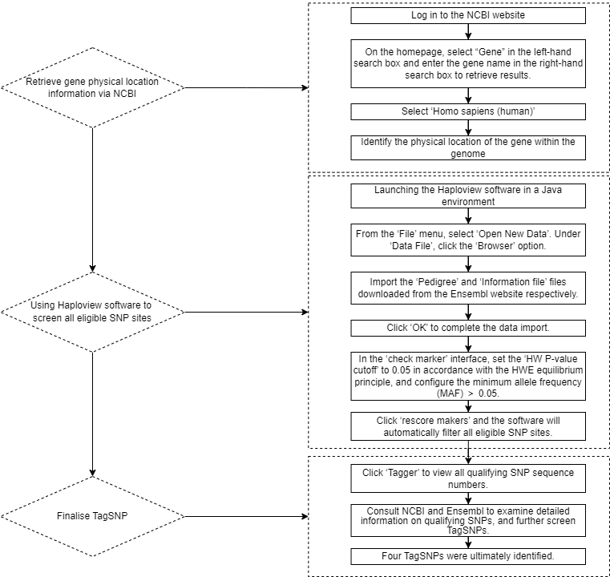
Supplementary Figure 1. TagSNP Selection Method.

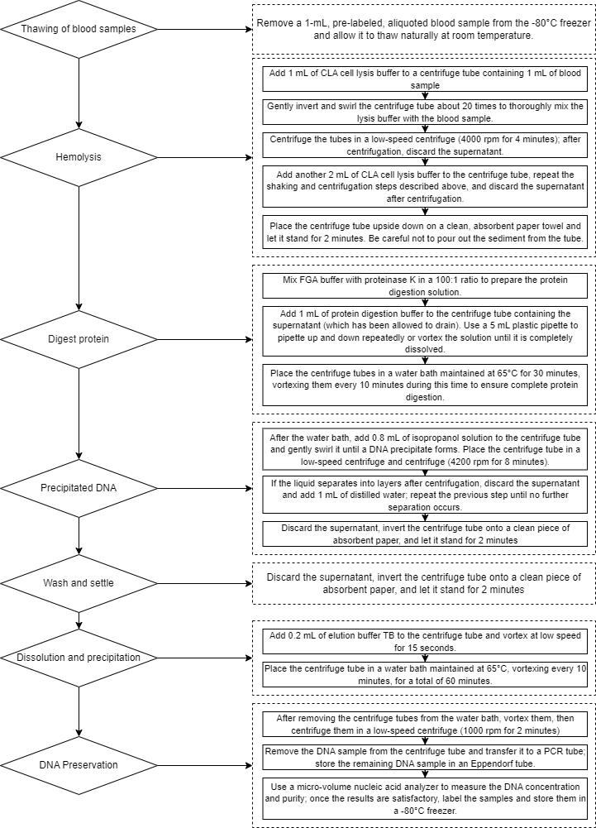
Supplementary Figure 2 DNA Extraction Flowchart

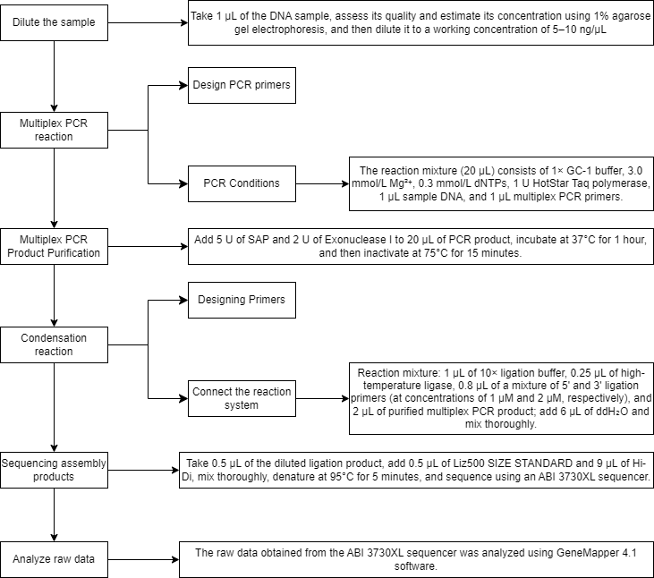
Supplementary Figure 3 MLDR Method for Multiple SNP Genotyping

Supplementary Table 1 Key reagents and consumables for the experiment
Reagent / Consumable | Manufacturer | Country/Region
Blood Genomic DNA Extraction System (DP349) | Tiangen Biotech | Beijing, China
PrimeScriptTM RT reagent Kit with gDNA Eraser | Takara Bio | Japan
TB Green Premix Ex TaqTM (Tli RNaseH Plus) | Takara Bio | Japan
Premix Ex Taq™ (Probe qPCR) | Takara Bio | Japan
DEPC-treated Water | COOLABER | Beijing, China
Absolute Ethanol | Fuyu Fine Chemical Co., Ltd. | Tianjin, China
Isopropanol | Fuyu Fine Chemical Co., Ltd. | Tianjin, China
Chloroform | Macklin | Shanghai, China
Centrifuge Tubes | Corning | USA
200 µL PCR Tubes | Labgic Technology Co., Ltd. | Beijing, China
96-Well PCR Plate | AXYGEN | USA
PCR Plate Sealing Film | Applied Biosystems | USA
RNA Extraction Solution | Wuhan Servicebio Technology Co., Ltd. | Wuhan, China
RNA Dissolution Solution | Wuhan Servicebio Technology Co., Ltd. | Wuhan, China

Supplementary Table 2 Major Laboratory Equipment
Instrument | Manufacturer | Country/Region
7900HT Fast Real-Time PCR System | Thermo Fisher Scientific | USA
StepOnePlus Real-Time PCR System | Thermo Fisher Scientific | USA
Thermal Cycler | Thermo Fisher Scientific | USA
BS-480 Automatic Biochemical Analyzer | Mindray Medical | Shenzhen, China
Refrigerator (4°C, -20°C) | SANYO | Japan
Low-Temperature Freezer (-20°C) | Changhong Meiling | Hefei, China
Ultra-Low Temperature Freezer (-80°C) | SANYO | Japan
Low-Speed Centrifuge | Zhongke Zhongjia Scientific Instrument | Anhui, China
High-Speed Centrifuge | Heima Medical Instrument | Zhuhai, China
High-Speed Refrigerated Centrifuge | Thermo Fisher Scientific | USA
SPIP-1000 Pipette | Wuhan Servicebio Technology Co., Ltd. | Wuhan, China
SPIP-200 Pipette | Wuhan Servicebio Technology Co., Ltd. | Wuhan, China
SPIP-100 Pipette | Wuhan Servicebio Technology Co., Ltd. | Wuhan, China
SPIP-10 Adjustable Pipette | Wuhan Servicebio Technology Co., Ltd. | Wuhan, China
SPIP-2.5 Adjustable Pipette | Wuhan Servicebio Technology Co., Ltd. | Wuhan, China
DYY-6C Electrophoresis Apparatus | Liuyi Instrument Factory | Beijing, China
NanoDrop® ND-1000 Microvolume UV-Vis Spectrophotometer | Thermo Fisher Scientific | USA
Fully Automatic Sample Rapid Grinder | Jingxin Technology Co., Ltd. | Shanghai, China
Constant Temperature Water Bath | Yiheng Technology Co., Ltd. | Shanghai, China
SM-F123 Ice Maker | SANYO | Japan
BS224S Electronic Balance | Sartorius | Germany
Autoclave Sterilizer | SANYO | Japan
Ultrapure Water Purification System | Millipore | USA
Clean Bench | Sujing Antai | Wuhan, China

EPAS1：
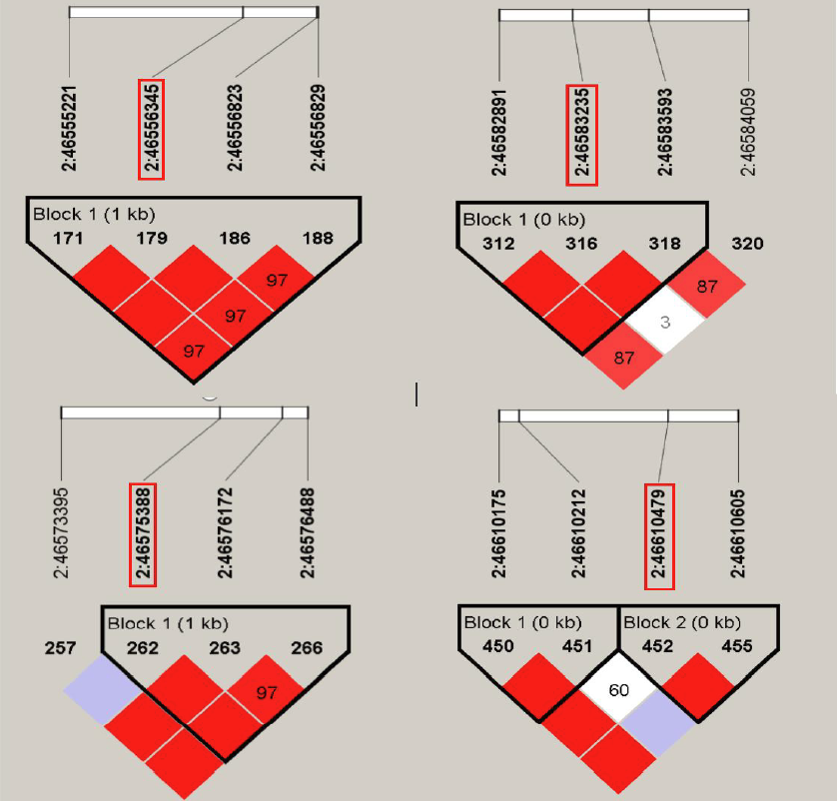
Supplementary Figure 4. EPAS1 Gene Linkage Inbalance Analysis Diagram.

Supplementary Table 3. Distribution of Demographic Characteristics in the EPAS1 Cohort.
Variables | Total | Case group, n (%)  n=517 |  | Control group, n (%)  n=580 | χ² | P | Power(1-β)
Gender
Male | 654 | 315 (60.9) |  | 339 (58.4) | 0.698 | 0.406 | 0.521
Female | 443 | 202 (39.1) |  | 241 (41.6) | 0.698 | 0.406
Age
≥60 | 569 | 334 (64.6) |  | 235 (40.5) | 63.521 | <0.001* | 1.000
<60 | 528 | 183 (35.4) |  | 345 (59.5) | 63.521 | <0.001*
Ethnicity
Han | 758 | 359 (69.4) |  | 399 (68.8) | 1.044 | 0.593 | 0.367
Tibetan | 317 | 150 (29.0) |  | 167 (28.8) | 1.044 | 0.593
Others | 22 | 8 (1.6) |  | 14 (2.4) | 1.044 | 0.593
Marital status
Married | 1012 | 470 (90.9) |  | 542 (93.5) | 4.476 | 0.107 | 0.995
Bereaved spouse | 54 | 33 (6.4) |  | 21 (3.6) | 4.476 | 0.107
Unmarried and divorced | 31 | 14 (2.7) |  | 17 (2.9) | 4.476 | 0.107
Educational level
Primary school and below | 708 | 350 (67.7) |  | 358 (61.7) | 4.630 | 0.099 | 0.972
Middle or High school | 345 | 150 (29.0) |  | 195 (33.6) | 4.630 | 0.099
College or above | 44 | 17 (3.3) |  | 27 (4.7) | 4.630 | 0.099
BMI
<18.5 | 29 | 16 (3.1) | 13 (2.2) |  | 1.965 | 0.374 | 0.745
18.5-23.9 | 446 | 218 (42.2) | 228 (39.3) |  | 1.965 | 0.374 | 0.745
≥24 | 622 | .0 283 (54.7) | 339 (58.5) |  | 1.965 | 0.374 | 0.745
Smoking
Yes | 368 | 178 (34.4) | 190 (32.8) |  | 0.342 | 0.559 | 0.218
No | 729 | 339 (65.6) | 390 (67.2) |  | 0.342 | 0.559 | 0.218
Note: *Statistically significant parameters.

Supplementary Table 4. Association of SNPs in EPAS1 with COPD Susceptibility.
Models | Genotypes | Case group, n (%) | Control group, n (%) | Pª | Adjusted OR (95%CI) ^{b} | P^{b} | Power(1-β) | FDR q^{c} | AIC
rs4953354A>G | AA | 329 (63.6) | 322 (55.5) | 0.012 |  |  |  |  | 1427.920
 | AG | 158 (30.6) | 227 (39.1) | 0.012 | 0.680(0.523-0.885) | 0.004* | 0.999 | 0.016 | 1427.920
Additive | GG | 30 (5.8) | 31 (5.3) | 0.012 | 0.909(0.529-1.562) | 0.730 | 0.154 |  | 1427.920
Dominant | AG+GG vs. AA | 188 (36.4) | 258 (44.5) | 0.006 | 0.708(0.551-0.910) | 0.007* | 0.999 |  | 1429.240
Recessive | GG vs. AA+AG | 487 (94.2) | 549 (94.7) | 0.741 | 1.048(0.615-1.784) | 0.864 | 0.287 |  | 1437.577
rs6743991C>A | CC | 8 (1.5) | 7 (1.2) | 0.769 |  |  |  |  | 1436.709
 | CA | 98 (19.0) | 103 (17.8) | 0.769 | 1.262(0.239-6.660) | 0.784 | 0.236 | 0.784 | 1436.709
Additive | AA | 411 (79.5) | 470 (81.0) | 0.769 | 1.166(0.225-6.034) | 0.855 | 0.853 |  | 1436.709
Dominant | CA+AAvs.CC | 509 (98.5) | 573 (98.8) | 0.628 | 1.183(0.229-6.118) | 0.841 | 0.914 |  | 1473.040
Recessive | AA vs. CC+CA | 106 (20.5) | 110 (19.0) | 0.523 | 0.930(0.680-1.271) | 0.647 | 0.135 |  | 1437.085
rs7589861A>G | AA | 304 (58.8) | 340 (58.6) | 0.806 |  |  |  |  | 1437.263
 | AG | 180 (34.8) | 208 (35.9) | 0.806 | 0.940(0.724-1.221) | 0.643 | 0.101 | 1.000 | 1437.263
Additive | GG | 33 (6.4) | 32 (5.5) | 0.806 | 1.082(0.638-1.835) | 0.769 | 0.154 |  | 1437.263
Dominant | AG+GG vs. AA | 213 (41.2) | 240 (41.4) | 0.952 | 0.959(0.748-1.231) | 0.744 | 0.052 |  | 1437.558
Recessive | GG vs. AA+AG | 484 (93.6) | 548 (94.5) | 0.544 | 1.108(0.659-1.861) | 0.699 | 0.239 |  | 1437.444
rs13419896G>A | GG | 196 (37.9) | 219 (37.8) | 0.841 |  |  |  |  | 1437.295
 | GA | 248 (48.0) | 272 (46.9) | 0.841 | 1.051(0.805-1.373) | 0.715 | 0.094 |  | 1437.295
Additive | AA | 73 (14.1) | 89 (15.3) | 0.841 | 0.923(0.633-1.345) | 0.677 | 0.185 | 0.903 | 1437.295
Dominant | GA+AAvs.GG | 321 (62.1) | 361 (62.2) | 0.959 | 1.019(0.792-1.312) | 0.883 | 0.051 |  | 1437.620
Recessive | AA vs. GG+GA | 444 (85.9) | 491 (84.7) | 0.568 | 0.898(0.635-1.270) | 0.542 | 0.153 |  | 1437.382
Notes: *Statistically significant parameters. ªχ²test.^{b}Logistic regression after correction gender, age, smoking status. .^{c.} FDR q-values were calculated using the Benjamini-Hochberg procedure.
Abbreviations: OR, Odds Ratio; CI, confidence interval; AIC, Akachi Information Criterion

Supplementary Table 5 Stratification Analysis and Interaction Analysis Between EPAS1 rs4953354A>G and COPD Susceptibility
 |  |  | Variables | Case Group |  |  |  |  | Control Group |  |  | AG+GG vs. AA |  |  |  |  |  |  | P Inter ^{d}
 |  |  | Variables | AA, n (%) |  |  |  | AG+GG, n (%) | AA, n (%) | AG+GG, n (%) |  | OR (95% CI) ª |  | P Homo ^{b} |  | CMH OR (95%CI) ^{c} |  | P CMH ^{c}
 |  |  | Gender
 |  |  | Male | 204(64.8) |  |  |  | 111(35.2) | 189(55.8) | 150(44.2) |  | 0.686(0.500-0.940) |  |  | 0.688 | 0.714(0.560-0.911) |  | 0.007 | 0.688
 |  |  | Female | 125(61.9) |  |  |  | 77(38.1) | 133(55.2) | 108(44.8) |  | 0.759(0.518-1.110)
 |  |  | Age
 |  |  | ≤60 | 117(63.9) |  |  |  | 66(36.1) | 194(56.2) | 151(43.8) |  | 0.725(0.501-1.048) |  |  | 0.841 | 0.705(0.549-0.905) |  | 0.006 | 0.841
 |  |  | >60 | 212(63.5) |  |  |  | 122(36.5) | 128(54.5) | 107(45.5) |  | 0.688(0.490-0.967)
 |  |  | Ethnic Groups
 |  | Han |  | 228(63.5) |  |  |  | 131(36.5) | 227(56.9) | 172(43.1) |  | 0.758(0.566-1.016) |  |  | 0.151 | 0.715(0.561-0.911) |  | 0.007 | 0.140
 |  | Tibetan |  | 98(65.3) |  |  |  | 52(34.7) | 86(51.5) | 81(48.5) |  | 0.563(0.358-0.886)
 |  | Others |  | 3(37.5) |  |  |  | 5(62.5) | 9(64.3) | 5(35.7) |  | 3.000(0.495-18.169)
 |  | BMI
 |  | <18.5 |  | 12(75.0) |  |  |  | 4(25.0) | 6(46.2) |  | 7(53.8) | 0.286(0.059-1.375) |  |  | 0.386 | 0.713(0.559-0.909) |  | 0.006 | 0.215
 |  | 18.5-23.9 |  | 139(63.8) |  |  |  | 79(36.2) | 122(53.5) |  | 106(46.5) | 0.654(0.448-0.956)
 |  | ≥24 |  | 178(62.9) |  |  |  | 105(37.1) | 194(57.2) |  | 145(42.8) | 0.789(0.571-1.090)
 | Education level
 | Primary school or below |  |  |  | 221(63.1) |  | 129(36.9) |  | 189(52.8) |  | 169(47.2) |  | 0.653(0.483-0.881) |  | 0.566 |  | 0.705(0.553-0.899) | 0.005 |  | 0.357
 | Middle or High school |  |  |  | 95(65.3) |  | 52(34.7) |  | 116(59.5) |  | 79(40.5) |  | 0.779(0.501-1.211)
 | College or above |  |  |  | 10(58.8) |  | 7 (41.2) |  | 17(63.0) |  | 10(37.0) |  | 1.190(0.344-4.121)
Marital status
Married |  |  |  |  |  | 302(63.0) |  | 177(37.0) | 310(56.2) |  | 242(43.8) |  | 0.751(0.584-0.964) |  | 0.072 |  | 0.713(0.559-0.908) | 0.006 |  | 0.999
Bereaved spouse |  |  |  |  |  | 22(66.7) |  | 11(33.3) | 10(47.6) |  | 11(52.4) |  | 0.455(0.148-1.395)
Unmarried & Divorced |  |  |  |  |  | 5 |  | 0 | 2(28.6) |  | 5(71.4)
 |  |  | Smoking status
 |  |  | Yes | 112(62.9) |  |  |  | 66(37.1) | 111(58.4) |  | 79(41.6) |  | 0.828(0.544-1.259) |  | 0.396 | 0.714(0.560-0.910) |  | 0.007 | 0.396
 |  |  | No | 217(64.0) |  |  |  | 122 (36.0) | 211(54.1) |  | 179(45.9) |  | 0.663(0.492-0.893)
Notes: ª Adjusted logistic regression model analysis for gender, age, smoking, etc. ^{b} Breslow-Day test of heteroscedasticity. ^{c} Cochran-Mantel-Haenszel test. ^{d} Multiplicative interaction.
Abbreviations: OR, Odds Ratio; CI, confidence interval; BMI, Body mass index.

VEGFA:
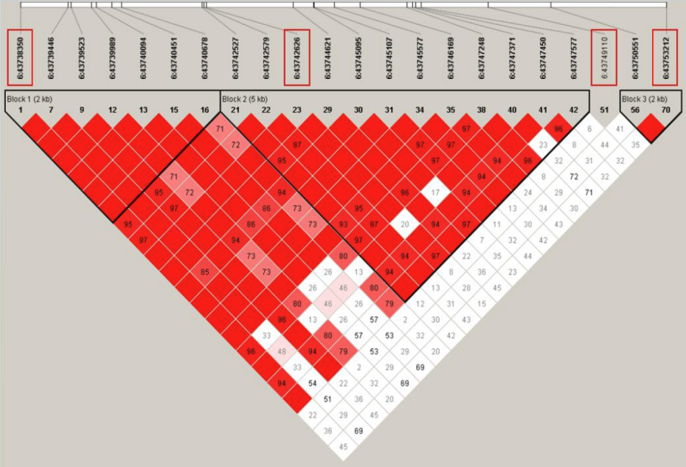
Supplementary Figure 5. VEGFA Gene Linkage Inbalance Analysis Diagram.

Supplementary Table 6. Distribution of Demographic Characteristics in the VEGFA Cohort (Tibetan).
Tibetan | Total | Case Group, n (%)  n=148 | Control Group, n (%)  n=251 | χ² | P | Power(1-β)
Gender |  |  |  | 6.898 | 0.009* | 0.999
Male | 179 | 79(53.4) | 100(39.8)
Female | 220 | 69(46.6) | 151(60.2)
Age |  |  |  | 18.676 | <0.001* | 1.000
≤60 | 241 | 69(46.6) | 172(68.5)
>60 | 158 | 79(53.4) | 79(31.5)
BMI |  |  |  | 0.028 | 0.986 | 0.059
<18.5 | 14 | 5(3.4) | 9(3.6)
18.5-23.9 | 168 | 63(42.6) | 105(41.8)
≥24.0 | 217 | 80(54.1) | 137(54.6)
Education level |  |  |  | 2.301 | 0.317 | 0.794
Primary school or below | 238 | 95(64.2) | 143(57.0)
Middle or High school | 71 | 25(16.9) | 46(18.3)
College and above | 90 | 28(18.9) | 62(24.7)
Marital status |  |  |  | 6.420 | 0.063 | 0.999
Married | 364 | 130(87.8) | 234(93.2)
Unmarried and Divorced | 5 | 1(0.7) | 4(1.6)
Bereaved spouse | 30 | 17(11.5) | 13(5.2)
Smoking |  |  |  | 10.771 | <0.001* | 1.000
Yes | 115 | 57(38.5) | 58(23.1)
No | 284 | 91(61.5) | 193(76.9)
Note: *Statistically significant parameters.

Supplementary Table 7. Distribution of Demographic Characteristics in the VEGFA Cohort (Han).
Han | Total | Case Group, n (%)  n=249 | Control Group, n (%)  n=556 | χ² | P | Power(1-β)
Gender |  |  |  | 20.009 | <0.001* | 0.999
Male | 403 | 154(61.8) | 249(44.8)
Female | 402 | 95(38.2) | 307(55.2)
Age |  |  |  | 60.289 | <0.001* | 1.000
≤60 | 508 | 108(43.4) | 400(71.9)
>60 | 297 | 141(56.6) | 156(28.1)
BMI |  |  |  | 3.85 | 0.146 | 0.882
<18.5 | 20 | 10(4.0) | 10(1.8)
18.5-23.9 | 329 | 104(41.8) | 225(40.5)
≥24.0 | 456 | 135(54.2) | 321(57.7)
Education level |  |  |  | 0.855 | 0.652 | 0.222
Primary school or below | 273 | 88(35.3) | 185(33.3)
Middle or High school | 245 | 78(31.3) | 167(30.0)
College and above | 287 | 83(33.3) | 204(36.7)
Marital status |  |  |  | 5.781 | 0.118 | 0.938
Married | 759 | 230(92.4) | 529(95.1)
Unmarried and Divorced | 7 | 1(0.4) | 6(1.1)
Bereaved spouse | 39 | 18(7.2) | 21(3.8)
Smoking |  |  |  | 12.752 | <0.001* | 0.999
Yes | 311 | 119(47.8) | 192(34.5)
No | 494 | 130(52.2) | 364(65.5)
Note: *Statistically significant parameters.

Supplementary Table 8 Association of SNPs in VEGFA with COPD Susceptibility(Han).
Models | Genotypes | Case Group, n(%) | Control Group, n (%) | Pª | Adjusted OR (95%CI) ^{b} | P^{b} | Power(1-β) | FDR q^{c} | AIC
rs10434A>G | AA | 12(4.8) | 26(4.7) | 0.307 |  |  |  |  | 993.529
 | AG | 89(35.7) | 169(30.4) | 0.307 | 0.848(0.392-1.835) | 0.675 | 0.080 | 0.675 | 993.529
Additive | GG | 148(59.4) | 361(64.9) | 0.307 | 1.118(0.528-2.366) | 0.770 | 0.150 |  | 993.529
Dominant | AG+GG vs. AA | 237(95.2) | 530(95.3) | 0.930 | 1.017(0.485-2.132) | 0.964 | 0.054 |  | 995.862
Recessive | GG vs. AA+AG | 101(40.5) | 195(35.1) | 0.136 | 1.292(0.935-1.785) | 0.121 | 0.845 |  | 993.656
rs2010963C>G | CC | 60(24.1) | 93(16.7) | 0.045 |  |  |  |  | 989.857
 | CG | 116(46.6) | 277(49.8) | 0.045 | 1.619(1.070-2.449) | 0.022* | 0.998 |  | 989.857
Additive | GG | 73(29.3) | 186(33.5) | 0.045 | 1.751(1.119-2.740) | 0.014* | 0.999 | 0.028 | 989.857
Dominant | CG+GGvs.CC | 189(75.9) | 463(83.3) | 0.014 | 1.670(1.133-2.462) | 0.010* | 0.966 |  | 989.992
Recessive | GG vs. CC+CG | 176(70.7) | 370(66.5) | 0.246 | 1.246(0.884-1.756) | 0.209 | 0.408 |  | 994.509
rs3025020C>T | CC | 114(45.8) | 212(38.1) | 0.006 |  |  |  |  | 984.896
 | CT | 114(45.8) | 253(45.5) | 0.006 | 1.127(0.805-1.578) | 0.485 | 0.561 |  | 984.896
Additive | TT | 21(8.4) | 91(16.4) | 0.006 | 2.290(1.321-3.971) | 0.003* | 0.999 | 0.012 | 984.896
Dominant | CT+TT vs.CC | 135(54.2) | 344(61.9) | 0.041 | 1.306(0.948-1.799) | 0.102 | 0.996 |  | 991.715
Recessive | CT+CC vs TT | 228(91.6) | 465(83.6) | 0.003 | 2.151(1.276-3.626) | 0.004* | 0.999 |  | 986.089
rs833070T>C | TT | 12(4.8) | 32(5.8) | 0.617 |  |  |  |  | 994.897
 | TC | 80(32.1) | 193(34.7) | 0.617 | 0.702(0.332-1.485) | 0.354 | 0.081 |  | 994.897
Additive | CC | 157(63.1) | 331(59.5) | 0.617 | 0.629(0.305-1.300) | 0.211 | 0.364 | 0.281 | 994.897
Dominant | CC+TCvs.TT | 237(95.2) | 524(94.2) | 0.590 | 0.654(0.320-1.338) | 0.245 | 0.223 |  | 995.572
Recessive | CC vs. TT+TC | 92(36.9) | 225(40.5) | 0.345 | 0.853(0.616-1.180) | 0.336 | 0.412 |  | 994.974
Notes: *Statistically significant parameters. ªχ²test.^{b}Logistic regression after correction gender, age, smoking status. .^{c.} FDR q-values were calculated using the Benjamini-Hochberg procedure.
Abbreviations: OR, Odds Ratio; CI, confidence interval; AIC, Akachi Information Criterion.

Supplementary Table 9. Association of SNPs in VEGFA with COPD Susceptibility(Tibetan).
Models | Genotypes | Case Group, n (%) | Control Group, n (%) | Pª | Adjusted OR (95%CI) ^{b} | P^{b} | Power(1-β) | FDR q^{c} | AIC
rs10434A>G | AA | 5(3.4) | 9(3.6) | 0.854 |  |  |  |  | 525.925
 | AG | 50(33.8) | 78(31.1) | 0.854 | 0.702(0.212-2.324) | 0.563 | 0.068 | 0.563 | 525.925
Additive | GG | 93(62.8) | 164(65.3) | 0.854 | 0.785(0.244-2.523) | 0.684 | 0.051 |  | 525.925
Dominant | AG+GG vs. AA | 143(96.6) | 242(96.4) | 0.913 | 0.756(0.237-2.408) | 0.636 | 0.175 |  | 526.227
Recessive | GG vs. AA+AG | 55(37.2) | 87(34.7) | 0.614 | 1.079(0.696-1.674) | 0.734 | 0.133 |  | 525.986
rs2010963C>G | CC | 28(18.9) | 36(14.3) | 0.485 |  |  |  |  | 524.815
 | CG | 76(51.4) | 136(54.2) | 0.485 | 1.428(0.790-2.583) | 0.238 | 0.687 |  | 524.815
Additive | GG | 44(29.7) | 79(31.5) | 0.485 | 1.570(0.823-2.992) | 0.171 | 0.657 | 0.342 | 524.815
Dominant | CG+GGvs.CC | 120(81.1) | 215(85.7) | 0.230 | 1.478(0.839-2.603) | 0.176 | 0.821 |  | 524.815
Recessive | GG vs. CC+CG | 104(70.3) | 172(68.5) | 0.716 | 1.195(0.753-1.897) | 0.449 | 0.072 |  | 526.106
rs3025020C>T | CC | 47(31.8) | 107(42.6) | 0.072 |  |  |  |  | 520.952
 | CT | 76(51.4) | 102(40.6) | 0.072 | 0.530(0.329-0.853) | 0.009* | 0.997 | 0.036 | 520.952
Additive | TT | 25(16.9) | 42(16.7) | 0.072 | 0.695(0.372-1.298) | 0.253 | 0.620 |  | 520.952
Dominant | CT+TTvs.CC | 101(68.2) | 144(57.4) | 0.032 | 0.571(0.365-0.893) | 0.014* | 0.993 |  | 521.538
Recessive | CT+CCvs.TT | 123(83.1) | 209(83.3) | 0.967 | 0.985(0.562-1.727) | 0.959 | 0.051 |  | 526.237
rs833070T>C | TT | 7(4.7) | 6(2.4) |  |  |  |  |  | 524.631
 | TC | 53(35.8) | 95(37.8) | 0.434 | 2.262(0.695-7.367) | 0.175 | 0.894 | 0.342 | 524.631
Additive | CC | 88(59.5) | 150(59.8) |  | 2.140(0.668-6.857) | 0.200 | 0.679 |  | 524.631
Dominant | CC+TCvs.TT | 141(95.3) | 245(97.6) | 0.212 | 2.189(0.693-6.917) | 0.182 | 0.989 |  | 524.684
Recessive | CC vs. TT+TC | 60(40.5) | 101(40.2) | 0.953 | 1.012(0.657-1.558) | 0.957 | 0.069 |  | 526.235
Notes: *Statistically significant parameters. ªχ²test.^{b}Logistic regression after correction gender, age, smoking status. ^{c.} FDR q-values were calculated using the Benjamini-Hochberg procedure.
Abbreviations: OR, Odds Ratio; CI, confidence interval; AIC, Akachi Information Criterion.

Supplementary Table 10 Stratification Analysis and Interaction Analysis Between VEGFA rs2010963C>G(HAN) and COPD Susceptibility
Variables | Case Group (n=249) |  | Control Group (n=556) |  | CG+GG vs.CC |  |  |  | P Inter ^{d}
Variables | CC, n (%) | CG+GG, n (%) | CC, n (%) | CG+GG, n (%) | OR (95%CI) ª | P Homo ^{b} | CMH OR (95%CI) ^{c} | P CMH ^{c} | P Inter ^{d}
Gender
Male | 37(24.0) | 117(76.0) | 40(16.1) | 209(83.9) | 0.605(0.367-0.999) | 0.841 | 0.626(0.432-0.908) | 0.013 | 0.841
Female | 23(24.2) | 72(75.8) | 53(17.3) | 254(82.7) | 0.653(0.375-1.138)
Age
≤60 | 28(26.0) | 80(74.0) | 69(17.2) | 331(82.8) | 0.596(0.360-0.984) | 0.921 | 0.606(0.413-0.888) | 0.010 | 0.921
>60 | 32(22.7) | 109(77.3) | 24(15.3) | 132(84.7) | 0.619(0.344-1.114)
BMI
<18.5 | 2(20.0) | 8(80.0) | 3(30.0) | 7(70.0) | 1.714(0.219-13.406) | 0.619 | 0.637(0.441-0.918) | 0.015 | 0.629
18.5-23.9 | 24(23.0) | 80(77.0) | 35(15.5) | 190(84.5) | 0.614(0.343-1.098)
≥24 | 34(25.1) | 101(74.9) | 55(17.1) | 266(82.9) | 0.614(0.378-0.998)
Education level
Primary school or below | 21(23.8) | 67(76.2) | 27(14.5) | 158(85.5) | 0.545(0.288-1.032) | 0.506 | 0.632(0.438-0.912) | 0.014 | 0.507
Middle or High school | 22(28.2) | 56(71.8) | 29(17.3) | 138(82.7) | 0.535(0.283-1.010)
College or above | 17(20.4) | 66(79.6) | 37(18.1) | 167(81.9) | 0.860(0.453-1.633)
Marital status
Married | 53(23.0) | 177(77.0) | 90(17.0) | 439(83.0) | 0.685(0.467-1.003) | 0.036 | 0.621(0.430-0.898) | 0.011 | 0.170
Bereaved spouse | 7(38.8) | 11(61.2) | 1(4.7) | 20(95.3) | 0.079(0.009-0.724)
Unmarried & Divorced | 0 | 1 | 2(33.3) | 4(66.7)
Smoking status
Yes | 31(26.0) | 88(74.0) | 29(15.1) | 163(84.9) | 0.505(0.286-0.892) | 0.315 | 0.629(0.434-0.911) | 0.014 | 0.315
No | 29(22.3) | 101(77.7) | 64(17.5) | 300(82.5) | 0.743(0.454-1.217)
Notes: ª Adjusted logistic regression model analysis for gender, age, smoking, etc. ^{b} Breslow-Day test of heteroscedasticity. ^{c} Cochran-Mantel-Haenszel test. ^{d} Multiplicative interaction.
Abbreviations: OR, Odds Ratio; CI, confidence interval; BMI, Body mass index.

Supplementary Table 11 Stratification Analysis and Interaction Analysis Between VEGFA rs3025020C>T(Tibetan) and COPD Susceptibility
Variables | Case Group (n=148) |  | Control Group (n=251) |  | CT+TT vs.CC |  |  |  | P Inter ^{d}
Variables | CC, n (%) | CT+TT, n (%) | CC, n (%) | CT+TT, n (%) | OR (95%CI) ª | P Homo ^{b} | CMH OR (95%CI) ^{c} | P CMH ^{c} | P Inter ^{d}
Gender
Male | 26(32.9) | 53(67.1) | 42(42.0) | 58(58.0) | 1.476(0.798-2.730) | 0.721 | 1.600(1.040-2.462) | 0.032 | 0.721
Female | 21(30.4) | 48(69.6) | 65(43.0) | 86(57.0) | 1.728(0.9433.165)
Age
≤60 | 17(24.6) | 52(75.4) | 73(42.4) | 99(57.6) | 2.255(1.207-4.216) | 0.184 | 1.693(1.089-2.632) | 0.019 | 0.185
>60 | 30(37.9) | 49(62.1) | 34(43.0) | 45(57.0) | 1.234(0.653-2.332)
BMI
<18.5 | 1(20.0) | 4(80.0) | 5(55.5) | 4(44.5) | 5.000(0.388-64.387) | 0.111 | 1.590(1.039-2.432) | 0.031 | 0.115
18.5-23.9 | 25(39.6) | 38(60.4) | 41(39.0) | 67(61.0) | 0.974(0.514-1.845)
≥24 | 21(26.2) | 59(73.8) | 61(44.5) | 76(55.5) | 2.255(1.236-4.114)
Education level
Primary school or below | 30(31.5) | 65(68.5) | 61(42.6) | 82(57.4) | 1.612(0.935-2.780) | 0.991 | 1.594(1.039-2.446) | 0.032 | 0.991
Middle or High school | 8(32.0) | 17(68.0) | 19(41.3) | 27(58.7) | 1.495(0.537-4.168)
College or above | 9(32.1) | 19(67.9) | 27(43.5) | 35(56.5) | 1.629(0.637-4.163)
Marital status
Married | 39(30.0) | 91(70.0) | 101(43.1) | 133(56.9) | 1.772(1.123-2.795) | 0.235 | 1.633(1.059-2.516) | 0.026 | 0.499
Bereaved spouse | 8(47.0) | 9(53.0) | 5(38.4) | 8(61.6) | 0.703(0.162-3.052)
Unmarried & Divorced | 0 | 1 | 1(25.0) | 3(75.0)
Smoking status
Yes | 22(38.5) | 35(61.5) | 25(43.1) | 33(56.9) | 1.205(0.572-2.538) | 0.305 | 1.658(1.073-2.562) | 0.022 | 0.306
No | 25(27.4) | 66(72.6) | 82(42.4) | 111(57.6) | 1.950(1.135-3.352)
Notes: ª Adjusted logistic regression model analysis for gender, age, smoking, etc. ^{b} Breslow-Day test of heteroscedasticity. ^{c} Cochran-Mantel-Haenszel test. ^{d} Multiplicative interaction.
Abbreviations: OR, Odds Ratio; CI, confidence interval; BMI, Body mass index.

Variables | Case Group (n=249) |  | Control Group (n=556) |  | TT vs. CC+CT |  |  |  | P Inter ^{d}
Variables | TT, n (%) | CC+CT, n (%) | TT, n (%) | CC+CT, n (%) | OR (95%CI) ª | P Homo ^{b} | CMH OR (95%CI) ^{c} | P CMH ^{c} | P Inter ^{d}
Gender
Male | 14(9.0) | 140(91.0) | 45(18.0) | 204(82.0) | 2.206(1.166-4.172) | 0.993 | 2.210(1.332-3.666) | 0.002 | 0.993
Female | 7(7.3) | 88(92.7) | 46(14.9) | 261(85.1) | 2.216(0.965-5.087)
Age
≤60 | 9(8.3) | 99(91.7) | 68(17.0) | 332(83.0) | 2.253(1.085-4.678) | 0.716 | 2.065(1.230-3.468) | 0.005 | 0.717
>60 | 12(8.5) | 129(91.5) | 23(14.7) | 133(85.3) | 1.859(0.888-3.892)
BMI
<18.5 | 0(0.0) | 10(100.0) | 3(30.0) | 7(70.0) | 0.700(0.467-1.050) | 0.242 | 2.106(1.280-3.466) | 0.003 | 0.636
18.5-23.9 | 6(5.7) | 98(94.3) | 33(14.6) | 192(85.4) | 2.807(1.138-6.927)
≥24 | 15(11.1) | 120(88.9) | 55(17.1) | 266(82.9) | 1.654(0.899-3.045)
Education level
Primary school or below | 10(11.3) | 78(88.7) | 33(17.8) | 152(82.2) | 1.693(0.793-3.615) | 0.725 | 2.150(1.302-3.552) | 0.002 | 0.727
Middle or High school | 6(7.6) | 72(92.4) | 28(16.7) | 139(83.3) | 2.417(0.957-6.105)
College or above | 5(6.0) | 78(94.0) | 30(14.7) | 174(85.3) | 2.690(1.006-7.193)
Marital status
Married | 21(9.1) | 209(90.9) | 84(15.8) | 445(84.2) | 1.879(1.133-3.115) | 0.067 | 2.104(1.280-3.457) | 0.003 | 1.000
Bereaved spouse | 0(0.0) | 18(100.0) | 6(28.5) | 15(71.5) | 0.714(0.545-0.936)
Unmarried & Divorced | 0 | 1 | 1(16.7) | 5(83.3)
Smoking status
Yes | 12(10.0) | 107(90.0) | 35(18.2) | 157(81.8) | 1.988(0.987-4.004) | 0.689 | 2.207(1.331-3.661) | 0.002 | 0.690
No | 9(7.0) | 121(93.0) | 56(15.3) | 308(84.7) | 2.444(1.173-5.096)
Supplementary Table 12 Stratification Analysis and Interaction Analysis Between VEGFA rs3025020C>T(HAN) and COPD Susceptibility
Notes: ª Adjusted logistic regression model analysis for gender, age, smoking, etc. ^{b} Breslow-Day test of heteroscedasticity. ^{c} Cochran-Mantel-Haenszel test. ^{d} Multiplicative interaction.
Abbreviations: OR, Odds Ratio; CI, confidence interval; BMI, Body mass index.

Genotypes | FEV1 | FVC | FEV1/FVC | FEV1%pred | GOLD 1  n(%) | GOLD 2  n(%) | GOLD 3  n(%) | GOLD 4  n(%) | χ² | P | Power(1-β)
EPAS1
rs4953354
AA | 2.028±0.694 | 3.271±0.970 | 61.434±9.055 | 74.522±21.981 | 133(56.8) | 155(68.0) | 32(71.1) | 9(90.0) | 11.469 | 0.061 | 0.757
AG | 2.239±0.691 | 3.484±0.978 | 64.023±7.827 | 81.791±19.667 | 88(37.6) | 59(25.9) | 10(22.2) | 1(10.0)
GG | 1.992±0.681 | 3.125±0.964 | 63.447±7.017 | 78.168±22.183 | 13(5.6) | 14(6.1) | 3(6.7) | 0(0.0)
VEGFA
rs2010963(HAN)
CC | 2.308±0.690 | 3.673±0.989 | 62.245±7.391 | 81.038±21.366 | 26(22.4) | 27(25.7) | 5(25.0) | 2(25.0) | 2.636 | 0.869 | 0.167
CG | 2.244±0.652 | 3.646±0.891 | 61.317±8.757 | 79.382±19.510 | 57(49.1) | 44(41.9) | 10(50.0) | 5(62.5)
GG | 2.318±0.659 | 3.695±0.910 | 62.588±7.388 | 80.906±20.777 | 33(28.5) | 34(32.4) | 5(25.0) | 1(12.5)
rs3025020(Tibetan)
CC | 2.153±0.532 | 3.452±0.815 | 62.435±5.957 | 83.172±15.605 | 29(32.2) | 16(32.7) | 1(12.5) | 1(100.0) | 4.804 | 0.586 | 0.301
CT | 2.131±0.692 | 3.472±1.037 | 61.330±8.068 | 81.942±20.708 | 48(53.3) | 23(46.9) | 5(62.5) | 0(0.0)
TT | 2.200±0.625 | 3.560±0.910 | 61.700±5.348 | 83.941±15.878 | 13(14.5) | 10(20.4) | 2(25.0) | 0(0.0)
rs3025020(HAN)
CC | 2.308±0.696 | 3.715±0.940 | 61.735±8.444 | 79.195±18.856 | 54(46.6) | 44(41.9) | 10(50.0) | 6(75.0) | 4.536 | 0.579 | 0.388
CT | 2.243±0.636 | 3.613±0.891 | 61.842±7.987 | 80.177±21.588 | 51(44.0) | 51(48.6) | 10(50.0) | 2(25.0)
TT | 2.338±0.633 | 3.706±0.965 | 63.044±6.548 | 85.322±19.966 | 11(9.4) | 10(9.5) | 0(0.0) | 0(0.0)
Supplementary Table 13 Association Analysis Between COPD Severity and SNPs
Notes: Both the χ² and P values were obtained using Fisher's exact test.

