Additional file
Additional file 1: Feasibility outcomes

Additional file 2: Preliminary effect evaluation
Additional file 3 General Information of One-on-One Interviewed Participants
Additional file 4: Interview Results After Implementation of Intervention for Enhancing PAC Among Family Caregivers of IWD

Additional file 1: Feasibility outcomes
Feasibility of the Intervention
A standardized implementation process record form was independently designed, covering several aspects: ① recruitment, enrollment, and reasons for withdrawal of participants; completion rates of the intervention and attendance; ② obstacles and challenges encountered during implementation.
Satisfaction
A modified version of the Client Satisfaction Questionnaire (CSQ) [1]was developed to assess satisfaction with the intervention. This scale, consisting of eight items, has been widely utilized in various project contexts and employs a 5-point Likert scale, where higher scores indicate greater satisfaction with the intervention.
Table 1 Satisfaction of Study Participants with the Intervention Program
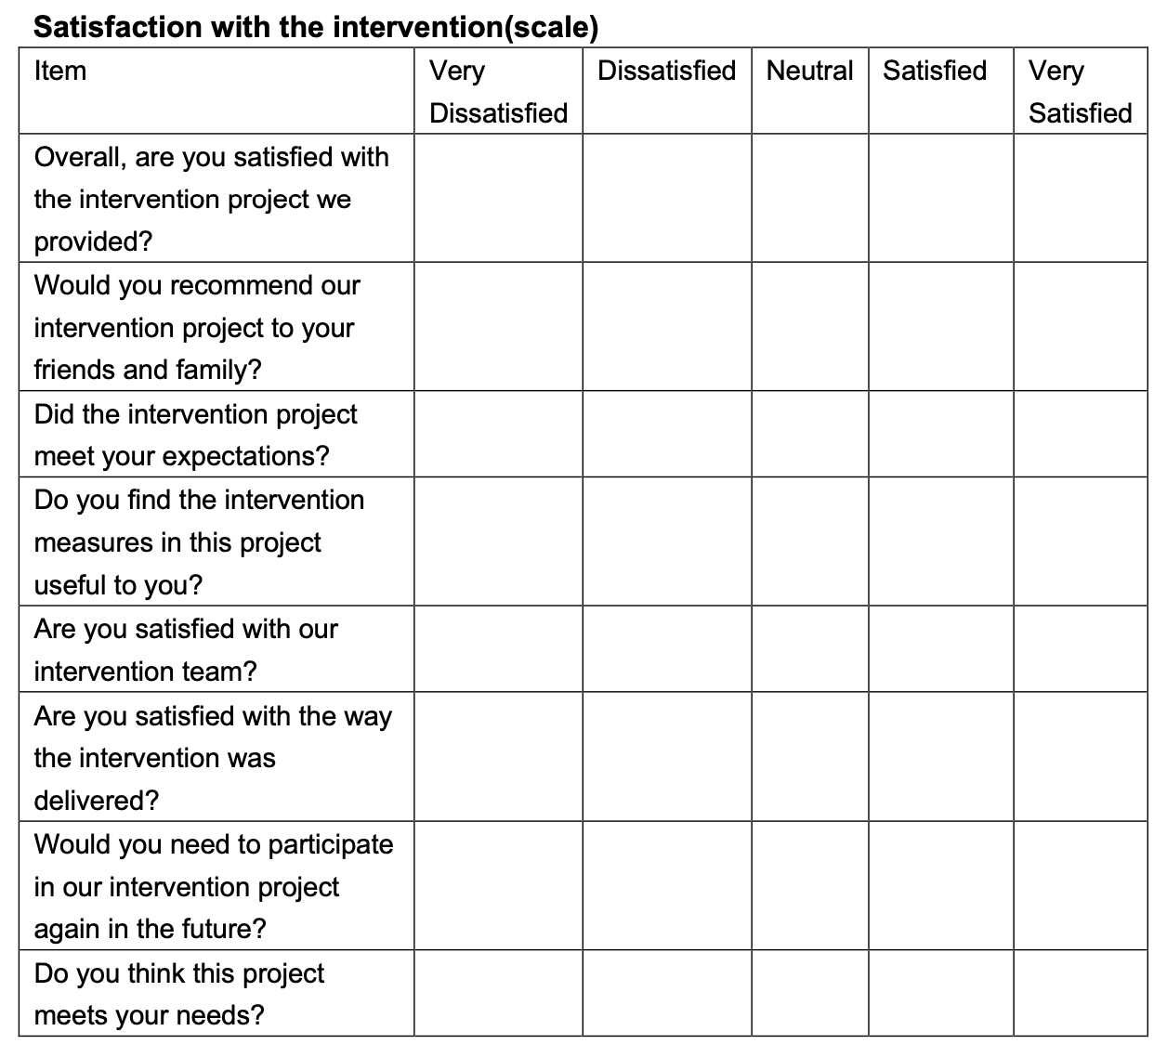

Engagement
6- items were independently designed to evaluate the level of participant engagement, including the degree of involvement in the intervention, commitment to the training process, enthusiasm for discussions and activities, completion of assignments and practical activities, utilization of instructional materials and resources, and instances of seeking help when facing challenges. The questionnaire was self-reported by family caregivers of dementia patients, with scores ranging from 1 to 5, where higher scores indicate greater engagement.
Table 2 Degree of Participation of Study Participants in the Intervention Program
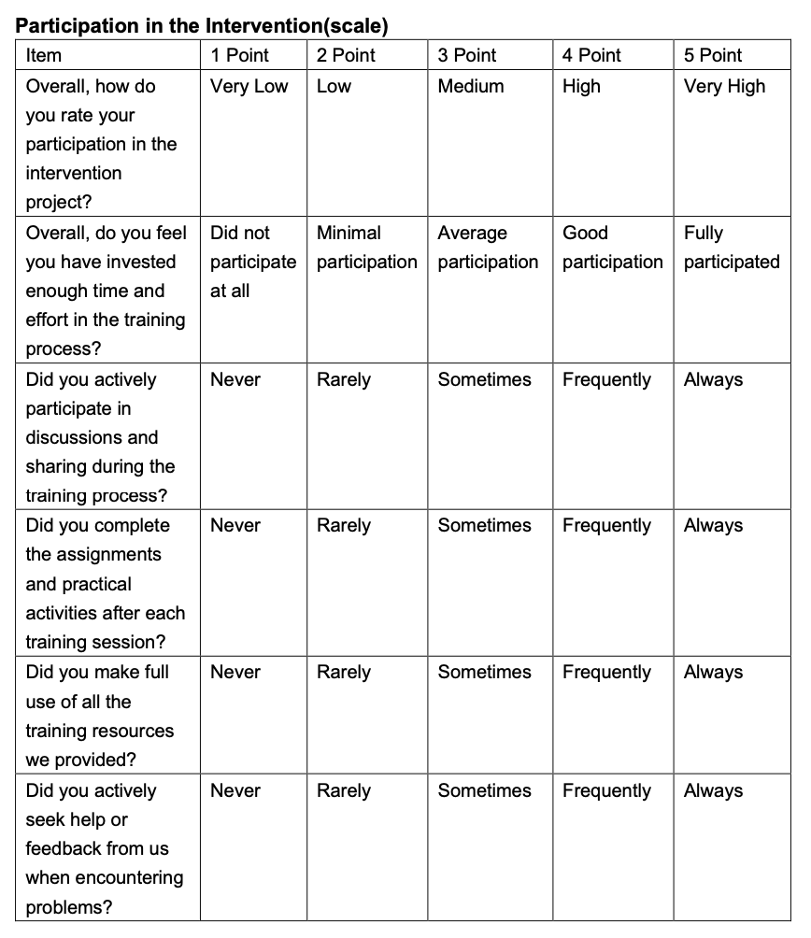
Practical Application
At 1-month intervention, a questionnaire was administered to assess the practical application of the training content by family caregivers of IWD. This included skills in managing psychiatric and behavioral symptoms, daily caregiving techniques, self-care, and relaxation training. Responses were scored on a scale from "never" (1 point) to "always" (5 point), with higher scores reflecting a higher level of skill utilization in caregiving.
Table 3 Frequency of Actual Application of Intervention Content by Study Participants
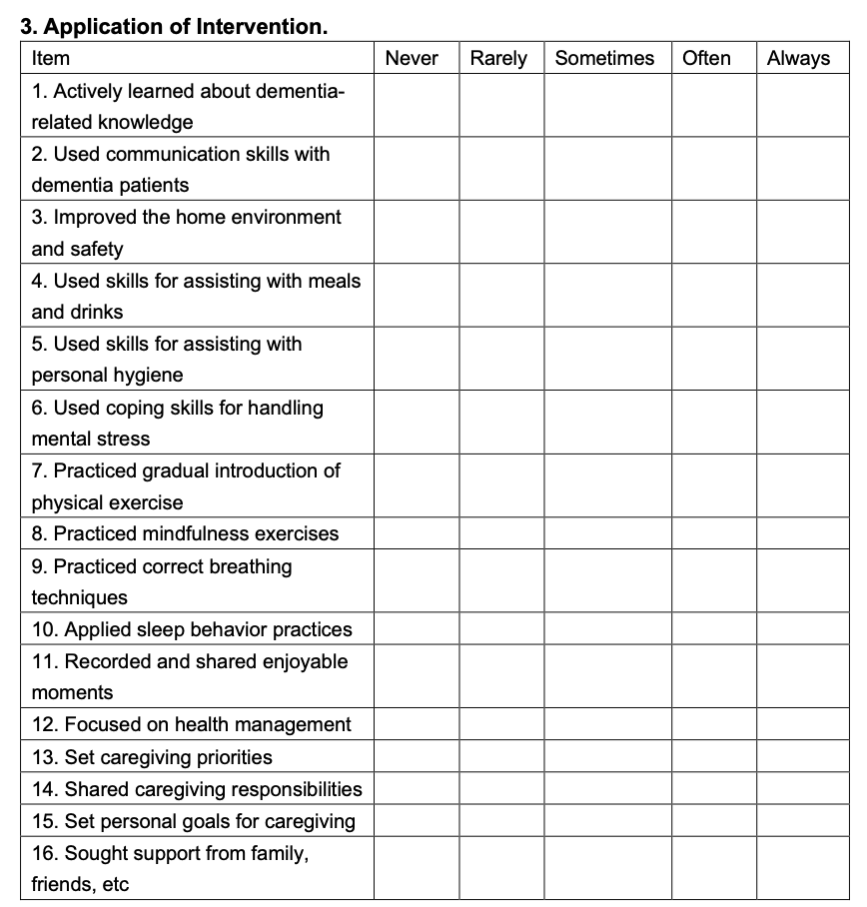

Qualitative Interview Outline
Family Caregivers:
- What were your feelings when receiving the intervention? Do you have any suggestions for improvement?
- Do you feel that the intervention content meets your needs? How has it helped you? What additional caregiving support do you expect?
- How have you applied the content from face-to-face group training in your caregiving process? What are the reasons behind its use or lack of use?

Additional file 2: Preliminary effect evaluation
Outcomes for IWD
Activities of daily living (ADL)(34): The Katz Index of Independence in Activities of Daily Living (ADL) assessed the level of disability by evaluating the ability of elderly individuals to live independently and was widely used for IWD in China. It included six basic activities of daily living, with each activity rated on a three-level scale: "completely independent," "partially independent," and "dependent," which were categorized as mild (dependence for 1–2 functions), moderate (dependence for 3–4 functions), and severe disability (dependence for 5–6 functions). The Cronbach's alpha coefficient for the scale was 0.897.
Behavioral and Psychological Symptoms(35): The Neuropsychiatric Inventory Questionnaire (NPI-Q) was a 12-item questionnaire designed to assess neuropsychiatric symptoms in IWD, including delusions, hallucinations, agitation, depression, anxiety, euphoria, apathy, disinhibition, irritability, abnormal motor behavior, sleep/nighttime behavior, and appetite/eating disorders. The total score for each symptom was the product of its frequency and severity, with scores ranging from 0 to 12. The overall NPI score ranged from 0 to 144, with higher scores indicating more severe neuropsychiatric symptoms. The Cronbach's alpha coefficient for the study was 0.771.
Quality of life(36): The AD-QOL scale included 13 items (physical health, energy, mood, living situation, memory, family, marriage, friends, overall self, ability to do chores, ability to engage in recreational activities, finances, and overall life). Items were rated on a 4-point Likert scale, ranging from 1 (poor) to 4 (excellent), with higher scores indicating better quality of life.
Caregiver-related outcome

Positive Aspects of Caregiving Scale (PACS)(37): The scale included two dimensions: self-affirmation (6 items) and life outlook (3 items). Items were rated on a 5-point Likert scale (0–4), ranging from 1 (strongly disagree) to 5 (strongly agree), with higher scores indicating a higher PAC.

Short Sense of Competence Questionnaire (SSCQ)(38): The scale included 7- items aimed at measuring the competence of caregivers in caring for IWD. The scoring ranged from 1 (strongly agree) to 5 (strongly disagree). Higher total scores indicated greater caregiver confidence in their ability to care for IWD, reflecting a higher level of competence.

Zarit Burden Interview (ZBI-6)(39): A 6-item caregiving burden assessment was used, with items rated on a 5-point Likert scale (0–4), ranging from 0 (never) to 4 (always). Higher scores indicated a greater caregiving burden.

Lubben Social Network Scale (LSNS-6)(40): This scale was used to measure the structural characteristics of an individual's family and friend networks, consisting of two dimensions: the family network and the friend network. Each item follwed options, with scores ranging from 0 to 5. The total score ranged from 0 to 30, with higher scores indicating a better social network level, while scores below 6 suggested a risk of network isolation.

Hospital Anxiety and Depression Scale (HADS)(41): The scale used a 14-item assessment to identify and quantify the severity of anxiety and depression symptoms, with a total score ranging from 0 to 42. Higher scores indicated more severe symptoms of anxiety or depression.

European Quality of Life-5 Dimensions (EQ-5D)(42): The scale was used to evaluate the essential quality of life components, divided into two parts: the EQ-5D Index and the European Quality of Life Visual Analogue Scale (EQ-VAS). The EQ-5D Index consisted of five items (mobility, self-care, usual activities, pain/discomfort, and anxiety/depression), with each item having one question to calculate the EQ-5D score, where 0 represented death and 1 represented full health. The EQ-VAS was a visual scale ranging from 0 (the worst imaginable health) to 100 (the best imaginable health). Together, the overall health index and EQ-VAS scores provided a comprehensive evaluation of the quality of life for family caregivers, with higher scores reflecting better quality of life. Scoring method[1]: The overall health index was calculated as 1.0 – constant (0.039) – conversion factor – additional factor (0.022). If all items were rated as "no problems," the constant was not subtracted; if any item was rated as "severe problems," the additional factor was subtracted, while in all other cases, it was not. The EQ-VAS was scored directly based on the patient's self-assessment.

Additional file 3 General Information of One-on-One Interviewed Participants
Code | Family Caregiver |  |  |  |  |  | IWD
Code | Gender | Age | Education Level | Relationship | Caregiving Duration |  | Gender | Age | Severity of Dementia | Level of Disability
P1 | Male | 49 | Bachelor's Degree | Son | February of Year 2 |  | Male | 75 | Mild | Mild
P2 | Female | 57 | Middle School | Daughter | October of Year 1 |  | Female | 79 | Severe | Severe
P3 | Female | 60 | Bachelor's Degree | Daughter | February of Year 1 |  | Female | 84 | Mild | Mild
P4 | Male | 69 | Primary school | Spouse | October of Year 1 |  | Female | 72 | Moderate | Moderate
P5 | Female | 72 | Middle School | Spouse | May of Year 3 |  | Male | 78 | Moderate | Moderate
P6 | Female | 65 | Junior college | Daughter | May of Year 2 |  | Female | 89 | Moderate | Moderate
P7 | Male | 52 | High School | Daughter-in-law | October of Year 1 |  | Male | 79 | Mild | Mild
P8 | Female | 55 | Primary school | Son -in-law | June of Year 4 |  | Female | 83 | Severe | Moderate

Additional file 4: Interview Results After Implementation of Intervention for Enhancing PAC Among Family Caregivers of IWD
Primary Themes | Secondary Themes | Interview Excerpts
Perceived Benifit | Reevaluating the Caregiving Role | "I had never fully accepted my father's illness. This training made me cherish every moment with him and recognize how important I am to him." (P1)  "I always thought caregiving for my mother with dementia was extremely frustrating. Gradually, I began to see that I was becoming more patient. The instructor encouraged us to focus on the beauty of life... Through this, I have come to know myself better." (P3)
Perceived Benifit | Focusing on Personal Feelings | "It was only after participating in this [intervention program] that I realized how important my emotions are to the well-being of the elderly with dementia. Only when we are healthy can we care for others better." (P2)  "When I feel tired, I ask my daughter to come help out on weekends so I can catch my breath." (P5)
Perceived Benifit | Improvement in Knowledge and Skills | "I learned a lot of things I didn't know before, like how to communicate with someone with dementia. I used to always reason with her, but I hadn't paid attention to this before." (P6)  "I learned many ways to reduce stress, which I sometimes use at home. It’s essential to have a professional guide us." (P5)
Peer Support | Making New Friends | "During the training, I sat next to a young woman who didn’t have much experience. Her mother’s condition seemed serious, and I often talked with her. We became familiar with each other." (P5)  "Since I met C [the social worker in this study], who invited me to participate in this activity, I frequently share things with her like a friend." (P3)
Peer Support | Finding a Sense of Belonging | "I was very happy during the in-person training; I felt like I wasn’t alone. Some people had even more severe situations. There are many people [caring for dementia patients] like me now." (P7)  "There was no one around me who could relate to these issues [caring for dementia patients]. Joining this activity made me feel like I found a family." (P8)
Peer Support | Sharing Information and Resources | "X [a caregiver participant in the training] shared with me the Lezhi Academy public account. H [a teacher focused on dementia] would invite experts to speak on these topics." (P3)  "I established a connection with your [research] team. I read the articles your team shared." (P7)
Suggestions for Improvement | Increase Online Learning Options | "If online learning sessions could be arranged, we could revisit and watch them multiple times." (Suggestions collected after the in-person intervention)
Suggestions for Improvement | Reduce Theoretical Explanations | "Some of the theoretical knowledge on dementia could be reduced; it would be better to share more practical skills." (Suggestions collected after the in-person intervention)
Suggestions for Improvement | Provide Home Visit Support Services | "Could you arrange for someone to visit my home to see my mother? They could stay at my place to understand the situation better and help guide us." (P6)
Reasons for Limited Application of Intervention Content | Lack of Awareness in Application | "I attended the training sessions, but I still lack sufficient awareness to apply this knowledge in caregiving. Sometimes I forget the techniques I've learned and can't recall to use them [dementia care techniques] in time." (P4)
Reasons for Limited Application of Intervention Content | Insufficient Skill Mastery | "When I tried to apply the measures from the training, I found that I wasn't skilled enough. I wasn’t sure if I should use this [technique] or if I should adjust it according to the specific situation of the person I am caring for." (P8)
Reasons for Limited Application of Intervention Content | Selective Application Based on Needs | "Some of the knowledge I learned doesn’t apply to my situation. I only use the content that I need, such as relieving my own stress—I often use muscle relaxation, but the meditation doesn’t suit me." (P3)

