Supplementary Materials
Supplementary Figures
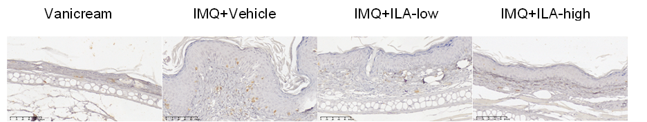

Supplementary figure 1 Representative immunohistochemical staining for CD3⁺ T cells in skin lesions from IMQ-treated mice receiving oral ILA supplementation at low or high doses.

Supplementary figure 2 Representative immunohistochemical staining for CD3⁺ T cells in skin lesions from IMQ-treated mice receiving topical ILA supplementation at low or high doses.
IMQ+Vehicle
IMQ+ILA-low
Vanicream
IMQ+ILA-high

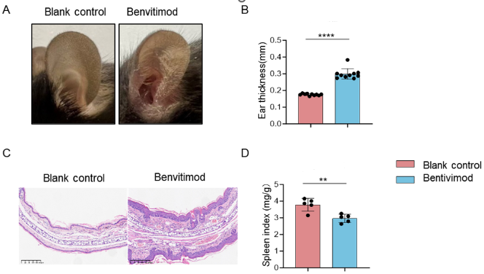
Supplementary figure 3. Topical application of benvitimod induces apparent skin inflammation.
Mice were treated with topical benvitimod (1%) twice daily or left untreated (blank control) from day 0 to day 6. (A) Representative photographs of ears, (B) ear thickness,(C) representative H&E-stained ear sections and (D) spleen index on day 7. Statistical comparisons between two groups used two-tailed unpaired t-tests. **p < 0.01,, ****p < 0.0001.

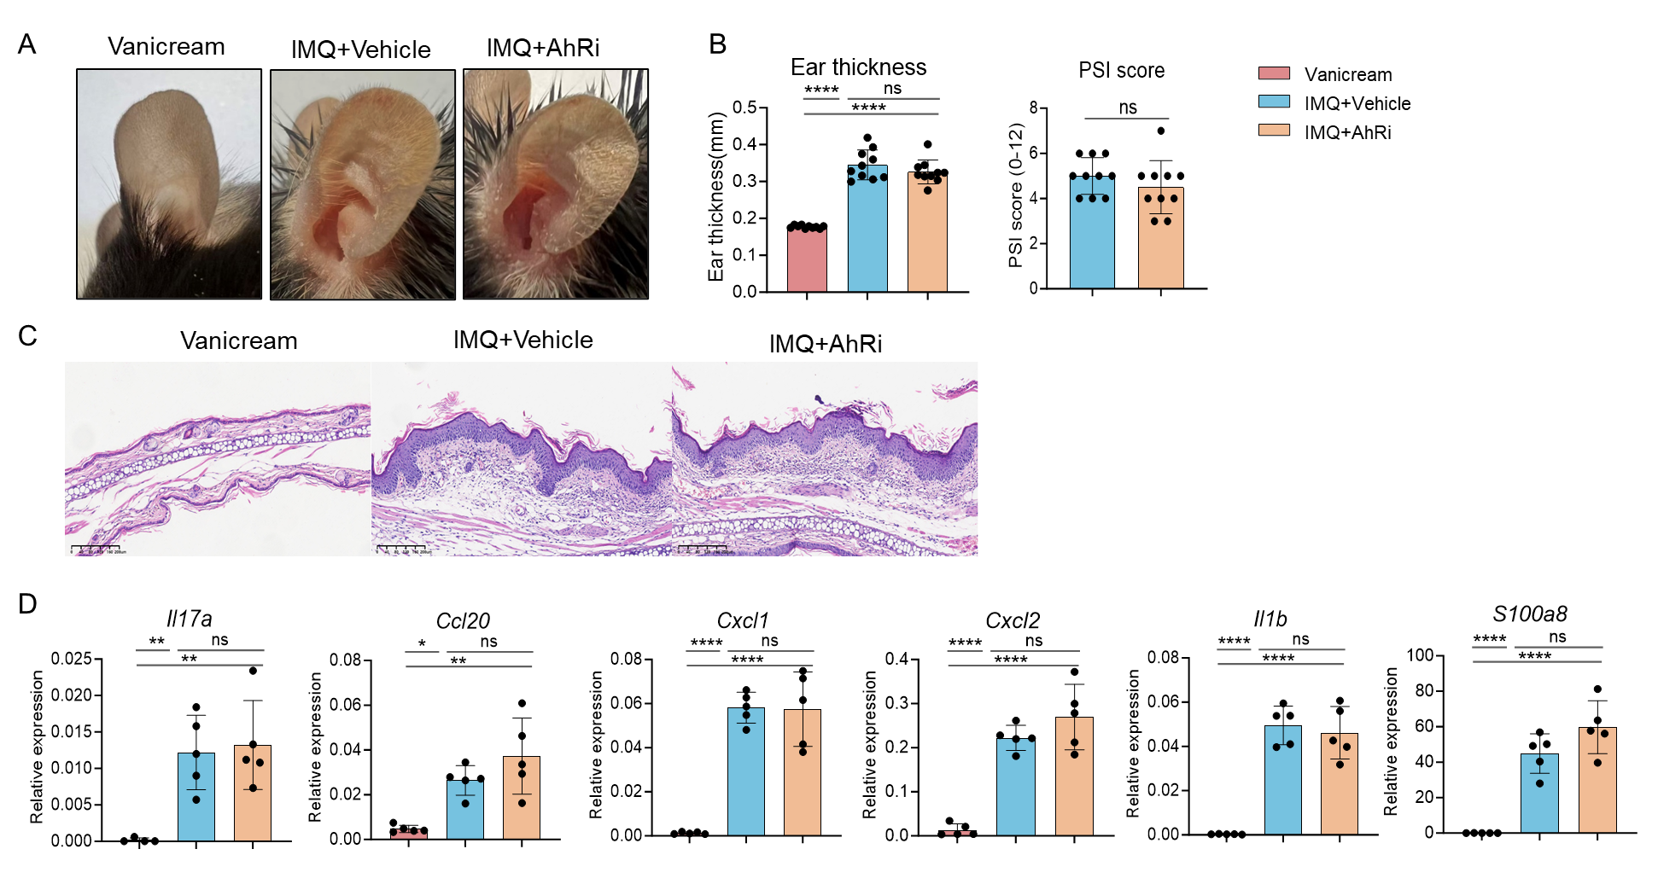
Supplementary Figure 4. Systemic pharmacological inhibition of AhR does not alter IMQ-induced skin inflammation.
Mice received daily intraperitoneal injections of the AhR antagonist CH-223191 (AhRi) or vehicle beginning 2 days before IMQ application. (A) Representative photographs of ears. (B) Ear thickness and Psoriasis Severity Index (PSI) at the endpoint. (C) Representative H&E-stained ear sections. (D) RT–PCR analysis of ear tissue showing relative mRNA expression of psoriasis-related genes. Multiple-group comparisons were analyzed by one-way ANOVA with Tukey’s post hoc test.ns, not significant, *p < 0.05, **p < 0.01, ****p < 0.0001.

Supplementary Table 1
The primers below were obtained according to the sequence from Primerbank database, and synthesized by BGI TECH SOLUTIONS (BEIJING LIUHE) CO.
Primer name (human) | Sequence
CCL20 | F:5’-TGCTGTACCAAGAGTTTGCTC-3’  R:5’-CGCACACAGACAACTTTTTCTTT-3’
IL6 | F:5’-ACTCACCTCTTCAGAACGAATTG-3’  R:5’-CCATCTTTGGAAGGTTCAGGTTG-3’
IL1B | F:5’-ATGATGGCTTATTACAGTGGCAA-3’  R:5’-GTCGGAGATTCGTAGCTGGA-3’
CXCL1 | F:5’-AAC CGA AGT CAT AGC CAC AC-3’  R:5’-GTT GGA TTT GTC ACT GTT CAG C-3’
CXCL2 | F:5’-GCTTGTCTCAACCCCGCATC-3’  R:5’-TGGATTTGCCATTTTTCAGCATCTT-3’
S100A7 | F:5’-ACGTGATGACAAGATTGACAAGC-3’  R:5’-GCGAGGTAATTTGTGCCCTTT-3’
S100A8 | F:5’-ATGCCGTCTACAGGGATGAC-3’  R:5’-ACTGAGGACACTCGGTCTCTA-3’
Primer name (mice) | Sequence
Il17a | F:5’-TTTAACTCCCTTGGCGCAAAA-3’  R:5’-CTTTCCCTCCGCATTGACAC-3’
IL1b | F:5’-GAAATGCCACCTTTTGACAGTG-3’  R:5’-TGGATGCTCTCATCAGGACAG-3’
Cxcl1 | F:5’-ACTGCACCCAAACCGAAGTC-3’  R:5’-TGGGGACACCTTTTAGCATCTT-3’
Cxcl2 | F:5’-CCAACCACCAGGCTACAGG-3’  R:5’-GCGTCACACTCAAGCTCTG-3’
S100a8 | F:5’-AAATCACCATGCCCTCTACAAG-3’  R:5’-CCCACTTTTATCACCATCGCAA-3’
Ccl20 | F:5’-ACTGTTGCCTCTCGTACATACA-3’  R:5’-GAGGAGGTTCACAGCCCTTTT-3’

The information of antibodies used in this study
Antibody | Supplier | Clone name | Catalogue number | Lot number
FITC-CD45 | BD Pharmingen | 30-F11 | 553080 | 1131901
PE-IL-17A | BD Pharmingen | TC11-18H10 | 561020 | B335932
Percy5.5-CD3 | eBioscience | 145-2C11 | 35-0031-82 | 2284170
APC-γδTCR | Biolegend | GL3 | 118116 | B348785
PE-CD11b | BD Pharmingen | M1/70 | 557397 | 9098765
APC-ly6G | eBioscience | 1A8 | 17-9668-82 | 2183550
PE-isotype | Biolegend | RTK2071 | 400407 | B279417

Supplementary methods
Histopathological analysis and immunohistochemistry (IHC)
Formaldehyde-fixed, paraffin-embedded ear skin samples were stained with H&E using standard procedures. Image capture was executed with a Nikon Optiphot 2 microscope (Nikon, Tokyo, Japan). Epidermal thickness was measured with a computer-assisted quantitative image analysis software (ImageJ). In the immunohistochemical analysis, skin sections were incubated with primary antibodies targeting murine Ki67, followed by the corresponding secondary antibodies. Rinsed sections were counterstained with hematoxylin.
Reverse transcription-quantitative PCR (RT-qPCR)
Total RNA of was extracted from mouse ear skin or keratinocytes, utilizing the RNeasy Fibrous Tissue Kit (Qiagen, Hilden, Germany) or EZ-press RNA Purification Kit (EZBioscience, Roseville, MN, USA) as per the manufacturer’s instructions. Subsequently, complementary DNA was synthesized utilizing Color Reverse Transcript Kit (EZBioscience, Roseville, MN, USA). RT-qPCR was conducted employing the Roche LightCycler® 480 instrument with SYBR Green Color qPCR Mix (EZBioscience, Roseville, MN, USA). The primer sequences are detailed in Supplementary Table 1.
Quantification of tryptophan (Trp) metabolites
Targeted LC–MS/MS was used to quantify tryptophan and selected tryptophan-derived metabolites, including microbiota-associated indole metabolites (e.g., ILA, IAA, IPA, and indoxyl sulfate) as well as host-derived kynurenine-pathway metabolites. Mouse fecal samples, mice or human skin were collected into pre-weighed tubes, flash-frozen, and stored at −80 °C. Blood samples were centrifuged to obtain serum, which was then stored at −80 °C until analysis.
Human and mouse skin tissues were processed as follows: 20.0 mg of tissue was cut into small pieces using clean surgical scissors and transferred to a 1.5-mL microcentrifuge tube. Samples were spiked with 25 μL of 1 μg/mL TRP-d5 as the internal standard, followed by addition of 475 μL extraction solvent (acetonitrile:isopropanol:water = 3:3:2, v/v/v). Two grinding beads were added, and samples were homogenized at 60 Hz for 5 min with 30-s cooling intervals, repeated as needed until complete homogenization was achieved. After vortexing for 30 s, samples were centrifuged at 12,000 rpm for 15 min at 4 °C, and 100 μL of the supernatant was transferred to an autosampler vial fitted with an insert for LC–MS/MS analysis.
For fecal samples, accurately weighed material was extracted with pre-chilled 80% methanol, followed by bead-mill homogenization, sonication on ice for 20 min, and precipitation at −20 °C for 1 h. After centrifugation (16,000 × g, 20 min, 4 °C), supernatants were dried and reconstituted in 50% methanol with normalization to sample mass. For serum samples, proteins were precipitated by adding 3–4 volumes of 80% methanol containing stable-isotope internal standards (IS), followed by incubation at −20 °C for 30–60 min and centrifugation (16,000 × g, 15 min, 4 °C). The resulting supernatants were dried and reconstituted in 50% methanol.
Chromatographic separation was performed on a reversed-phase C18 column (1.7 μm, 2.1 × 100 mm) maintained at 40 °C, using water with 0.1% formic acid as mobile phase A and acetonitrile with 0.1% formic acid as mobile phase B, at a flow rate of 0.40 mL/min. The gradient was programmed from 5% to 40% B over 8 min, increased to 95% B from 9 to 10 min, and then re-equilibrated to initial conditions by 11 min. The autosampler was maintained at 4 °C, and the injection volume was 2 μL. Mass spectrometric detection was performed on a triple-quadrupole instrument using electrospray ionization (ESI) in both positive and negative modes with multiple reaction monitoring (MRM); source parameters were optimized for the specific instrument platform. Quantification was based on external matrix-matched calibration curves (≥6 concentration levels; 1/x or 1/x² weighting; R² ≥ 0.995). Pooled quality-control samples were injected periodically throughout the run (acceptance criterion: RSD ≤ 30%), and blank samples were interleaved to monitor carryover (≤20% of the LLOQ). Peaks were identified by retention time and MRM transitions relative to authentic standards and quantified using analyte-to-IS peak area ratios. Metabolite concentrations were expressed as μg/g wet feces, ng/mL serum, or ng/mg for skin samples, as appropriate.

