Supplementary Materials
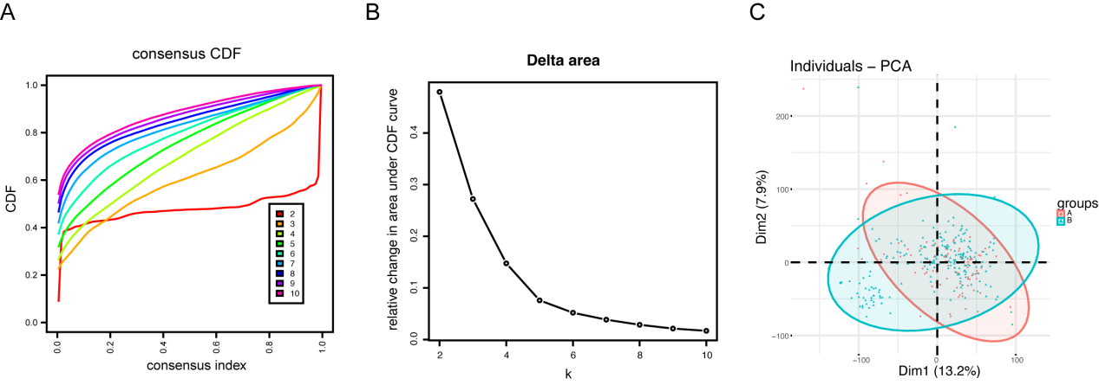
Supplementary Figure S1
- Cumulative distribution function (CDF)；（B）Delta area plot；（C）PCA depicted the distribution for clusters of cuproptosis-related genes.

Supplementary Figure S2
Construction of ceRNA network by integrated analysis.
Supplementary Figure S3
- The heatmaps of the DEGs in low expression group and high expression group among SLC6A6, AC067930.4 and miR-375；（B）The volcano plots of differential expression analysis of SLC6A6, AC067930.4 and miR-375 in low expression group and high expression group.

Supplementary Table 1 The sequence of siRNA
gene | Sequence (5'→3')
siSLC6A6 | GACACTCTTGTTCTTGCGCA

Supplementary Table 2 The sequence of primer
gene | Primer sequence (5'→3')
MFN2 | F:AGACAACAGACACGCGAGGT；R:GGCCATCTCCTTGGTTTGGGA
has-miR-375 | TTTGTTCGTTCGGCTCGCGTGA
AC067930.4 | F: GCCACCGCGCCCGGCCCA；R:GGCAGGGCAGCATATTAA

