Figure S1. Epidemiological cascade defining the study target population
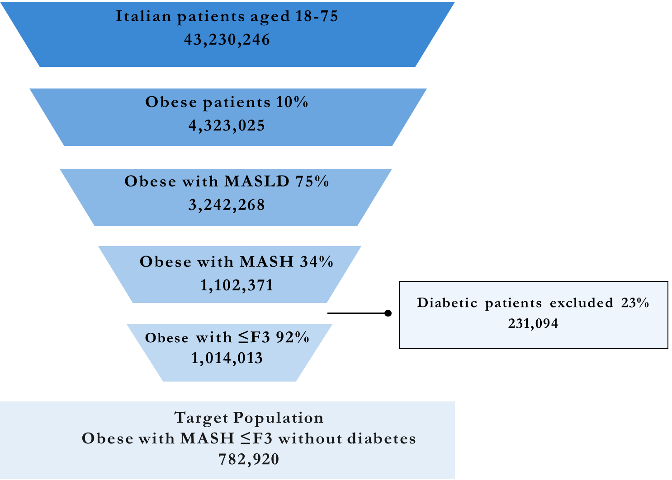
Figure S1. Epidemiological cascade used to identify the study target population of obese and MASLD patients with MASH (≤F3) without diabetes. From the Italian population aged 18–75 years in 2025, sequential prevalence estimates for obesity (10%), MASLD (75%), and MASH (34%) were applied. The analysis focused on obese patients with fibrosis stages F0–F3 (≈92% of obese patients with MASH), excluding individuals with diabetes.

Table S1. Relative risk reduction of major obesity-related comorbidities in patients treated with semaglutide 2.4 mg as result of a 15% weight reduction
Major obesity-related comorbidities | Relative risk reduction (%)
Dyslipidemia | 12.4%
Hypertension | 18.7%
CKD | 6.2%
T2DM | 39.2%
Osteoarthritis | 18.0%
AF | 8.0%
UA/IMA | 22%
HF | 20%
Asthma | 20.2%
OSA | 56.4%
Abbreviations: CKD, Chronic Kidney Disease; T2DM, Type 2 Diabetes Mellitus; AF, Atrial Fibrillation; UA/AMI, Unstable Angina/ Acute Myocardial Infarction; HF, Heart Failure; OSA, Obstructive Sleep Apnea
Table S2. Annual transition probability for liver disease progression states with adjustment for non-advanced fibrosis stages (≤F3) based on the ESSENCE study
 | F0 | F1 | F2 | F3 | CC | DCC | HCC | LT | 1yPLT | PLT | LRM | CVM | OM
F0 | 91.8% | 4.5% | 1.4% | 0.6% | 0.9% | 0.0% | 0.0% | 0.0% | 0.0% | 0.0% | 0.0% | 0.2% | 0.7%
F1 | 36.4% | 59.6% | 1.9% | 0.8% | 0.3% | 0.0% | 0.0% | 0.0% | 0.0% | 0.0% | 0.1% | 0.2% | 0.7%
F2 | 3.8% | 35.5% | 55.2% | 2.4% | 1.8% | 0.0% | 0.0% | 0.0% | 0.0% | 0.0% | 0.4% | 0.2% | 0.7%
F3 | 1.3% | 5.8% | 33.8% | 47.7% | 9.5% | 0.0% | 0.4% | 0.0% | 0.0% | 0.0% | 0.7% | 0.1% | 0.6%
CC | 1.6% | 0.0% | 0.0% | 2.8% | 83.2% | 6.6% | 2.6% | 0.0% | 0.0% | 0.0% | 2.3% | 0.2% | 0.7%
DCC | 0.0% | 0.0% | 0.0% | 0.0% | 0.0% | 23.1% | 4.0% | 55.1% | 0.0% | 0.0% | 17.0% | 0.1% | 0.7%
HCC | 0.0% | 0.0% | 0.0% | 0.0% | 0.0% | 0.0% | 8.6% | 64.8% | 0.0% | 0.0% | 25.9% | 0.1% | 0.7%
LT | 0.0% | 0.0% | 0.0% | 0.0% | 0.0% | 0.0% | 0.0% | 0.0% | 95.3% | 0.0% | 4.0% | 0.0% | 0.7%
1yPLT | 0.0% | 0.0% | 0.0% | 0.0% | 0.0% | 0.0% | 0.0% | 0.0% | 0.0% | 80.8% | 18.4% | 0.1% | 0.7%
PLT | 0.0% | 0.0% | 0.0% | 0.0% | 0.0% | 0.0% | 0.0% | 0.0% | 0.0% | 86.8% | 12.0% | 0.5% | 0.7%
Abbreviations: F, fibrosis; CC, compensated cirrhosis; DCC, decompensated cirrhosis; HCC, hepatocellular carcinoma; LT, liver transplant; yLT, year-LT; PLT, post-LT; LRM, liver related mortality; CVM, cardiovascular mortality, BM, background mortality.

Table S3. Reference annual transition probability matrix used as input in the model
 | F0 | F1 | F2 | F3 | CC | DCC | HCC | LT | 1yPLT | PLT | LRM | CVM | OM
F0 | 90.0% | 6.1% | 1.7% | 0.9% | 0.9% | 0% | 0% | 0% | 0% | 0% | 0% | 0.22% | 0.7%
F1 | 2.2% | 93.0% | 2.3% | 1.3% | 0.3% | 0% | 0% | 0% | 0% | 0% | 0.1% | 0.22% | 0.7%
F2 | 1.3% | 6.7% | 85.0% | 3.8% | 1.8% | 0% | 0% | 0% | 0% | 0% | 0.4% | 0.20% | 0.7%
F3 | 0% | 4.1% | 11.0% | 87.0% | 11.0% | 0% | 0.5% | 0% | 0% | 0% | 0.8% | 0.16% | 0.7%
CC | 0% | 0% | 0% | 4.4% | 83.0% | 6.6% | 2.6% | 0% | 0% | 0% | 2.3% | 0.16% | 0.7%
DCC | 0% | 0% | 0% | 0% | 0% | 23.0% | 4.0% | 55.0% | 0% | 0% | 17.0% | 0.08% | 0.7%
HCC | 0% | 0% | 0% | 0% | 0% | 0% | 8.6% | 65.0% | 0% | 0% | 26.0% | 0.07% | 0.7%
LT | 0% | 0% | 0% | 0% | 0% | 0% | 0% | 0% | 95.0% | 0% | 4.0% | 0.03% | 0.7%
1yPLT | 0% | 0% | 0% | 0% | 0% | 0% | 0% | 0% | 0% | 80.0% | 18.2% | 0.05% | 0.7%
PLT | 0% | 0% | 0% | 0% | 0% | 0% | 0% | 0% | 0% | 87.0% | 12.0% | 0.48% | 0.7%
Abbreviations: F, fibrosis; CC, compensated cirrhosis; DCC, decompensated cirrhosis; HCC, hepatocellular carcinoma; LT, liver transplant; yLT, year-LT; PLT, post-LT; LRM, liver related mortality; CVM, cardiovascular mortality, BM, background mortality.

Table S4. Main unit costs included in the model
Major obesity-related comorbidities | Direct cost
Dyslipidemia | € 820
Dyslipidemia | € 864
CKD | € 4,352
T2DM | € 2,791
Osteoarthritis | € 622
AF | € 4,008
UA / AMI | € 6,066
HF | € 5,910
Asthma | € 1,291
OSA | € 2,500
Liver disease evolution state | Direct cost
Steatosis | € 60
F0 | € 139
F1 | € 1,189
F2 | € 1,189
F3 | € 2,989
CC | € 2,989
DCC | € 3,194
HCC | € 4,001
LT | € 107,000
1yPLT | € 115,545
PLT | € 39,798
Abbreviations: CKD, Chronic Kidney Disease; T2DM, Type 2 Diabetes Mellitus; AF, Atrial Fibrillation; UA/AMI, Unstable Angina/ Acute Myocardial Infarction; HF, Heart Failure; OSA, Obstructive Sleep Apnea; F, fibrosis; CC, Compensated Cirrhosis; DCC, Decompensated Cirrhosis; HCC, Hepatocellular Carcinoma; LT, Liver Transplant; yLT, year-LT; PLT.

Table S5. Semaglutide 2.4 mg price assumptions
Semaglutide 2.4 mg price assumptions | Drug packages (per year) | Annual Ex-Factory price
Wegovy® (base case value) | 13 | € 2,993.12
Base case value - 15% | 13 | € 2,544.15
Base case value - 30% | 13 | € 2,095.18
Base case value - 45% | 13 | € 1,646.22

Table S6. Treatment effects on incidence of major obesity-related complications based on 15% weight loss with semaglutide 2.4 mg
Major obesity-related complications | Semaglutide 2.4 mg | No treatment | Δ Events
Dyslipidemia | 141,283 | 161,281 | -19,999
Hypertension | 124,757 | 153,452 | -28,696
CKD | 75,641 | 80,641 | -5,000
Type 2 diabetes (T2DM) | 41,556 | 68,349 | -26,793
Osteoarthritis | 41,344 | 50,420 | -9,076
Atrial fibrillation (AF) | 40,912 | 44,470 | -3,558
Unstable angina / IMA | 37,481 | 48,052 | -10,572
Heart failure (HF) | 28,647 | 35,809 | -7,162
Asthma | 15,494 | 19,416 | -3,922
Obstructive sleep apnea (OSA) | 5,564 | 12,762 | -7,198
Abbreviations: CKD, Chronic Kidney Disease; T2DM, Type 2 Diabetes Mellitus; AF, Atrial Fibrillation; UA/AMI, Unstable Angina/ Acute Myocardial Infarction; HF, Heart Failure; OSA, Obstructive Sleep Apnea; Δ, Delta, indicates the difference between semaglutide 2.4 mg and the no treatment scenario.

Table S7. Cost savings associated with incidence reduction of major obesity-related complications with semaglutide 2.4 mg treatment
Major obesity-related complications | 1 Y | 2 Y | 3 Y | 4 Y | 5 Y | 6 Y | 7 Y | 8 Y | 9 Y | 10 Y
Dyslipidemia | -€ 837,971 | -€ 2,440,693 | -€ 3,949,341 | -€ 5,368,037 | -€ 6,700,739 | -€ 7,951,255 | -€ 9,123,241 | -€ 10,220,210 | -€ 11,245,538 | -€ 12,202,469
Hypertension | -€ 1,266,887 | -€ 3,689,961 | -€ 5,970,811 | -€ 8,115,666 | -€ 10,130,512 | -€ 12,021,104 | -€ 13,792,970 | -€ 15,451,423 | -€ 17,001,565 | -€ 18,448,301
CKD | -€ 1,111,845 | -€ 3,238,383 | -€ 5,240,102 | -€ 7,122,468 | -€ 8,890,737 | -€ 10,549,958 | -€ 12,104,983 | -€ 13,560,473 | -€ 14,920,909 | -€ 16,190,593
T2DM | -€ 3,821,083 | -€ 11,129,369 | -€ 18,008,688 | -€ 24,477,828 | -€ 30,554,848 | -€ 36,257,101 | -€ 41,601,263 | -€ 46,603,357 | -€ 51,278,774 | -€ 55,642,302
Osteoarthritis | -€ 288,453 | -€ 840,154 | -€ 1,359,473 | -€ 1,847,828 | -€ 2,306,581 | -€ 2,737,043 | -€ 3,140,473 | -€ 3,518,081 | -€ 3,871,027 | -€ 4,200,430
AF | -€ 728,605 | -€ 2,122,152 | -€ 3,433,902 | -€ 4,667,440 | -€ 5,826,208 | -€ 6,913,516 | -€ 7,932,542 | -€ 8,886,343 | -€ 9,777,853 | -€ 10,609,892
UA/ IMA | -€ 3,276,801 | -€ 9,544,080 | -€ 15,443,495 | -€ 20,991,158 | -€ 26,202,555 | -€ 31,092,568 | -€ 35,675,497 | -€ 39,965,083 | -€ 43,974,525 | -€ 47,716,503
HF | -€ 2,162,823 | -€ 6,299,485 | -€ 10,193,341 | -€ 13,855,027 | -€ 17,294,763 | -€ 20,522,373 | -€ 23,547,295 | -€ 26,378,597 | -€ 29,024,994 | -€ 31,494,853
Asthma | -€ 258,735 | -€ 753,598 | -€ 1,219,414 | -€ 1,657,456 | -€ 2,068,947 | -€ 2,455,061 | -€ 2,816,927 | -€ 3,155,632 | -€ 3,472,216 | -€ 3,767,682
OSA | -€ 919,461 | -€ 2,678,040 | -€ 4,333,399 | -€ 5,890,056 | -€ 7,352,359 | -€ 8,724,482 | -€ 10,010,438 | -€ 11,214,083 | -€ 12,339,121 | -€ 13,389,109
Total | -€ 14,672,664 | -€ 42,735,915 | -€ 69,151,967 | -€ 93,992,965 | -€ 117,328,250 | -€ 139,224,460 | -€ 159,745,630 | -€ 178,953,282 | -€ 196,906,524 | -€ 213,662,133

Abbreviations: Y, year; CKD, Chronic Kidney Disease; T2DM, Type 2 Diabetes Mellitus; AF, Atrial Fibrillation; UA/AMI, Unstable Angina/ Acute Myocardial Infarction; HF, Heart Failure; OSA, Obstructive Sleep Apnea
Table S8. Cost of liver disease evolution and savings associated with fibrosis reduction with semaglutide 2.4 mg treatment
No treatment | 1 Y | 2 Y | 3 Y | 4 Y | 5 Y | 6 Y | 7 Y | 8 Y | 9 Y | 10 Y
F0 | € 94,421,672 | € 82,838,679 | € 72,854,456 | € 64,237,130 | € 56,789,112 | € 50,341,986 | € 44,752,168 | € 39,897,204 | € 35,672,636 | € 31,989,321
F1 | € 30,622,480 | € 77,566,461 | € 114,633,523 | € 143,488,451 | € 165,529,958 | € 181,932,719 | € 193,682,754 | € 201,607,202 | € 206,399,409 | € 208,640,046
F2 | € 8,534,134 | € 22,585,221 | € 34,062,846 | € 43,319,802 | € 50,668,994 | € 56,386,263 | € 60,713,559 | € 63,862,192 | € 66,016,030 | € 67,334,533
F3 | € 10,643,161 | € 27,236,595 | € 40,469,183 | € 50,912,570 | € 59,036,524 | € 65,229,779 | € 69,815,871 | € 73,065,332 | € 75,205,209 | € 76,426,579
CC | € 10,643,161 | € 28,318,284 | € 42,756,533 | € 54,413,913 | € 63,690,803 | € 70,936,806 | € 76,455,909 | € 80,511,583 | € 83,331,603 | € 85,112,471
DCC | € 0 | € 1,351,417 | € 2,775,352 | € 4,006,641 | € 5,015,311 | € 5,820,486 | € 6,449,034 | € 6,926,629 | € 7,276,073 | € 7,517,226
HCC | € 0 | € 702,040 | € 1,405,256 | € 2,001,648 | € 2,486,122 | € 2,870,795 | € 3,169,598 | € 3,395,336 | € 3,559,233 | € 3,671,003
LT | € 0 | € 0 | € 19,898,769 | € 40,303,462 | € 57,800,049 | € 72,084,940 | € 83,464,287 | € 92,330,371 | € 99,052,010 | € 103,955,105
1yPLT | € 0 | € 0 | € 0 | € 24,453,096 | € 49,530,311 | € 71,034,204 | € 88,591,063 | € 102,576,986 | € 113,474,043 | € 121,735,503
PLT | € 0 | € 0 | € 0 | € 0 | € 20,311,521 | € 49,916,290 | € 84,175,341 | € 120,300,365 | € 156,380,437 | € 191,076,365
LRM | € 0 | € 352,507 | € 856,744 | € 2,060,186 | € 6,640,860 | € 11,729,972 | € 16,656,121 | € 21,216,960 | € 25,335,327 | € 28,980,319
CVM | € 115,404 | € 203,219 | € 273,800 | € 334,884 | € 392,753 | € 463,522 | € 544,088 | € 629,073 | € 713,886 | € 795,104
BM | € 367,195 | € 686,587 | € 948,567 | € 1,287,549 | € 1,715,275 | € 2,123,039 | € 2,487,961 | € 2,805,592 | € 3,076,302 | € 3,302,112
Total | € 155,347,208 | € 241,841,010 | € 330,935,029 | € 430,819,333 | € 539,607,592 | € 640,870,801 | € 730,957,753 | € 809,124,825 | € 875,492,198 | € 930,535,688
Semaglutide 2.4 mg | 1 Y | 2 Y | 3 Y | 4 Y | 5 Y | 6 Y | 7 Y | 8 Y | 9 Y | 10 Y
F0 | € 96,776,758 | € 94,679,491 | € 91,805,951 | € 88,535,517 | € 85,080,924 | € 81,570,250 | € 78,082,832 | € 74,667,534 | € 71,353,449 | € 68,156,766
F1 | € 22,493,969 | € 48,197,818 | € 62,946,693 | € 70,836,446 | € 74,430,924 | € 75,358,500 | € 74,656,430 | € 72,983,274 | € 70,754,491 | € 68,230,064
F2 | € 7,056,223 | € 16,760,417 | € 22,346,162 | € 25,328,266 | € 26,700,144 | € 27,091,243 | € 26,893,038 | € 26,346,658 | € 25,599,993 | € 24,743,661
F3 | € 6,726,478 | € 13,579,958 | € 17,204,867 | € 19,069,280 | € 19,931,563 | € 20,201,675 | € 20,111,341 | € 19,797,109 | € 19,342,521 | € 18,800,413
CC | € 10,643,161 | € 27,699,662 | € 40,942,973 | € 50,981,023 | € 58,383,732 | € 63,649,937 | € 67,201,035 | € 69,386,029 | € 70,490,648 | € 70,747,172
DCC | € 0 | € 1,351,417 | € 2,743,767 | € 3,901,217 | € 4,798,654 | € 5,466,258 | € 5,942,747 | € 6,264,092 | € 6,461,121 | € 6,559,478
HCC | € 0 | € 665,174 | € 1,303,414 | € 1,815,790 | € 2,205,264 | € 2,490,795 | € 2,691,725 | € 2,824,826 | € 2,904,022 | € 2,940,689
LT | € 0 | € 0 | € 19,530,690 | € 38,989,811 | € 54,953,702 | € 67,245,332 | € 76,343,276 | € 82,805,079 | € 87,135,770 | € 89,763,449
1yPLT | € 0 | € 0 | € 0 | € 24,002,908 | € 47,920,922 | € 67,543,928 | € 82,653,428 | € 93,837,346 | € 101,780,889 | € 107,104,794
PLT | € 0 | € 0 | € 0 | € 0 | € 19,937,581 | € 48,417,933 | € 80,562,481 | € 113,514,140 | € 145,426,947 | € 175,112,871
LRM | € 0 | € 315,081 | € 757,271 | € 1,870,242 | € 6,268,228 | € 11,040,319 | € 15,506,616 | € 19,482,447 | € 22,920,892 | € 25,824,564
CVM | € 115,404 | € 182,576 | € 223,869 | € 253,467 | € 280,939 | € 323,632 | € 378,605 | € 440,219 | € 503,546 | € 564,903
BM | € 367,195 | € 614,065 | € 773,103 | € 999,212 | € 1,312,596 | € 1,608,675 | € 1,867,121 | € 2,085,329 | € 2,264,969 | € 2,408,892
Total | € 144,179,189 | € 204,045,659 | € 260,578,759 | € 326,583,180 | € 402,205,170 | € 472,008,478 | € 532,890,678 | € 584,434,082 | € 626,939,258 | € 660,957,714
Δ Total costs | -€ 11,168,020 | -€ 37,795,351 | -€ 70,356,271 | -€ 104,236,153 | -€ 137,402,422 | -€ 168,862,323 | -€ 198,067,075 | -€ 224,690,743 | -€ 248,552,939 | -€ 269,577,974

Abbreviations: Y, year; F, fibrosis; CC, compensated cirrhosis; DCC, decompensated cirrhosis; HCC, hepatocellular carcinoma; LT, liver transplant; yLT, year-LT; PLT, post-liver transplant; LRM, liver related mortality; CVM, cardiovascular mortality, BM, background mortality; Δ, Delta, indicates the difference between semaglutide 2.4 mg and the no treatment scenario.

