sFig. 1 USP9X promotes HCC malignancy by stabilizing HSP90AA1, which acts as a key downstream effector.
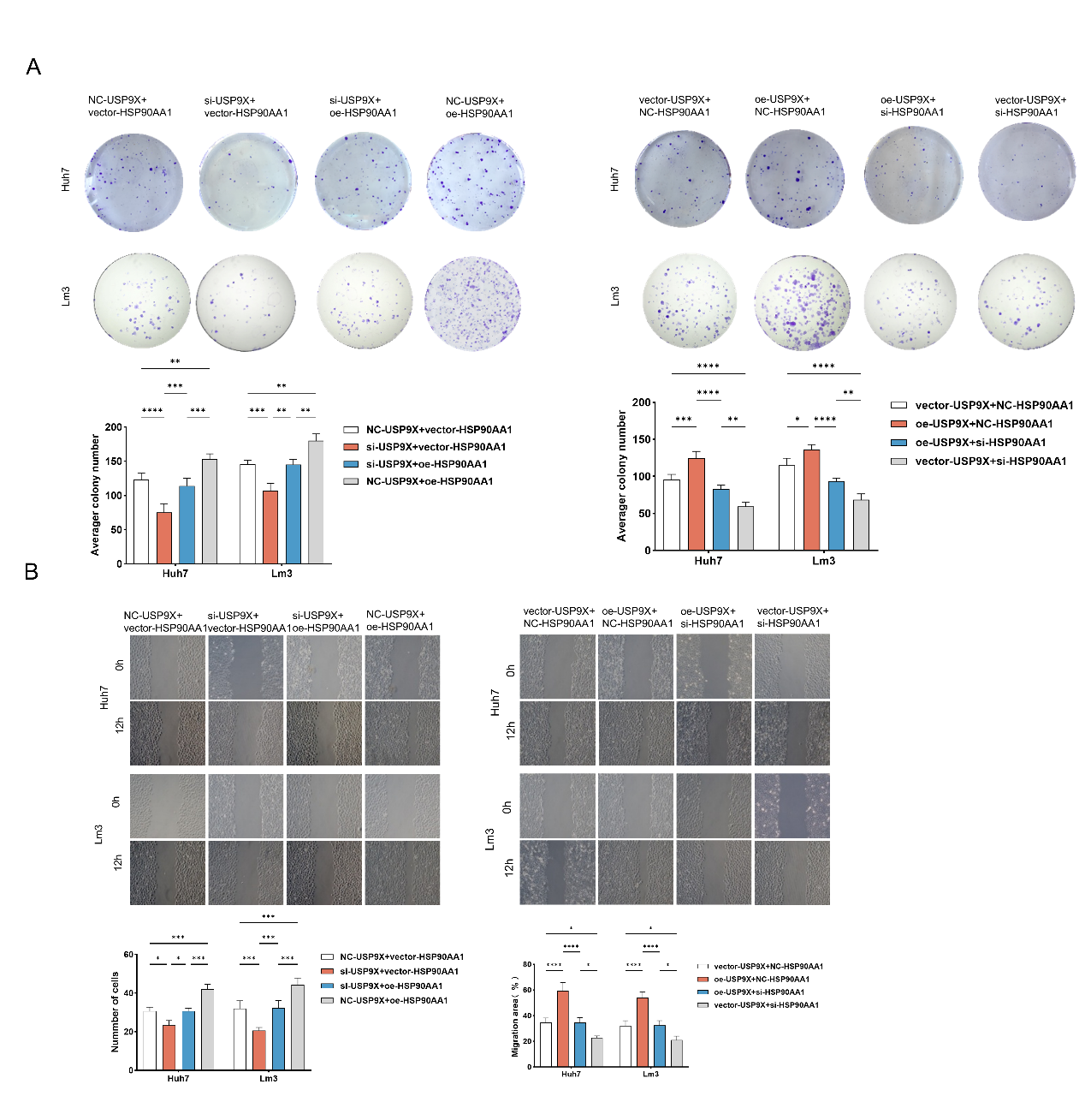
(A) Colony formation assays consistent with proliferation results: USP9X knockdown reduced colony numbers, rescued by HSP90AA1 overexpression; USP9X overexpression increased colonies, reversed by HSP90AA1 silencing. (B) Wound-healing assays showing representative images (0 h, 12 h) and quantification: USP9X knockdown slowed wound closure, rescued by HSP90AA1 overexpression; USP9X overexpression accelerated migration, attenuated by HSP90AA1 silencing (Huh7 and Lm3) (*P < 0.05, **P < 0.01, ***P < 0.001, **** P < 0.0001).

Supplementary table 1. The primer sequences in this study

Primer name | Forward | Reverse
USP9X | CAGCCGAAACCACCATCATT | TGTAGCCACCACGATGACCT
HSP90AA1 | AGGAGGTTGAGACGTTCGC | AGAGTTCGATCTTGTTTGTTCGG
GAPDH | GGTGGTCTCCTCTGACTTCAACA | GTTGCTGTAGCCAAATTCGTTGT

Supplementary table 2. The siRNA sequences in this study

siRNA name | Sense | Antisense
si-NC | UUCUCCGAACGUGUCACGUTT | ACGUGACACGUUCGGAGAATT
siUSP9X-1# | CCCGCACUGAAACAAAUUATT | UAAUUUGUUUCAGUGCGGGTT
siUSP10-2# | GCUUAUUACAGCCAAACUUTT | AAGUUUGGCUGUAAUAAGCTT
siHSP90AA1 | GCUUGACAGAUCCCAGUAATT | UUACUGGGAUCUGUCAAGCTT

Supplementary Table 3. The detailed information of plasmids in this study

Symbol | Transcript ID | Amino acids sequence | Vector | Source
Flag-USP9X | NM_001039591.3 | Full length | pCMV | TRANSHEEP BIO
Myc-HSP90AA1 | NM_001017963.3 | Full length | pCMV | TRANSHEEP BIO

