Supplemental materials
Construction and Validation of a Predictive Model for Post-TACE Recurrence Risk in Hepatocellular Carcinoma: A Retrospective Cohort Study

Supplementary figures legend
Supplementary Figure S1 Venn diagram of univariate Cox regression and LASSO analysis.
Supplementary Figure S2 Calibration curve of prognostic nomogram. (A) calibration curve of training set and (B) calibration curve of validation set.
Supplementary Figure S3 DCA curve of validation set. (A-D) DCA curves of validation sets at 6 months (A), 1 year (B), 18 months (C) and 2 years (D).

Supplementary tables legend
Table S1: Head-to-head C-index data of the training set.
Table S2: Head-to-head C-index data of the validation set.

Supplementary Figure S1

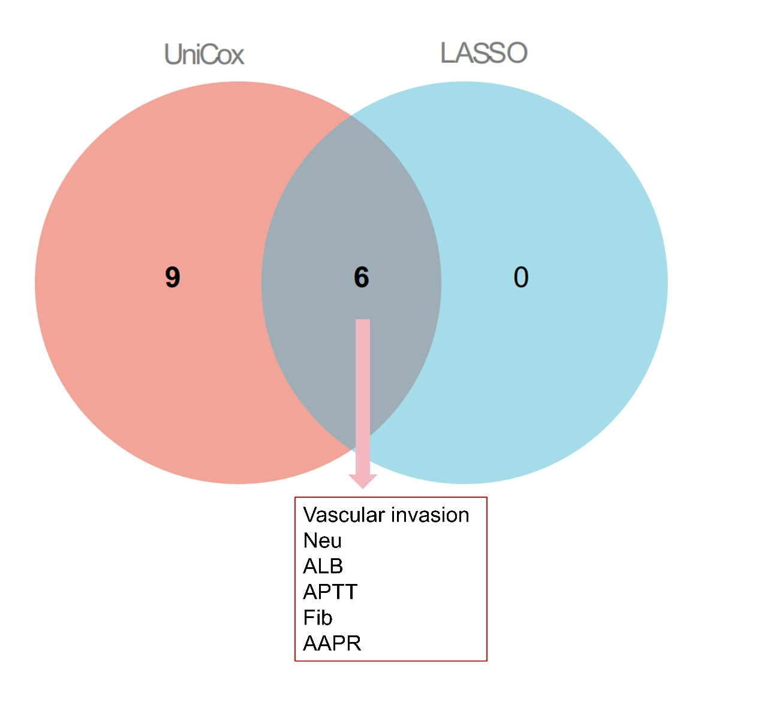
Abbreviations: UniCox, univariate Cox regression analysis; Neu, neutrophil count; LASSO, Least Absolute Shrinkage and Selection Operator; ALB, albumin; APTT, activated partial thromboplastin time; Fib, fibrinogen; AAPR, albumin-to-alkaline phosphatase ratio.

Supplementary Figure S2

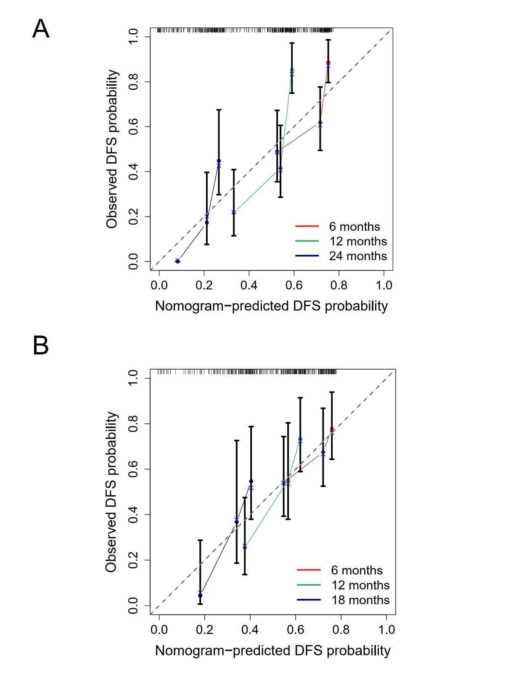
Abbreviations: DFS, disease-free survival.

Supplementary Figure S3
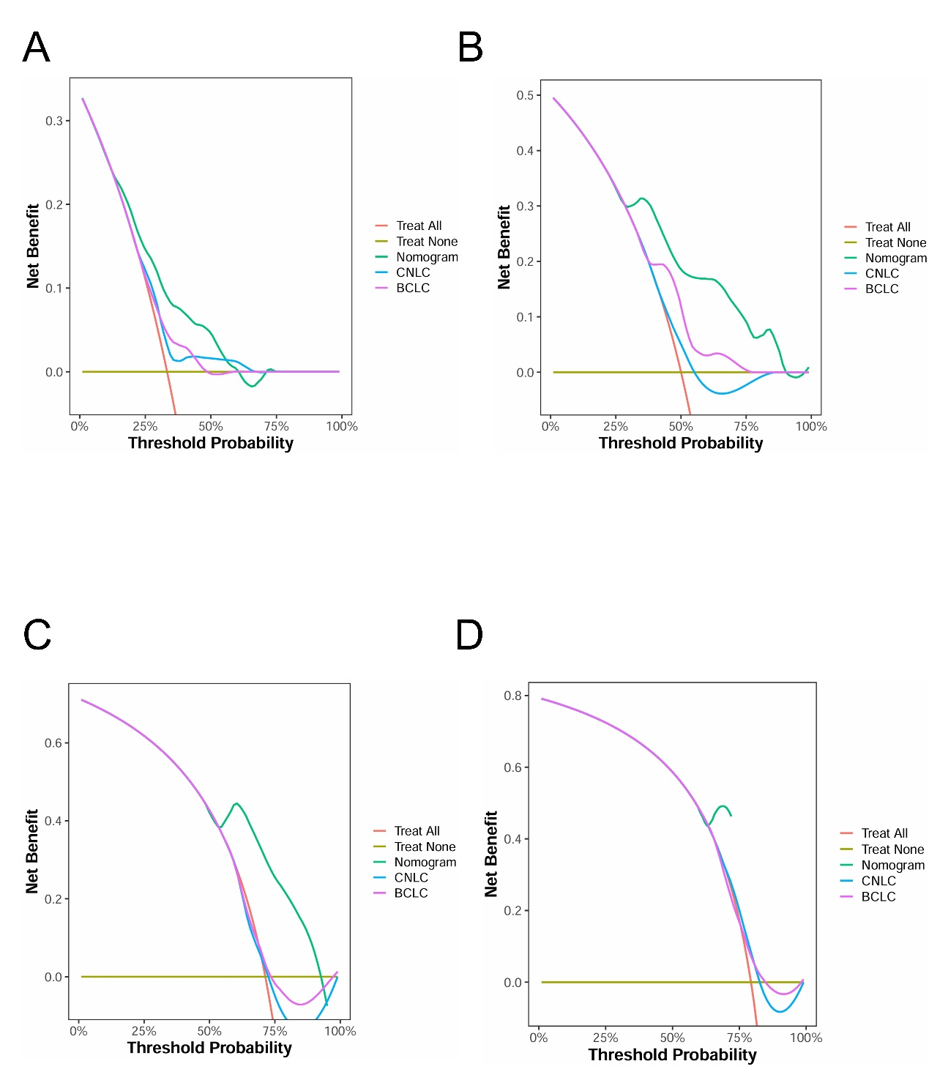
Abbreviations: Nomogram, nomogram score; BCLC, Barcelona Clinic Liver Cancer; CNLC, China Liver Cancer Staging.

Table S1: Head-to-head C-index data of the training set.
Comparison | Delta C-index | CI lower | CI upper | P value
Nomogram vs BCLC | 0.103 | 0.016 | 0.191 | 0.016
Nomogram vs CNLC | 0.123 | 0.047 | 0.202 | 0.004
Abbreviations: Nomogram, nomogram score; BCLC, Barcelona Clinic Liver Cancer; CNLC, China Liver Cancer Staging, CI, confidence interval.

Table S2: Head-to-head C-index data of the validation set.
Comparison | Delta C-index | CI lower | CI upper | P value
Nomogram vs BCLC | 0.064 | -0.043 | 0.178 | 0.268
Nomogram vs CNLC | 0.059 | -0.047 | 0.166 | 0.256
Abbreviations: Nomogram, nomogram score; BCLC, Barcelona Clinic Liver Cancer; CNLC, China Liver Cancer Staging, CI, confidence interval.

